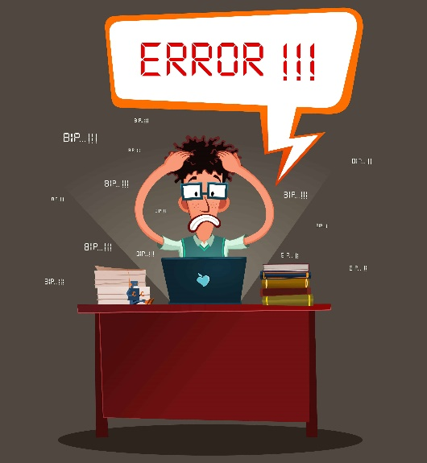
Application not functioning at its peak performance?
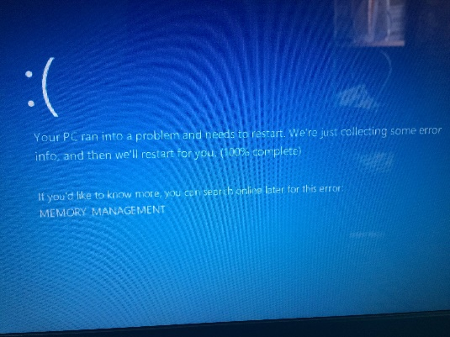
Wanting to punch the Blue Frowny Face of death?

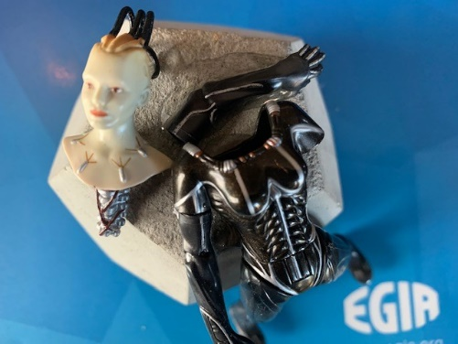
Falling to pieces over Microsoft Updates?
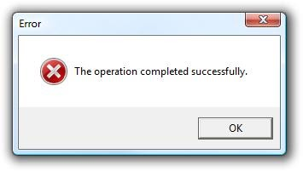
Computer sending mixed messages?
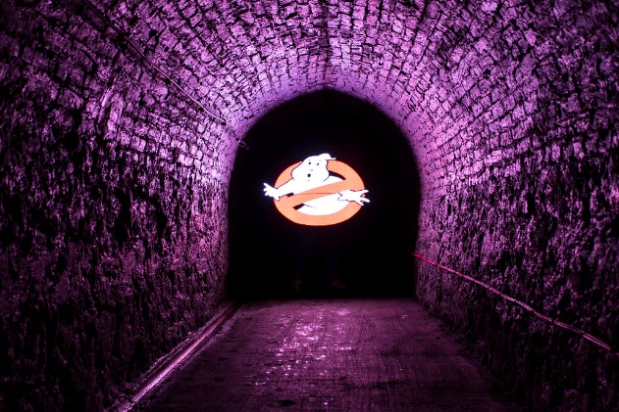
No light at the end of the tunnel?
Ghosts in the machine?
Well who do you call?
(No, no, not them…..)
Call the EGIA Tech Help Line:
1-877-260-6877
Or send an email to:
egiasupport@egia.org

- Various methods of submission:
  - Self-Help Desk portal request
    - https://egiaitteam.atlassian.net/servicedesk/customer/portals
  - Self-Help Desk email requests
    - egiasupport@egia.org
    - Auto-creates service request ticket based on email received
  - Help Desk call-in
    - 1-(877) 260-6877
    - Ticket created by help desk specialist

