PART 1: Local AD Steps
*Important: This step will sync users AD password to MS 365 account. Make sure end-users are aware.
1 – If user already exists in AD, move them to the MS365EGIA > USERS. If not, create them directly within this OU. *Ensure you change suffix to @egia.org
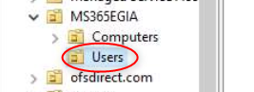
2- Confirm they sync successfully to Entra ID.
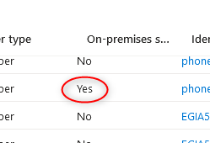
PART 2: End users existing Windows profile Steps
OneDrive
- Install OneDrive and sign in using their MS 365 credentials.
- Ensure that OneDrive sync has completed (OneDrive not showing processing or sync status). *The time it takes will depend on how much data users have stored on Desktop, Documents, and Pictures
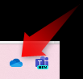
Edge

- Ensure that Edge browser is signed in under their MS 365 account and synchronized.
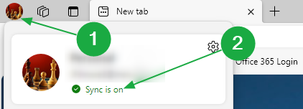
PART 3: Joining Entra ID and confirmation steps

- Log into local admin account.
- Join computer to Entre ID using users 365 cred (Doesn’t have to be the end user cred)
  - Type “Domain” in Windows Search.
  - Click Access Work or School.
  - Click Connect.
  - Select “Join this device to Microsoft Entra ID”.
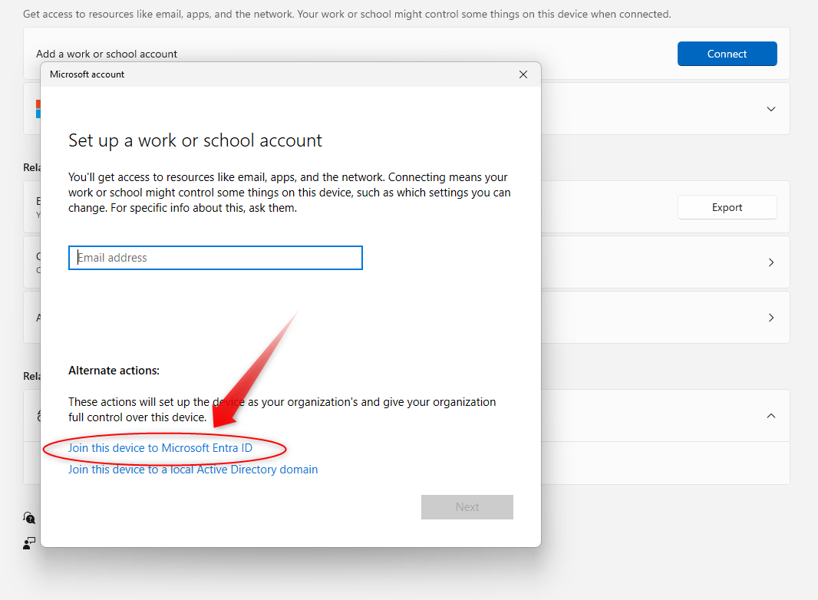
- After it joins, restart the computer and at the Sign In screen, click “Other User”. Then sign in using the end user MS 365 creds.
Make sure the following happens (Add more if you would like)….
*OneDrive is logged in. Intune should automatically have OneDrive restore their desktop, documents, & pictures. If OneDrive doesn’t always auto sign in after the first login, might to reboot a 2nd time.
*Edge is signed in and syncing enabled. Edge bookmarks should automatically appear.
*Ensure MS Outlook and Teams open.

Restoring Google and Firefox Bookmarks
Summary: I will run a Datto job that will back up everyone’s Google and Firefox bookmarks into their existing Windows profiles Documents > BrowserBookmarksBackup directory.
The steps below will show you how to restore each.

To restore Chrome bookmarks 
Copy the file FROM this directory:
C:\users\*old user account path*\Documents\BrowserBookmarksBackup\ChromeBookmarks
Paste and overwrite the file into this directory:
%localappdata%\Google\Chrome\User Data\Default

To restore Firefox bookmarks 
Copy the file FROM this directory:
C:\users\*old user account path*\Documents\BrowserBookmarksBackup\FirefoxBookmarks
Paste and overwrite the same file into this directory:
%appdata%\Mozilla\Firefox\Profiles\*folder with suffix “-release”

