Astrid, Laurie,& Alex
- CPA holding off on the media release until the digital platforms are completed by EGIA
  - Per LD – this is best as there might be an increase of manual application submissions.
- CPA hoping to be able o launch next week.
Alex
- Make sure we are all using the same folder:
  - Sun Storage Rebate External Drive
  - https://cleanpoweralliance.sharepoint.com/:f:/r/sites/CPAExternalShare/Shared%20Documents/Sun%20Storage%20Rebate%20External%20Drive?csf=1&web=1&e=xMySys
Byron
- Posted feedback for email templates on the shared drive:
  - https://cleanpoweralliance.sharepoint.com/:f:/r/sites/CPAExternalShare/Shared%20Documents/Sun%20Storage%20Rebate%20External%20Drive/Email%20Notifications/CPA%20Email%20Templates/R1%20Revisions.%20BJ?csf=1&web=1&e=e5cKcd
  - Clayton uploaded the Screenshots in Jira
- CPA Email Template Feedback:
  - Application has been Approved
    - Logo -> should be high resolution
      - Use same logo as the one shown on the “Your Sun Storage rebate Claim Application Has Been Received” email.
    - Update Font to Nunito Suans (Regular)
      - Application Number
      - Body of email
    - Signature -> should look like a standard footer.
    - Remove the empty space between “Thank you” and the Signature.

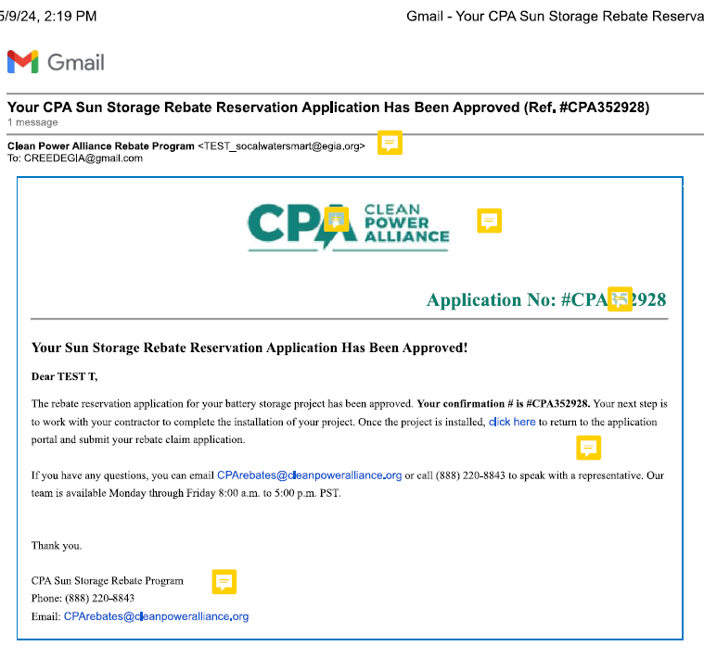
  - Application is incomplete
    - Logo is stretched
      - Use same logo as the one shown on the “Your Sun Storage rebate Claim Application Has Been Received” email.
    - Rebate Number line looks inconsistent to the Application Approved email.
      - Font & Color
    - Signature
      - Make it more consistent
    - There should be a coma after the greeting, “Dear [Name],”
      - Dear TEST EMAIL REQUEST INFO,
    - Remove the empty space between “Thank you” and the Signature.

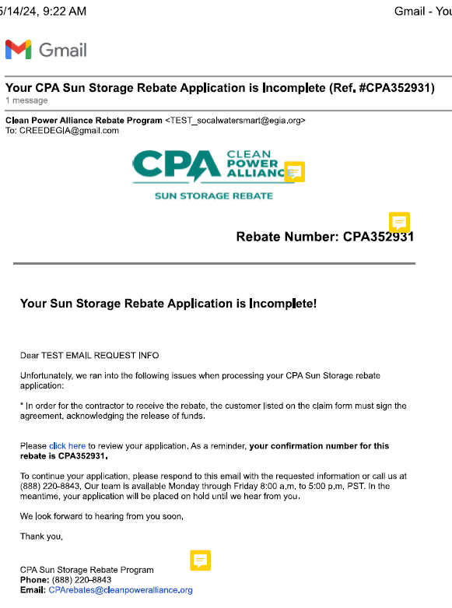
  - Application is not eligible for a rebate
    - We appreciate your participation in the CPA Sun Storage rebate Program. Upon careful review, we have determined that the application # CPA352927 for your home efficiency update is ineligible …
      - Replace “home efficiency upgrade” with “battery storage project”
    - Use this link: https://cleanpoweralliance.org/programs/
    - There should be a coma after the greeting “Dear [Name],”
      - Dear CLAY TEST APPLICATION,
    - Remove the empty space between “Thank you” and the Signature.

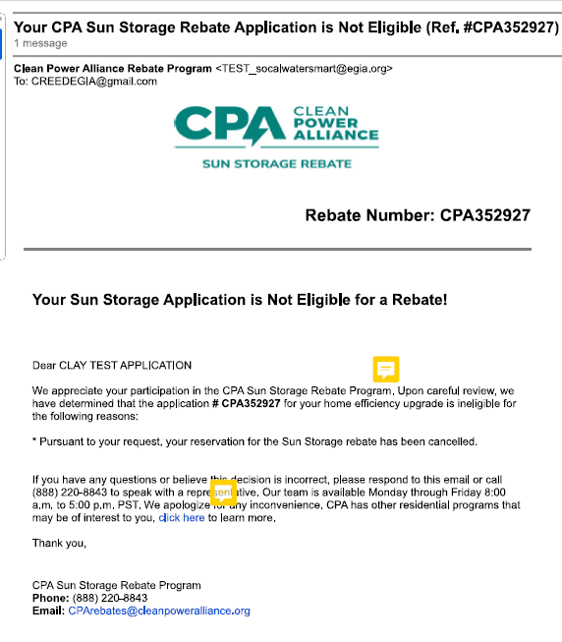
  - Rebate claim application has been approved
    - Logo looks stretched
      - Use same logo as the one shown on the “Your Sun Storage rebate Claim Application Has Been Received” email.

    - There should be a comma after the greeting.
      - Dear [Name],
      - Dear TEST T,
    - Email Font should be: Nunito Sans (Regular)
    - Remove the empty space between “Thank you” and the Signature.

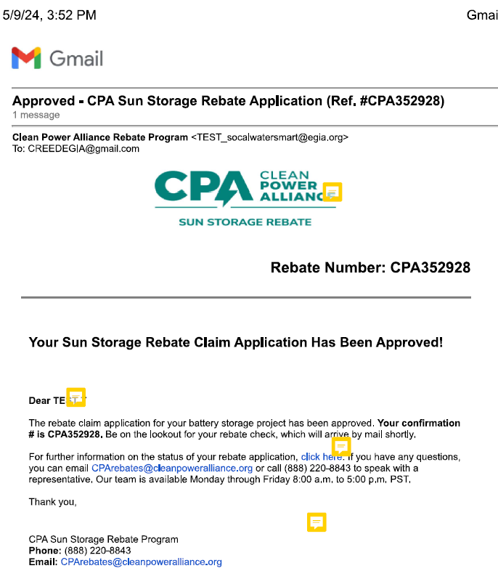

  - We’ve received your sun storage rebate claim application
    - Email font should be: Nunito Sans (Regular)
    - Remove the empty space between “Thank you” and the Signature.
    - Email shows partial Signature -> needs to show complete signature
    - NOTE – This logo looks good. Use this logo for all notification emails.
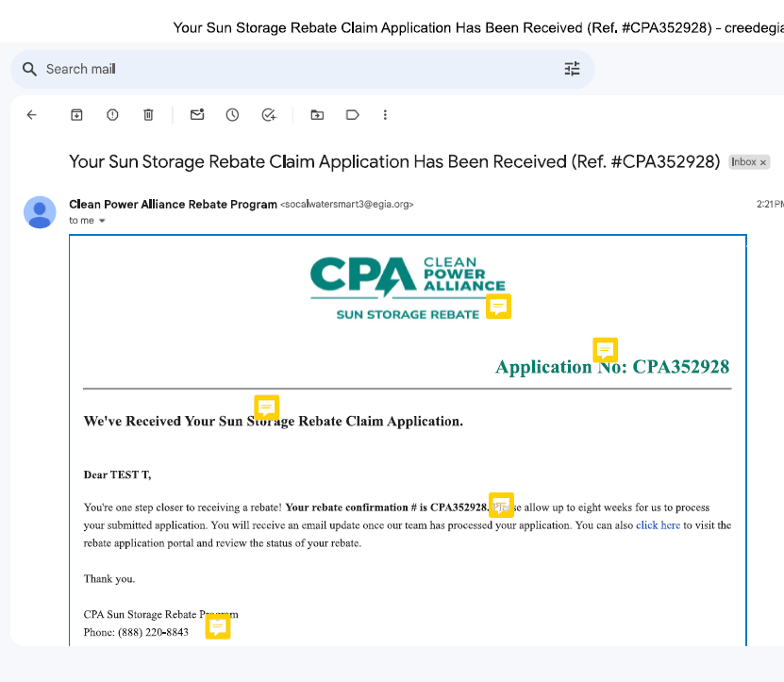
  - We’ve received your sun storage rebate reservation application
    - Check the Font & Color of the Application No.
      - On the top right corner.
    - Remove the empty space between “Thank you” and the Signature.
    - Remove the period (.) after “Click here”
    - Shows partial signature -> needs to show the complete signature.
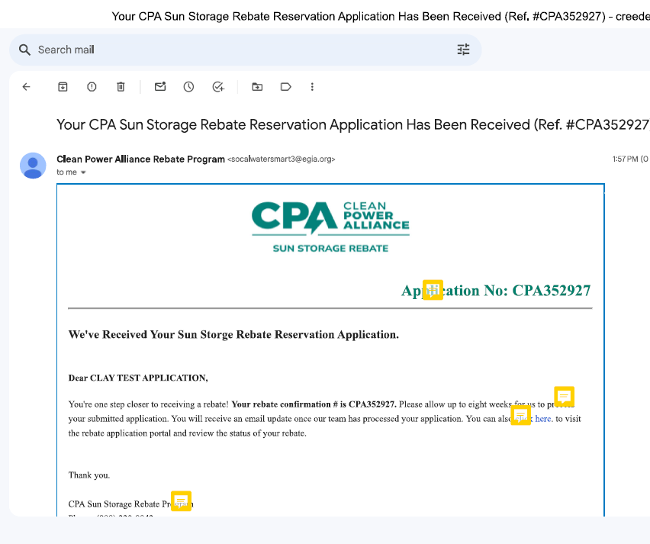
  - Your registration is complete
    - Check Logo
      - Use same logo as the one shown on the “Your Sun Storage rebate Claim Application Has Been Received” email.
    - Remove the empty space between “Thank you” and the Signature.
    - Check the font, should be Nunito Sans (Regular)
  - 