Byron Items:
- Emails
  - Clayton confirmed he did a final review before forwarding them to CPA team
  - Byron confirmed – emails were received.
    - Should have feedback to EGIA within a week.
  - Byron to verify email font was updated.
- Rough turnaround time to launch
  - @CR: The sooner the better -> stop using the paper application as soon a possible, but there is no hard deadline date.
  - @Byron: hoping to turnaround in about a week
Alex Items:
- “CEC-AC Rating” is the “Solar CEC-ACRating(kWh)”
  - CPA to come up with a process for EGIA rebate team to validate this.
  - Per CPA - No need to request additional information for claims in queue to review.
    - Ok to send the Approval Notification Email
- System should calculate the total of all Energy Capacities
  - Add line item “Total Energy Capacity”
    - Battery Quantity * Energy Capacity (kWh) = Total Energy Capacity amount.
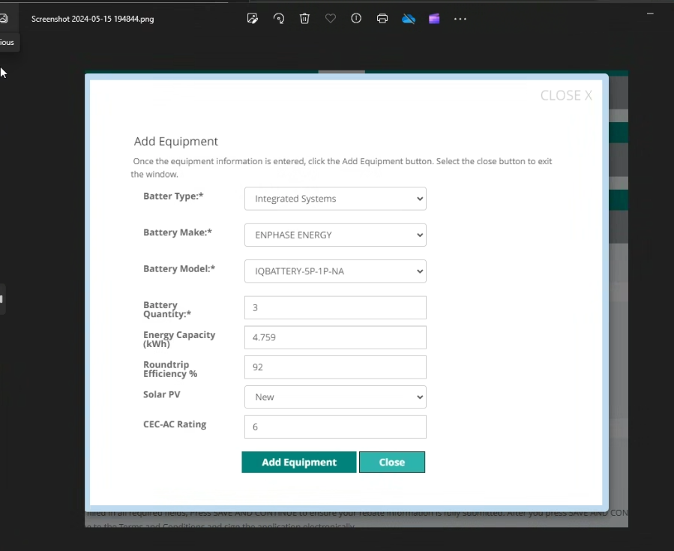
- Reservation
  - Integrated Systems -> need to show Model Number
  - LD confirmed ok to show EGIA Address at the bottom of the Confirmation page of claim submitted.
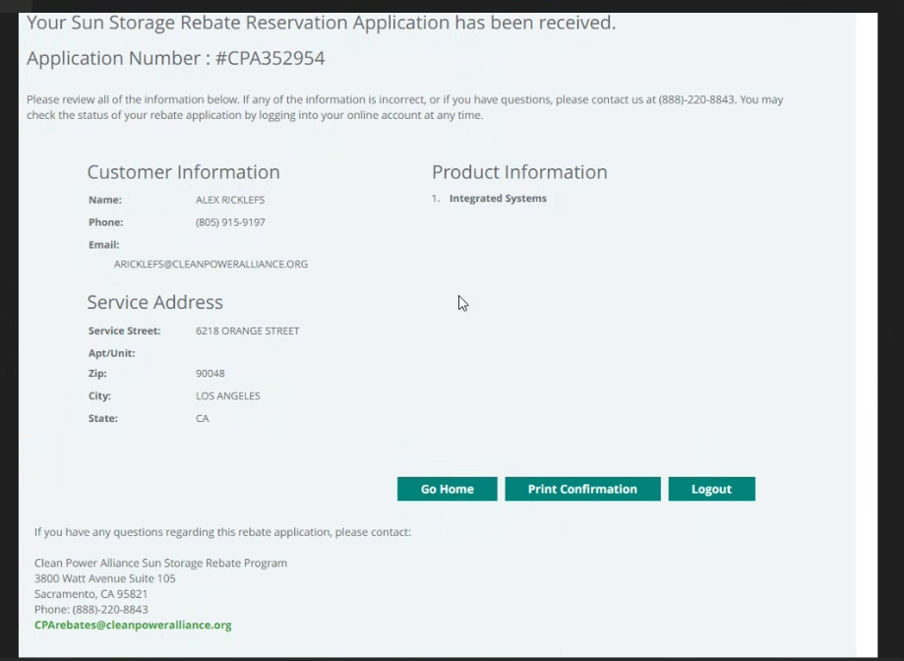
- URL for PDF translations coming soon
Laurie
- Currently while processing claims, team requests both the:
  - Solar billing plan
  - Project ID
- However, the Permision to Operate page shows both above listed items
  - Can we accept the Permission to Operate instead of the other two items?
  - Alex with CAP = Approve.
