Spring 2019 Amana® Brand Smart Home Bundles: March 1, 2019 – May 31, 2019

Welcome to the Spring 2019 Amana® Brand Smart Home Bundles Program. This document will familiarize you with the program, including the smart home bundle options and claims processes for both homeowners and dealers. Dealers should review this information carefully and complete the steps indicated to ensure a smooth experience.
Program Overview
The 2019 Amana Brand Smart Home Bundles Program will provide FREE “smart home” items to homeowners when they purchase select Amana brand high efficiency systems from March 1, 2019 through May 31, 2019. Dealers will be able to offer a range of smart home bundles (smart thermostat + other smart home items) to homeowners that buy a qualifying Amana brand system; dealers will then submit a claim on behalf of the homeowner to trigger the shipment of FREE smart home items to the homeowner’s home address. The program will be administered by EGIA on our behalf. Eligible products and the associated smart home bundle items are outlined below.

With the purchase of a qualifying 16-20 SEER two-stage / inverter Amana® brand system, the consumer will receive a FREE smart thermostat (provided by dealer as a No Charge item at point of sale), plus other FREE smart home items from the options outlined below. There are four levels of qualifying Amana brand systems:

The FREE smart home items will consist of the following:

FREE smart thermostat - Dealer provides FREE thermostat from eligible list below as a No Charge item to homeowner at point of sale. Dealer applies for smart thermostat rebate via EGIA website (more details below).

- Nest Learning Thermostat® OR
- Nest Thermostat E OR
- Honeywell Round Smart Thermostat OR
- Honeywell T6 Pro Smart Thermostat OR
- CTK04 (only allowed for Amana brand 18/20 SEER inverter systems, where ComfortBridge technology is not yet available for matching air handler indoor units)

+ FREE smart home item(s) - Depending on Amana brand system efficiency level. See smart home bundle items in tables below.

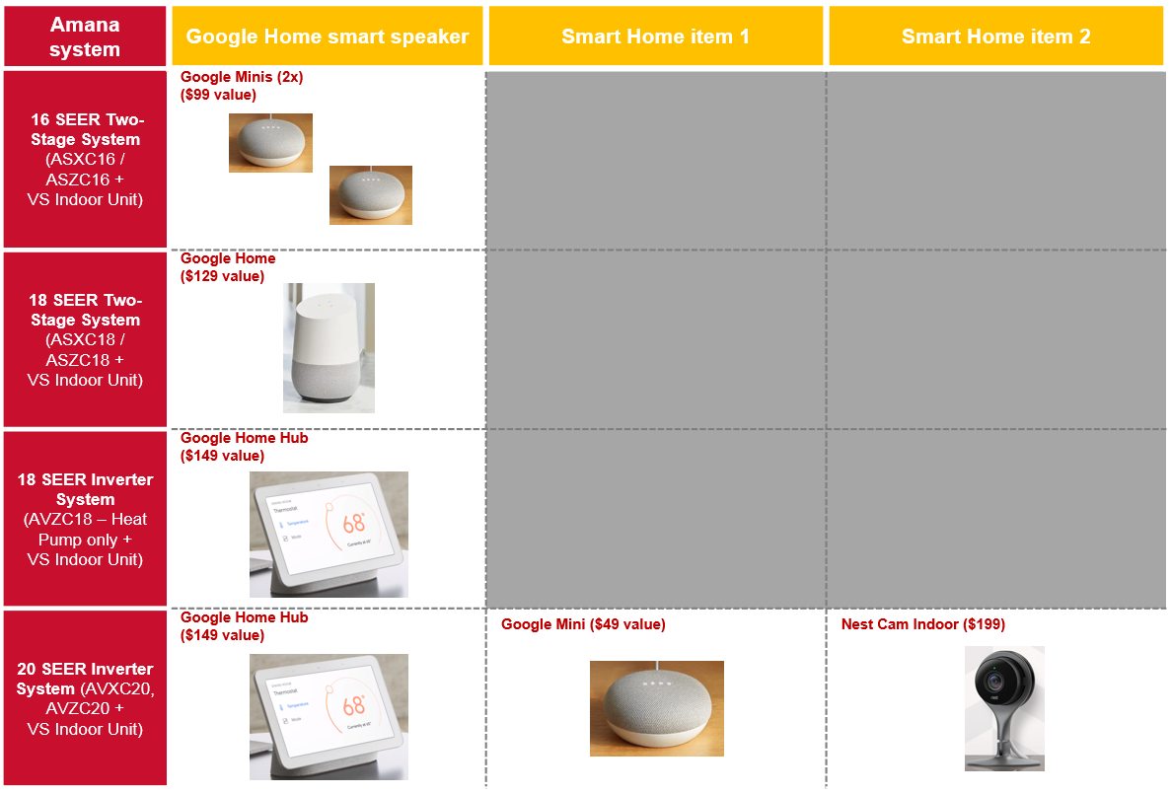

OR

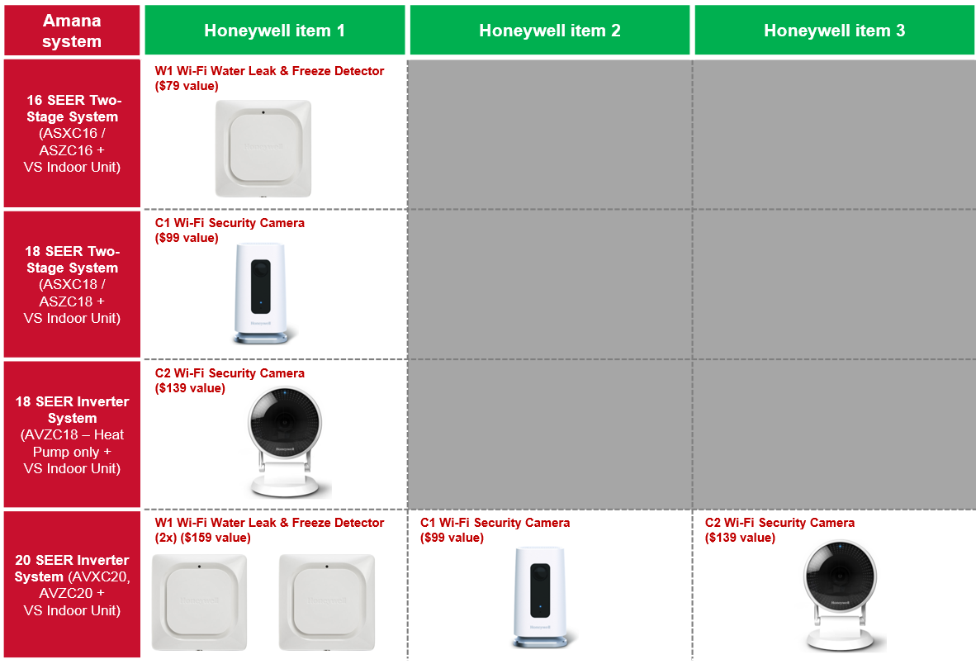

Terms and Conditions Overview
- FREE smart home items limited to one smart home bundle per qualifying Amana brand system installed.
- Only applicable to single-family dwellings in the continental U.S. and Canada.
- Applicable to residential installations only. Commercial installations, residential new construction installations, multi-family installations and self-sales do not apply.
- Products sold through a National Retailer program do not qualify for this program.

Instructions
Please follow the instructions outlined below to ensure a smooth process for both homeowners and dealers participating in this program. The EGIA website, where dealers will submit smart thermostat rebate claims, will be active March 1, 2019. Any time after that date participating dealers may complete the EGIA registration process and begin entering claims for smart home Amana brand system bundles sold under this program. Certain restrictions apply and not all dealers will be eligible to participate in the program. Dealers should contact their Amana Brand Distributor with any questions regarding eligibility.
1
Dealer enrollment on EGIA website
In order to participate in the Spring 2019 Amana® Brand Smart Home Bundles Program, dealers will need to enroll with EGIA at http://amana.egia.org/finance-promotions/ once they select the “Amana Smart Home Bundles” program. Dealers will enroll by clicking on “Register Now” if they don’t have an EGIA account, or “Sign In” if they are already enrolled with EGIA.
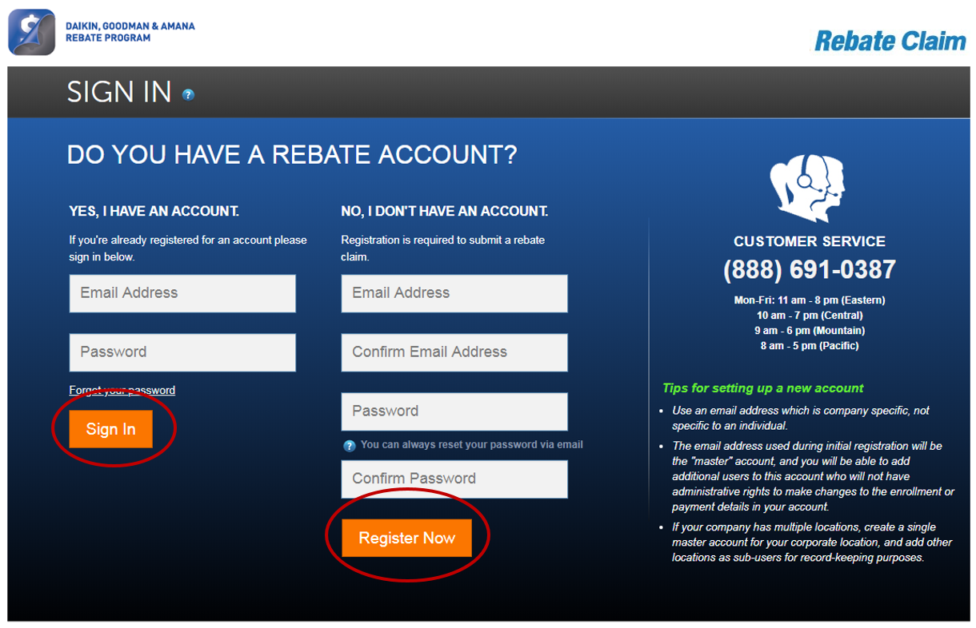

Sale of Amana brand high-efficiency system sale
2
Dealer sells qualifying Amana brand high-efficiency system to homeowner under the Spring 2019 Amana Smart Home Bundles Program, bundled with FREE smart home items.

Dealer provides FREE thermostat from eligible list below as a No Charge item to homeowner at point of sale.

- Nest Learning Thermostat® OR
- Nest Thermostat E OR
- Honeywell Round Smart Thermostat OR
- Honeywell T6 Pro Smart Thermostat OR
- CTK04 (only allowed for Amana brand 18/20 SEER inverter systems, where ComfortBridge technology is not yet available for matching air handler indoor units)

Dealer captures homeowner’s preference with regard to the FREE smart home bundle items on the form provided as a separate attachment, “Spring 2019 Amana Smart Home Bundles Claim Form”, summarized below:

3

Smart Home bundle claim submission
Once enrolled, dealers will submit a smart thermostat rebate claim at http://amana.egia.org/finance-promotions/ to claim their smart thermostat rebate of $25 (or $XX if a CTK04 was provided as FREE thermostat with the sale of an Amana brand 18/20 SEER inverter system). Dealers will be paid by check or ACH, depending on the payment method selected upon enrollment with EGIA. The claim form information will be used to send the homeowner the selected FREE smart home items included as part of their bundle. To do this effectively, the following information will need to be provided by the dealer as part of the claim form:

- Homeowner contact information: full name; mailing address; email address; phone number
- Installation details: model number & serial number for outdoor and indoor units; FREE smart thermostat; date of install; homeowner invoice showing FREE smart thermostat provided to homeowner and Amana brand equipment installed (should match claimed equipment)

Delivery of smart home items to homeowner
4
EGIA will review and validate the smart thermostat rebate claim information submitted under the Spring 2019 Amana Brand Smart Home Bundles Program. Once approved, EGIA will send the details of the FREE smart home items to the appropriate third party to ship those items directly to the homeowner’s address, provided by the dealer on the claim form. Homeowners should expect to receive the smart home items within 2-4 weeks of the dealer claim submission. For this reason, dealers should submit the claim form on behalf of the homeowner as soon as the sale & installation of the qualifying Amana brand high-efficiency system is complete.
5
Checking Claim Status
Dealers can check the status of their claims at any time by logging into their EGIA account at http://amana.egia.org/finance-promotions/ and clicking on the “Reports” tab across the top, then selecting the program from the Dropdown list (in this case Amana Smart Home Bundles), then “Go”. You can export to Excel by then clicking “Download Detail”. Dealers will be notified via email when the claim is approved and the smart home bundles selection has been sent to the appropriate third party.
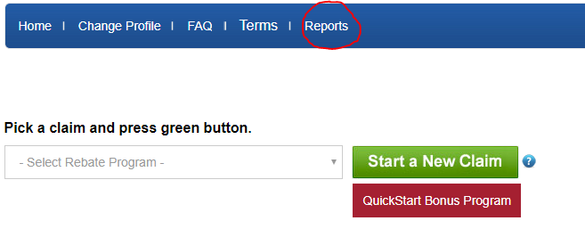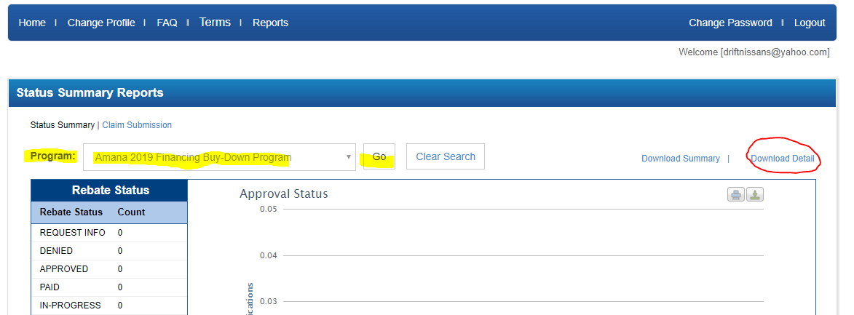

Questions
?
If you have questions regarding:
- Enrolling on the EGIA website
- Claim entry, claim follow-up, claim status or smart thermostat rebate payments
- Any issues or problems with the www.egia.org/Amana website
Answers
- Call an EGIA customer service representative at 1-888-691-0387
- Send an email to DealerRebates@egia.org
- For all other program-related questions, contact Andy Barrenechea
(Manager – Marketing Programs & Promotions) at Andy.Barrenechea@amana-hac.com

Good Luck and Good Selling!

