Winter 2019 Amana Brand Smart Home Bundles: October 1, 2019 – December 31, 2019

Welcome to the Winter 2019 Amana brand smart home bundles program! This document will familiarize you with the program, including the smart home bundle options and claims process. Dealers should review this information carefully and complete the steps indicated to ensure a smooth experience. We have made several enhancements to the winter program (vs. spring program) - we are confident you will be able to use this as a compelling closing tool at the kitchen table to sell more Amana brand high-efficiency equipment!
Program Overview
The Winter 2019 Amana Brand smart home bundles program will provide FREE Nest® / Google® smart home items to homeowners when they purchase select Amana brand high-efficiency systems from October 1, 2019 through December 31, 2019. Dealers will be able to offer a range of smart home bundles to homeowners that buy a qualifying Amana brand system. Dealers will then submit a claim on behalf of the homeowner to trigger the shipment of FREE smart home items to the homeowner’s home address. The program will be administered by EGIA on our behalf; however, dealers are not required to be an EGIA member or user of EGIA financing to participate in the program. Eligible products and the associated smart home bundle items are outlined below.

Winter 2019 Amana brand smart home bundles program options
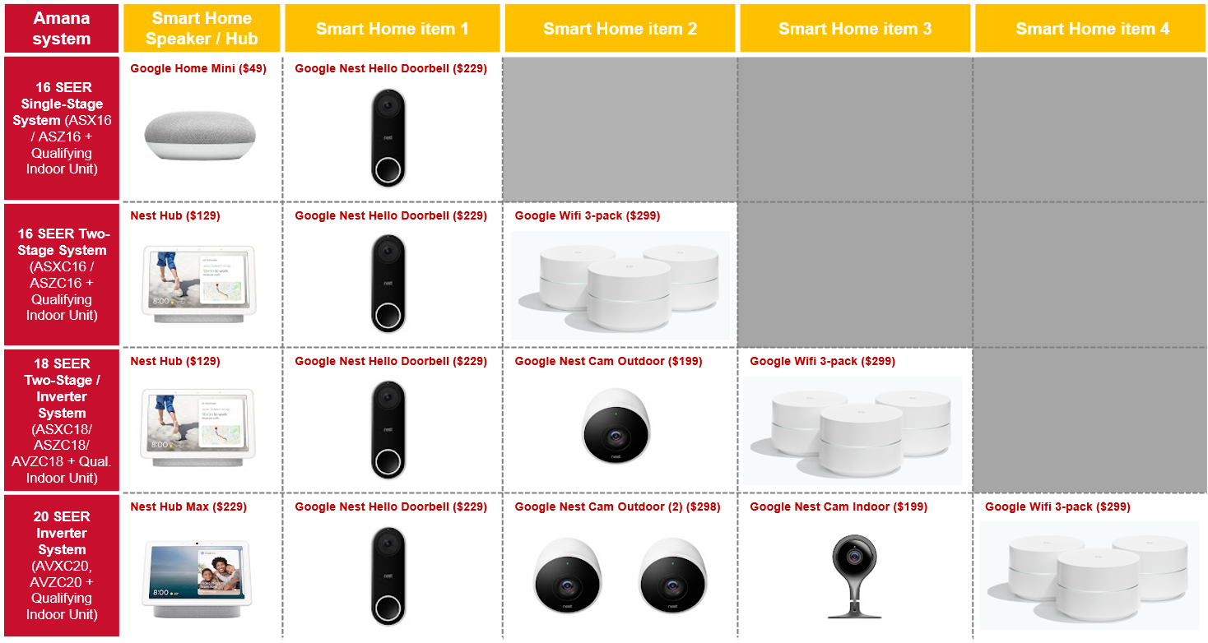

There are four levels of qualifying Amana brand systems:
*Highlighted system level is a new addition for the Winter 2019 Amana Smart Home Bundles program.
Terms and Conditions Overview
- FREE smart home items are limited to one smart home bundle per qualifying Amana brand system installed.
- Only applicable to single-family dwellings in the continental U.S. and Canada.
- Applicable to residential installations only. Commercial installations, residential new construction installations, multi-family installations, and self-sales do not apply.
- Products sold through a National Retailer program do not qualify for this program.
- For a qualifying high-efficiency Amana brand system and corresponding equipment serial numbers, dealers may EITHER claim:
  - FREE smart home items (on behalf of the homeowner) under the Winter 2019 Amana brand smart home bundles program OR
  - Consumer financing buy down rebate under the Amana Brand 2019 Consumer Financing Program

Instructions
Please follow the instructions outlined below to ensure a smooth process for both homeowners and dealers participating in this program. The EGIA website, where dealers will submit claims for smart home items on behalf of homeowners, will be active October 1, 2019. Any time after that date, participating dealers may complete the EGIA registration process and begin entering claims for the smart home bundles sold under the Amana brand smart home bundles program. Dealers will have until January 15, 2020 to submit any claims for qualifying system installations between October 1, 2019 and December 31, 2019. Certain restrictions apply, and not all dealers will be eligible to participate in the program. Dealers should contact their Amana brand Distributor with any questions regarding eligibility.
1
Dealer enrollment on EGIA website
In order to participate in the Winter 2019 Amana Brand smart home bundles program, dealers will need to enroll for the “Amana Smart Home Bundles” program with EGIA at http://amana.egia.org/finance-promotions/. Dealers will enroll by clicking on “Register Now” if they don’t have an EGIA account, or “Sign In” if they are already enrolled with EGIA. A screenshot of this page is below:
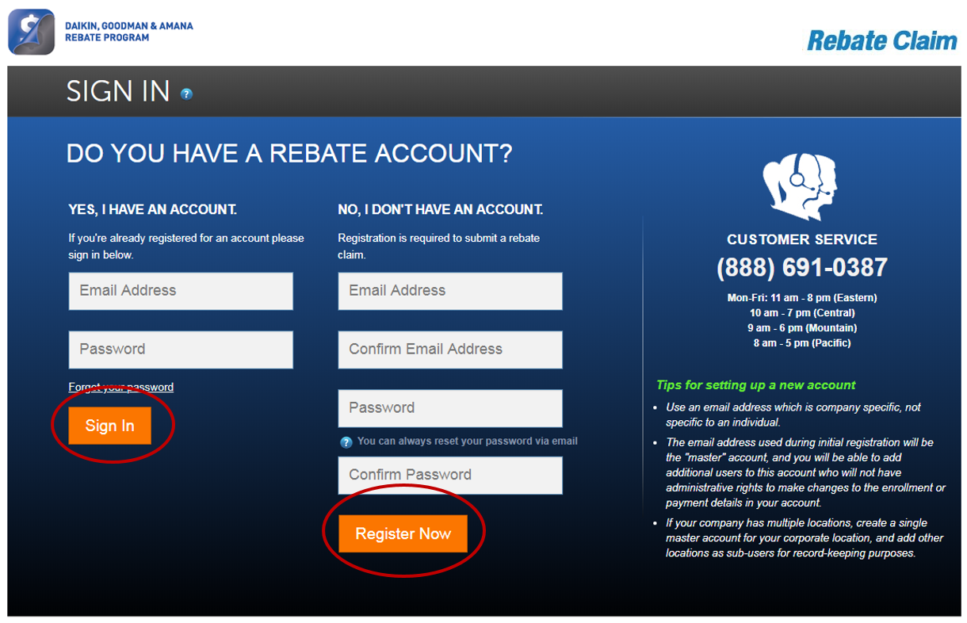

Sale of Amana brand high-efficiency system
2
Dealer sells qualifying Amana brand high-efficiency system to a homeowner under the Winter 2019 Amana brand smart home bundles Program. There are four levels of qualifying Amana brand systems:
*Highlighted system level is a new addition for the Winter 2019 Amana Smart Home Bundles program.
3
Amana brand smart home bundles program claim submission
Once enrolled, dealers will submit a claim at http://amana.egia.org/finance-promotions/ for smart home Amana brand system bundles sold under this program, on behalf of the homeowner. The claim form information will be used to send the homeowner the selected FREE smart home items. To do this effectively, the dealer must provide the following information as part of the claim form:
- Homeowner contact information: full name; mailing address; email address; phone number
- Installation details: model number and serial number for outdoor and indoor units; date of install
***Homeowner invoices are NOT required to be uploaded to claim form***
4
Delivery of smart home items to the homeowner
EGIA will review and validate the smart home bundle claim information submitted under the Winter 2019 Amana Brand smart home bundles program. Once approved, a third party will ship the FREE smart home items directly to the homeowner’s address provided by the dealer on the claim form. It is not recommended that dealers ship the FREE smart items to their business address for hand-delivery to the homeowner. This would prolong the process and detract from the customer’s experience. Homeowners should expect to receive the smart home items within
2-4 weeks of the Amana brand smart home bundles claim approval by EGIA. For this reason, dealers should submit the claim form on behalf of the homeowner as soon as the sale and installation of the qualifying Amana brand high-efficiency system is complete.
?
Questions

For questions regarding enrolling on the EGIA website, claim entry, claim follow-up, claim status, etc.:
- Call an EGIA customer service representative at 1-888-691-0387
- Send an email to DealerRebates@egia.org

For question on Nest®/ Google® claims, shipping and handling, lost items, etc.:
- Call Susan Tilidetzke at 404-519-3820, or send an email to stilidetzke@google.com

For all other program-related questions, contact Andy Barrenechea (Manager – Marketing Programs)
at Andy.Barrenechea@amana-hac.com

Good Luck and Good Selling!

