Winter 2019 Amana Brand Smart Home Bundles: October 1, 2019 – December 31, 2019

- As an Amana brand dealer, what is my cost for participating in the smart home bundles program?
$0, also known as FREE! You may actually make more money if you sell more Amana brand high-efficiency systems under the Winter 2019 Amana brand smart home bundles program. So get started soon!

- How will the homeowner receive the FREE smart home items as part of this program?
Once the smart home bundles claim (located here: http://amana.egia.org/finance-promotions/) is approved, EGIA will send the details to a third party for shipping. The FREE items will be sent directly to the homeowner’s address that was provided by the dealer on the claim form.

It is not recommended that dealers ship the FREE smart items to their business address for hand-delivery to the homeowner. This would prolong the process and detract from the customer’s experience. Homeowners should expect to receive the smart home items within 2-4 weeks of the claim approval by EGIA. For this reason, dealers should submit the claim form on behalf of the homeowner as soon as the sale and installation of the qualifying Amana brand high-efficiency system is complete.

- Do I have to be an EGIA member to offer this program? Do I have to offer consumer financing?
Dealers are not required to be an EGIA member or user of financing through an EGIA lender to participate in the Winter 2019 Amana brand smart home bundles program. The program is administered by EGIA on our behalf.

However, consumer financing helps sell high-efficiency Amana brand equipment! Over the last three years, we have studied elite dealers and have found that there is a clear correlation between consumer financing usage and effectiveness in selling Amana brand high-efficiency equipment. As such, although not required, it is strongly encouraged that Amana brand dealers sign up with EGIA to offer consumer financing as part of the high-efficiency selling process. The Amana brand offers buy down rebates on qualifying high-efficiency equipment as part of our Consumer Financing Buy Down Program when dealers use consumer financing through a qualifying EGIA lender; to learn more visit http://amana.egia.org/.

Please note - for a qualifying high-efficiency Amana brand system and corresponding equipment serial numbers during the program period, dealers may EITHER claim:
FREE smart home items (on behalf of the homeowner) under the Winter 2019 Amana brand smart home bundles program OR
Consumer financing buy down rebate under the Amana Brand 2019 Consumer Financing Program

- What is the perceived value of the smart home bundles to the homeowner?
The perceived value of the smart home bundle can be from $280 - $1,250. The tables below summarize the FREE smart home items and associated manufacturer’s suggested retail price (MSRP) for all FREE items.

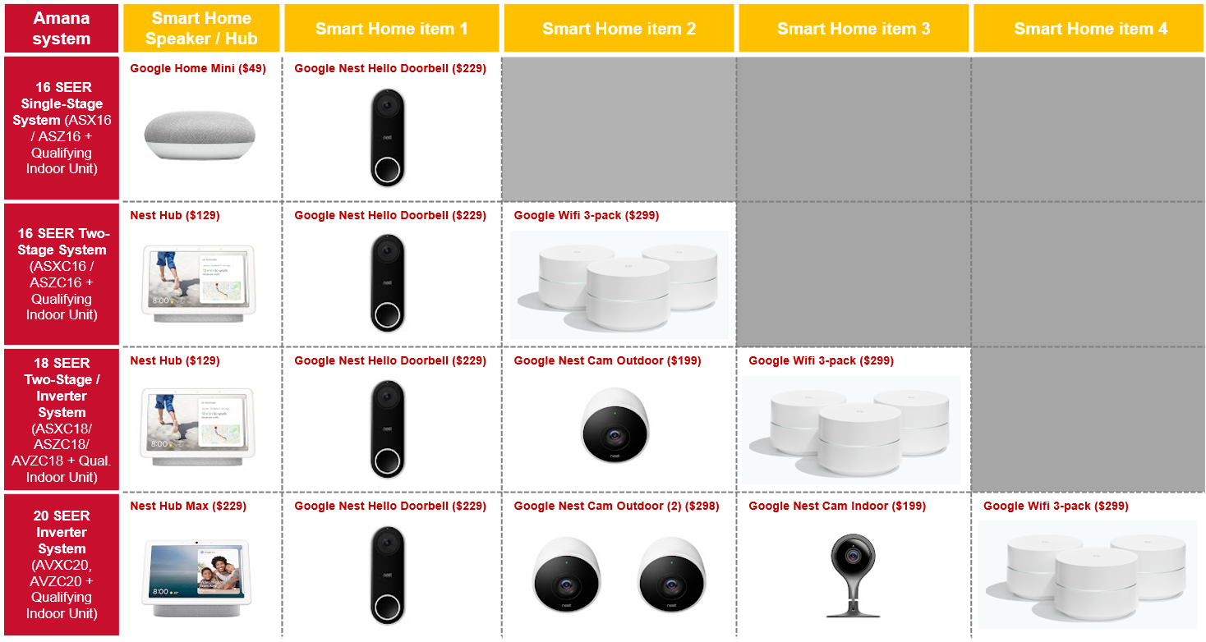

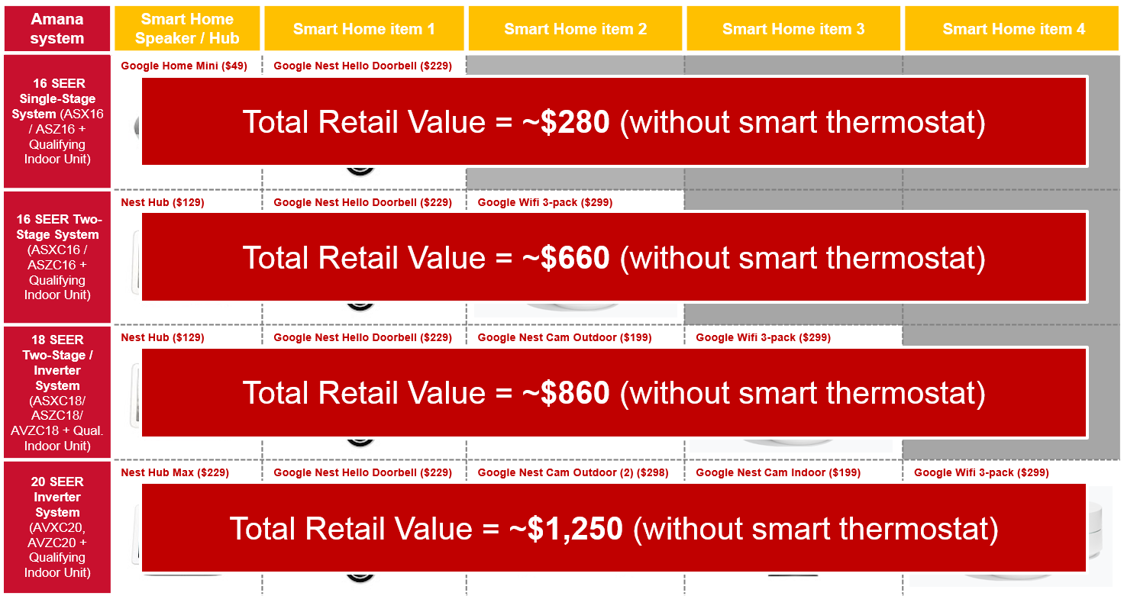

- Why are the smart home items Nest® and Google® products?
The Amana brand has partnered with some of the largest and most recognized consumer brands, namely Nest and Google. This will enable Amana brand dealers to effectively sell smart/connected home solutions to homeowners in need of a high-efficiency Amana brand HVAC system, effectively providing a more holistic whole-home solution!

Amana brand dealers should consider the variety of add-on sales that become possible when an Amana brand system is sold in the context of a connected home solution, all of which are designed to work optimally with a specific smart thermostat. For a full overview of all connected home products, please visit our partner’s websites:

- https://store.google.com/us/
- https://nest.com/

- Why is the Amana brand offering a consumer bundle promotion tied to smart home items?

The Amana brand wants to support our dealers in growing their high-efficiency business and draw consumers to Amana brand systems. The Winter 2019 Amana brand smart home bundles program is not only designed to compete with consumer-facing programs from key competitors, but it also leverages Amana brand’s unique and cutting-edge ComfortBridge™ technology. ComfortBridge technology enables Amana brand dealers to offer the highest-efficiency Amana brand communicating systems with any thermostat; for more information visit https://www.comfortbridge.com/.

As a result, Amana brand dealers are uniquely able to bundle Amana brand high-efficiency systems with the most popular smart thermostats, for example, the Nest Learning Thermostat. These appealing smart thermostats can be controlled via Google Assistant, effectively enabling voice-controlled comfort. Lastly, Amana brand dealers should consider how smart home products fit into annual maintenance service agreements, which drive value for a dealership from a business valuation standpoint.

- What do I do if it has been more than four weeks since the claim submission and my customer (homeowner) has yet to receive their FREE smart home items?

First, contact an EGIA customer service representative at 1-888-691-0387 or send an email to DealerRebates@egia.org to ensure the smart home bundles claim has been reviewed and approved.

If the claim has been approved and communicated to a third party, please contact Susan Tilidetzke at
404-519-3820, or send an email to stilidetzke@google.com

