Amana Brand 2022 Consumer Financing Program – U.S. & CANADA

Eligible Participants and Timing:
This program is eligible for a licensed independent Amana Heating and Air Conditioning Brand Dealers in the U.S. and Canada. The 3% standard buy down will run year-round, but claims must be submitted by the end of each quarter per the guidelines below.
- U.S. or Canadian Homeowner must purchase eligible equipment and execute a consumer financing contract with an EGIA lender between April 1, 2022 and June 30, 2022.
- Licensed independent dealer must install qualifying equipment between April 1, 2022 and June 30, 2022
- All consumer financing contracts must be funded by EGIA by July 15, 2022.
- All buy down rebate claims must be submitted by July 15, 2022.
  - Late claims will be paid out at 50% of the dealer rebate amount only for a short period after the initial deadline. Any late claims will be paid at Goodman Manufacturing’s discretion.

Standard Amana 3% Financing Buy Down - Qualifying Amana Brand Equipment
- Installation of a complete Amana Brand HVAC “system” is not required. See eligible product matrix* for full details.
- To qualify for the Amana Brand 2022 3% financing buy down, the consumer financing contract must include either:
  - An AVXC20, AVZC20, AVZC18, ASXC18, ASZC18, ASXC16, ASZC16, ASX16, ASZ16 Outdoor Unit OR
  - An AMVM97, ACVM97, AMVC96, ACVC96, AMES96-U, AMVC8/80, ADVC8/80, ACVC8/80, AMES80-U Indoor Unit OR
  - An APG16M, APH16H, APH16M, APD14M Packaged Unit

Standard Amana 3% Financing Buy Down through EGIA
- Consumer financing buy down is fulfilled by a 3% rate rebate to the Amana Brand Dealer for eligible equipment* on any approved plan type.
- If the standard dealer discount rate is less than 3%, the rebate will be calculated based on that lower discount rate.
- Example below:
  - Amount Financed: $12,500
  - Standard Dealer Discount Rate: 7.25% = $906.25 discount rate amount paid by dealer
  - Amana Brand Discount Rate participation rebated to dealer: 3.0% = $375
  - Net Promotional Dealer Discount Rate: 4.25% or $531.25 net amount paid by dealer
- Amana buy down can be applied across any EGIA plan type with any EGIA lender.
- Financing offers apply only to Amana Brand qualifying equipment* financed under the EGIA program.

Consumer Financing Details:
- Amana 2022 Consumer Financing Plan(s) buy downs are available in the US and Canada through EGIA lenders only. Any other lenders will not qualify for a buy down.
- Amana Brand Dealer must be approved and in good standing with EGIA prior to offering Amana brand Financing Offers to Homeowners.
- Finance contracts are subject to a $15,000 USD / $15,000 CAD maximum retail sale amount.
- Sales amount used to calculate financing buy down rebate excludes taxes.
- All EGIA plans are subject to applicable origination fees and credit card processing fees.
- Homeowners are subject to credit approval by EGIA or their approved lenders.

EGIA Rebate Claims Process
- Amana Brand Dealer is “funded” by EGIA for each qualifying job, less appropriate EGIA discount cost plus any applicable credit card processing fee.
- Amana Brand Dealer is responsible for submitting the consumer financing rebate claim and all supporting paperwork to EGIA by July 15, 2022.
- Consumer Finance rebate claims will be entered online at https://www.egia.org/directory/partners/amana/#rebate_application.
- All required consumer financing back-up paperwork must be sent to EGIA via www.egia.org/amana by the Amana Brand Dealer. EGIA or Amana Brand Heating and Air Conditioning are not responsible for lost/missing paper work.
- Please contact EGIA at 888-691-0387 or dealerrebates@egia.org with questions on the dealer enrollment or rebate claims process.

*Eligible Product Matrix:
Finance Contract must include at least one Amana brand unit from the table below. Installation of a complete “system” is not required.

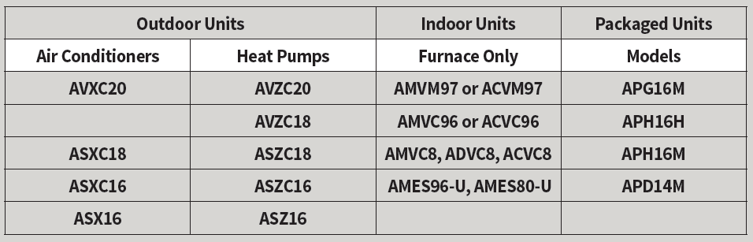

Advertising Guidelines:
If an Amana Brand Dealer plans to advertise one of the Amana 2022 Consumer Financing Programs, the following disclaimer is required PLUS additional disclaimers regarding the specific financing plan. Plan specific advertising disclaimers are available directly from EGIA and its lenders.

Financing Advertising Disclaimer – Required Language
The consumer finance program is separately administered by EGIA (Electric & Gas Industries Association). This information is only a summary of current terms of the program. Program is subject to change at any time at Goodman Manufacturing or EGIA’s decision. Other financing plans and programs are also available. See your independent Amana Brand Dealer for complete financing eligibility, dates, details and restrictions for all financing programs.

Depending on the installment finance program featured, please include plan specific disclaimers provided by the actual lender.
The consumer finance program is separately administered by the Electric & Gas Industries Association (EGIA). This information is only a summary of current terms of the program. Program is subject to change at any time at Goodman Manufacturing or EGIA's decision. Other financing plans and programs are also available.

