- Use Google Chrome to submit the rebate applications.
- Follow link provided to login to your rebate portal
  - https://dkng.conservationrebates.com/dealer-portal/
  - NOTE- if you need to reset the password you may do so by selecting “Forgot your password” you will receive an email with a temporary password.
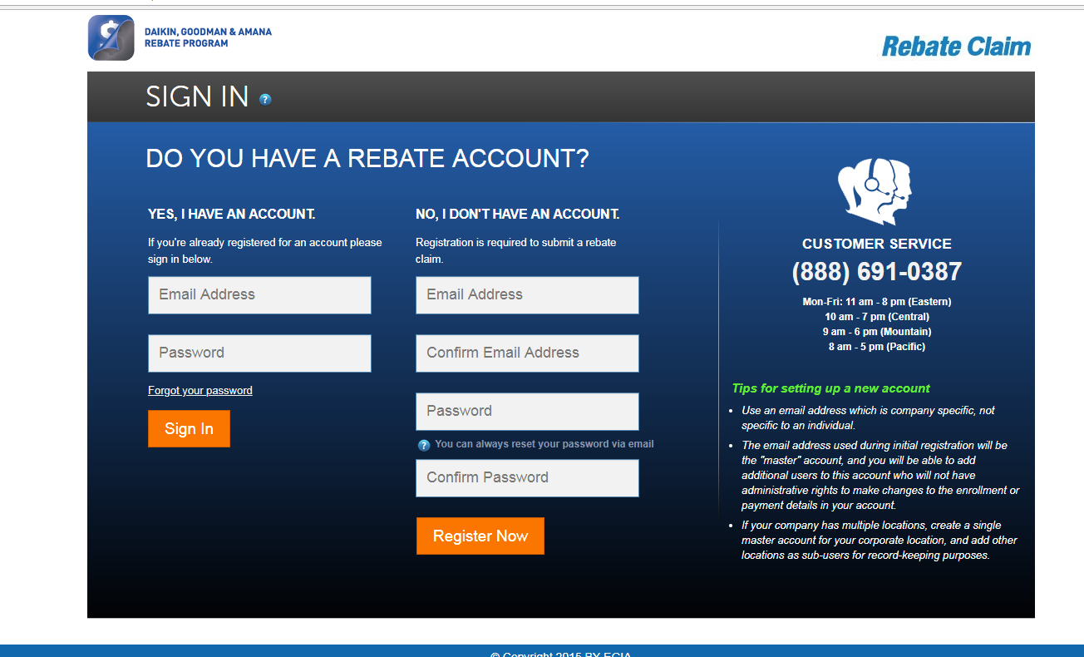

- Once logged in
  - Select the program, under the “Pick a claim and press green button” section.
  - Press the green button “Start a New Claim”
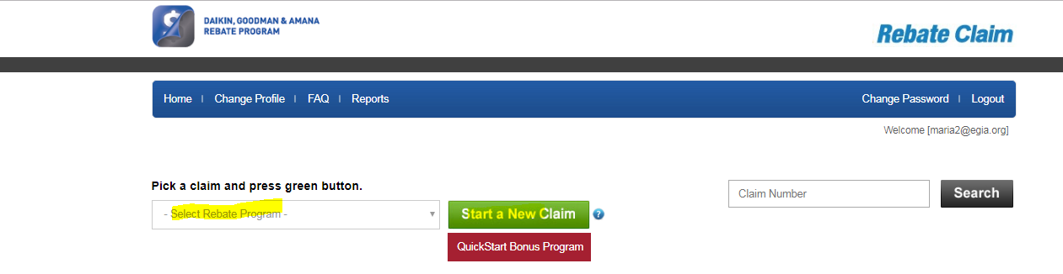
- This will take you to the rebate application.
  - Under Installation Information
    - Enter the Customer’s First name, Last name, install Zip (then press TAB) this will auto populate the install city, and state. Enter the installation address, and the total loan amount.
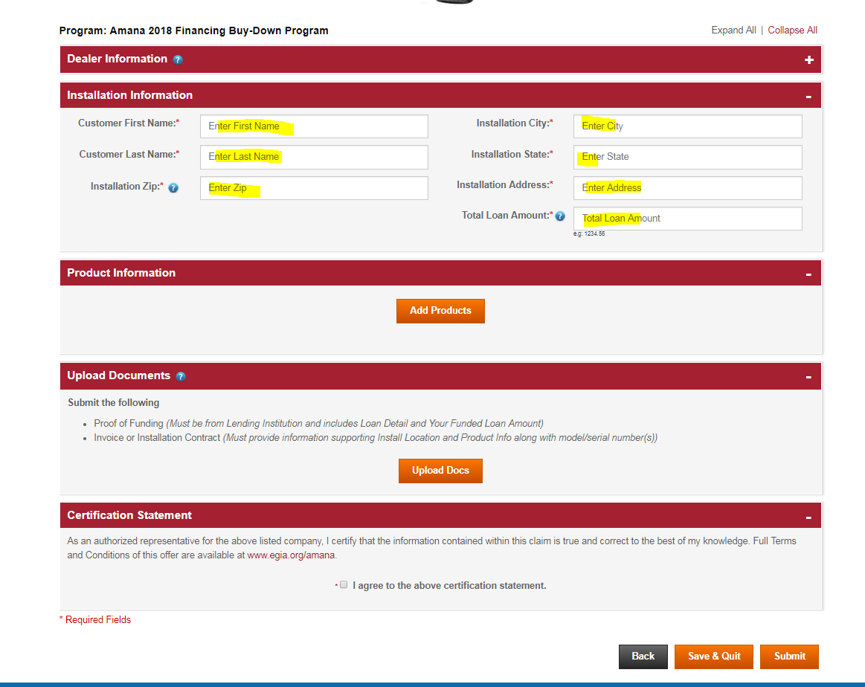
  - Add Product
    - Pres the orange “Add Product” button
    - Select the product you are applying for from the drop down.
    - Select model from dropdown
    - Enter models & serial number
    - Enter Installation date
    - Press Add Product
    - NOTE- this will add the product to the rebate application.
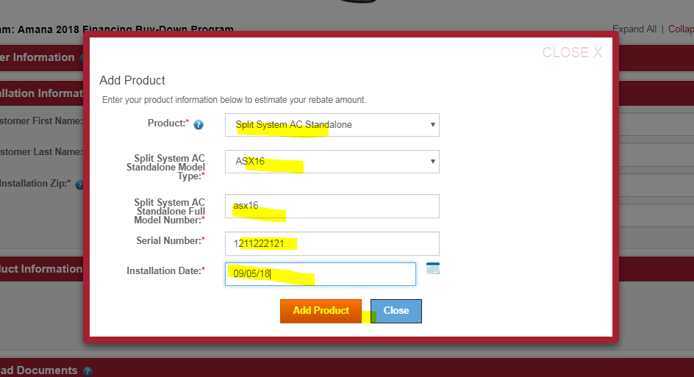
- Upload Documents
  - Press the orange “Upload Docs”
  - We need a copy of the invoice given to the homeowner and a copy of the funding proof.
  - Invoice needs to show all of the following information
    - Your company Heather
    - Homeowners first name
    - Homeowners last name
    - Installation address
    - Installation date/Date on invoice
    - All models
    - All serial numbers
    - Total job cost
  - The funding proof should come from the lending agency and should show funding dispersed.
- Agree to the certification Statement located at the bottom of the rebate application.
- Press - Submit (located on the bottom right corner)
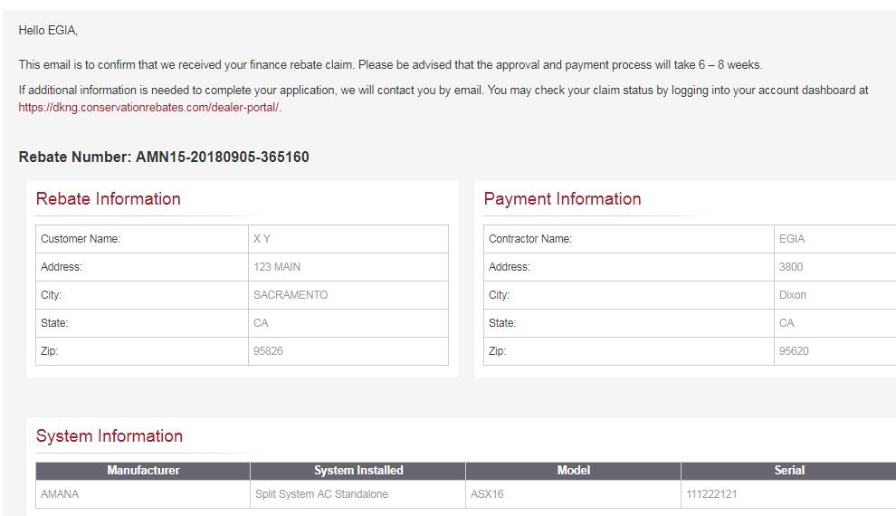

- Once submitted you will get a confirmation page with the rebate claim number. Print this four your records. You can check the status of the rebate from the homepage

If you have any questions, or need assistance please call (888) 691-0387 or send an email to dealerrebates@egia.org

