Hey! Sorry for the delay on this! Yes Jen Air is a DCP still. Not sure why they weren’t on the Daikin report. I think there are some delays getting accounts re-registered or transferred over to this new Distributor called ABCO in the North East. I did receive the attached report from them showing active accounts – this is only one region (NY NJ PA CT MA MD) but might help if you see any other new ones come in from that area.

 | Jeremy Chandler  Regional Manager  Cell: 916-759-0515

From: Maria Alatorre
Sent: Monday, September 13, 2021 11:37 AM
To: Jeremy Chandler <jchandler@egia.org>
Cc: Adriana Lamberti <alamberti@egia.org>
Subject: RE: Jen Air DCP?

Hi Jeremy,

Any update?

Thanks

 | Maria Alatorre  Rebate Processing Customer Service  888-691-0387

From: Maria Alatorre
Sent: Thursday, September 9, 2021 10:31 AM
To: Jeremy Chandler <jchandler@egia.org>
Cc: Adriana Lamberti <alamberti@egia.org>
Subject: Jen Air DCP?

Hi Jeremy,
We have an interesting situation. Jen Air was DCP in 2020 and were part of the DCP list we received from Daikin in FEB 2021. However they are no longer listed on the DCP list we received in July. Would you be able to confirm that they are truly no longer DCP and we can deny the Consumer Instant Claims they have submitted, they have 3 in queue for review. NOTE- we have approved about 15 claims in 2021 submitted Jan – July. Only two submitted in August and those are part of the pending review claims.

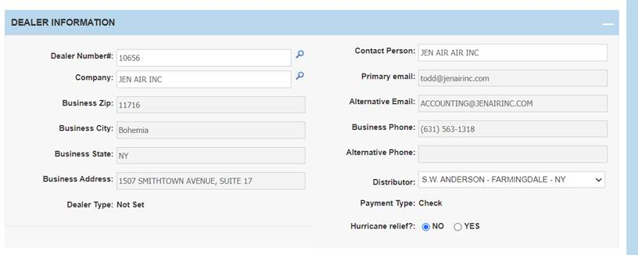

Thanks,
Maria Alatorre
Rebate Processing Customer Service
866-367-3442 x311

