- Follow the link below.
https://dkng.conservationrebates.com/dealer-portal/
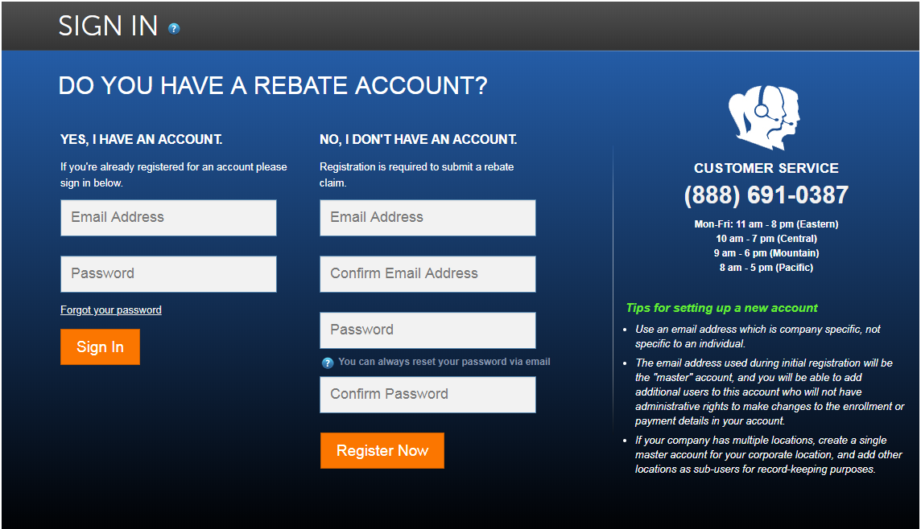
- If you already have an account: Login by entering your Email and Password on the left hand side and press “Sign In”.
- If you are a new Dealer: You will need to create an new account on the right hand side under “No, I don’t have an account”
  - Enter an Email Address, Confirm Email Address, enter Password, Confirm Password then press “Register Now”

- User Profile
Once logged in you will be prompted to complete your “User Profile” all sections highlighted in yellow on the screenshot below need to be filled in.
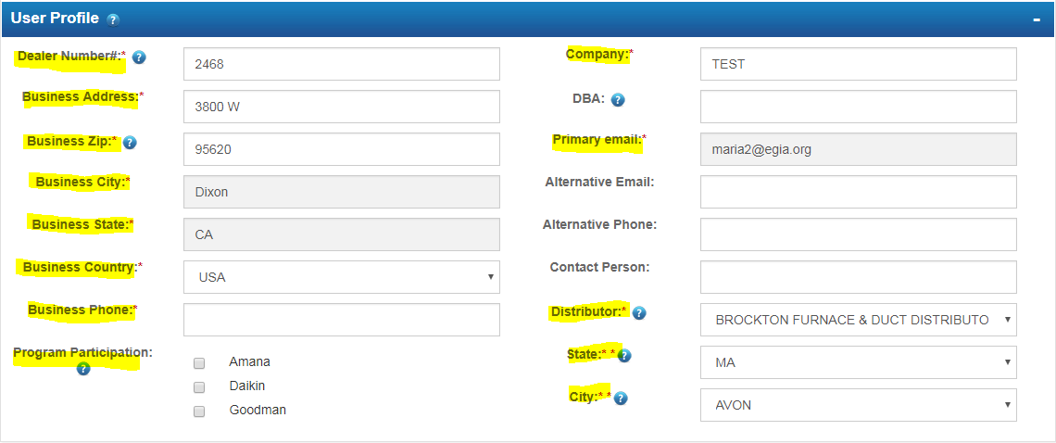
NOTES:
- Dealer Number - can be found on an invoice from your distributor under your Customer Number. It should be the exact same number on all invoices from your distributor.
- Once you enter the Business Zip, press “TAB” on the keyboard. This will auto populate the City and State, which will also allow you to select from the “Program Participation”
- Primary Email should already be entered per it’s the same email you used to create the account. *** You can add additional users under this one account – no need to create new accounts. ***

- Program Participation
Select the program(s) you will be submitting rebates under (Amana, Daikin, Goodman or Liberty) once selected each will give you a drop down to select the “Rebate Programs” select all that apply.
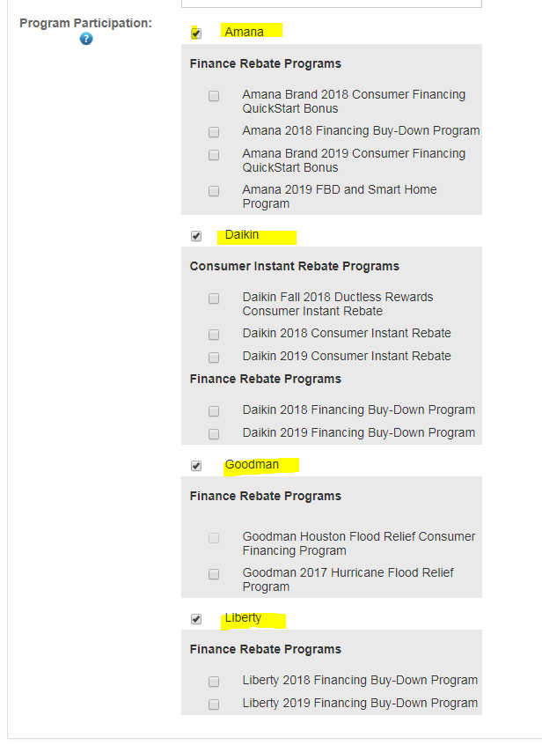

- Additional Users
You may add Additional Users if there will be multiple people submitting rebates. This way each person will have their own login account but all rebates will be tracked under one “Primary Account”
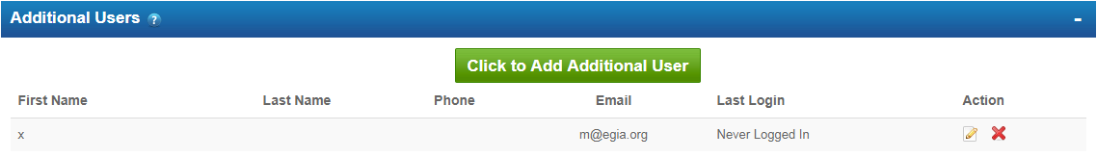
- Press the green button “Click to Add Additional User” a Pop Up window will appear:
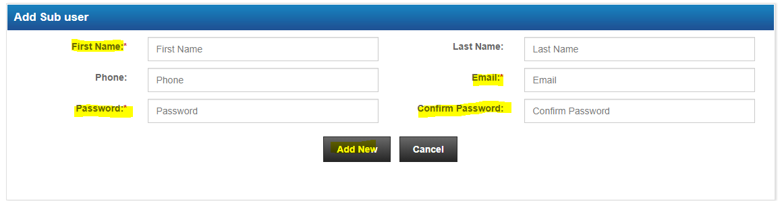
- Fill in all highlighted sections – First name, Password, Confirm Password, and Email.
- Press “Add New”
NOTES:
- Only the Primary Account holder will have access to make changes within the User Profile. Additional User accounts will only have access to manage the rebates.
- The Primary Account holder may Delete Additional Users at any time by pressing the red “X” under Action.
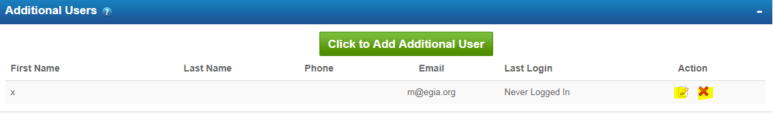
- Rebate Payment Information
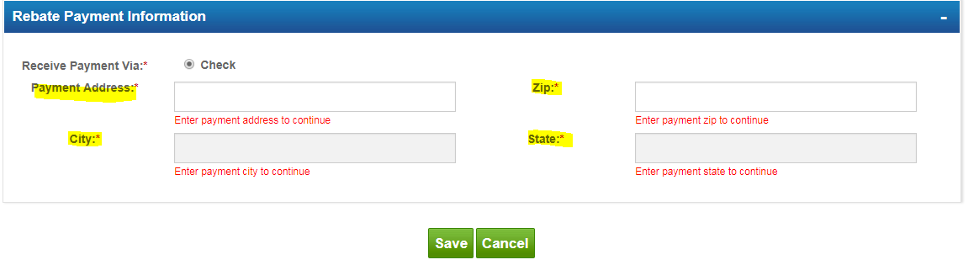Check: Enter the mailing Address of where you would like to receive the rebate payment.
ACH: Enter the Banking information for where you would like the rebate payment to be deposited.
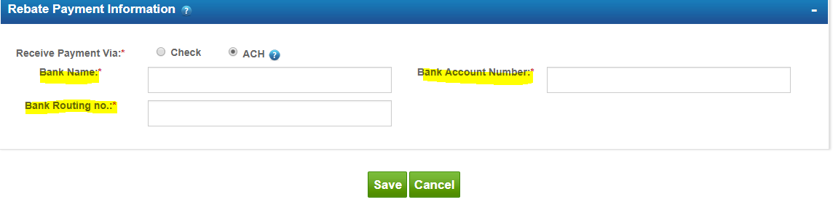
Once all the above has been completed, make sure to press “Save” located to the bottom of the page. This will take you back to the home page.
- Rebate Home Page
You can manage all rebate submissions from your Rebate Home Page.
- Search Engine: Located on the top right corner. Enter the last 6 digits of the claim number to search for a rebate.
- Claims to be Submitted: This section shows claims that have been Saved but not submitted. You may edit by pressing the paper and pencil icon. Or you can delete them by pressing the red “X” located under Action.
- Claim Submitted – Includes a list of claims that have been submitted and are in queue for review.
- Claims Completed - will have the list of claims that have been processed and approved.
- Use the “Pick a Claim and Press the green Button” section to select the rebate program and submit your rebates.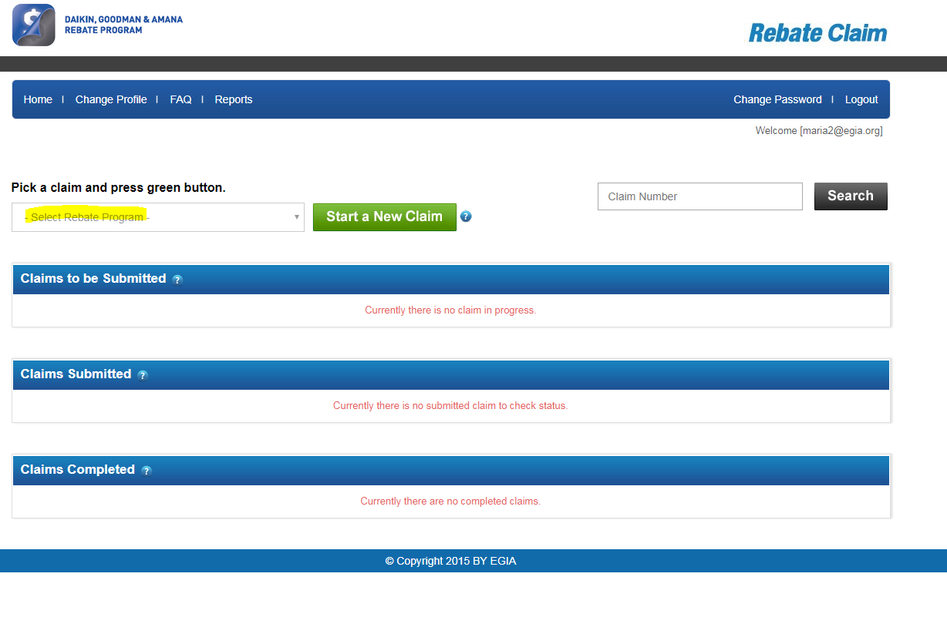
General Notes
- Use Google Chrome as the internet browser.
- It usually takes about 24-48 hours for Approval to submit rebates. If 48 hours have passed and the option to submit rebates under the “Pick a Claim Section” is not there, give us a call as a manual approval might be needed.
- You can always go back and edit your profile by selecting “Change Profile” from the Primary Account holder account.
- If you ever need to change your Password, press the “Change Password” on the top right corner. Enter the old password then enter and confirm the new password.
- Forget your password.
  - Select Forgot Password from the from the Rebate Portal login page.
  - Enter your login email
  - Press “Submit”
  - The system will send you an automatic email with a Temporary Password. Make sure to check all inboxes per sometimes auto generated emails go to the junk mail inbox.
- Rebate payment takes about 6-8 weeks from the claim’s approval date.

