Approved to pay in full. Thanks all.

Jason Grigg
Sales Programs Manager
DAIKIN NORTH AMERICA
E: jason.grigg@daikincomfort.com
C: 713-454-3251

From: Gibson, Richard A. <Richard.Gibson@daikincomfort.com>
Sent: Thursday, September 30, 2021 6:46 AM
To: Kayla Jost <kayla.jost@moreventservices.com>; Dealer Rebates <dealerrebates@egia.org>; Grigg, Jason K. <Jason.Grigg@daikincomfort.com>
Cc: Christine Mclellan <christine.mclellan@moreventservices.com>
Subject: RE: [EXTERNAL] RE: Daikin 2021 Consumer Instant Rebate - Claims placed on hold need additional information

I will confirm this issue is correct with Morevent Enterprises.
I am requesting these be approved.
I have added Jason to the email.

Thank you,
Richard Gibson
NE Territory Sales Mgr
M: 443.519.9920
E: richard.gibson@daikincomfort.com | www.daikincomfort.com

19001 Kermier Road | Waller, TX, 77484


 | Fits your comfort. Fits your budget. Fits your space. Fits your life.  Get Fit Every Day. Click here to see the New Daikin Fit System.  Do you know how much energy you can save? Click here to find out!

From: Kayla Jost <kayla.jost@moreventservices.com>
Sent: Wednesday, September 29, 2021 11:58 AM
To: Dealer Rebates <dealerrebates@egia.org>
Cc: Christine Mclellan <christine.mclellan@moreventservices.com>; Gibson, Richard A. <Richard.Gibson@daikincomfort.com>
Subject: [EXTERNAL] RE: Daikin 2021 Consumer Instant Rebate - Claims placed on hold need additional information

Hi Erika,

I’m following up on these loans. They are showing that they were denied because the submission deadline for the program has passed. We’re working with Daikin because there was an issue with our account that didn’t allow us to process our claims in a timely manner. I’m hoping these could be reviewed or continue to be placed on hold until Daikin can approve their exception.

Thank you!

Kayla

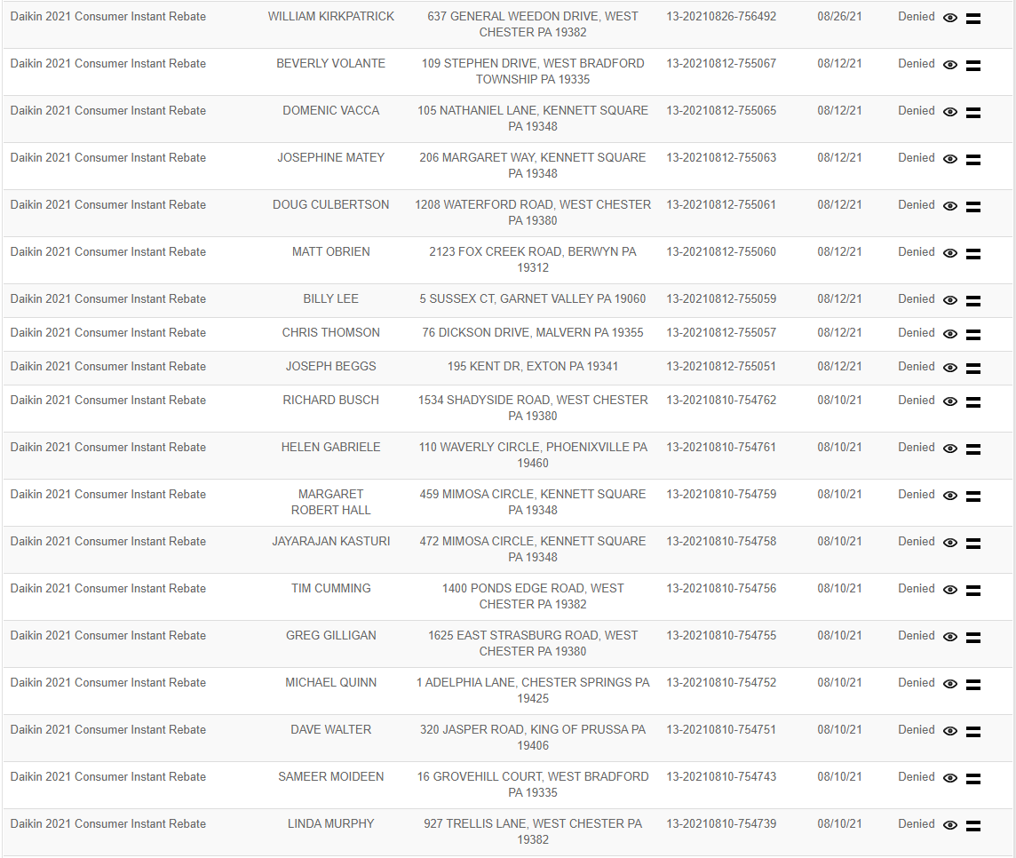
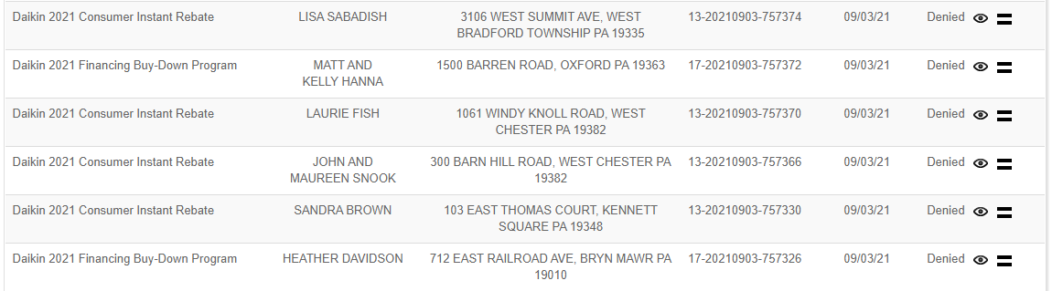

From: Dealer Rebates <dealerrebates@egia.org>
Sent: Wednesday, September 15, 2021 1:36 PM
To: Kayla Jost <kayla.jost@moreventservices.com>
Cc: Christine Mclellan <christine.mclellan@moreventservices.com>
Subject: Re: Daikin 2021 Consumer Instant Rebate - Claims placed on hold need additional information

​Hello Kayla,
Thanks for letting us know. We will let it be as is so that we can hopefully process them once Daikin approves their exception. Please let us know of any updates as you get them.
Best,
Erika

From: Kayla Jost <kayla.jost@moreventservices.com>
Sent: Wednesday, September 15, 2021 7:30 AM
To: Dealer Rebates
Cc: Christine Mclellan
Subject: RE: Daikin 2021 Consumer Instant Rebate - Claims placed on hold need additional information

Hello,

I wanted to reach out in regards to our claims that were submitted after the program end date. We are working with Richard Gibson at Daikin in regards to these outstanding claims. If you could please keep them on record- we had issues with our Daikin account that did not allow us to submit them in our regular timely manner.

Thank you,

Kayla Jost

From: Christine Mclellan
Sent: Tuesday, September 14, 2021 11:39 AM
To: Kayla Jost <kayla.jost@moreventservices.com>
Subject: FW: Daikin 2021 Consumer Instant Rebate - Claims placed on hold need additional information

From: Dealer Rebates <dealerrebates@egia.org>
Sent: Tuesday, September 14, 2021 11:36 AM
To: Christine Mclellan <christine.mclellan@moreventservices.com>
Cc: Marco Giancroce <marco.giancroce@moreventservices.com>
Subject: Daikin 2021 Consumer Instant Rebate - Claims placed on hold need additional information

​The claims below need additional information in order for them to be processed. Please upload revised documents to the Rebate Portal. If you have any questions please let me know.
​Have a great rest of your day,
Erika​
Rebate Processing Customer Service
888-691-0387​​​​

Daikin 2021 Consumer Instant Rebate Report
Contractor | Rebate Number | Rebate Status | Rebate Amount | Date Installed | Installation Street Address | Reasons for Hold
MOREVENT HEATING COOLING PLUMBING | 13-20210903-757379 | REQUEST INFO | $500 | 7-Jul-21 | 4126 JUSTIN CT | Registration certificate provided is not for this client. Corrections needed
MOREVENT HEATING COOLING PLUMBING | 13-20210812-755061 | DENIED | $450 | 17-Jun-21 | 1208 WATERFORD ROAD | This claim was submitted after program end date, it is denied.
MOREVENT HEATING COOLING PLUMBING | 13-20210812-755063 | DENIED | $450 | 17-Jun-21 | 206 MARGARET WAY | This claim was submitted after program end date, it is denied.
MOREVENT HEATING COOLING PLUMBING | 13-20210812-755065 | DENIED | $250 | 17-Jun-21 | 105 NATHANIEL LANE | This claim was submitted after program end date, it is denied.
MOREVENT HEATING COOLING PLUMBING | 13-20210812-755067 | DENIED | $525 | 18-Jun-21 | 109 STEPHEN DRIVE | This claim was submitted after program end date, it is denied.
MOREVENT HEATING COOLING PLUMBING | 13-20210810-754739 | DENIED | $450 | ######## | 927 TRELLIS LANE | This claim was submitted after program end date, it is denied.
MOREVENT HEATING COOLING PLUMBING | 13-20210810-754743 | DENIED | $450 | ######## | 16 GROVEHILL COURT | This claim was submitted after program end date, it is denied.
MOREVENT HEATING COOLING PLUMBING | 13-20210810-754751 | DENIED | $450 | ######## | 320 JASPER ROAD | This claim was submitted after program end date, it is denied.
MOREVENT HEATING COOLING PLUMBING | 13-20210810-754756 | DENIED | $450 | 8-Jun-21 | 1400 PONDS EDGE ROAD | This claim was submitted after program end date, it is denied.
MOREVENT HEATING COOLING PLUMBING | 13-20210810-754758 | DENIED | $450 | 10-Jun-21 | 472 MIMOSA CIRCLE | This claim was submitted after program end date, it is denied.
MOREVENT HEATING COOLING PLUMBING | 13-20210812-755060 | DENIED | $525 | 16-Jun-21 | 2123 FOX CREEK ROAD | This claim was submitted after program end date, it is denied.
MOREVENT HEATING COOLING PLUMBING | 13-20210812-755059 | DENIED | $450 | 16-Jun-21 | 5 SUSSEX CT | This claim was submitted after program end date, it is denied.
MOREVENT HEATING COOLING PLUMBING | 13-20210812-755059 | DENIED | $450 | 16-Jun-21 | 5 SUSSEX CT | This claim was submitted after program end date, it is denied.
MOREVENT HEATING COOLING PLUMBING | 13-20210812-755057 | DENIED | $525 | 15-Jun-21 | 76 DICKSON DRIVE | This claim was submitted after program end date, it is denied.
MOREVENT HEATING COOLING PLUMBING | 13-20210812-755051 | DENIED | $450 | 14-Jun-21 | 195 KENT DR | This claim was submitted after program end date, it is denied.
MOREVENT HEATING COOLING PLUMBING | 13-20210810-754762 | DENIED | $450 | 14-Jun-21 | 1534 SHADYSIDE ROAD | This claim was submitted after program end date, it is denied.
MOREVENT HEATING COOLING PLUMBING | 13-20210810-754761 | DENIED | $450 | 14-Jun-21 | 110 WAVERLY CIRCLE | This claim was submitted after program end date, it is denied.
MOREVENT HEATING COOLING PLUMBING | 13-20210810-754759 | DENIED | $450 | 11-Jun-21 | 459 MIMOSA CIRCLE | This claim was submitted after program end date, it is denied.
MOREVENT HEATING COOLING PLUMBING | 13-20210810-754755 | DENIED | $450 | 3-Jun-21 | 1625 EAST STRASBURG ROAD | This claim was submitted after program end date, it is denied.
MOREVENT HEATING COOLING PLUMBING | 13-20210810-754752 | DENIED | $525 | 2-Jun-21 | 1 ADELPHIA LANE | This claim was submitted after program end date, it is denied.
MOREVENT HEATING COOLING PLUMBING | 13-20210826-756492 | DENIED | $450 | 22-Jun-21 | 637 GENERAL WEEDON DRIVE | This claim was submitted after program end date, it is denied.
MOREVENT HEATING COOLING PLUMBING | 13-20210903-757374 | DENIED | $525 | 30-Jun-21 | 3106 WEST SUMMIT AVE | This claim was submitted after program end date, it is denied.
MOREVENT HEATING COOLING PLUMBING | 13-20210903-757370 | DENIED | $450 | 29-Jun-21 | 1061 WINDY KNOLL ROAD | This claim was submitted after program end date, it is denied.
MOREVENT HEATING COOLING PLUMBING | 13-20210903-757366 | DENIED | $450 | 28-Jun-21 | 300 BARN HILL ROAD | This claim was submitted after program end date, it is denied.
MOREVENT HEATING COOLING PLUMBING | 13-20210903-757330 | DENIED | $525 | 24-Jun-21 | 103 EAST THOMAS COURT | This claim was submitted after program end date, it is denied.

