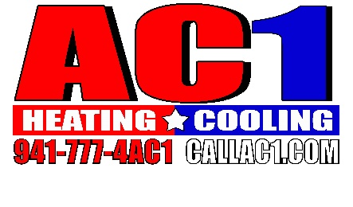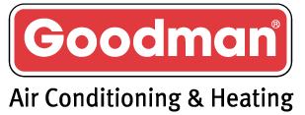

Program Details:
Effective Dates: January 1, 2020- December 31, 2023
- 10%- Volume Rebate on all purchases to be paid quarterly (serialized Goodman, Daikin equipment, & PSA) **Amana residential equipment will qualify as well when purchased and sold in the Ft Myers and Naples markets from a Company Owned Distribution center.
- 5%- Goodman A Plus loyalty accrual on all Goodman serialized equipment
- 6% Buydown on all EGIA financed jobs
- Tier 1 Discounted Service Agreements
- Sarasota- 10% discount off Factory direct bulk orders - minimum purchase of $100,000
- Sarasota- 5% discount off Factory direct bulk orders- minimum purchase of $50,000
- Sarasota- 10% discount can be used two times per month on bulk orders over $25,000, no cap.
  - **Amana residential equipment will qualify for all of the above programs when purchased from a Goodman Company Owned Distribution location in the Ft Myers and Naples markets.
- Price Increase Protection
  - AC1 to participate in all Goodman MFG nationally announced price increases.
  - AC1 will not receive more than 3% price increase during any single price increase.
  - Price increase will not exceed 6% in a calendar year for the term of this agreement
  - AC1 will receive ½ the total of nationally announced increase if less than 6%
  - AC1 price increase will be ½ of Goodman’s nationally announced increase not to exceed 3% per increase.
(Example 1: If Goodman MFG announced a 5% price increase AC1 would receive 2.5%)
(Example 2: If Goodman MFG announced an 8% price increase AC1 would receive 3%)
  - If Goodman MFG announced a price increase percentage range, we will base of calculations off the lower percentage.
(Example: nationally announced price increase 6%-8%, the price increase will be calculated off the lower number, so the price increase would be for 3% for AC1)

_____________________________ _____________________________
Doug Lewis – AC1 Kevin Pomeroy - RM Goodman Mfg

