GAD ACH Update Payment Details Module
GAD ACH Update Payment Details Module:
Link: https://dkng.conservationrebates.com/gmana/cms-check-ach-rebate-report.php
How to login:
- To access this link, you must be first logged in to GAD RPS.
- Open the link on this email.
- Use the same Login credentials that you used to login to GAD RPS.
How to update the Database with Payment Details for ACH batch files only.
- Select the Contract from the DDL
- Select the batch # from the DDL
- Enter the Paid date using the calendar icon.
  - You can find the batch paid date on the Jira ticket.
- Save
  - 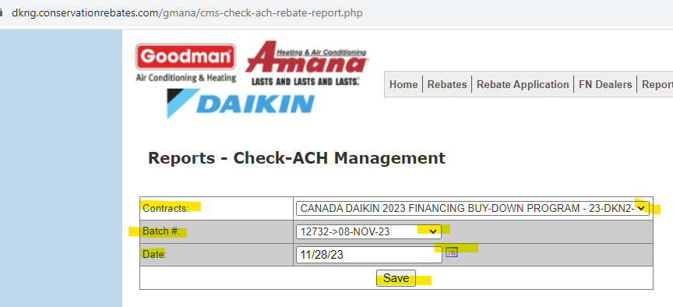 Jira ticket: 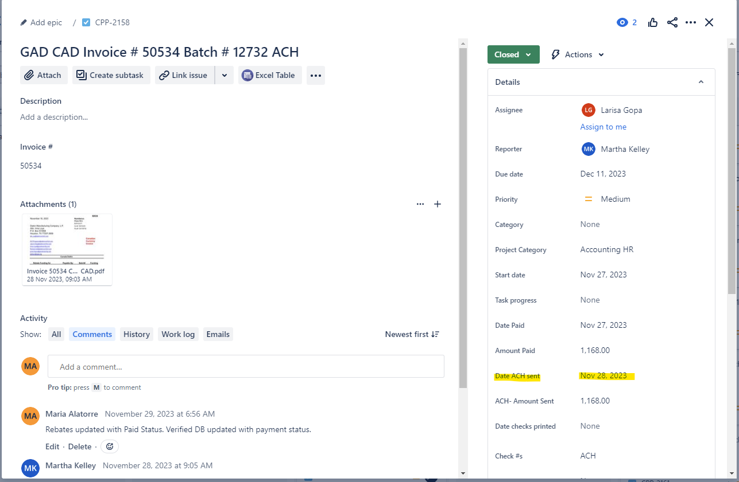
To verify the Database is updated
- Select the program
- Change Search criteria to Batch No
- Enter batch number you just updated
- Search
- NOTE – ACH payment notification emails go out the next day.
Once the DB is updated you need to Move the Jira Ticket from DATABASE UPDATING to CLOSED.
- Add a note on the Jira ticket, as long it has the bolded section on below example. The Ticket will automatically move and update the Status to Closed.
  - Rebates updated with Paid Status. Verified DB updated with payment status.
  - If you enter anything else you will need to move the ticket manually & update the status to closed.

