GDI – How to Update Batch to Paid
- Login to the GDI Portal https://gdiincentives.egia.org/sce/rps
- On the Home page click Reports, then Check ACH Reports
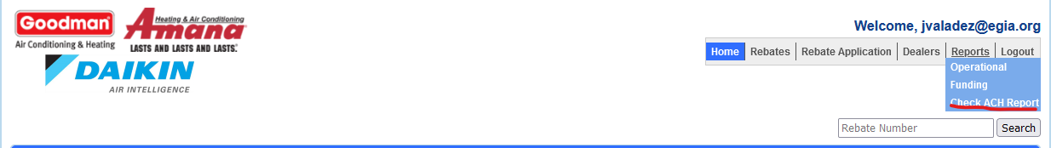
- You will be asked to select the Program name from the Contracts list.
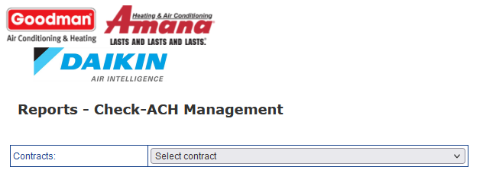
- After selecting the Program you will select the Batch # you are paying from the dropdown.
- Select the Payment Date from the calendar.
- Click Save.
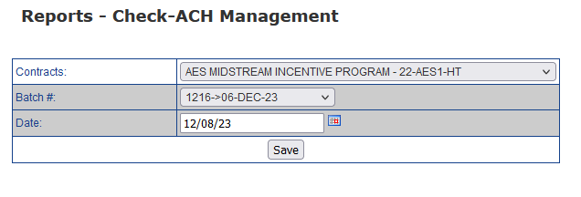
- When save, there is a message at the bottom of the page that lists out the number of rebates that were updated. You are done. If you have other batch payment, go back to step 3.

