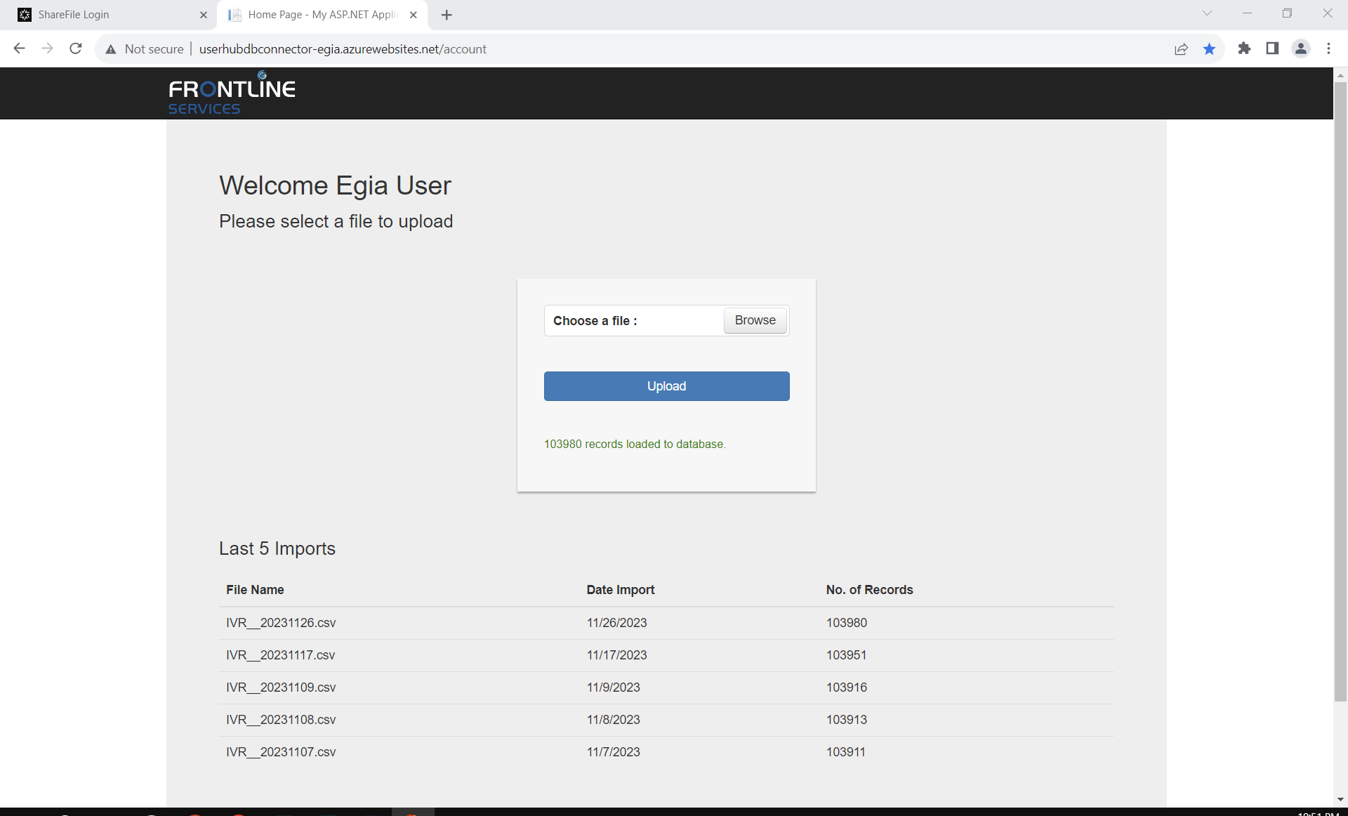
User: egiauser
PW: Upl0@dF!les

Email from Devteam:

Hi Clinton/Jose,
IVR file has been placed on shared drive.
S:\Folders\egiafs10\IVR\IVR FILES

Thank you,
Devteam Automation

