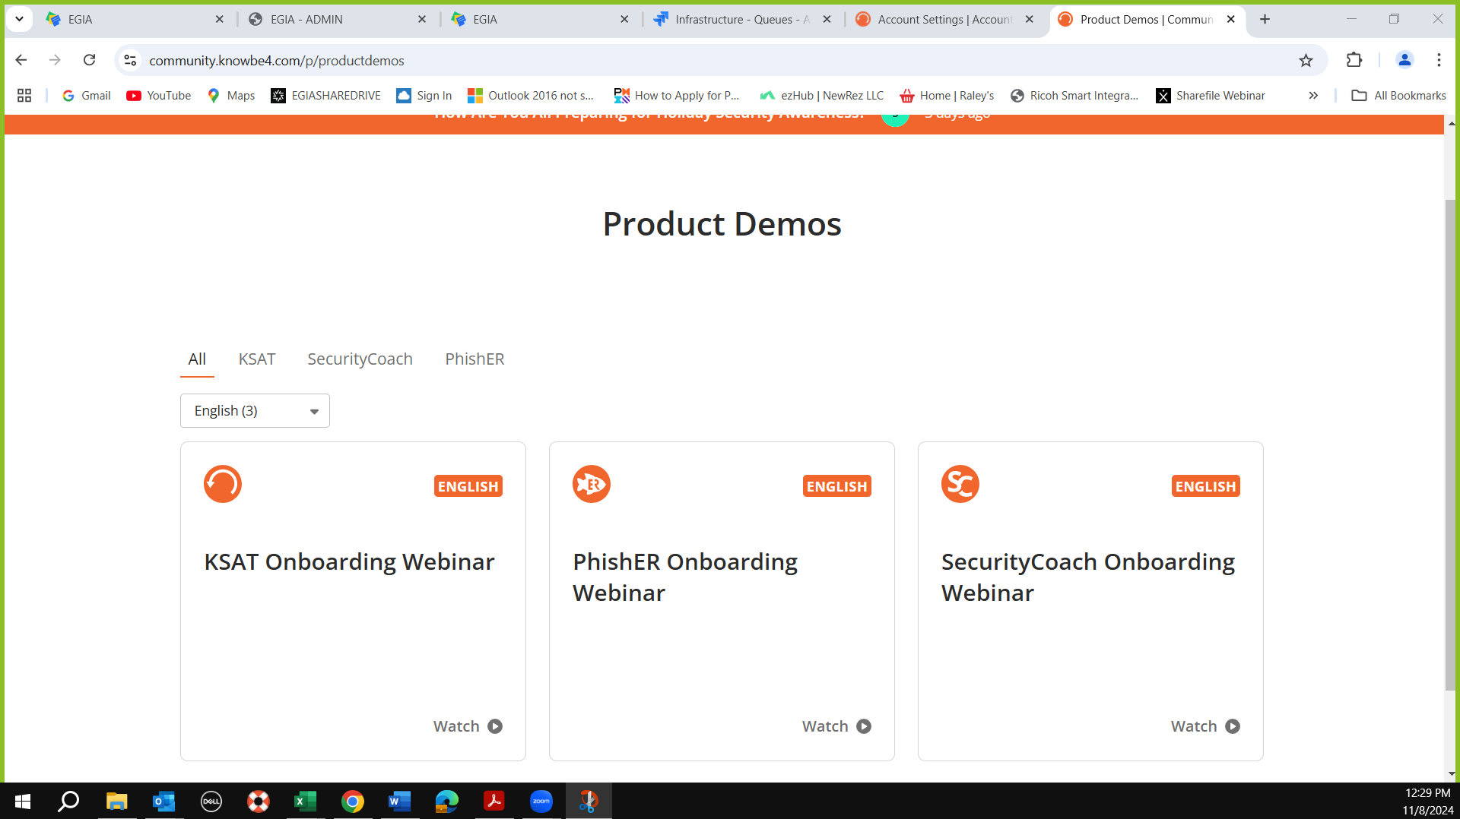
Watch first 2 for sure.
Home work

Whitelisting
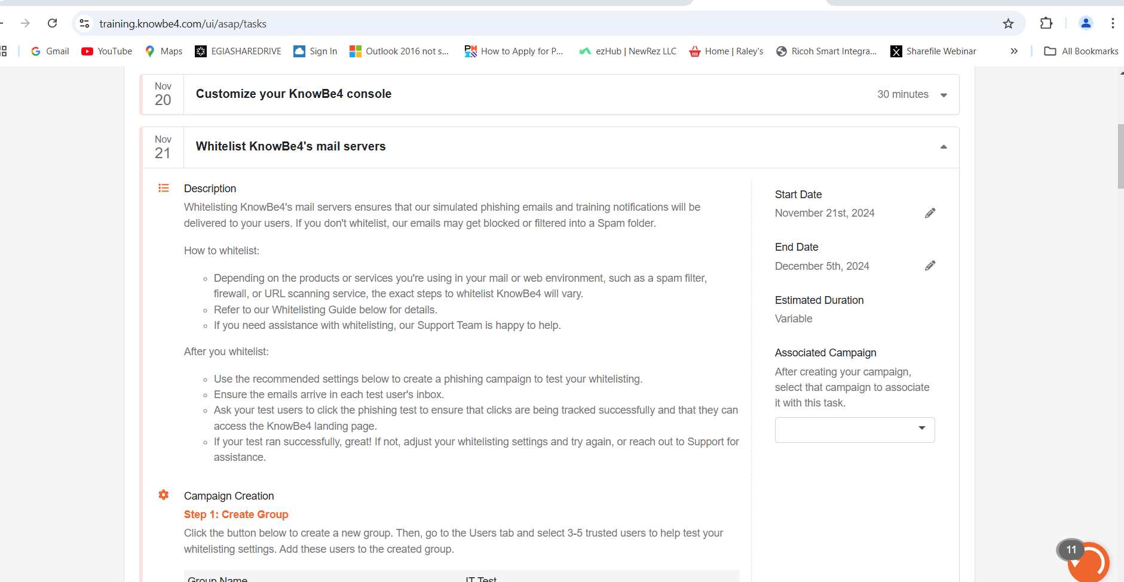
6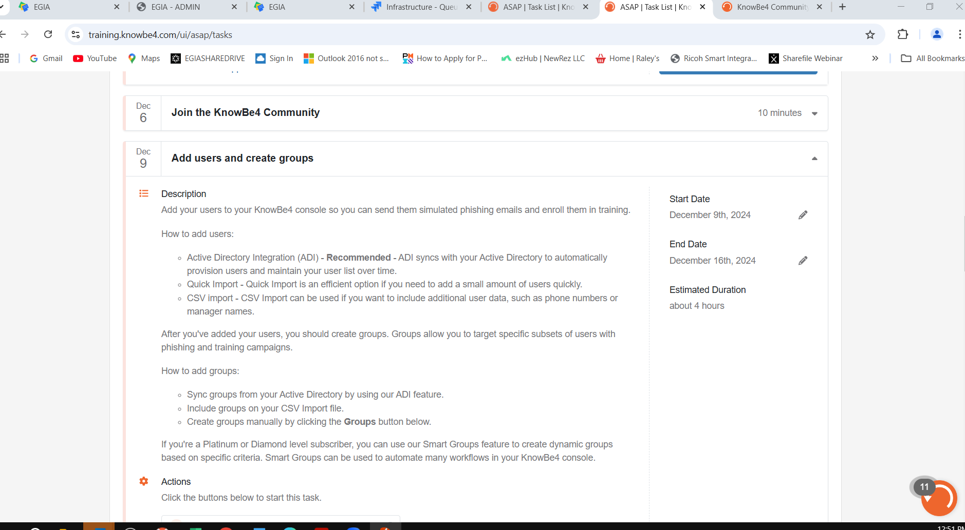 users to test IT

Add Users and Create groups
Integrate to AD (abtech)

PAB Phish alert button for user reporting back
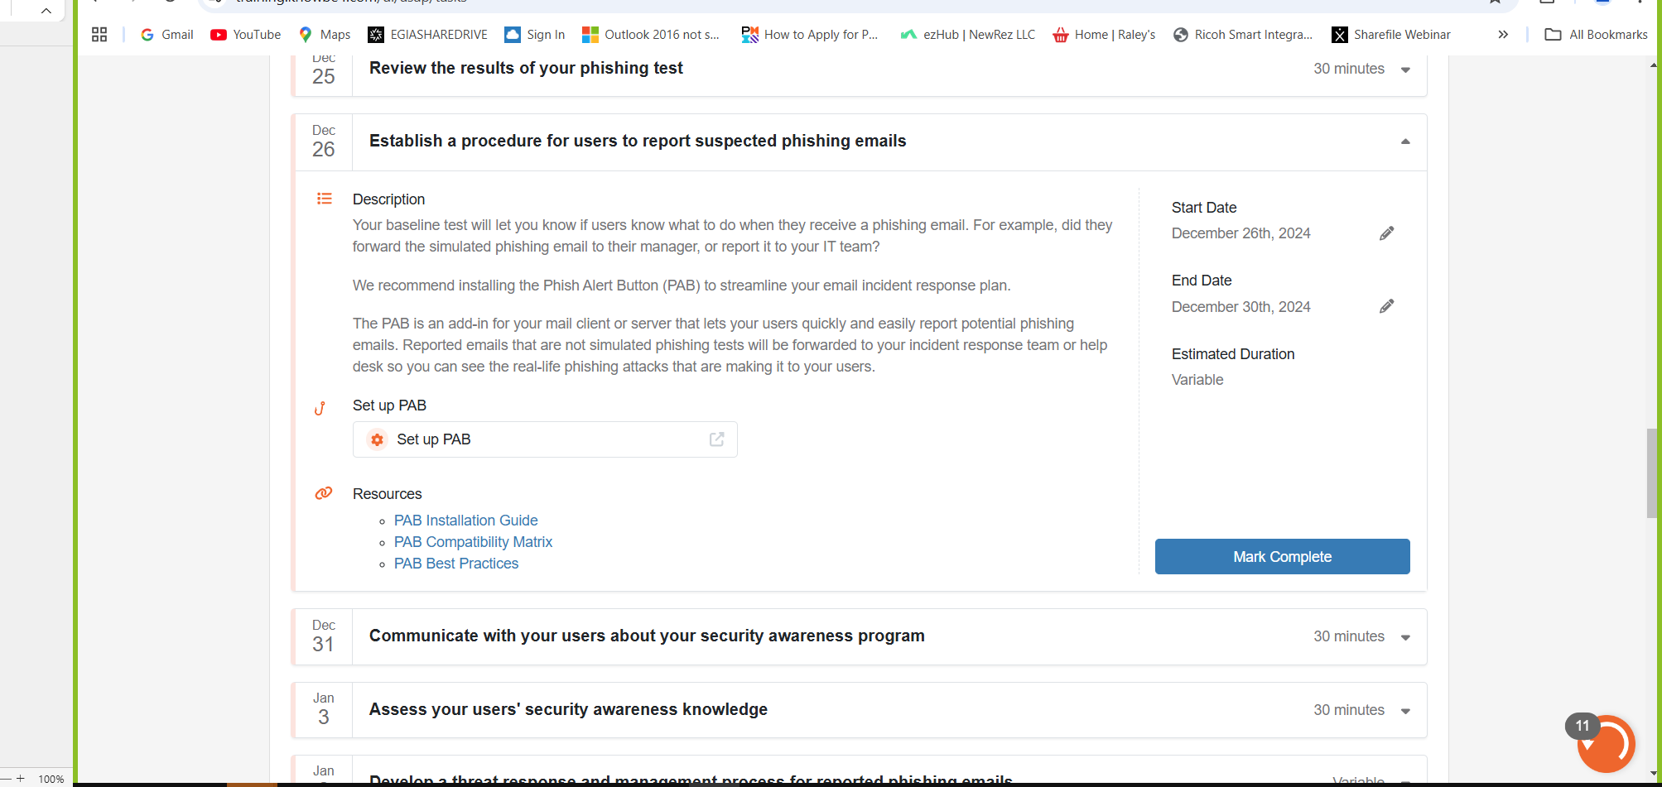
Contact Jenn for stuck items
Contact list

