Add people to Jira boards
- Projects
- Select Category
- 3 dots on the right > Project Settings
- People
- Add people on the right
- Type Name of person added
- Choose a Role
- Add
Add Description to all Jira Boards
- Select project/board
- On the right, select Project Setting
- Enter details
- Save Details.
Add New Board
- Make sure you are on the All Projects Page.
- Select Create Project on the top right corner.
- Select Work Management located on the left hand under the Project Templates section.
- Select Project Management from the center of the page (Templates)
- Select Use Template
- Name It
- Project Type: Company-managed
- Make sure there is a KEY (NOTE – we can override and enter any key we want)
- Select “Share Setting with an Existing Board”
- Choose Project – select from dropdown board we want to mimic
- Create Board
- You will get an error message, its ok. Go back to - All projects in Jira. The one we just created should be listed there.
- Now we need to add people from the three dots on the right.
Add new Category in Jira
- All projects
- Setting on the right
- Projects
- On the left hand Project Categories
- Scroll down and enter Name
- Save

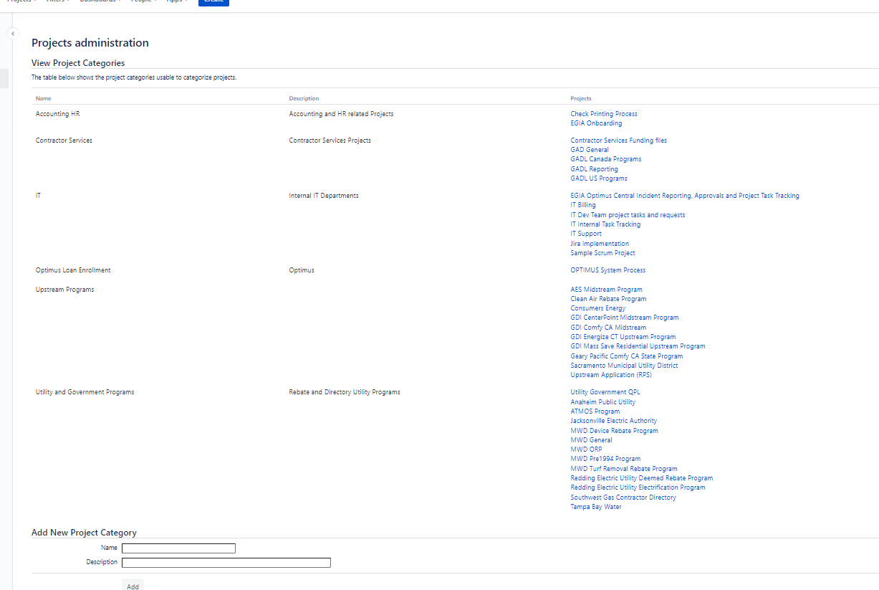
Update Project Category in a board
- Project
- Project setting
- I with circle
- Add project category
- Category Name
- Description

- Add
- Create new

Exchange –
help.emailsrvr.com
Login My email & PW for outlook

