All,

For enhanced security, EGIA/Microsoft will be implementing Multi-Factor Authentication (MFA) across all Office 365 accounts. This additional layer of protection is similar to the verification codes required when accessing various websites, like online banking. MFA will be activated on all accounts by the scheduled date and time: December 5 2023, After 5 PM.

Once activated, you will need to perform the following steps:

- Navigate to the Microsoft 365 portal (office.com).
- Enter your Office 365 credentials and sign in.
- You will be presented with the following ‘More information required’ pop up.
- Click ‘Next’.

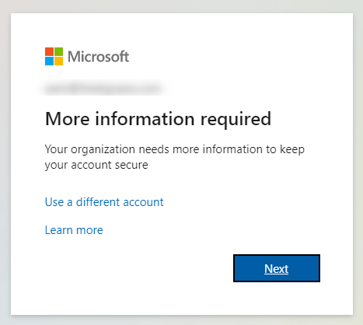

You’ll be brought to a ‘Keep your account secure’ page. To complete the setup, you will have 2 options:

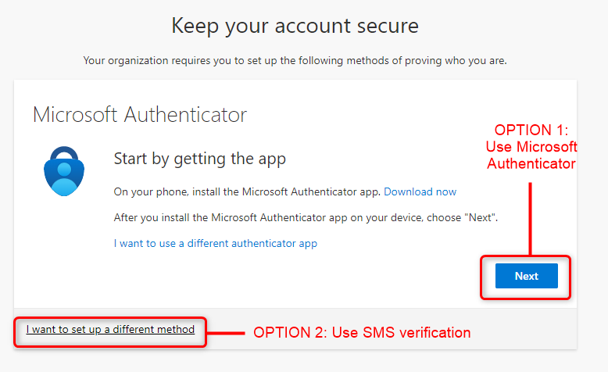

OPTION 1: Microsoft Authenticator App:

- Click ‘Next’.
- You will install the Microsoft Authenticator app on your phone.
- In the app, tap the + on the top-right.
- Select ‘Work or school account’.
- Tap Scan QR Code.
- This should bring up your phone’s camera. Scan the QR code displayed on your computer.
- You will then be asked to confirm the code displayed on your app screen.

More detailed steps here: https://support.microsoft.com/en-us/topic/use-microsoft-authenticator-with-microsoft-365-1412611f-ad8d-43ab-807c-7965e5155411#ID0EBBH=Step_2

OPTION 2: SMS Verification:

- Click ‘I want to set up a different method’.
- Enter your cell phone number.
- Confirm the code sent to your cellphone via SMS.
- Click OK once it has verified successfully.

Please contact the helpdesk at egiasupport@egia.org 877-260-6877 if you have any questions or run into any issues.

