Changing a password in Active Directory for a device and user to sync with Microsoft Entra

- Adding or moving user for the AD 365 Entra Sync process:
  - Ensure that the AD user account and specific device being used to access Microsoft Office 365 are in the proper Active Directory Organizational Unit locations:
MS365EGIA
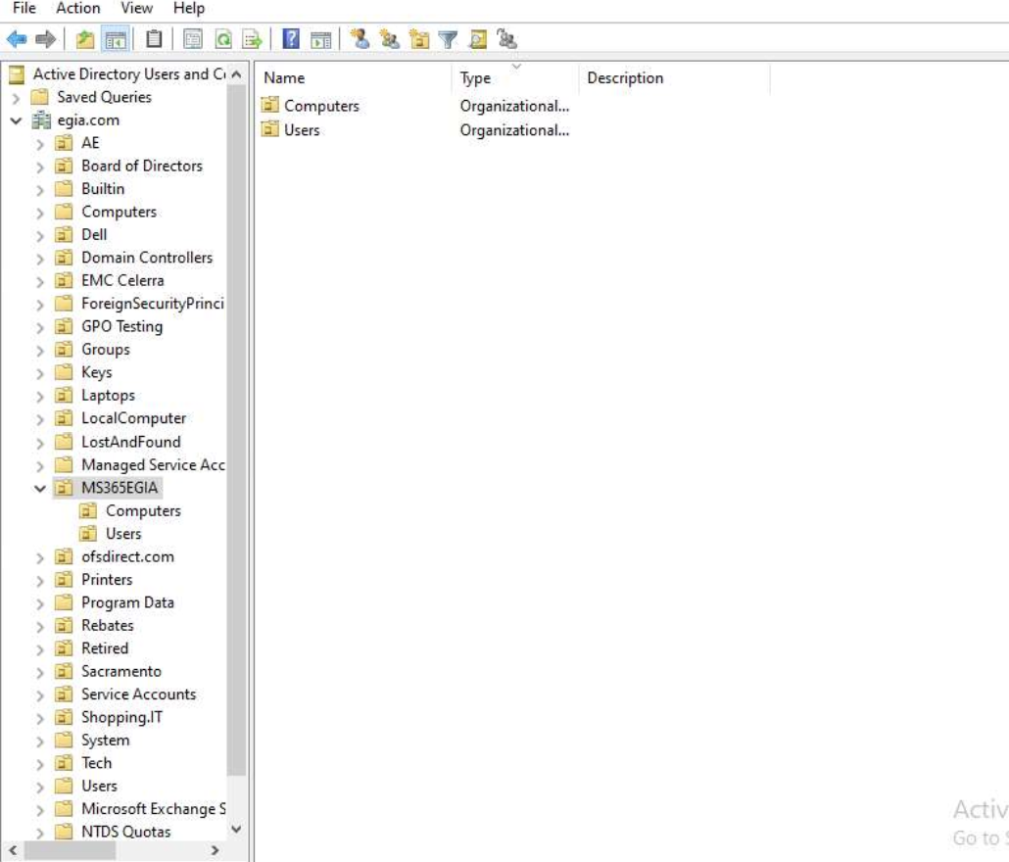
  - The Device and user ID must be in the Computers and Users sub folder of the MS365EGIA:
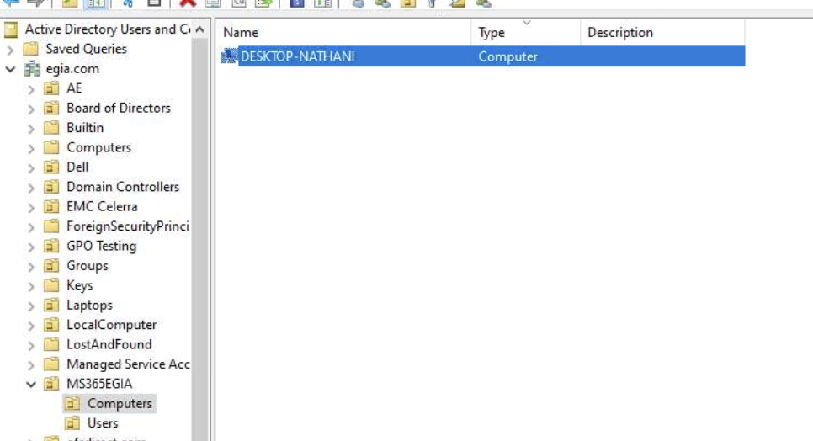
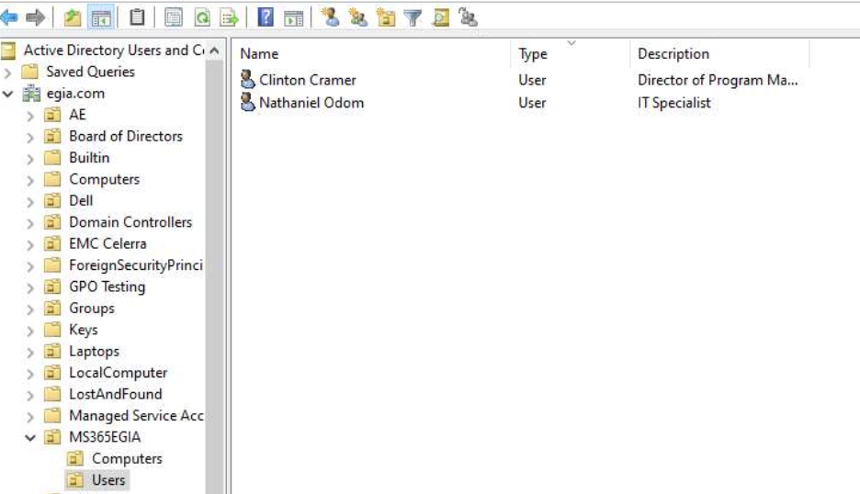
- Change user password:
- Find the user or open the proper OU.
  - For users that have passwords that automatically sync with MS 365, look in the MS365EGIA OU folder.
- Right click on the user and choose Reset Password.
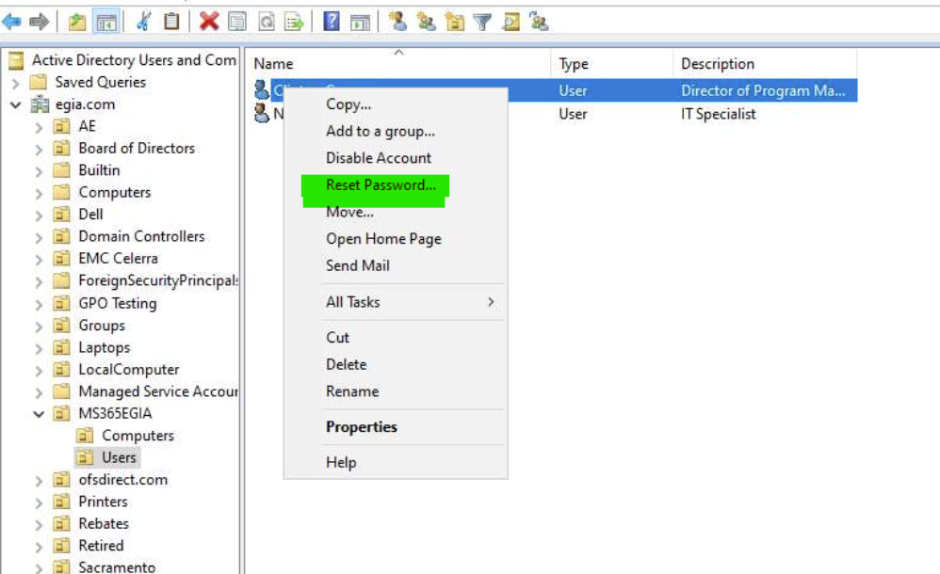
- In each of the fields for New and Confirm Password, Enter the new password.
- Typically, ‘User must change password at next logon’ is left unchecked.
  - Note: If checked, it would take time for the sync to happen and cause some MS office password challenges unless the manual sync button is triggered after the user has created a new password.
- Check the box for unlocking the user’s account.
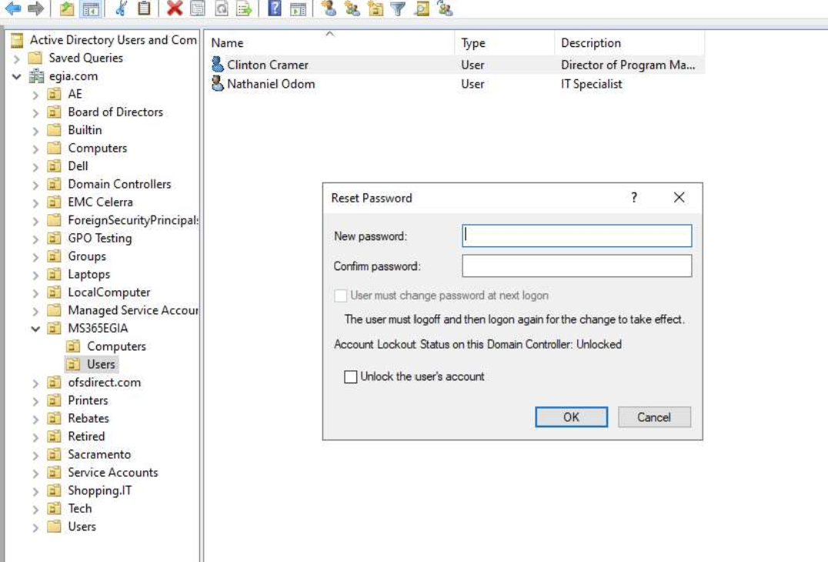
- Click OK
  - Login and 365 access steps post changing a user password in AD
- Disclose password to user.
- Have the user log in to the device with the new password.
- Have the user log on to outlook.com via a browser with the same new password prior to opening a Microsoft 365 Office product.
- After a successful logon to outlook.com, open the Desktop Outlook application.
- Enter the new password utilized in the steps above.

