Sending emails from a different domain

The task of figuring out how to send emails from a different domain.

Example:

company's domain is 'abc.com

Send emails on a client’s behalf. (Example of client's domain is 'xyz.com).
The steps might be different for different clients, depending on the technologies they use.
- What steps are needed to send emails on a client's behalf?

- What steps do clients need to take to allow emails to send on their behalf?
  - DNS, SPF, and DKIM need consideration.
Generally, you cannot send emails on client’s behalf. Spammers would really love for this to be possible, and this is the reason why there are lots of systems in place to avoid this behavior.

If you have a legitimate reason for sending emails on behalf of someone else, there are two solutions:
- Send the emails through their mail server.
- Ask them to configure their anti-spam settings (SPF, DKIM, DMARC, etc.), to allow your mail server to send emails using their SMTP domain in the sender address.

Both solutions require their willing cooperation, but the technical details depend on which mail server and anti-spam settings they are using.
Additional options for sending email on behalf of your customers, each has its own benefits and drawbacks. You can:
- Use a verified “From” email address from your customer’s domain to send from that specific email address.
- Verify your customer’s entire domain and send from any address on that domain. This is the most customer-branded option, but also the one that may require the most implementation effort.
This chart shows how an example app called plumbercrm.com could use each method and how this would look for each option as it relates to from name, from address, and reply-to address for your recipients.
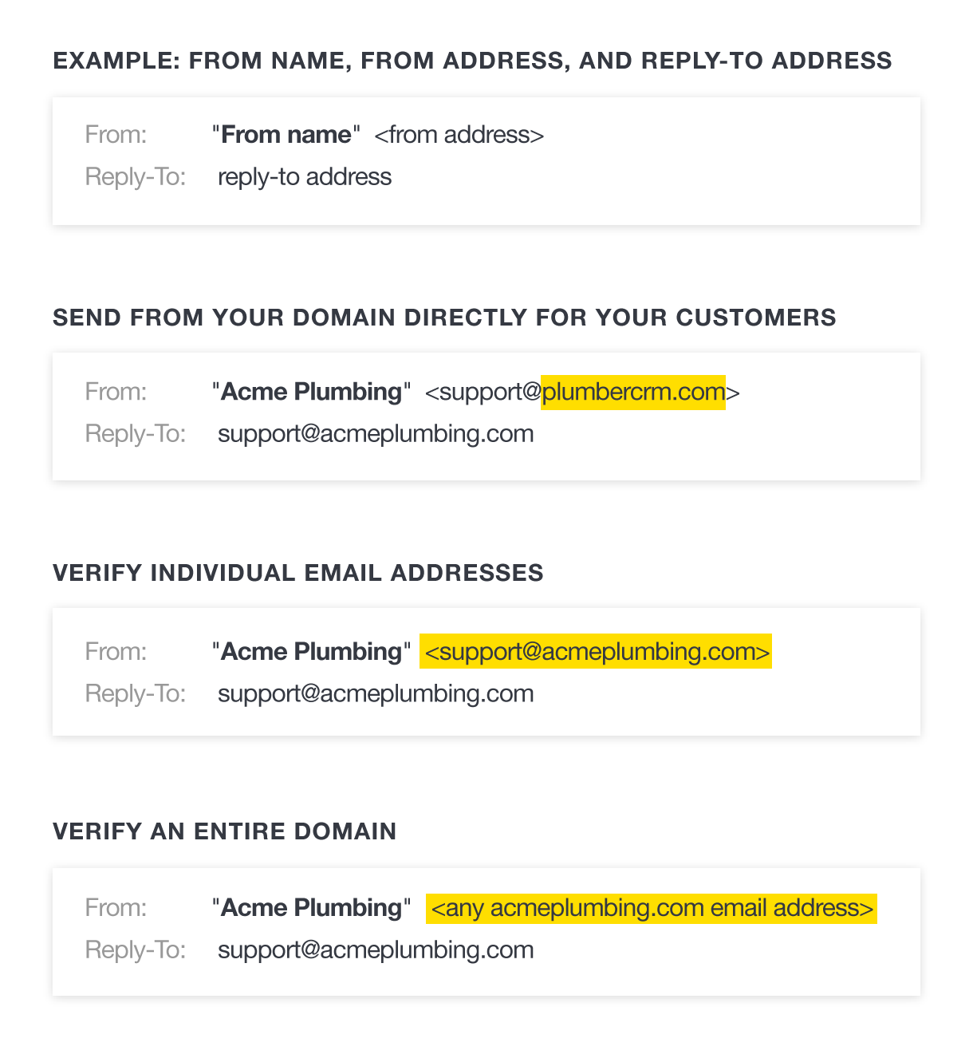
If your product or agency sends email on behalf of customers, like the imaginary CRM for plumbers from our chart, how do you choose which method is right for you? It really depends on the type and volume of email you’ll be sending, and on your customer’s expectations for those messages.
When you login to Postmark, you’ll see a menu item called “Sender Signatures” and when you select it you’ll see an option to “Add a new signature or domain.” Click here and you’ll be given two choices, verify a domain or an email address with what we call a Sender Signature.
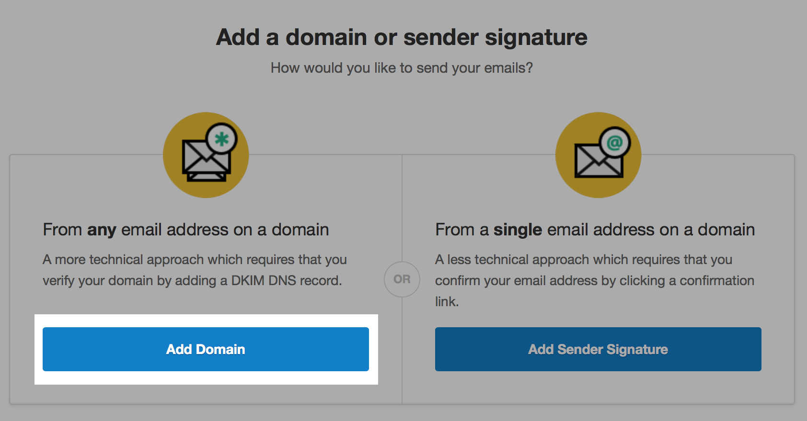

Option 1: Sending from your domain#
This is the fastest way to send for your customers because they don’t need to take any action outside of your app to send email. Another big advantage to this method is your customers don’t have to worry about setting up DKIM, Return Path, or DMARC. You can manage all of those email authentication protocols for them.
You can change the From name and ReplyTo address in your code when sending with SMTP. There are a variety of ways to accomplish this in your code, but the main thing to remember is you need to set this information in the header for SMTP messages.
If you are sending with the Postmark API you can set the From and ReplyTo for each message. You can see what you’d need to update with the example values sender@example.com and reply@example.com below:
{
"From": "sender@example.com",
"To": "receiver@example.com",
"Cc": "copied@example.com",
"Bcc": "blank-copied@example.com",
"Subject": "Test",
"Tag": "Invitation",
"HtmlBody": "<b>Hello</b>",
"TextBody": "Hello",
"ReplyTo": "reply@example.com",
"Headers": [
{
"Name": "CUSTOM-HEADER",
"Value": "value"
}
],
"TrackOpens": true
}
This isn’t the best method if your customers want to send email from their own domain, so if that’s a concern for your customers then you should consider one of the following methods.

Option 2: Verifying an email address in the Postmark interface#
Verifying an email address is a really great if your customers need to send from their own domain and you don’t want to ask them to update their DNS records. To send with this method, Postmark needs to know the email address your customers will be using. We’ll send them an email with a link they need to click to verify their email address. One place you can manage this setting is in the Postmark interface.
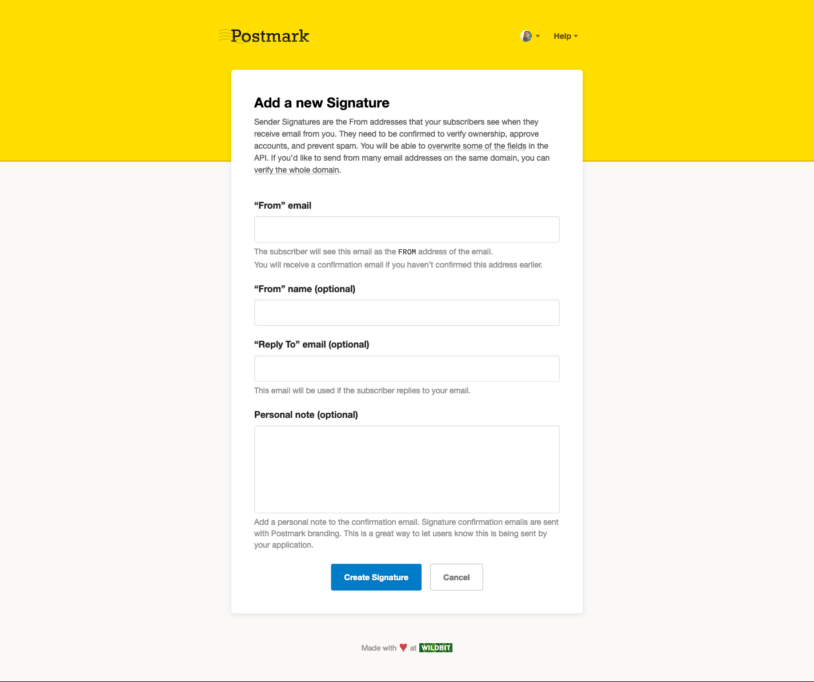
After you select ‘Add Sender Signature’ from the Sender Signatures page, fill in the full name and email address you want to use. Remember, this email address will need to be setup and accepting email so you or your customer can verify it by following a link in the next step.
The Personal note is a field to provide context to the recipient of what the confirmation email is for. This field is helpful if you're sending on behalf of a customer that might not know you're using Postmark for email, and is available via our API or UI when adding a Sender Signature.
Select Create Signature and your customer will receive a confirmation email from Postmark to verify their email address. This message will look like the one pictured here, and your customers will need select Confirm Sender Signature to verify their email address.
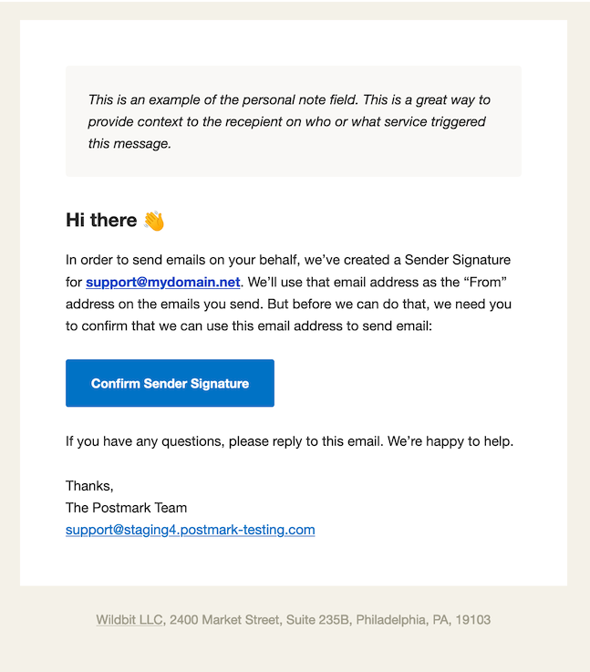

Option 3: Verifying a domain in the Postmark interface#
This option takes a bit more time for your customers to set up to get started, but it’s worth it. They can build on their domain’s email reputation and will be able to send from any address on their domain. To get started your customers will need to add a DKIM record to the DNS for their domain.
If you choose to verify a domain, Postmark will ask you to enter the domain you’d like to verify. Then on the next page, you’ll get a DKIM key to add to the DNS for the domain you’re verifying. Your customers will need to add this value to their DNS. Like everything related to DNS, it can take some time for these records to propagate. Standard practice says to give them up to 48 hours to show up, but it normally doesn’t take that long.
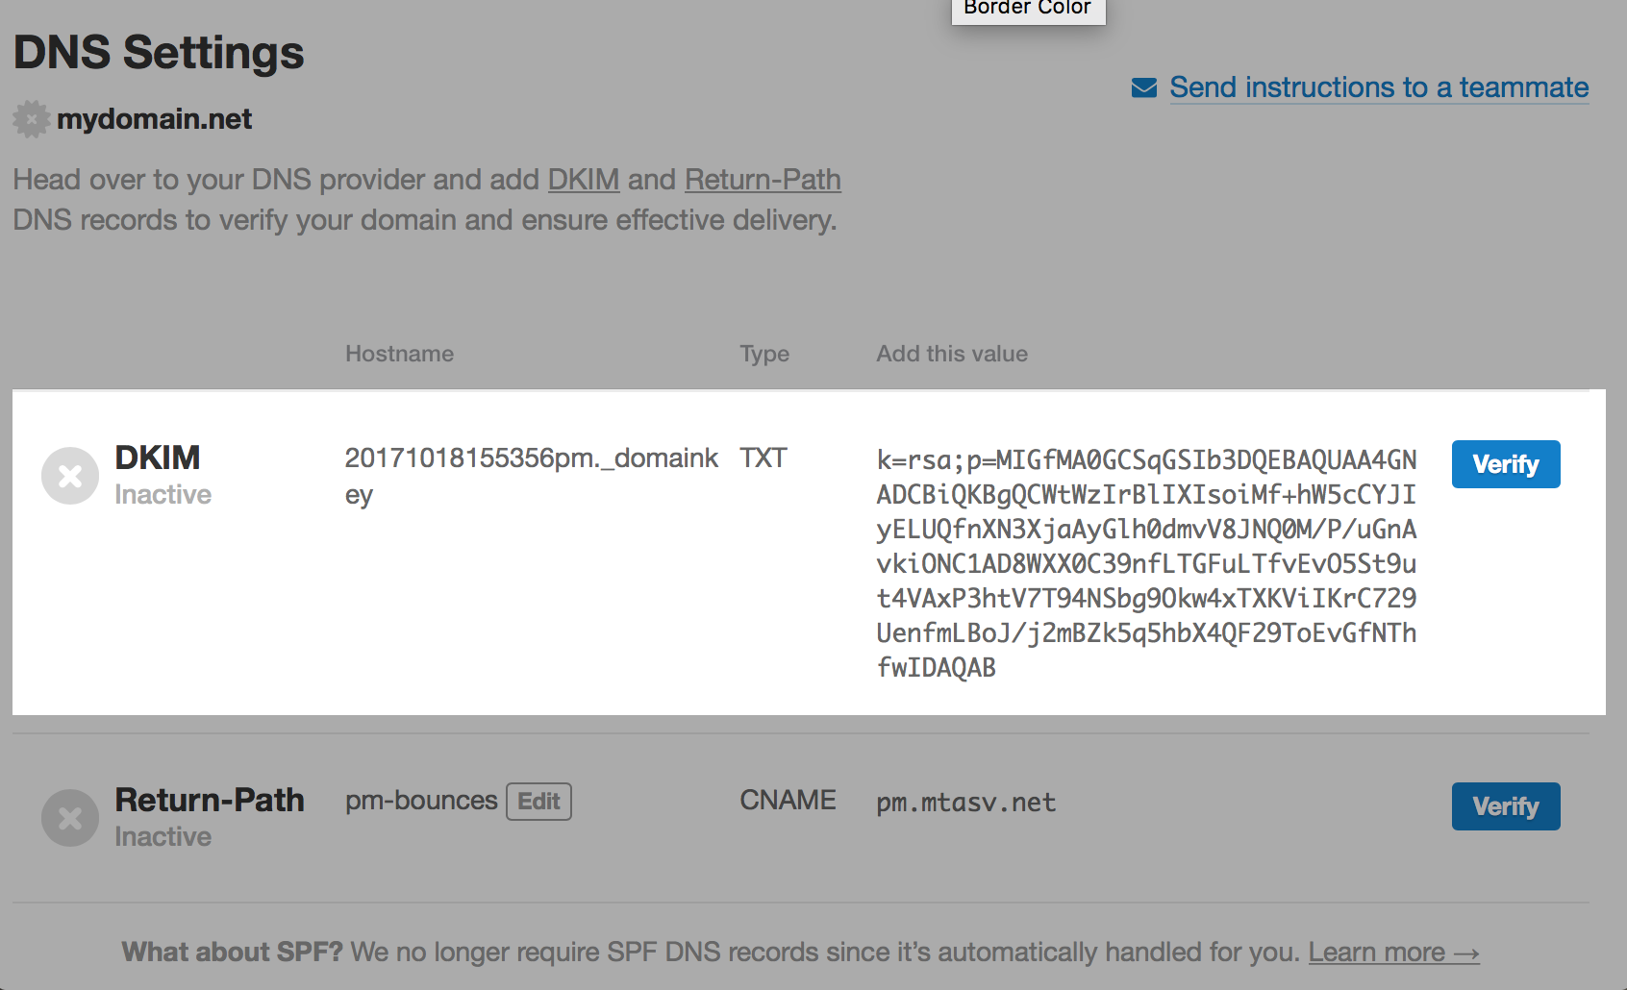
Postmark Pro Tip #1: Verify an email address or domain with the Postmark API#
As mentioned previously, if you are sending on behalf of a multiple customers, you may not wish to manually add each domain or sender signature to your domain. This is where the Postmark API can do some of the heavy lifting for you!
You’ll need to use the Postmark API to create a Sender Signature to verify an individual email address or a domain. The first thing you need to know is an email address your customers want to verify. Remember, your customers can’t verify email addresses from free email providers like Gmail with Postmark.
Once you have your customers email address, send that email address to our Create Sender Signature endpoint, and the user will get an email from Postmark asking them to click to verify their email address. You should let your customers know an email will be coming from Postmark and they can confirm their email address in that message.
If you’re new to Postmark’s API you can see how a call to create a sender signature works with the Postmark API Explorer. You’ll need an account token to see the create a sender signature endpoint in action. Paste in your account token, fill in the values for FromEmail, Name, and ReplyToEmail, and try it out.
Here’s an example of the response I got from Postmark’s API when creating a Sender Signature using my account:
{
"Domain": "example.com",
"EmailAddress": "john.doe@example.com",
"ReplyToEmailAddress": "reply@example.com",
"Name": "John Doe",
"Confirmed": false,
"SPFVerified": false,
"SPFHost": "example.com",
"SPFTextValue": "v=spf1 a mx include:spf.mtasv.net ~all",
"DKIMVerified": false,
"WeakDKIM": false,
"DKIMHost": "",
"DKIMTextValue": "",
"DKIMPendingHost": "20140220130148.pm._domainkey.example.com",
"DKIMPendingTextValue": "k=rsa; p=MIGfMA0GCSqGSIb3DQEBAQUAA4GNADCBiQKBgQCQ35xZciGB0g...",
"DKIMRevokedHost": "",
"DKIMRevokedTextValue": "",
"SafeToRemoveRevokedKeyFromDNS": false,
"DKIMUpdateStatus": "Pending",
"ReturnPathDomain": "pmbounces.wildbit.com",
"ReturnPathDomainVerified": true,
"ReturnPathDomainCNAMEValue": "pm.mtasv.net",
"ID": 1,
"ConfirmationPersonalNote": "This is an optional note visible to the recipient in the Sender Signature Confirmation email to provide context of what Postmark is."
}
Using our Domains API, you can add a Domain to your Postmark account and get back the information you need to verify it. The API response when creating a Domain only slightly differs from the response you get when creating a Sender Signature using the API:
{
"Name": "newdomain.com",
"SPFVerified": false,
"SPFHost": "newdomain.com",
"SPFTextValue": "v=spf1 a mx include:spf.mtasv.net ~all",
"DKIMVerified": false,
"WeakDKIM": false,
"DKIMHost": "",
"DKIMTextValue": "",
"DKIMPendingHost": "20131031155228.pm._domainkey.newdomain.com",
"DKIMPendingTextValue": "k=rsa; p=MIGfMA0GCSqGSIb3DQEBAQUAA4GNADCBiQKBgQCFn...",
"DKIMRevokedHost": "",
"DKIMRevokedTextValue": "",
"SafeToRemoveRevokedKeyFromDNS": false,
"DKIMUpdateStatus": "Pending",
"ReturnPathDomain": "pmbounces.newdomain.com",
"ReturnPathDomainVerified": false,
"ReturnPathDomainCNAMEValue": "pm.mtasv.net",
"ID": 36736
}
When you create a Domain using the API, the values DKIMPendingHost and DKIMPendingTextValue are also created (same as when you add a Sender Signature using the API). Your customers will need to add this DKIM record to their DNS records using the DKIMPendingHost (for the TXT record’s host) and DKIMPendingTextValue (for the TXT record’s value) returned for the added Domain.
Once Postmark sees these DKIM values in the DNS records, your customer will be able to send from any email address on their domain.

Postmark Pro Tip #2: Use Servers and Streams to separate messages#
After you’ve determined your domain and branding approach, we recommend using Servers (which act like folders) and Streams (which help you separate different types of mail) to organize each customer’s sending activities within your account.
Within each Server, you can have up to 30 Streams for transactional, inbound, and broadcast mail. For example:
Server A - Client 1
- Message Stream A - Receipts - Transactional
- Message Stream B - Feature Updates - Broadcasts
Server B - Client 2
- Message Stream A - Internal Alerts - Transactional
- Message Stream B - Terms of Service Updates - Broadcasts
- Message Stream C - Booking Confirmations - Inbound
Separating mail with Servers and streams helps you:
- Isolate reputation issues: If there is an issue with Client 2, Stream B, sending can be paused on that specific Stream while allowing all other messages to continue flowing.
- Manage risks like spam complaints, bounces, bots and form abuse, from affecting other customers/clients on your account.
- Report on unique stats for each customer/client (sent, bounces, complaints, opens, clicks, etc.)
- Maintain separate unsubscribes and suppressions for each Stream
Use the Servers API to programmatically manage creating new servers.
For more tips review our guide: Best practices for sending on behalf you customers.

Last updated August 8th, 2023

