Call flows adapting AI for (Primary reason for call will be for scheduling inspections customer was alerted on to call in – which does not exist today):
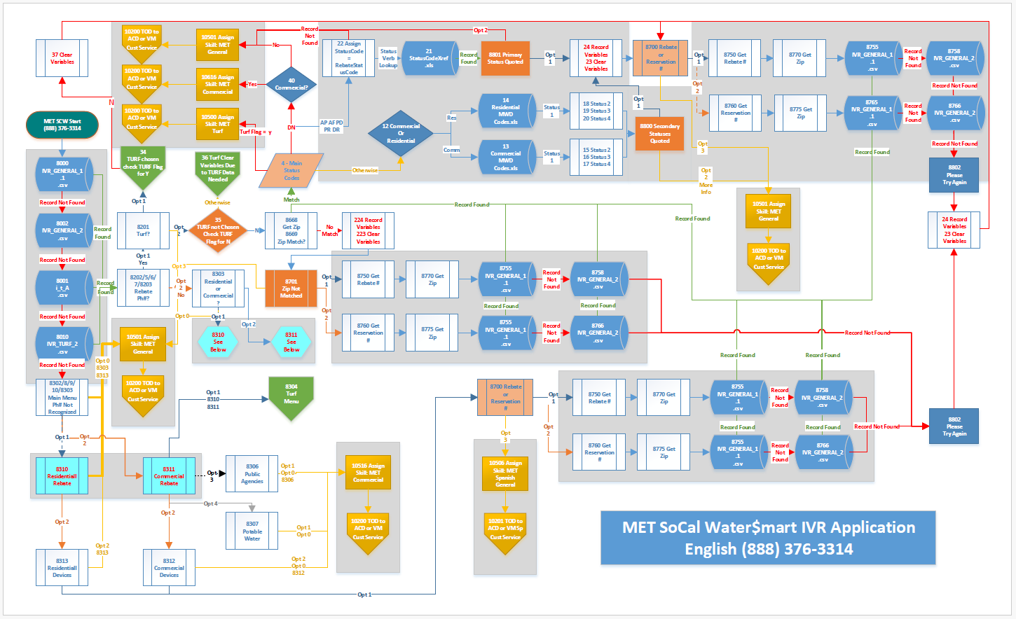
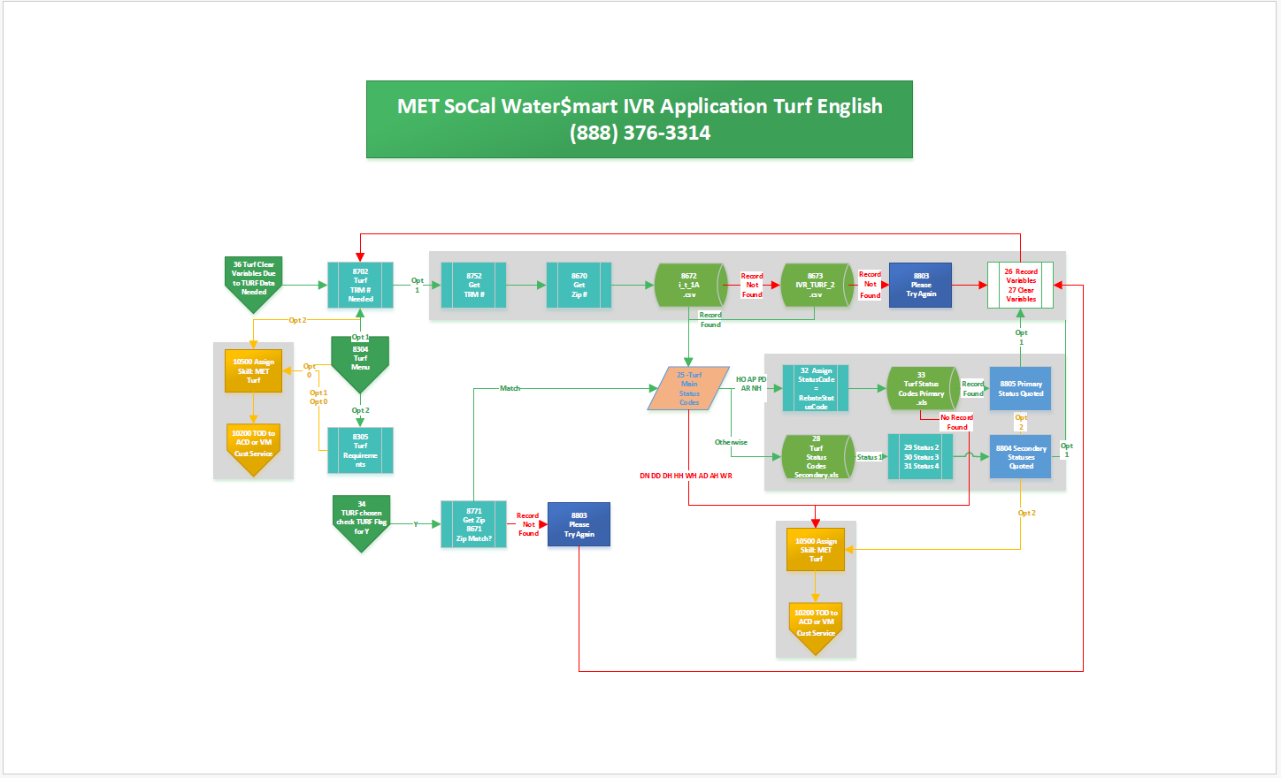
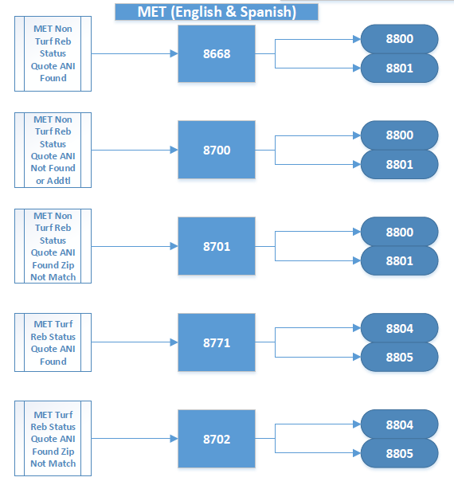
Current DB lookup (DB connector to 3rd party site appears to actually appears to be API)

DYNAMIC request
ASSIGN proxy=GetRESTProxy()
proxy.ContentType="application/json"
ASSIGN Global:URL="https://userhubdbconnector.azurewebsites.net/api/db"
request.uniqueId="aZtBxrBF0hOTMMOoY5Af"
request.secretKey="BfuRCGeAhk8pFROyoDNQnPiITd7gflSPuINpB3gw"
//request.query="select * from IVR_DEVICE WHERE CustomerID = 6198610622"

ASSIGN Global:LookUpCount = 0
ASSIGN Global:bLookUp = 0
ASSIGN Global:StatusCodeCount = 0

IF Type = "ANI" {
request.query= "select * from IVR_DATA WHERE CustomerID = '{Global:ANI}'"
requestJson="{request.asjson()}"
ASSIGN APIResponse=proxy.MakeRestRequest(Global:URL, requestJson, 0, "POST")
}

IF Type = "ZIPCODE" {
request.query= "select * from IVR_DATA WHERE ZipCode = {Global:ZIPCODE}"
requestJson="{request.asjson()}"
ASSIGN APIResponse=proxy.MakeRestRequest(Global:URL, requestJson, 0, "POST")
}

IF Type = "REBATE" {
IF Global:CallFlow = "FutureProgramTemplate" {
request.query= "select * from IVR_DATA WHERE ReservationNo = {Global:Reservation} AND TURF = 'F'"
}IF Global:CallFlow = "Tampa" {
request.query= "select * from IVR_DATA WHERE ReservationNo = {Global:Reservation} AND TURF = 'T'"
} ELSE {
request.query= "select * from IVR_DATA WHERE ReservationNo = {Global:Reservation}"
}
requestJson="{request.asjson()}"
ASSIGN APIResponse=proxy.MakeRestRequest(Global:URL, requestJson, 0, "POST")
}

ASSIGN Global:LookUpStatusCode = "{proxy.StatusCode}"
ASSIGN Global:LookUpStatusDescription = "{proxy.StatusDescription}"

ASSIGN Global:LookUpCount = count(APIResponse)

IF Global:LookUpCount > 0 {
ASSIGN Global:bLookUp = 1

ASSIGN Global:ProgramType = "{APIResponse[1].ProgramType}"
ASSIGN Global:ProgramType = "{Global:ProgramType.lower}" //Make Lower
ASSIGN Global:Turf = "{APIResponse[1].TURF}"
ASSIGN Global:Turf = "{Global:Turf.upper}" //Make Upper
ASSIGN Global:Reservation = "{APIResponse[1].ReservationNo}"
ASSIGN Global:Reservation = "{Global:Reservation.replace(".0","")}"
ASSIGN Global:ZipCode = "{APIResponse[1].ZipCode}"
ASSIGN Global:ZipCode = "{Global:ZipCode.replace(".0","")}"
ASSIGN Global:Contract = "{APIResponse[1].ContractNo}"
ASSIGN Global:RebateStatusCode = "{APIResponse[1].RebateStatusCode}" //Make Upper
ASSIGN Global:RebateStatusCode = "{Global:RebateStatusCode.upper}"
ASSIGN Global:RebateStatus = "{APIResponse[1].RebateStatus}"
ASSIGN Global:StatusCode1 = "{APIResponse[1].StatusCode1}"
ASSIGN Global:StatusCode2 = "{APIResponse[1].StatusCode2}"
ASSIGN Global:StatusCode3 = "{APIResponse[1].StatusCode3}"
ASSIGN Global:StatusCode4 = "{APIResponse[1].StatusCode4}"
ASSIGN Global:ApplicantFirstName = "{APIResponse[1].ApplicantFirstName}"
ASSIGN Global:ApplicantLastName = "{APIResponse[1].ApplicantLastName}"
ASSIGN Global:Rebate = "{APIResponse[1].RebateNo}"

ASSIGN Global:RebateStatusCode = "{Global:RebateStatusCode.replace("-","")}"
ASSIGN Global:StatusCode1 = "{Global:StatusCode1.replace("-","")}"
ASSIGN Global:StatusCode2 = "{Global:StatusCode2.replace("-","")}"
ASSIGN Global:StatusCode3 = "{Global:StatusCode3.replace("-","")}"
ASSIGN Global:StatusCode4 = "{Global:StatusCode4.replace("-","")}"

IF Global:StatusCode1.length > 0 {
ASSIGN Global:StatusCodeCount = Global:StatusCodeCount + 1
ASSIGN Global:SecondaryStatusArray[Global:StatusCodeCount] = "{Global:StatusCode1}"
}
IF Global:StatusCode2.length > 0 {
ASSIGN Global:StatusCodeCount = Global:StatusCodeCount + 1
ASSIGN Global:SecondaryStatusArray[Global:StatusCodeCount] = "{Global:StatusCode2}"
}
IF Global:StatusCode3.length > 0 {
ASSIGN Global:StatusCodeCount = Global:StatusCodeCount + 1
ASSIGN Global:SecondaryStatusArray[Global:StatusCodeCount] = "{Global:StatusCode3}"
}
IF Global:StatusCode4.length > 0 {
ASSIGN Global:StatusCodeCount = Global:StatusCodeCount + 1
ASSIGN Global:SecondaryStatusArray[Global:StatusCodeCount] = "{Global:StatusCode4}"
}
}

1-1 Socal Water$mart (MET) (888) 376-3314 (844) 725-6449

3 Holiday Consideration Assign StatusCode5=2 & StatusCode6=1 (If Holiday, then 400000/400500)/ 300100 Retrieve IVR Flag 1 Status/300200 Retrieve IVR Flag 2 Status/1 Initialize Variables and Route by Number

Thank you for calling the (Line Title) Rebate Processing Center.
pause
We will be closed in honor of the holiday. If you choose to speak to a representative following our customer options, you will be prompted to leave a voicemail which can be returned on the next business day. Thank you and have a wonderful holiday.

8000/8002/8001/8010 Initial Customer Look-up Based on Phone #

Customer recognized (8202)
customer not recognized (8302)

8202/5/6/7/8203 Customer Recognized by Phone Number (RP and Turf Files Check)

Hello.
pause
Thank you for calling the so cal water rebate, processing center.
pause
Please listen closely as our options have changed.
pause
Para escuchar las opciones en español, Por favor, diga español,O presione 5 (11).
pause
If you are calling from the phone number noted on your reservation or rebate application
and wish to check on your application status,
pause
please say 1.or, press 1 (8201)
pause
Otherwise
pause
please say 2 or, press 2 (8303).
pause
To repeat these options, please say repeat, or, press 9 (8202).

8201 Customer Recognized by Phone Number Greeting (RP and Turf Files Check) – Option 1

If you are calling to check status for Turf Removal, please say 1, or, press 1 (34).
pause
If you are calling to check the status of a Residential, or Commercial, Rebate or Reservation, please say 2, or, press 2 (35).
pause
For an issue other than the status of a Reservation or Rebate, please say 3, or, press 3 (40)
pause
To repeat these options, please say repeat, or, press 9 (8201).

8303 Customer Not Recognized by Phone Number Greeting (RP and Turf files check)

For more information regarding available rebates, as well as the program terms and conditions and frequently asked questions, please visit our website at w w w dot, so cal water dot com.
pause
If you are calling for information on the residential program, or to check the status of a residential rebate, please say 1, or, press 1 (8310).
pause
If you are calling for information on the commercial program, or to check the status of a commercial rebate or reservation, please say 2, or, press 2 (8311).
pause
To return to the main menu at any time, please say return, or press, 8 (Home page 3).
pause
To repeat these options, please say repeat, or, press 9 (8302).
(zero - 10501)
(five – 11)

8310 Residential Rebate Program

For turf removal rebates, please say 1, or, press1 (8304).
Pause
for all other rebates, please say 2, or, press 2 (8313).
Pause
To return to the previous menu, please say Go Back, or, press 7. To return to the main menu, please say return, or, press 8.
Pause
To repeat these options, please say repeat, or, press 9 (8310).
(zero – 10501)
(Five – 11)

8311 Commercial Rebate Program

For turf removal rebates, please say 1, or, press 1 (8304).
Pause
For Commercial device rebates, please say 2, or, press 2 (8312)
Pause
For information on the Public Agency Landscape program, please say 3, or, press 3 (8306).
Pause
For information on the Retrofit program for retrofitting existing potable water systems to recycled water, please say 4, or, press 4 (8307).
Pause
To return to the previous menu, please say Go Back, or, press 7. To return to the main menu, please say return, or, press 8.
Pause
To repeat these options, please say repeat, or, press 9 (8311).
(Zero – 10616)
(Five -11)

8312 Commercial Device Rebates

When applying for your commercial reservation, please keep the following program requirements in mind.
Pause
Reservations must be made before the purchase and installation of your devices.
Pause
Once your item has been purchased and installed, you must return to the website to complete the rebate application and then submit your documents.
Pause
The metropolitan Water district is limiting its base incentive funding to one hundred thousand dollars per each water service address, per program year. actual rebates may exceed this limit where additional funding is made available by your retail water agency.
Pause
for more information regarding available rebates, please visit our website at w w w dot so cal water smart dot com.
Pause
If you are calling to check the status of an existing rebate or reservation, please say 1, or press 1(8700).
Pause
to be connected to a customer service representative, please say 2 or press 2 (10616).
Pause
To return to the previous menu, please say Go Back, or, press 7. To return to the main menu, please say return, or, press 8.
Pause
To repeat this information, please say repeat, or press 9 (8312).
(ZERO – 10616)

8313 Residential Devices

Please listen closely to the following program highlights.
Pause
In order to be eligible for a rebate, you must purchase a qualifying item from our qualified products list that can be found on our website at w w w dot so cal water smart dot com.
Pause
Please note, So Cal Water Smart does not sell, distribute, or install devices.
Pause
In addition, customers cannot receive a second rebate for the same device at the same address.
Pause
All applications must be submitted within 90 days of purchase.
Pause
Rebate applications expire after 60 days of submission if the required documentation is not received.
Pause
For the full terms and conditions, and frequently asked questions, please visit our website.
Pause
to check the status of an existing rebate, please say 1, or, press 1(8700).
Pause
To be connected to a customer service representative, please say 2, or, press 2 (10501).
Pause
To return to the previous menu, please say Go Back, or, press 7. To return to the main menu, please say return, or, press 8.
Pause
To repeat these options, please say repeat, or, press 9 (8313).
(Zero – 10501)

4/8771 Customer Recognized by phone number greeting (rp and turf files check) – Option 1 – Option 1 (Turf Flag = Yes) (If Turf Flag = No, then 34/37/8700 instead)

Please say or enter the five digit zip code associated with your rebate status (8671).

8671 Zip Code match for Turf rebate found?

yes ?(25)
no ?(8803)

32/33 Turf Primary Code File look-up

primary status code found (8805)
primary status code not found (10500)

8805 Primary Status Code Found

I have found the information. The current status of your rebate is
pause
(Primary status code verbiage)
pause
If you would like to ask about another status, please say 1, or press 1 (26).
pause
If you would like more information, or would like to speak to a representative, please say 2, or press 2 (10500).
pause
To repeat these options, please say repeat, or, press 9 (8805).

28/29/30/31/8804 Secondary Status look-ups and Quote (Up to 4 possible consecutive statuses)

I have found the information. The current status of your rebate is
pause
(Secondary Status code 1 verbiage)
pause
(Secondary Status code 2 verbiage)
pause
(Secondary Status code 3 verbiage)
pause
(Secondary Status code 4 verbiage)
pause
If you would like to ask about another status, please say 1, or press 1 (26).
pause
If you would like more information, or would like to speak to a representative, please say 2, or press 2 (10500).
pause
To repeat these options, please say repeat, or, press 9 (8804).

8803 Zip Code not matched for Turf rebate found.

I am sorry. I was not able to find your rebate status based on the information entered. Please try again (26).

26/27 Record Info to File; Clear Variables
(8702)

36 Clear Variables
(8702)

8702 Ask for TRM #.

In order to help you, I will need to identify you by an application number. Also known as a T, R, M, Number.
pause
If you have your application number, please say 1 or press 1 (8752).
pause
If you do not have one, please say 2, or press 2 (10500).
pause
To repeat these options, please say repeat, or, press 9 (8702).

8752 Opt 1 - Ask for TRM Number

Please say or enter the application number.
pause
That would be any numbers following the letters T, R and M (8670).

8670 Ask for Turf Rebate Related Zip Code

Thank You
Please say or enter the five digit zip code associated with your rebate status (8672).

8672 and 8673 Turf Rebate File Look-up

turf Rebate Information FOUND (25)
turf rebate information not found (8803)

25 Status Code Look-up

Primary Status match (32)
Secondary status match (28)
Transfer due to Primary Code (10500)

8803 Rebate Info Not Found

I am sorry. I was not able to find your rebate status based on the information entered. Please try again (26).

35/8668 Customer Recognized by phone number greeting (rp and turf files check) – Option 1 – Option 2 (Turf Flag = No) (If Turf Flag = Yes, then 36/8702 instead)

Please say or enter the five digit zip code associated with your rebate status (8669).

8669 Zip Code match for Residential or Commercial rebate found?

Yes (4)?
No (224)?

224/223 Record Variable Information; Clear Variables
(8701)

8701 Zip Code match for Residential or Commercial rebate = No, Record Information & Clear Variables.

The zip code entered did not match the record we found associated with your phone number. There may be another record on file.
pause
In order to help you, I will need to identify you by either a Rebate Number, or a Reservation Number.
pause
Which do you have?
pause
Please say Rebate, or press 1 (8750).
pause
Or please say Reservation, or press 2 (8760).
pause
If you do not have either, or would like to speak to a representative, please say 3, or press 3 (10501).
pause
To repeat these options, please say repeat, or, press 9 (8701).

4 Zip Code match for Residential or Commercial rebate = Yes.

Primary status Match (22)
Commercial or residential check (12)
Transfer due to Primary Code (40)

22/21 Primary Status Code Look-up.

primary status code found (8801)
Primary status code not found (10501)

8801 Primary Status Code Found

I have found the information. The current status of your rebate is
pause
(Primary status code verbiage)
If you would like to ask about another status, please say 1, or press 1(24).
pause
If you would like more information, or would like to speak to a representative, please say 2, or press 2 (40).
pause
To repeat these options, please say repeat, or, press 9 (8801).

12 Program Type = Residential or Commercial

Commercial (13)
residential (14)
Neither (10501)

13/15/16/17/8800 Program Type = Commercial Secondary Status Quote

I have found the information. The current status of your rebate is
pause
(Secondary Status code 1 verbiage)
pause
(Secondary Status code 2 verbiage)
pause
(Secondary Status code 3 verbiage)
pause
(Secondary Status code 4 verbiage)
pause
If you would like to ask about another status, please say 1, or press 1 (24).
pause
If you would like more information, or would like to speak to a representative, please say 2, or press 2 (40).
pause
To repeat these options, please say repeat, or, press 9 (8800).

14/18/19/20/8800 Program Type = Residential Secondary Status Quote

I have found the information. The current status of your rebate is
pause
(Secondary Status code 1 verbiage)
pause
(Secondary Status code 2 verbiage)
pause
(Secondary Status code 3 verbiage)
pause
(Secondary Status code 4 verbiage)
pause
If you would like to ask about another status, please say 1, or press 1 (24).
pause
If you would like more information, or would like to speak to a representative, please say 2, or press 2 (10501).
pause
To repeat these options, please say repeat, or, press 9 (8800).

24/23 Record Info to File; Clear Variables.
(8700)

34/37 Clear Variables.
(8700)

8700 Ask for Rebate or Reservation #.

In order to help you, I will need to identify you by either a Rebate number or a Reservation number.
pause
Which do you have?
pause
Please say Rebate, or press 1 (8750).
pause
Or please say Reservation, or press 2 (8760).
pause
If you do not have either, please say 3, or press 3 (10501).
pause
To repeat these options, please say repeat, or, press 9 (8700).

8750 Get Rebate Number

Please say or enter the rebate number.
pause
That would be any numbers following a letter (8770).

8770 Get Zip Code

Thank you.
pause
Please say or enter the five digit zip code associated with your rebate status (8755).

8755 & 8758 Rebate File Look-up

Rebate information found (4)
rebate information not found (8802)

8802 Rebate Information Not Found

I am sorry. I was not able to find your rebate status based on the information entered. Please try again (24).

8760 Get Reservation Number

Please say or enter the reservation number.
pause
That would be any numbers following a letter (8775)

8775 Get Zip Code

Thank you.
pause
Please say or enter the five digit zip code associated with your rebate status (8765).

8765 & 8766 Rebate File Look-up

Rebate information found (4)
rebate information not found (8802)

8302/8/9/10 Customer Not Recognized by Phone Number (RP and Turf Files Check)

Hello
pause
Thank you for calling the socal watersmart rebate, processing center.
pause
Please listen closely as our options have changed.
pause
Para escuchar las opciones en español, Por favor, diga español,O presione 5.
pause (8303)

8304 Customer Recognized Opt 2 – Not Checking Status.

As of July 9th, 2015, Metropolitan water districts turf funds were exhausted.
pause
To check if your local water agency has available funding, visit our website at, w w w dot so cal water smart dot com, and select the turf removal link from the available rebates option.
pause
Otherwise, we are no longer accepting new applications.
pause
If you are calling to check the status of an existing turf removal rebate, please say 1, or, press 1 (8702).
pause
If you are calling for additional information on our turf removal rebate program, please say 2, or, press 2 (8305).
pause
To return to the previous menu, please say Go Back, or, press 7. To return to the main menu, please say return, or, press 8.
pause
To repeat these options, please say repeat, or, press 9 (8304).
(Zero – 10500)
(Five – 11)

8305 Turf Additional Information.

For the complete terms and conditions, and frequently asked questions, please visit our website at w w w dot so cal water smart dot com.
pause
Please listen closely to the following program highlights.
pause
You must currently have grass, alive or dead, in the proposed project area in order to qualify for the rebate.
pause
If you have already started or completed your conversion project, you will not qualify.
pause
Please note, all notifications are sent by email, unless you applied with a paper application to receive notification through the mail.
pause
If you have not received email notifications, please visit the frequently asked questions section on our website for assistance.
pause
Once you have submitted your application, please allow up to 2 weeks for a response. Applications will be processed in the order received.
pause
Once you have received the Post Approval email, please allow up to ten weeks for payment.
pause
Other resources and tools are available for you on our website, including,
pause
the online application,
pause
the option to estimate your rebate amount for your specific area,
pause
basic photo guidelines and qualifications for the program,
pause
a step by step process on how to apply and receive a rebate,
pause
and steps for measuring your lawn.
pause
If you have additional questions and would like to speak with a customer service representative, please say 1, or press 1 (10500).
pause
To return to the previous menu, please say Go Back, or, press 7. To return to the main menu, please say return, or, press 8.
pause
To repeat this information, please say repeat, or press 9 (8305).
(ZERO – 10500)
(FIVE – 11)

8308 Rebate or Reservation Not Turf

If you are calling to check the status of an existing rebate or reservation, please say 1, or, press 1 (8700).
pause
If you would like more information regarding our rebate programs, or to apply for a rebate, please visit w w w dot so cal water smart dot com.
pause
To be connected to a customer service representative for residential rebate information, please say 2, or press 2 (10500).
pause
When applying for your commercial reservation, please keep the following program requirements in mind.
pause
Reservations must be made before the purchase and installation of your devices.
pause
Once your item has been purchased and installed, you must return to the website to complete the rebate application and then submit your documents.
pause
The Metropolitan Water District is limiting its base incentive funding to $100,000 per each water service address, per program year. Actual rebates may exceed this limit where additional funding is made available by your retail water agency.
pause
To be connected to a customer service representative for additional information regarding our rebate programs, please say 2, or press 2 (10501).
pause
To return to the previous menu, please say Go Back, or, press 7. To return to the main menu, please say return, or, press 8.
pause
To return to the previous menu, please say Go Back, or, press 7. To return to the main menu, please say return, or, press 8.(zero – 10501)
(five – 11)

8306 Public Agency Landscape Program

Thank you for calling the so cal water smart Public Agency Landscape Program Hotline. The pal program is not only an enhanced incentive, but features an upfront payment system to encourage and supplement the installation of water saving devices within federal, state, county and city owned properties. Please visit w w w dot, (Line Title) dot com to apply for your incentive today!
pause
Please note,
pause
When applying for your incentive online, you will need to choose the, Public Agency Landscape, facility type, to ensure proper processing.

pause
If you have additional questions and would like to speak with a customer service representative, please say 1, or press 1 (10501)
pause
To return to the previous menu, please say Go Back, or, press 7. To return to the main menu, please say return, or, press 8.
pause
To repeat this information, please say repeat, or, press 9 (8306).
(zero – 10501)
(five – 11)

8307 On-Site Potable Water System Retrofit Program

Thank you for calling the so cal water smart OnSite Retrofit Hotline. Beginning on July 1st, 2014 the so cal water program offers incentives for retrofitting existing potable water systems to recycled water.
pause
The Onsite Retrofit Program will provide financial incentives to property owners who convert potable water irrigation or industrial water systems to recycled water.
pause
The Program works on a first come, first served basis. Applications will be accepted until June 30, 2016 or until funding for this Program is exhausted, whichever is earlier.
pause
Please refer to w w w dot, so cal water dot com and choose the Commercial Customer link to begin your reservation application for the OnSite Retrofit Program.
pause
If you have additional questions and would like to speak with a customer service representative, please say 1, or press 1(10501)
pause
To return to the previous menu, please say Go Back, or, press 7. To return to the main menu, please say return, or, press 8.
pause
To repeat this information, please say repeat, or, press 9 (8307).
(zero – 10501)
(five – 11)

40 Compare Commercial Variable
Variable ProgramType = “Commercial” (10616)
otherwise (10501)

10500 Assign Skill MET_Turf/10200

10616 Assign Skill MET_Commercial/10200

10501 Assign Skill MET_General/10200

Notes from meeting (Clinton)

License fees driven costing
Call minutes
AI usage costs
Implementation by BP
Timeline - aggressive
One project
MET
8 agents (Possibly 4) for licensing
3 Numbers

Call Flow needed
Inspection scheduling initial reason for calling in
More information
Met rebate
Chat/ voice/ email/ sms/
6 internal notifications
New numbers (Not porting over)
3 locations based on number
Out calling with vm
List of numbers for out calling (inspection scheduling)
Agent list (Agency handlers)
Info on customer in list
Text message –
Email – no distribution list internally
Receipt response – opened? No read receipt possible
Kb, rebate info could be accessed there – Rest API preferred method
Reporting – exporting info
Surveys after call
Basic service observe – not AI QM for agents
AI analysis on customer behavior and questions not programmed for.

Preliminary pricing:
