New Employee Phone Number Assignment
- Choose a number from within the Talkdesk Studio Application
  - Go into Talkdesk Studio
    - 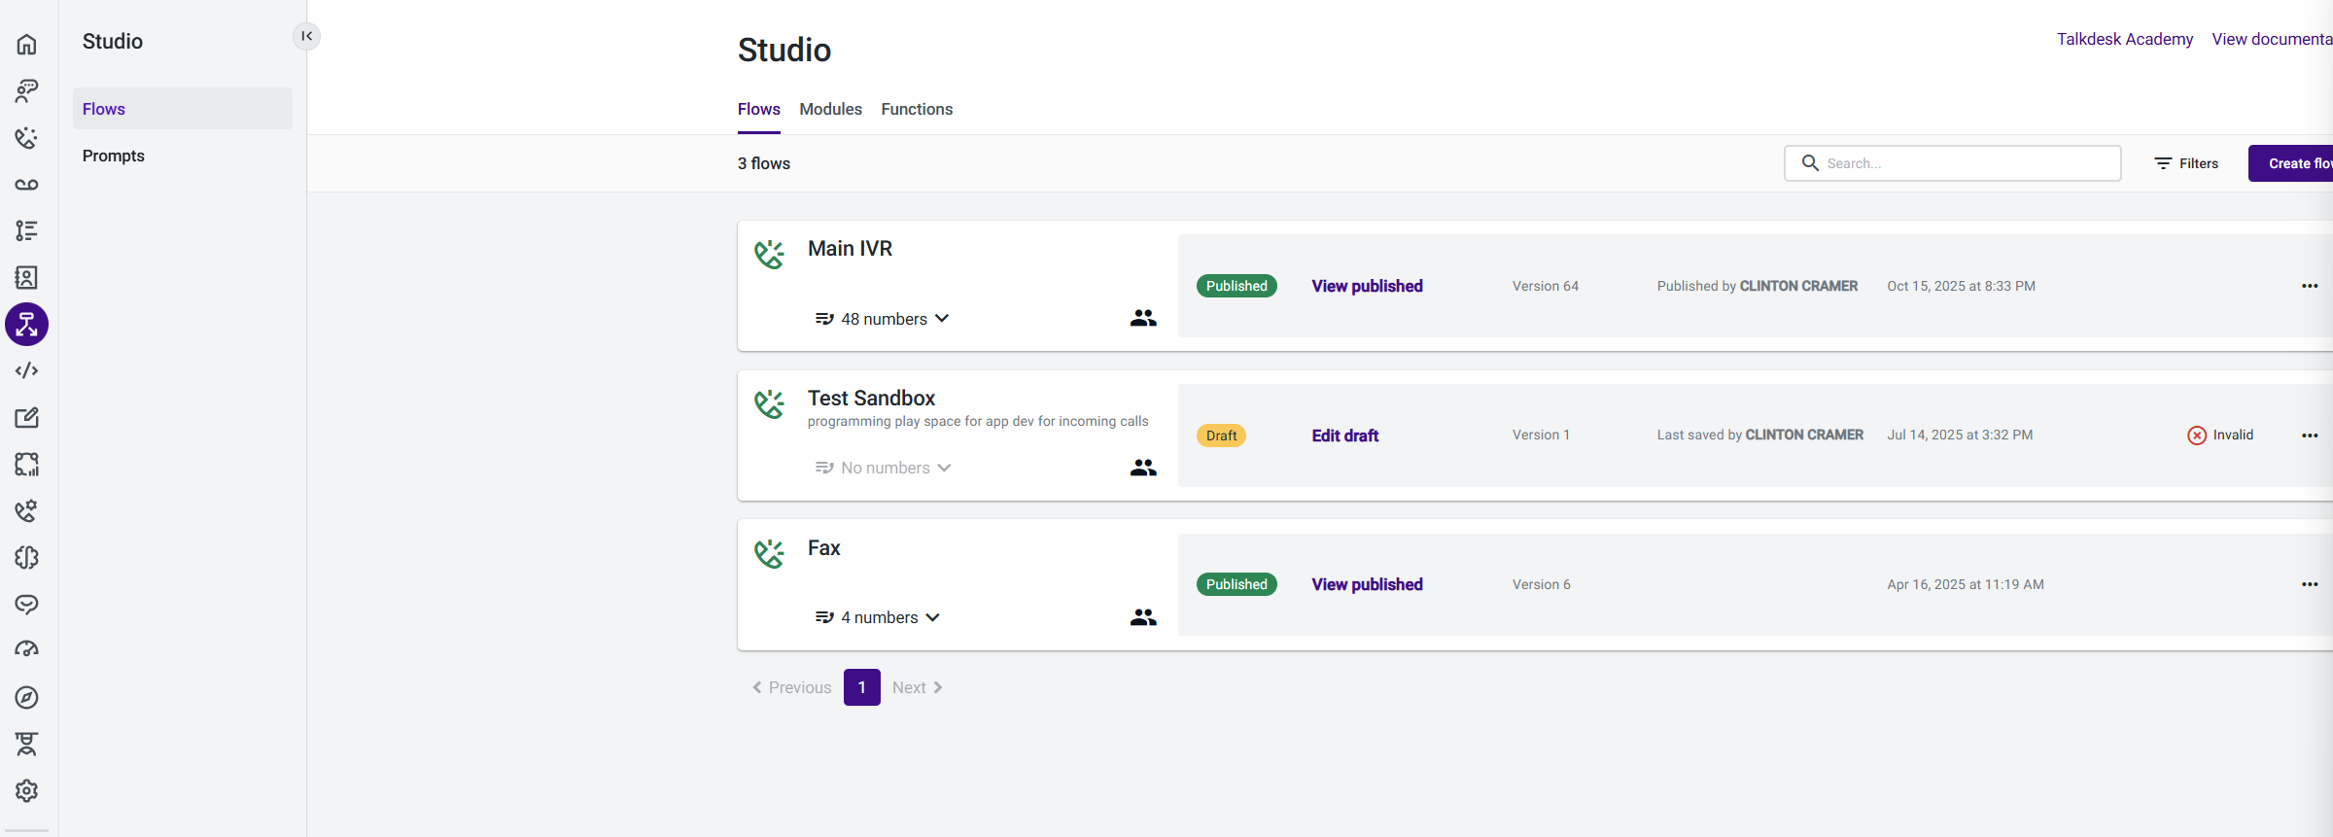
  - Click on the Functions tab
    - 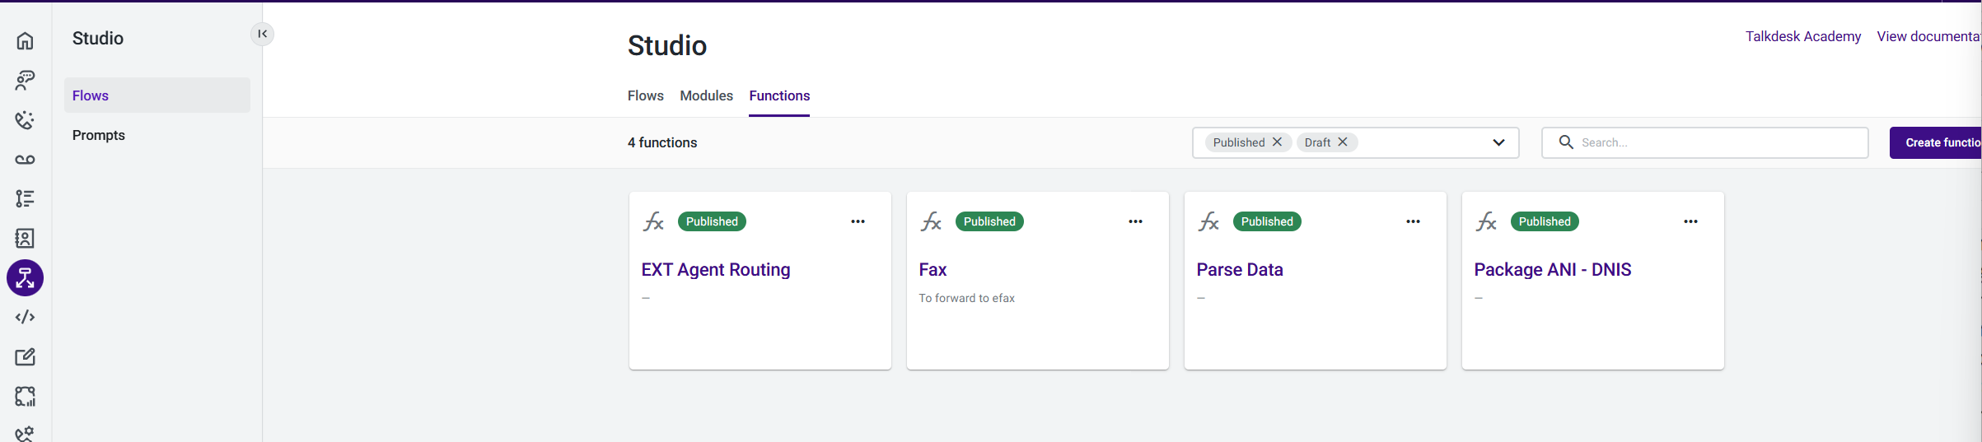
  - Choose the Ext Agent Routing function
    - 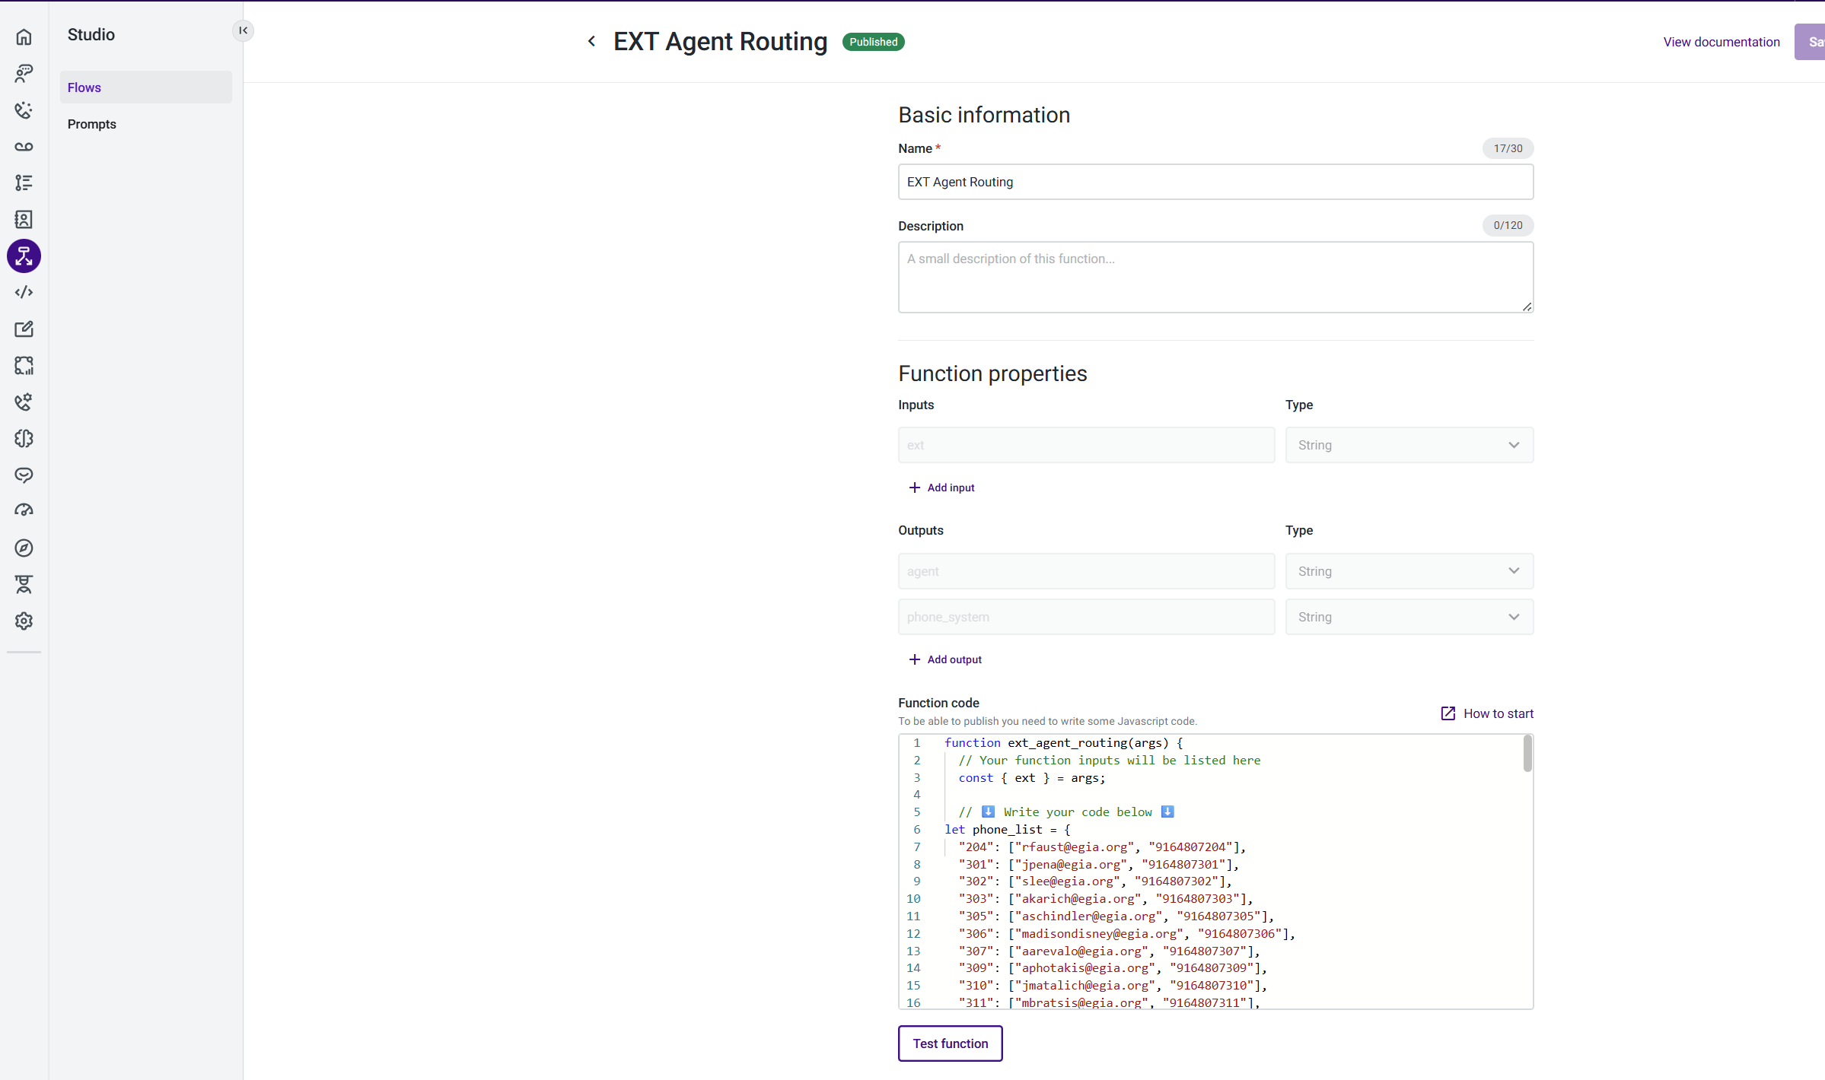
  - Choose an extension under the Function code area
    - If replacing an exiting or previous employee, you can use that number unless otherwise stated by manager to not give that number – or – choose a number that is labeled as “Open”.
      - Example: "327": ["Open", "9164807327"],
  - Replace the previous email address in the line of code of the chosen number or the word “Open” with the new employees email address
    - "327": ["aeskew@egia.org", "9164807327"],
  - Select the Test function button to ensure no errors
    - In the Test function window, choose the ext dropdown and select Add custom value
    - Enter the extension just replaced
        - Enter the extension chosen 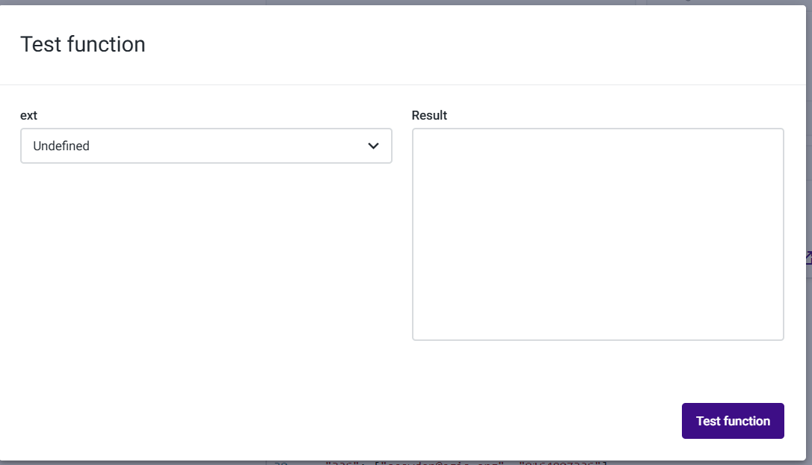
      - Select Add value
        - 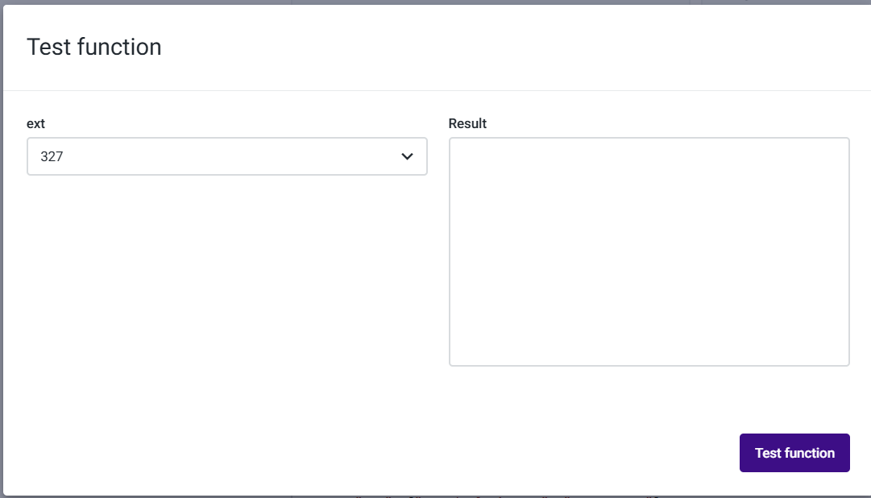
      - Click Test function for results of the test
        - 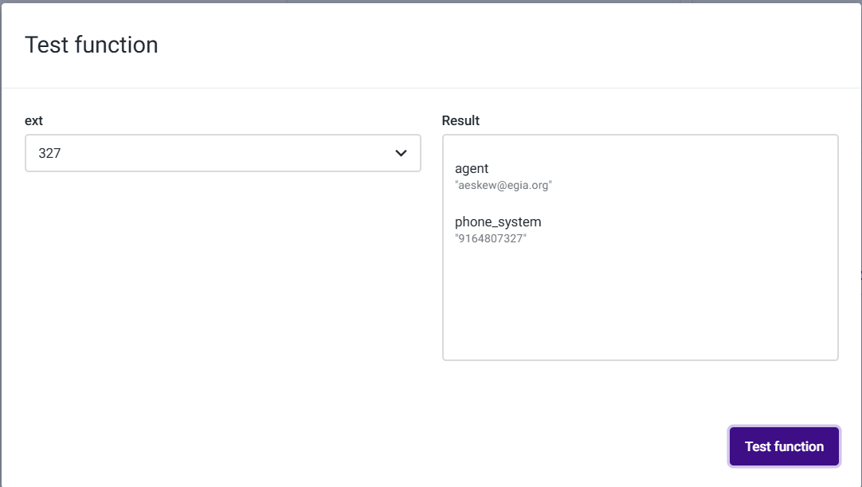
      - If the entry is displayed with the information entered, close the window and the click Save in the upper right-hand corner.
        - 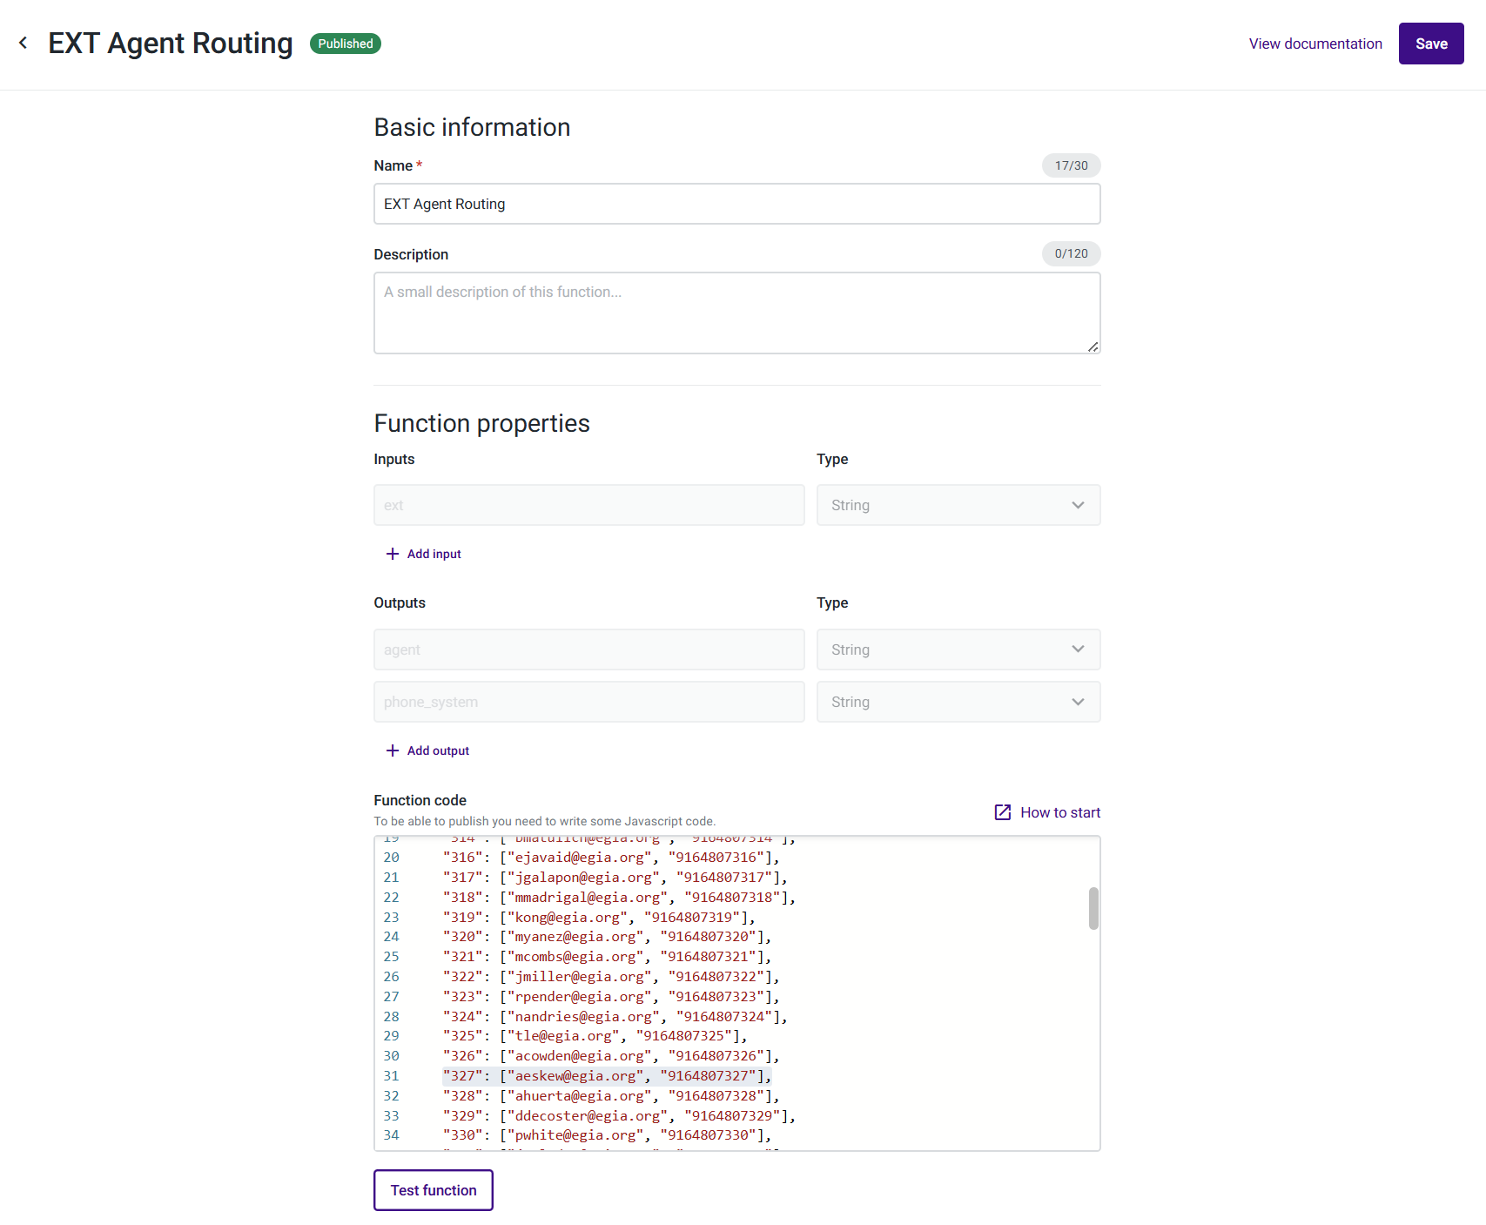
        - 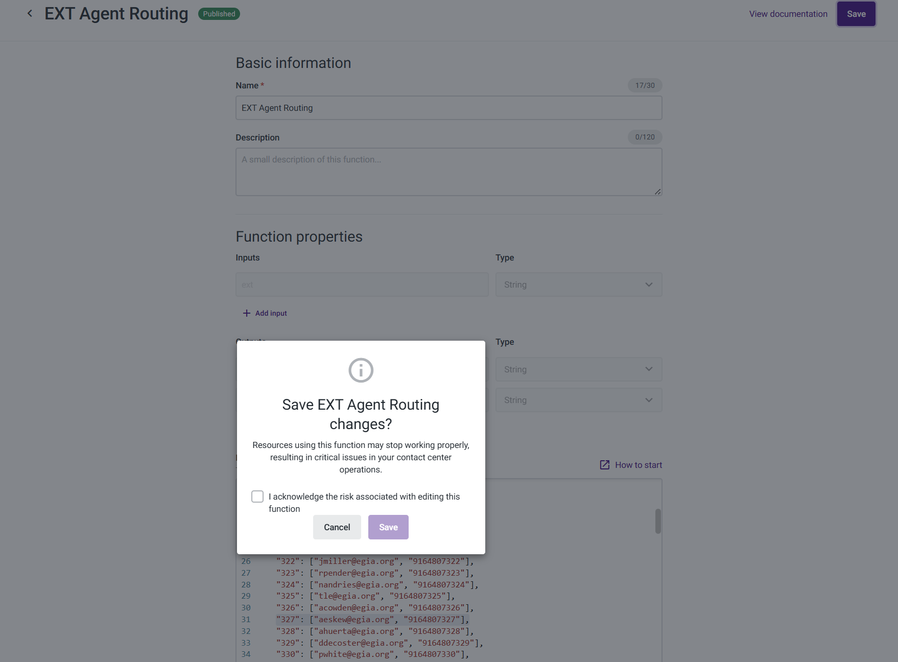
      - Click the Acknowledge check box and click save and the it will display the Functions tab once again.
        - 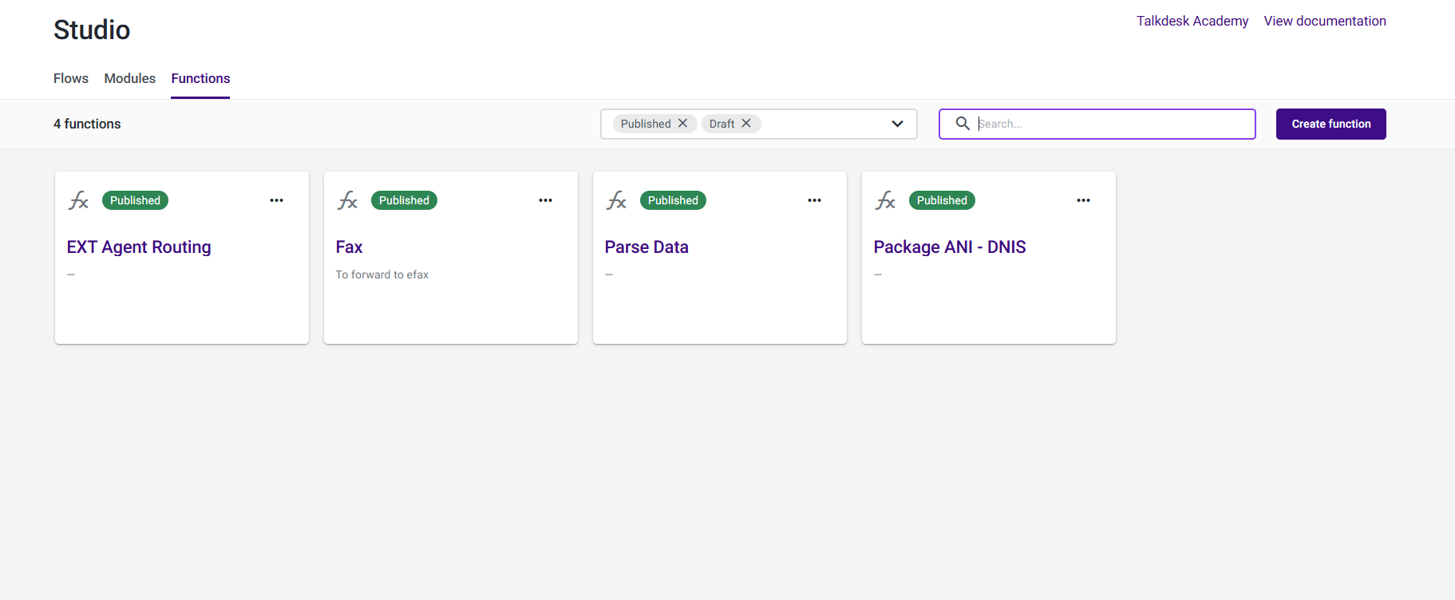
- Find the number and change the title to reflect the new employee information under Admin and Numbers.

