Meeting Notes
- Need to know which out dialer EGIA wants to move forward with.
  - Preview Dialer
    - Create a campaign
    - Upload phone number list in CSV format.
      - List – do not call
      - List – call
    - Select how you want the campaign to un
      - Priority level
      - Dailing model = Automatic/manual
      - Connection time
      - Skip a record
    - Strategy
      - Caller ID can be set up here
      - Set up calling hours
        - Hours when the campaign will be calling.
      - Dialing orders – how you want the list to read
      - Number of tries for the call to be retired
    - Dispositions – these are still set within talkdesk, you will create an outbound disposition & system disposition
      - if call is busy what should happen? Final try or should it try to call again, & how many times.
    - Agents – search for the agent to assign them the campaign
    - List – shows which list are going to get called on this campaign
      - Lists can always be updated.
    - Reporting
    - Conversation Settings -> create a VM here for the campaign, you can listin to the VM from here.
    - Once all is set up, you press play & it starts.
  - Agent list campaign, can handle both the SM & Voice
    - Templates need to be set up
    - Start & End time needs to be set
    - Enter IVR message to be seen
    - Enter voice message to be read
    - This is an out-dialer SMS, user is not able to reply that SM
      - Unless they start a new SMS Chain
    - The supervisors can have permission to crate their own campaigns by giving them permissions.
      - Outbound Dialer Permissions.
  - Next steps
    - JJ to send flow chart to Clinton to present to Eddie & see which is better for Rancho.
Clinton’s Screenshots:
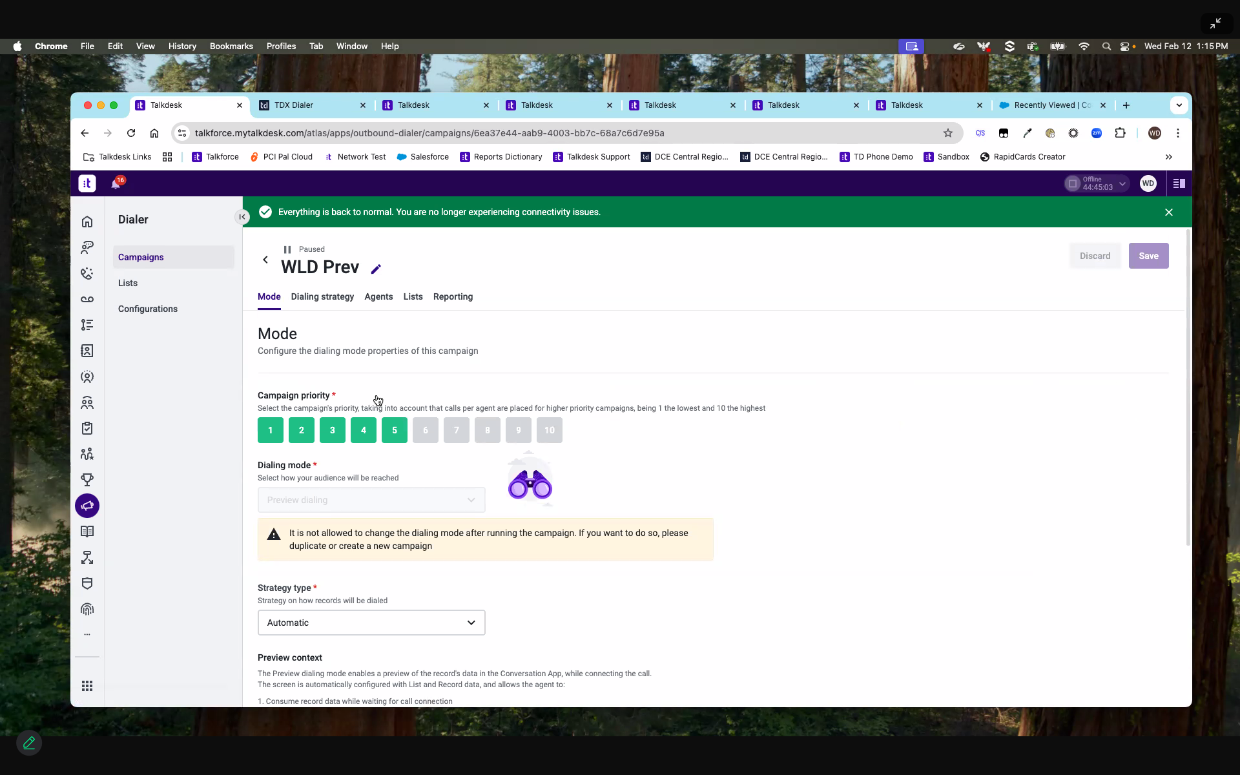
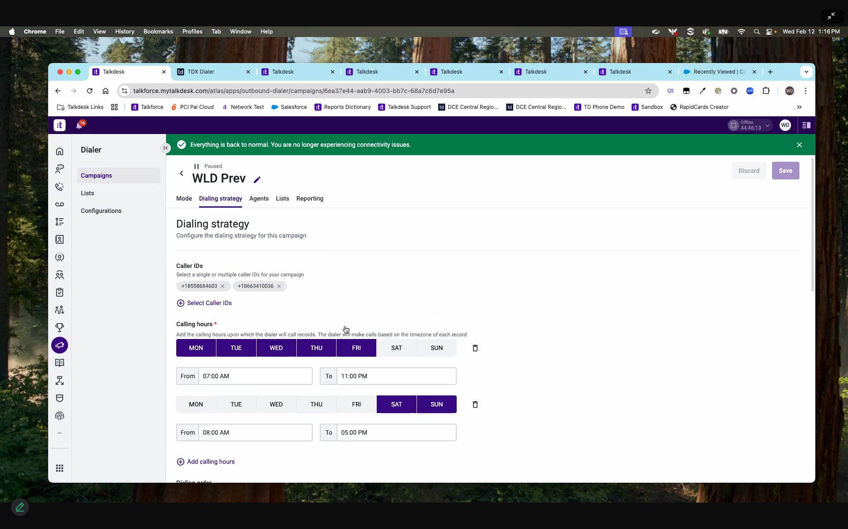
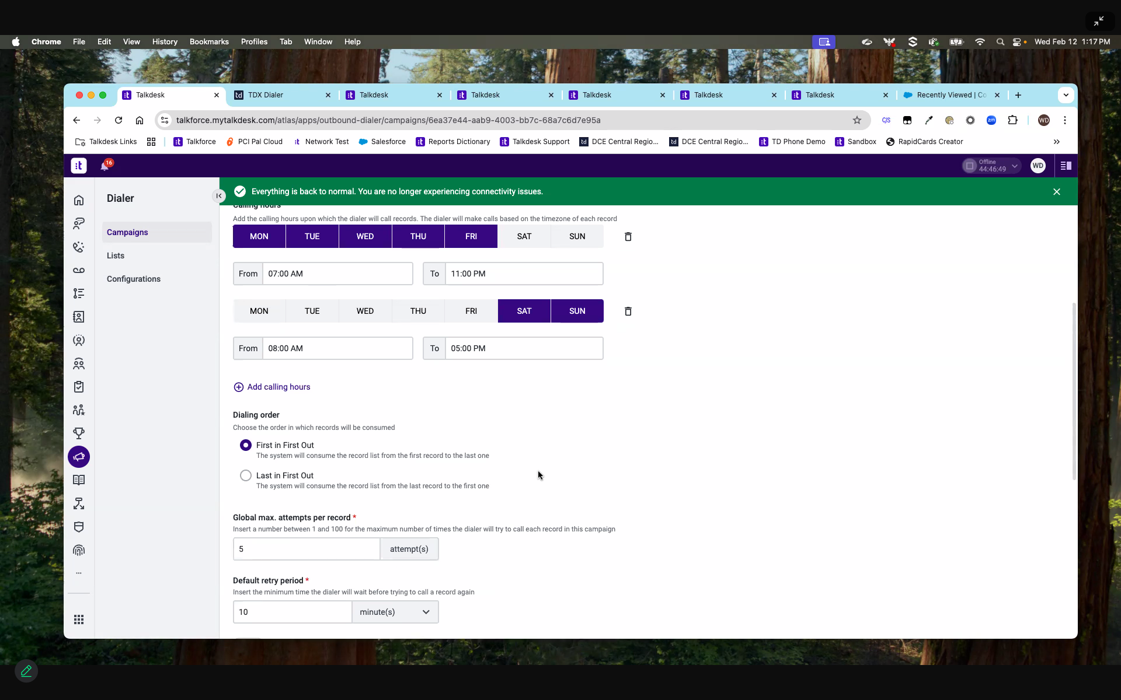
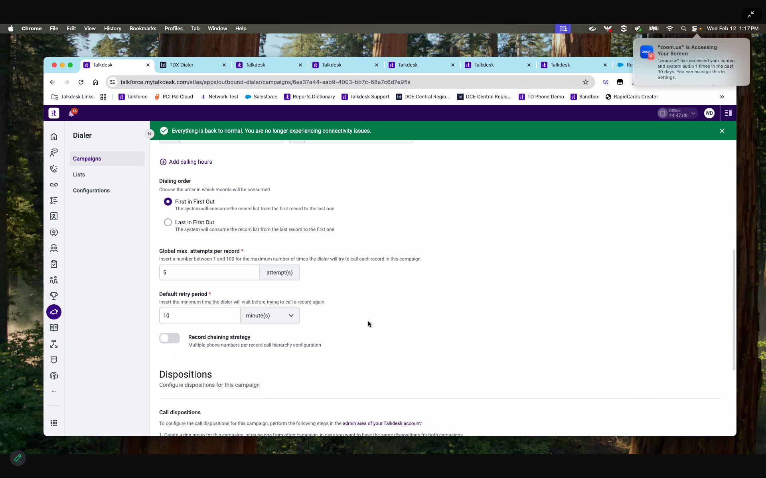
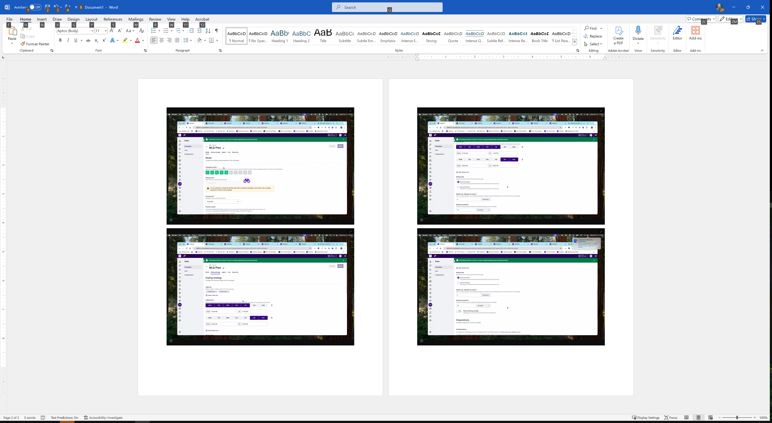
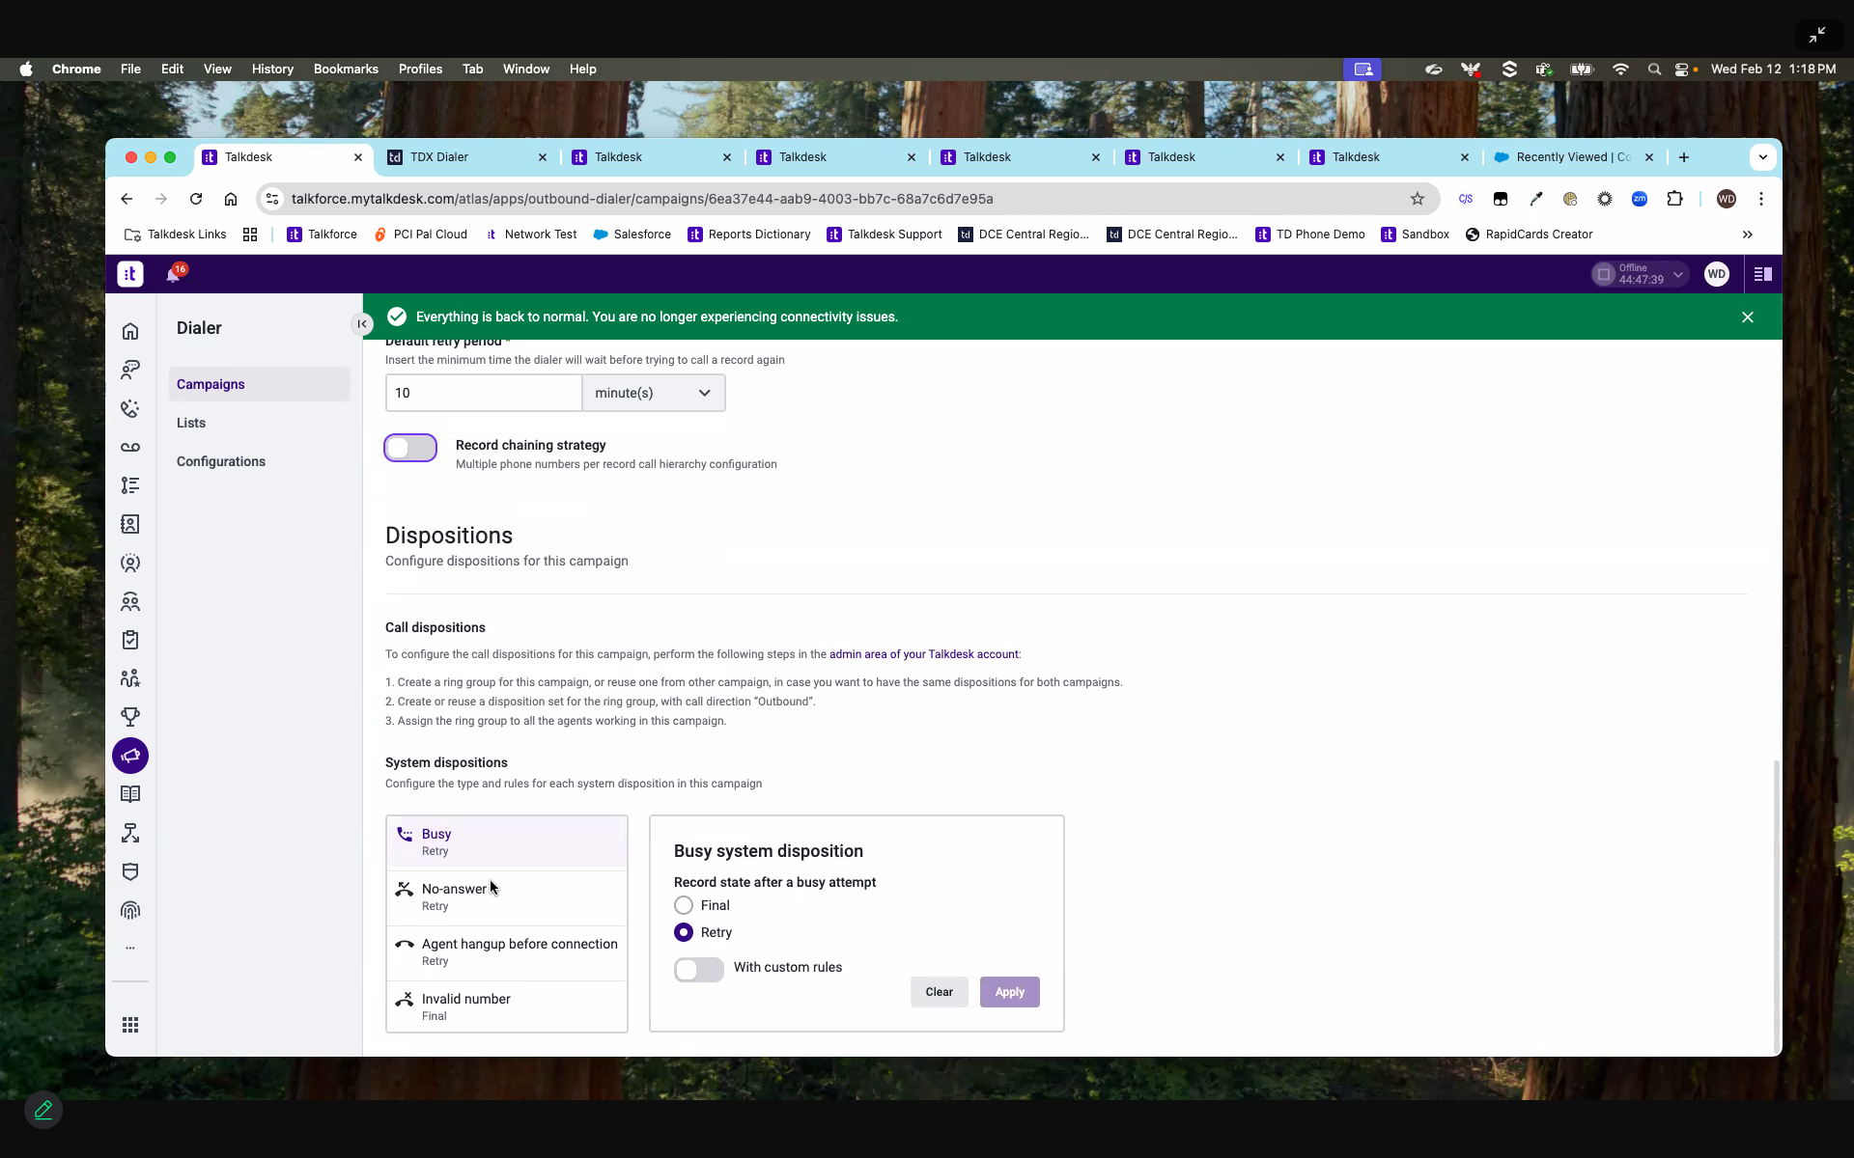
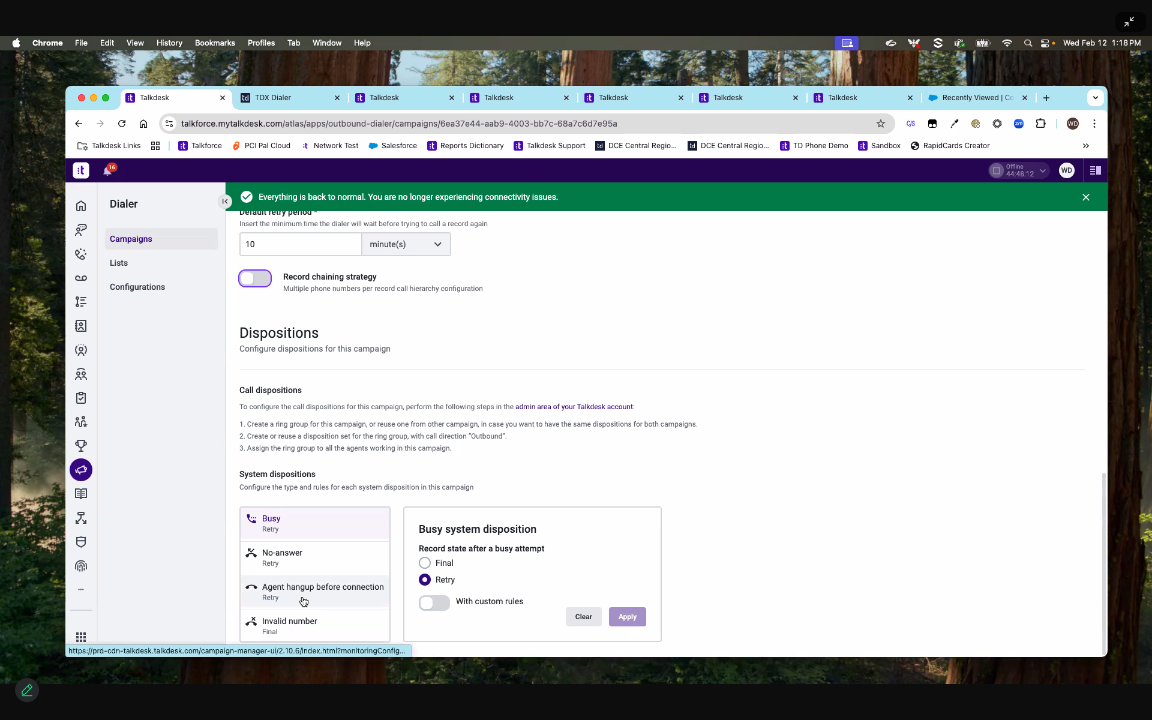
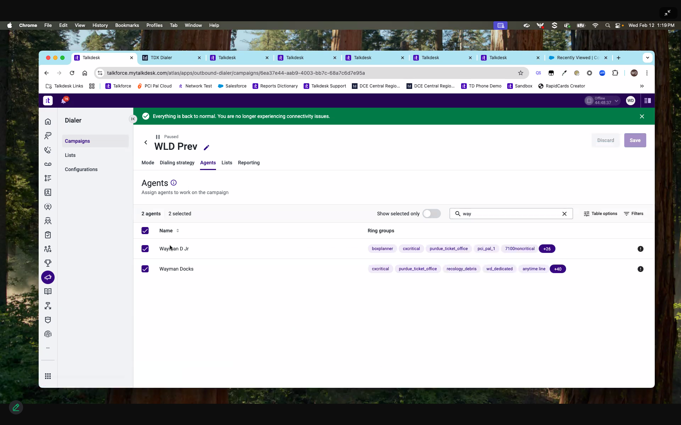
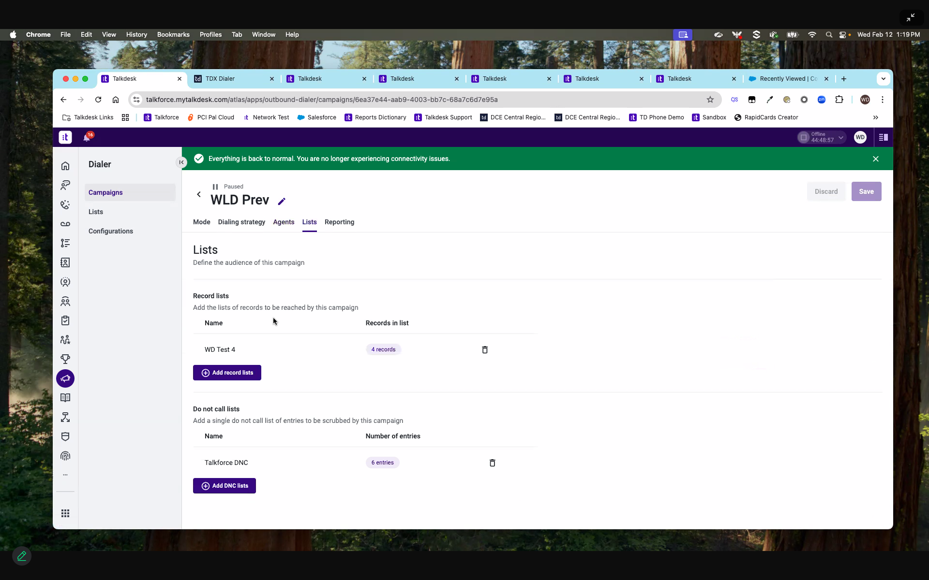

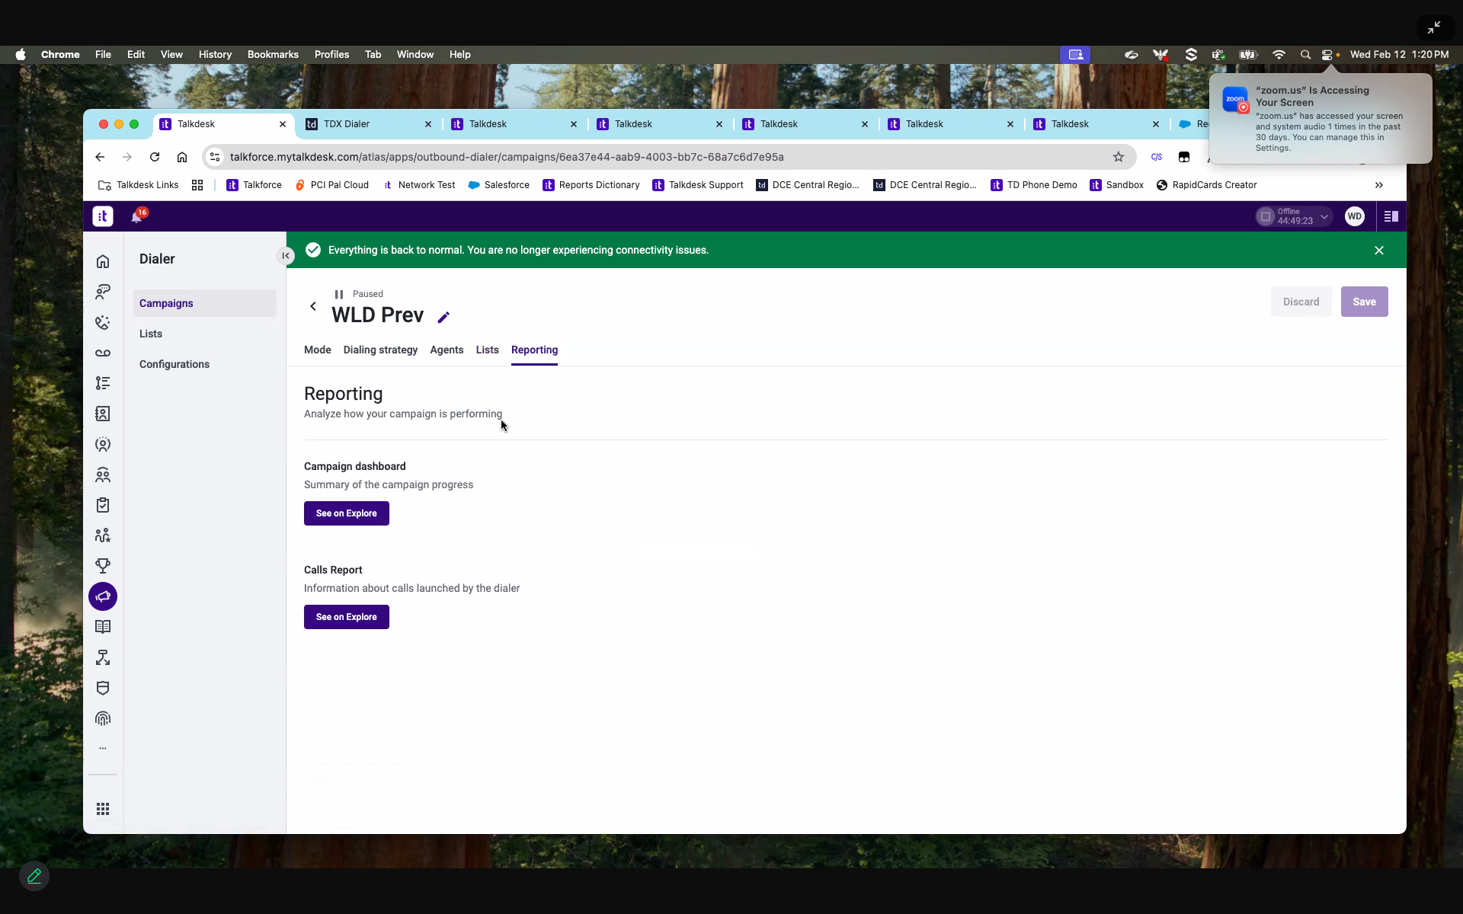
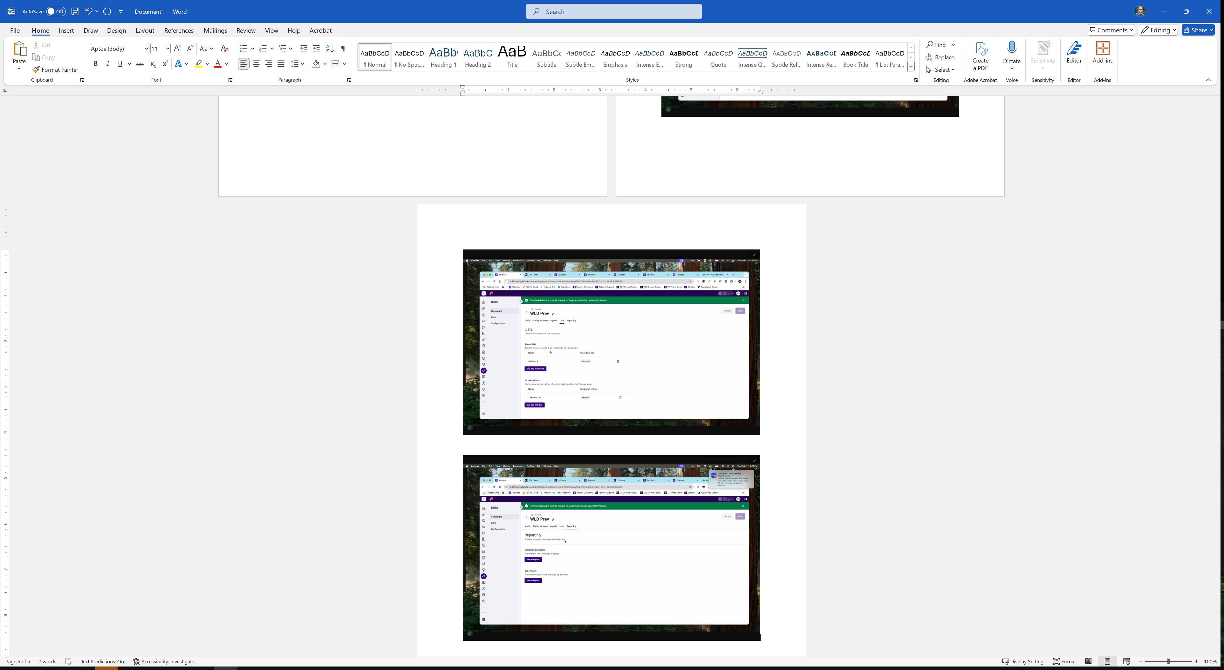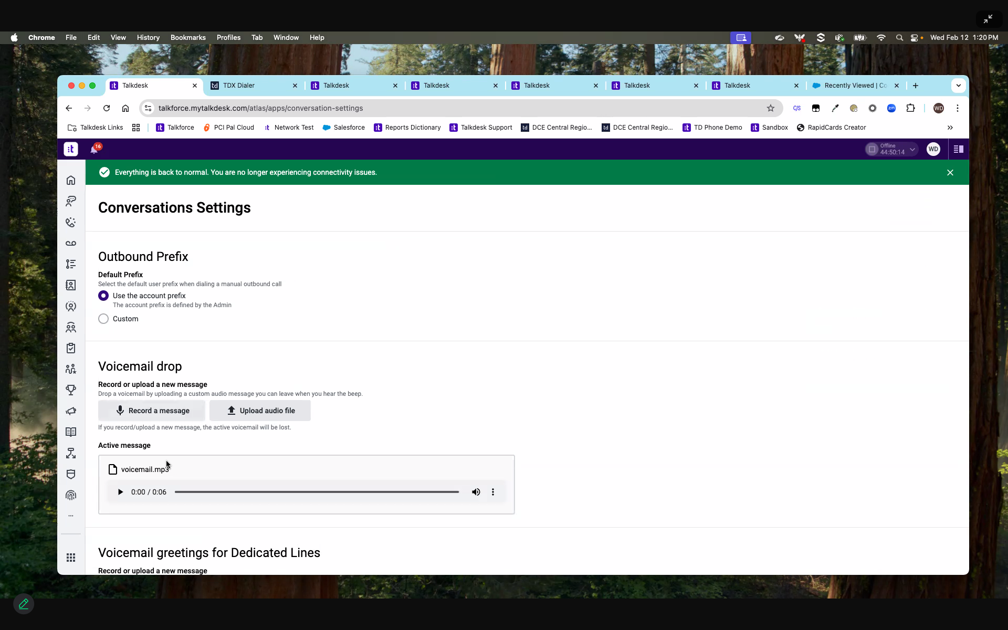
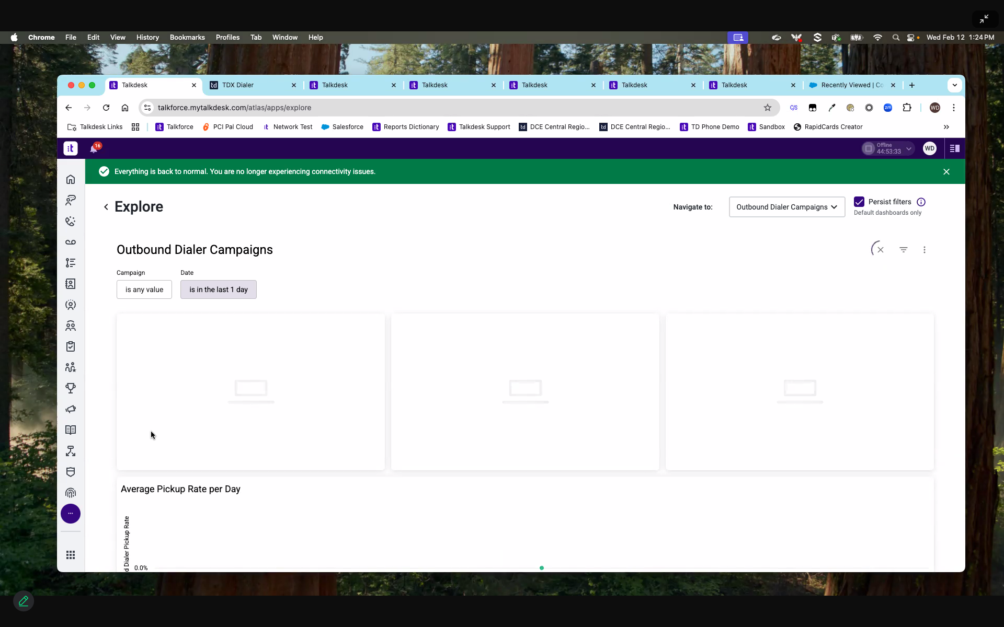

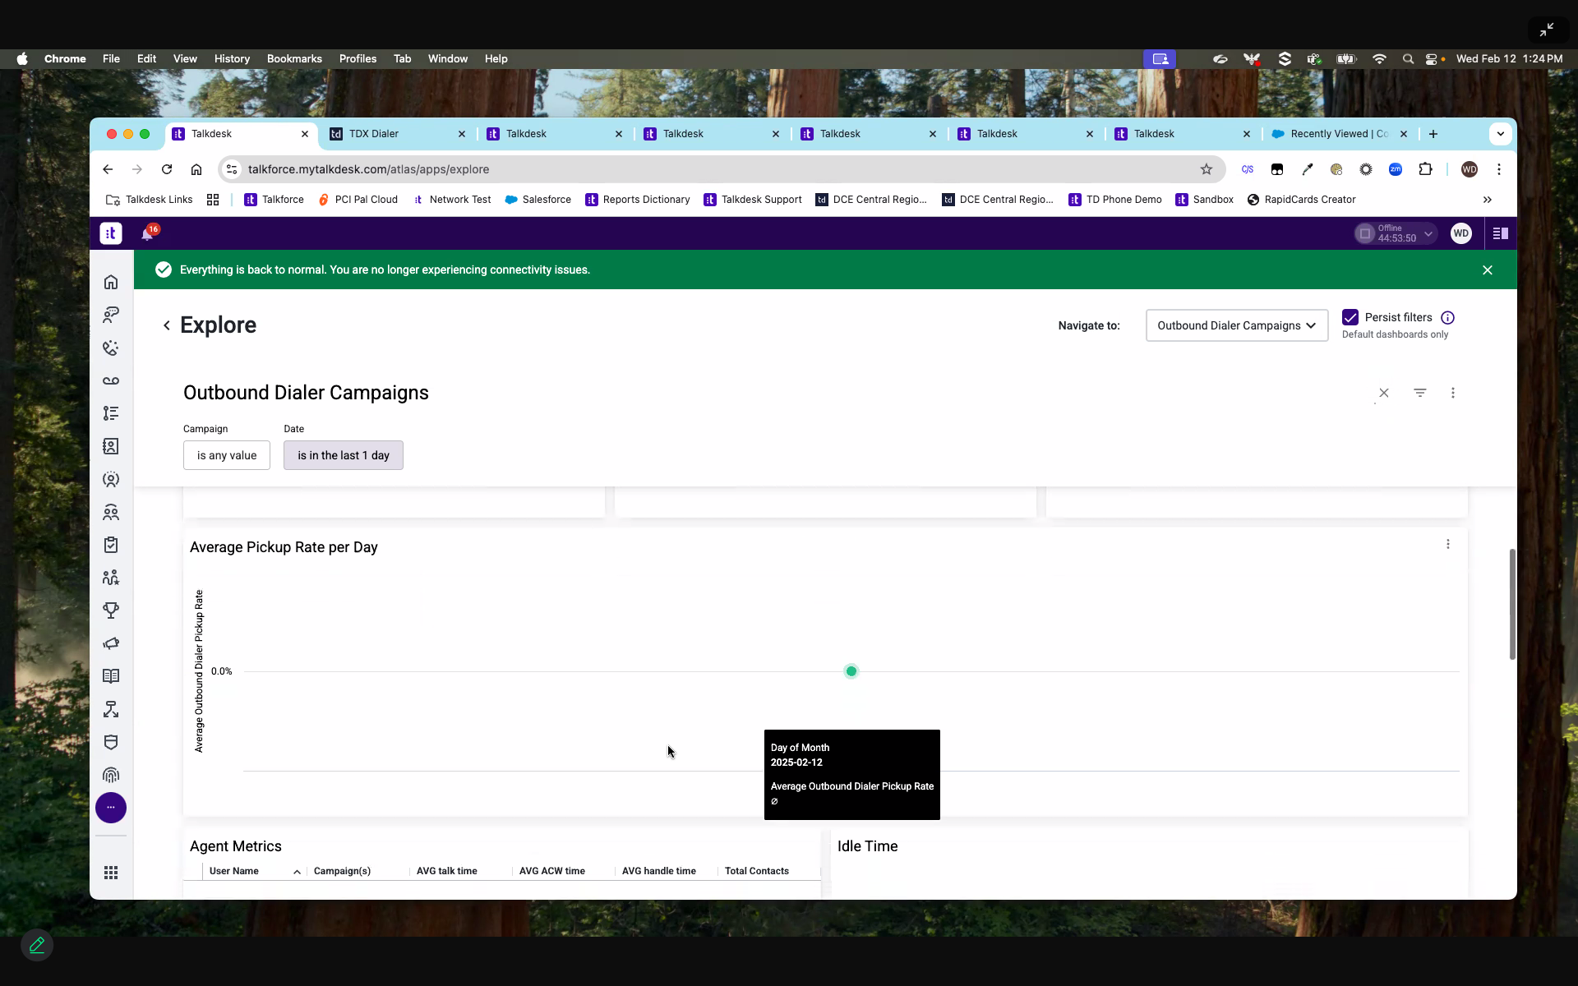
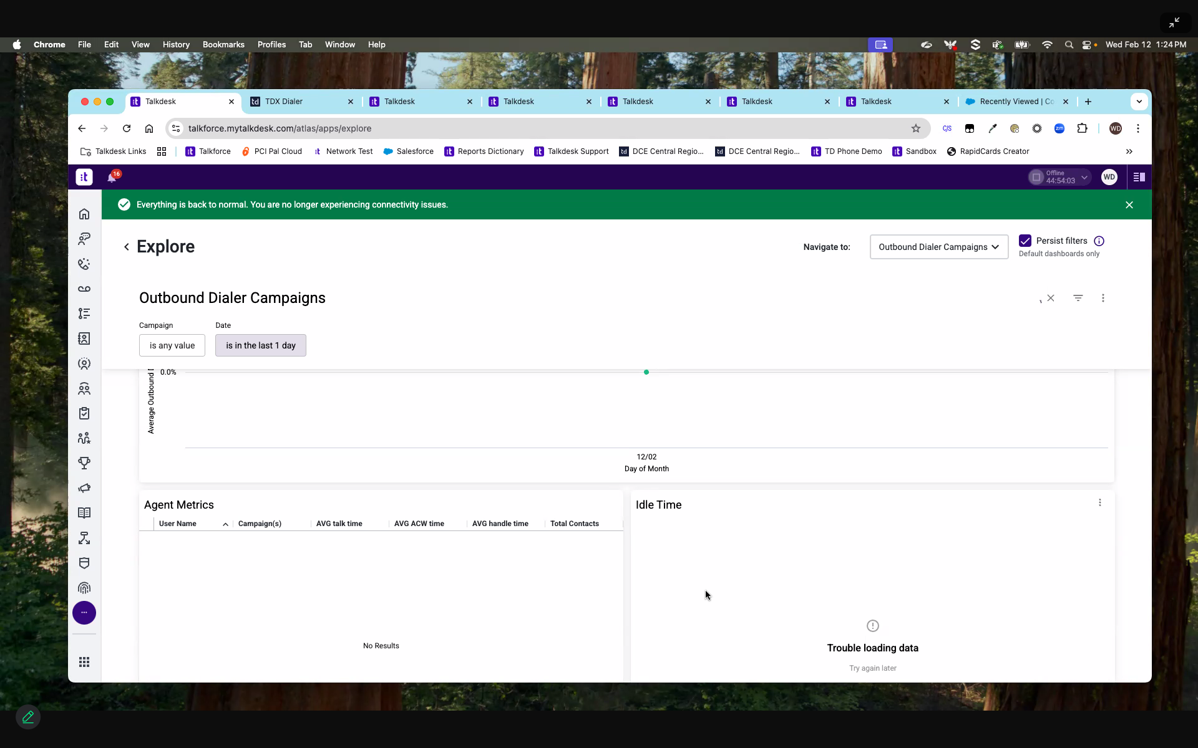

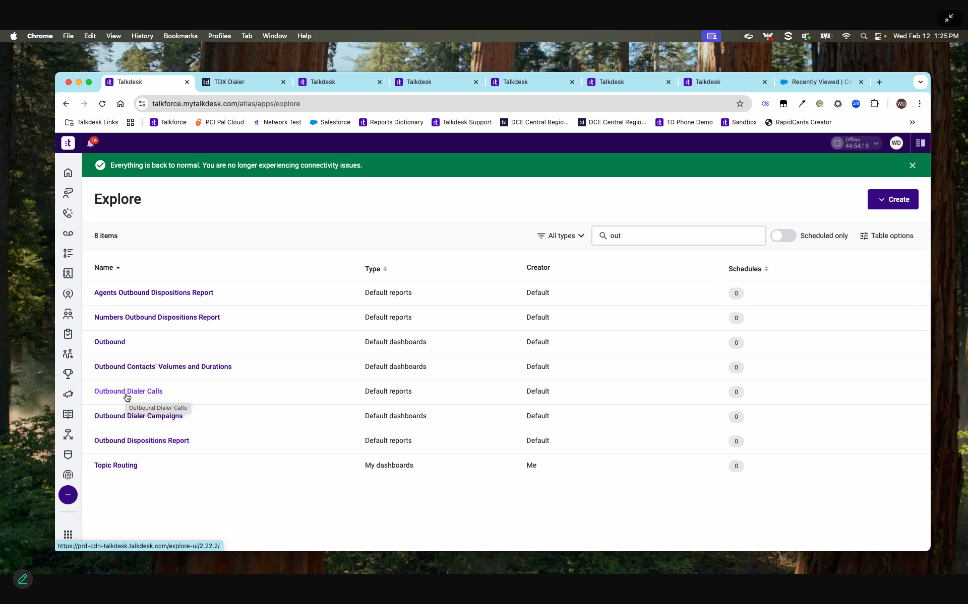
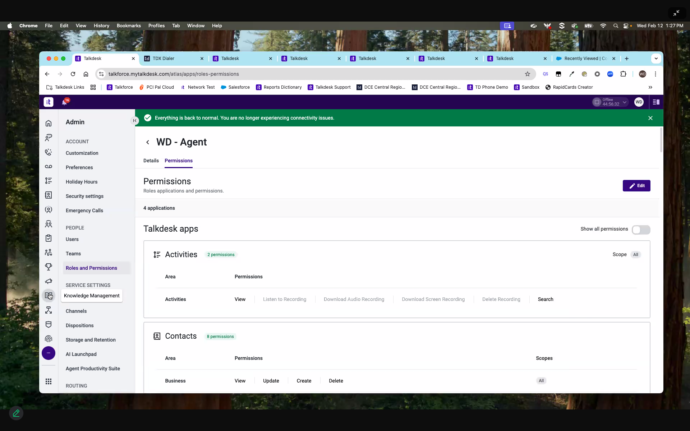

New dualer
