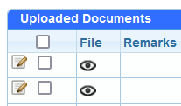
Turf Replacement Processing Steps
- Select Upload Documents and check your boxes
  - Checking the boxes verifies that the document has been viewed.
  - Unchecked boxes will skew the number of rebates in the new docs queue.
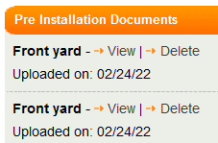
- Open uploaded documents
  - Make sure that you open all documents
  - Some documents may have more than one page.
  - Missed documentation could result in an upset customer.

- Review water bill

  - Name of water agency
  - Water usage
  - Account holder name
  - Account holder name
  - Service address
  - Bill Date

- Review photos

  - Must be in color
  - No close ups, must have a reference
  - No online images
  - Must represent the footage requested

- Review Footage
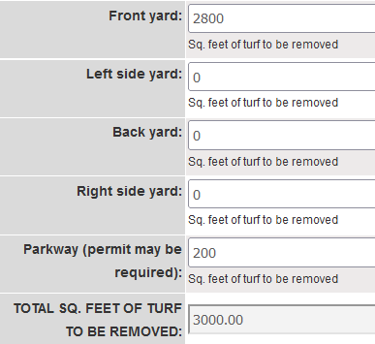
  - We should have one photo of each area the customer is applying for (front yard, back yard, parkway)
  - If the footage seems too low, the application should be flagged so that we can request the correct footage from the customer before pre-approval.
  - If the footage seems too high an aerial measurement should be performed. (See handout for aerial measurements). The customer should be notified if the footage is not reasonable (within 10% accuracy).

- Aerial Measurements (Part 1)
  - 10% of all applications will need to be verified with Nearmap. https://www.nearmap.com/us/en
  - Check footage and if the area currently has grass.
  - Upload your results and document your findings on the inspection spreadsheet.
    - Folders>MWD Turf Replacement Program>TRP Inspections 2019

- Physical Inspections (Part 2)
  - 20% of all complete (ok to approve) applications will be selected for a random physical inspection.
  - We can also send an application for a forced inspection if needed. This may occur if the customer does not agree with our review of the application, i.e. footage too low or not enough plants.

- Review Landscape Plan

  - Ground cover
  - Plants
  - Storm water retention feature
  - Look for non-qualifying items (concrete or synthetic turf)
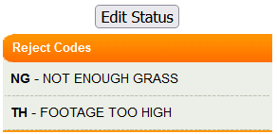
- Review property owner name and mailing address for errors

- Add codes under Edit Status (if applicable)
  - If any information in the application is missing
  - Or if information does not seem correct

- Add Received Date
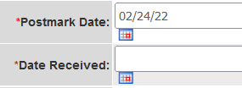
  - For online applications, this is the date the application was submitted (postmark date)
  - For paper applications, this is the received date indicated on the envelope.

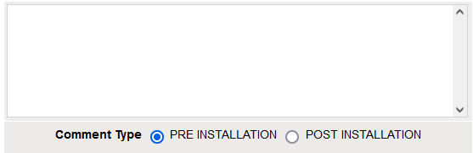
- Add Processing Comment
  - You must add a comment in order to submit the application
  - Make sure your comments make sense and are easy for anyone to understand
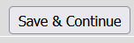
- Submit application by selecting “Save & Continue”

- Visually Review Reservation amount for accuracy
  - Check MET funding (if applicable)
  - Check Member Agency funding (if applicable)
  - Check Retail Agency funding (if applicable)

- Visually Review Status for accuracy
  - If review status is incorrect you may need to notify a lead
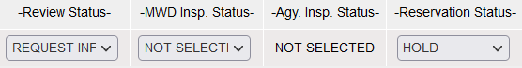

  - If review status is correct send the pre-approval email (if approved). Request information notifications will automatically be emailed the following morning.
