Create Configuration File
Open Talkdesk and select Phone Admin, Devices and Add device.
Open the configuration file that has the same mac address in the file title as the phone you are adding.
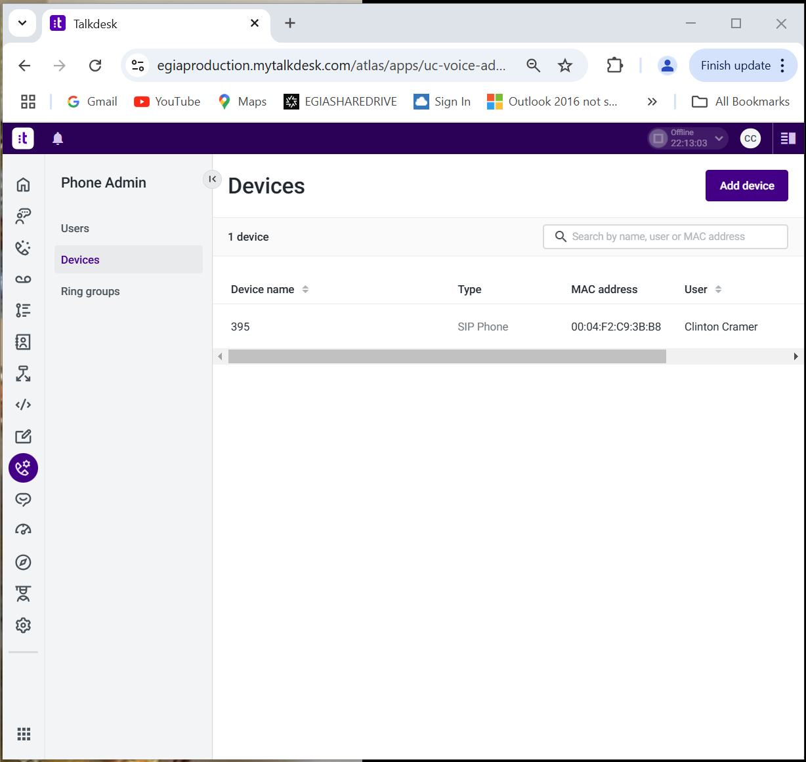
Enter the extension number for Device name. Enter the MAC address of the phone. Assign a user and then leave the window open…
Copy the listed SIP user Replace the user info in 2 places on the config file with the information just copied. Do the same for SIP Password and extension (See highlights to match below):
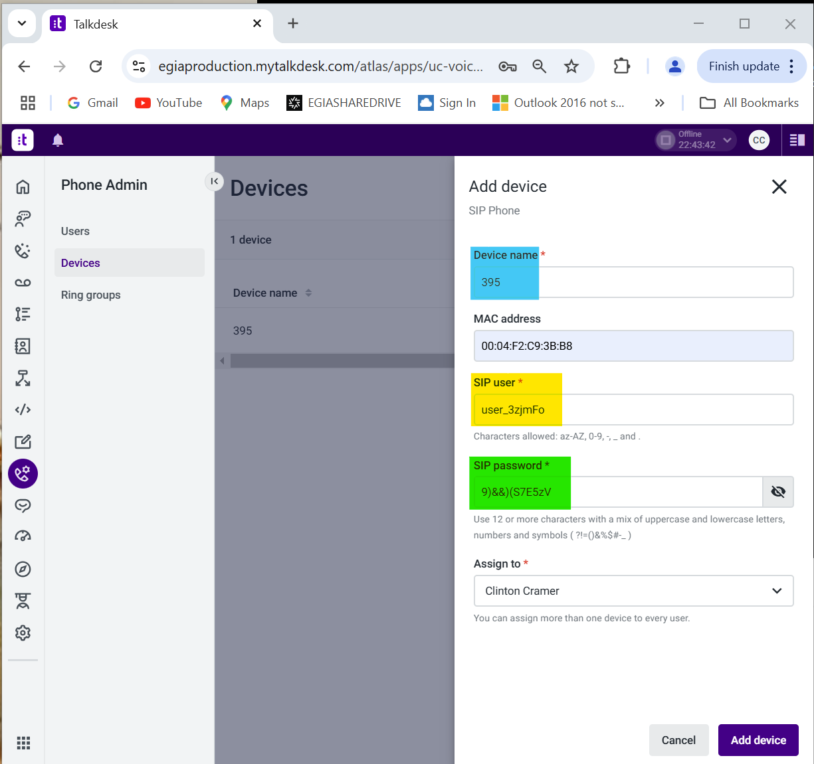

<?xml version="1.0" encoding="UTF-8" standalone="yes"?>
<PHONE_CONFIG>
<ALL
device.set="1"
dialplan.digitmap=""
dialplan.digitmap.timeOut=""
qos.ip.callControl.dscp="EF"
qos.ip.rtp.dscp="EF"
reg.1.address="user_3zjmFo@egiaproduction.uc.talkdesk.com"
reg.1.auth.userId="user_3zjmFo"
reg.1.auth.loginCredentialType="usernameAndPassword"
reg.1.auth.password=" 9)&&)(S7E5zV"
reg.1.displayName="395"
reg.1.label="395"
reg.1.srtp.offer="1"
reg.1.srtp.require="1"
reg.1.outboundProxy.address=""
reg.1.outboundProxy.port="0"
reg.1.outboundProxy.transport="DNSnaptr"
reg.1.server.1.address="us1.sip.a.cpaas.talkdeskapp.com"
reg.1.server.1.port="0"
reg.1.server.1.expires="1800"
reg.1.server.1.subscribe.expires="1800"
reg.1.server.1.expires.lineSeize="30"
reg.1.server.1.transport="TLS"
reg.1.server.1.retryTimeOut="500"
reg.1.server.1.retryMaxCount="2"
reg.1.tcpFastFailover="1"
sec.TLS.SIP.strictCertCommonNameValidation="0"
tcpIpApp.keepalive.tcp.sip.tls.enable="1"
tcpIpApp.keepalive.tcp.noResponseTransmitInterval="30"
msg.mwi.1.callBack="*97"
msg.mwi.1.callBackMode="contact"
/>
</PHONE_CONFIG>
Save the Config file, (ensure the mac address is in the title).
Click Add Device in Talkdesk

Configure phone for Web Configuration & obtain the IP address
Home button/screen>Settings>Advanced>PW = 3724>Administrative Settings>Web Server Configuration>Web Server: Change to Enabled, Web Config Mode: Change to HTTPS Only
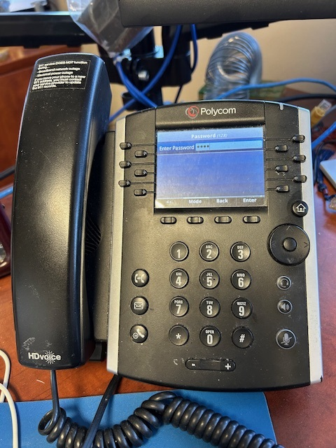
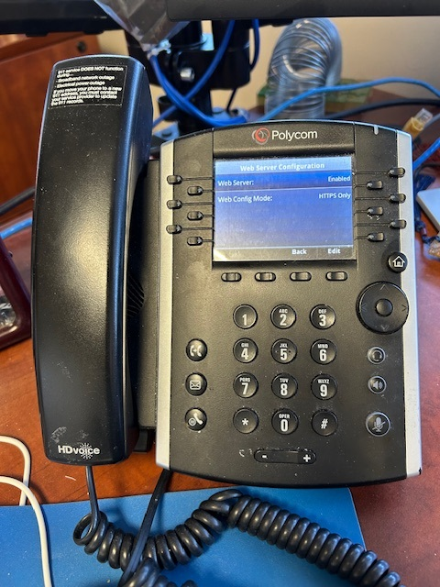
Home button/screen>Settings>Advanced>PW = 3724>Enter>Administrative Settings>Network Configuration>Ethernet>IPv4 Configuration>IP Address
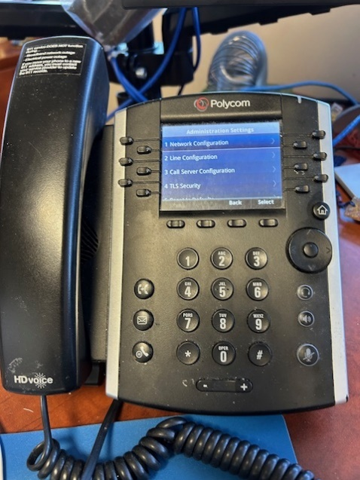
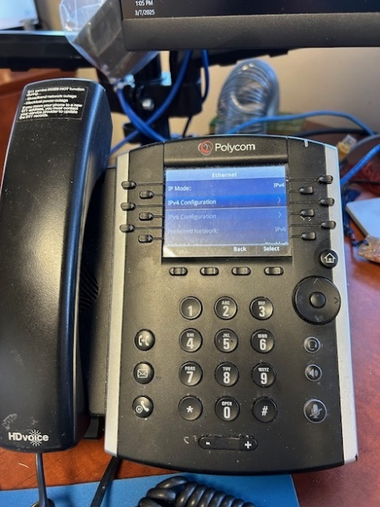
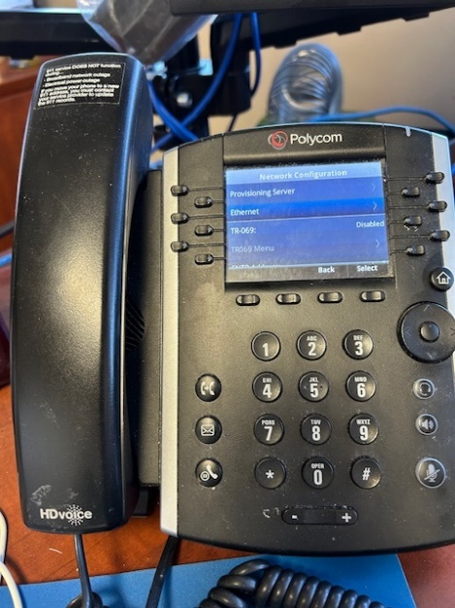
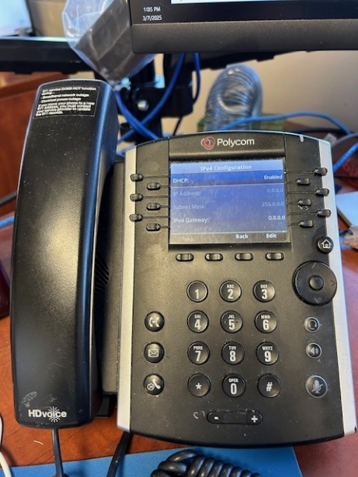

Reset phone to factory default and upgrade software to latest version from within the Poly Web Configuration Utility

Open a browser and type in https:// (IP address of the phone)
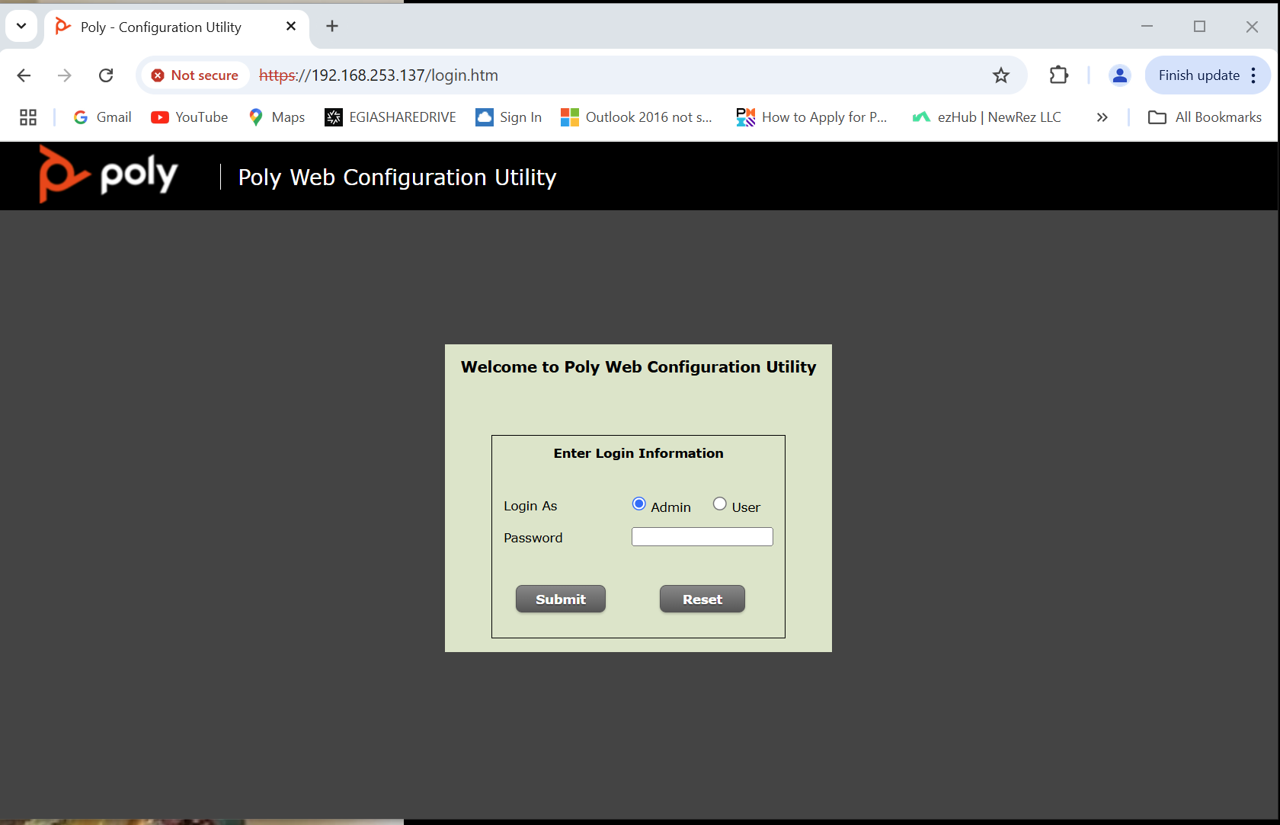
Password: 3724
Under Utilities, select Phone Backup & Restore.
Expand Global Settings and select Restore for Restore phone to factory settings.
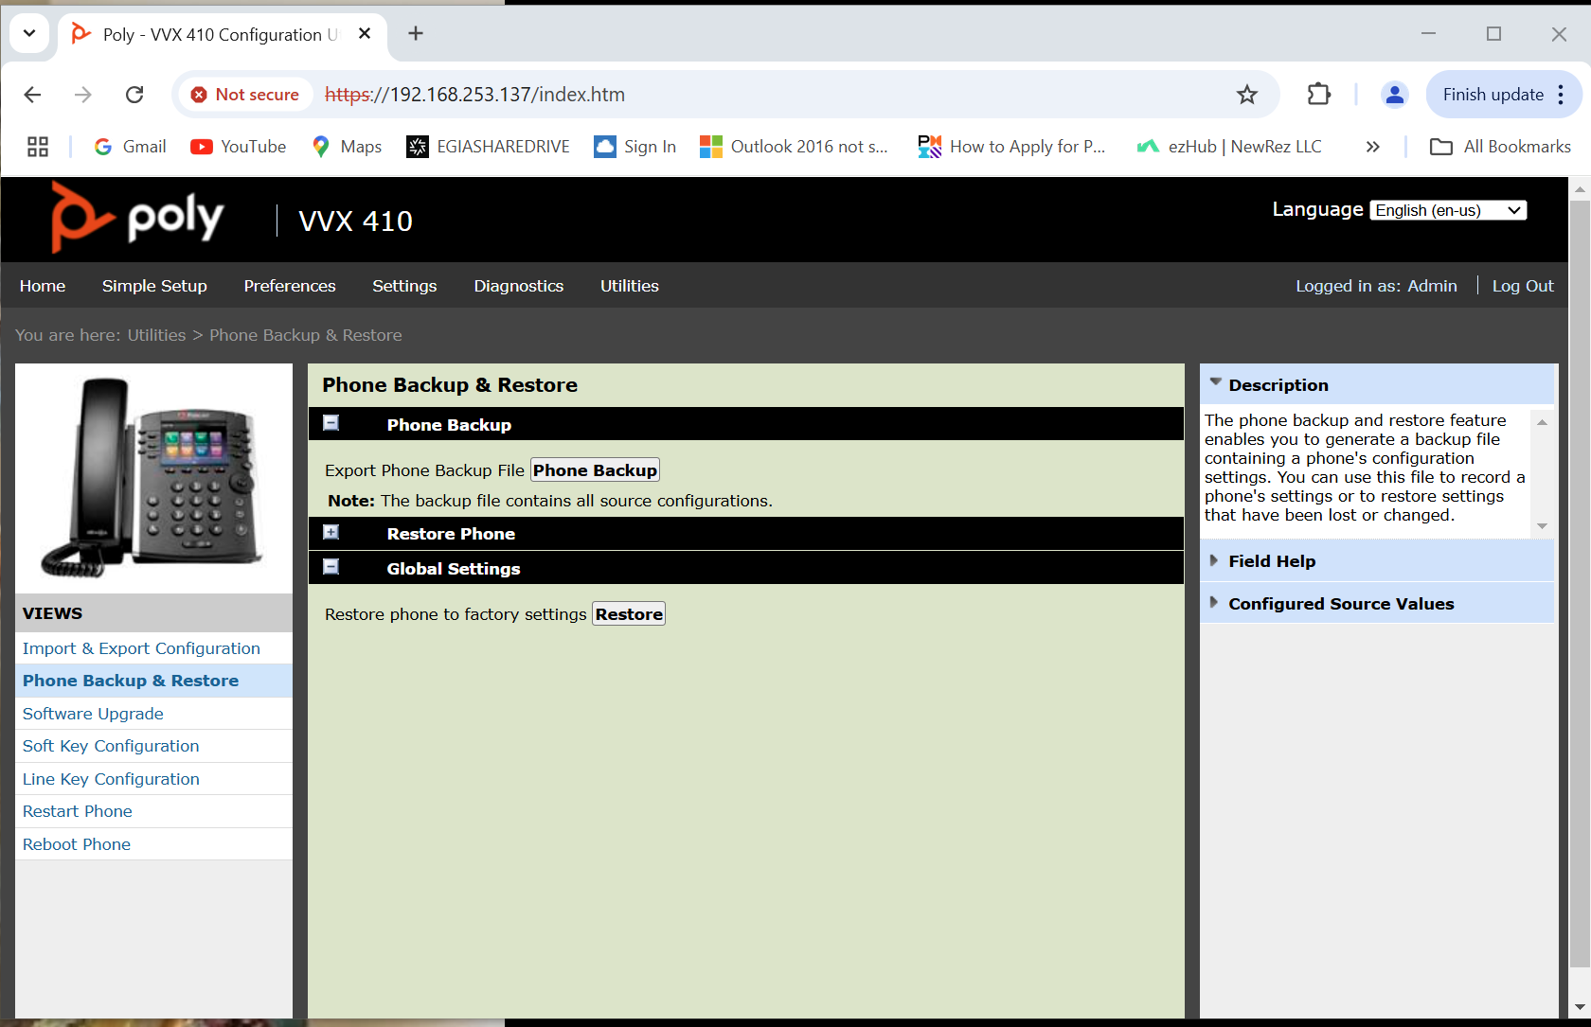
The phone will reboot and ask that you change the password. The default password is now 456. Change the password to 3724. You will enter it and enter again to verify.
Refresh the browser. You may have to click a displayed link to get the login page again.
Enter the 3724 password.
Under Utilities, select Software Upgrade and choose Check for Updates.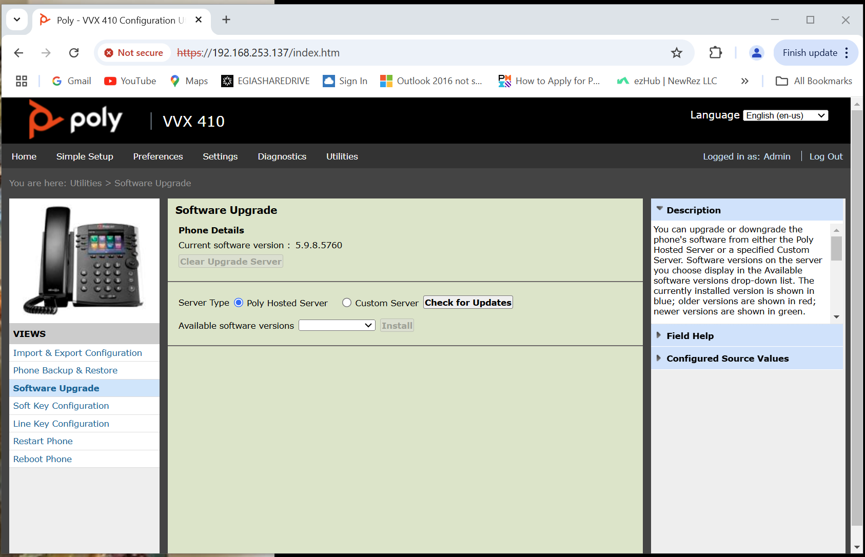
Select Close
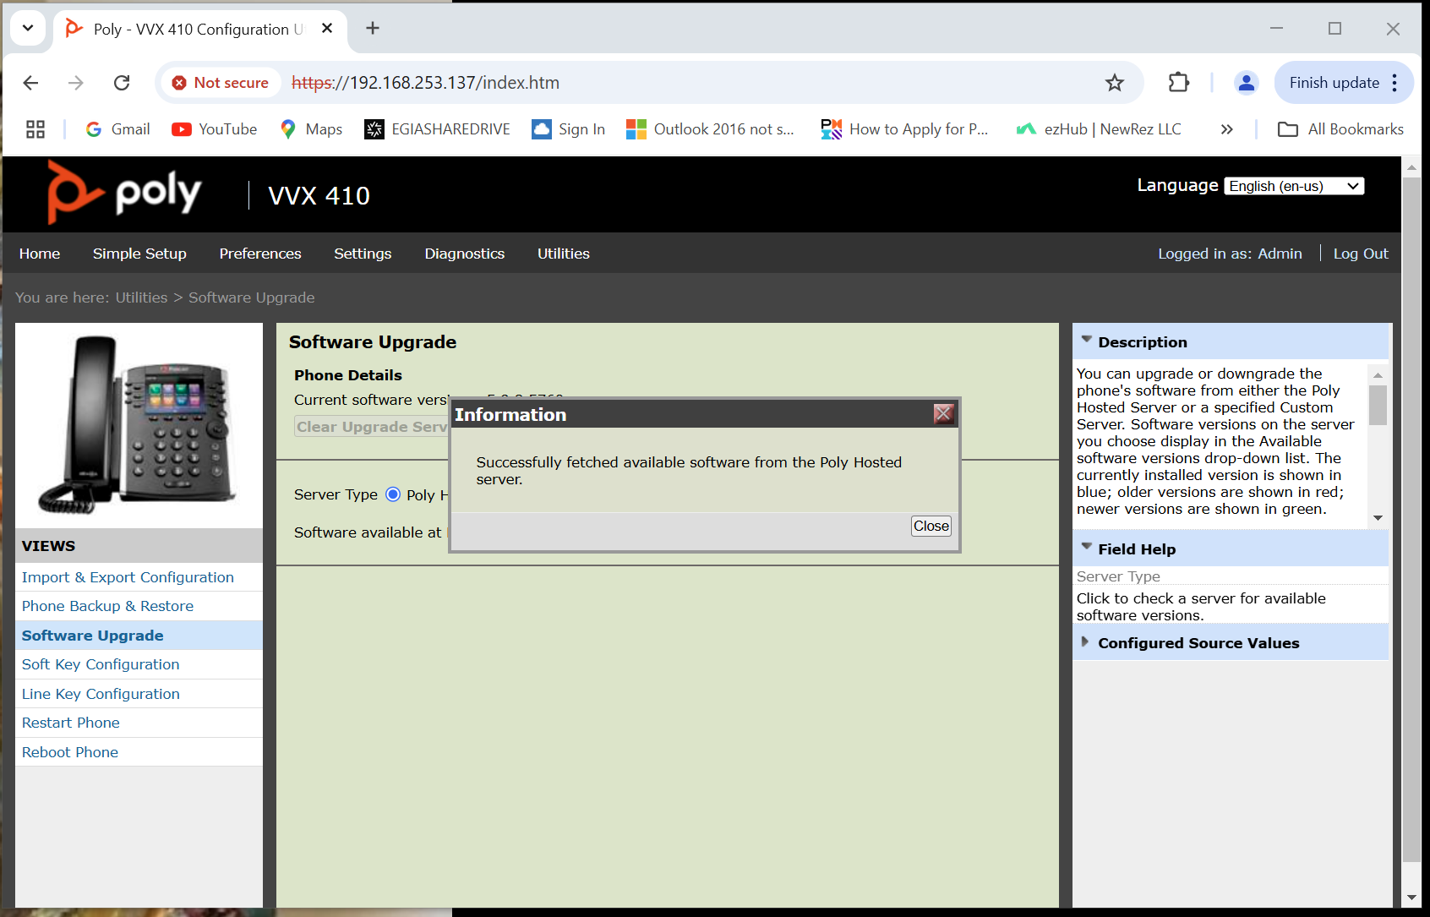
If the version available is not the same as what shows above next to Current software version, select Install.
The phone will reboot and you will need to refresh you browser once again.
Navigate to Import & Export Configuration. Select Choose File. Navigate to the configuration file that matches the MAC address on the phone. Select Open. Select Import.
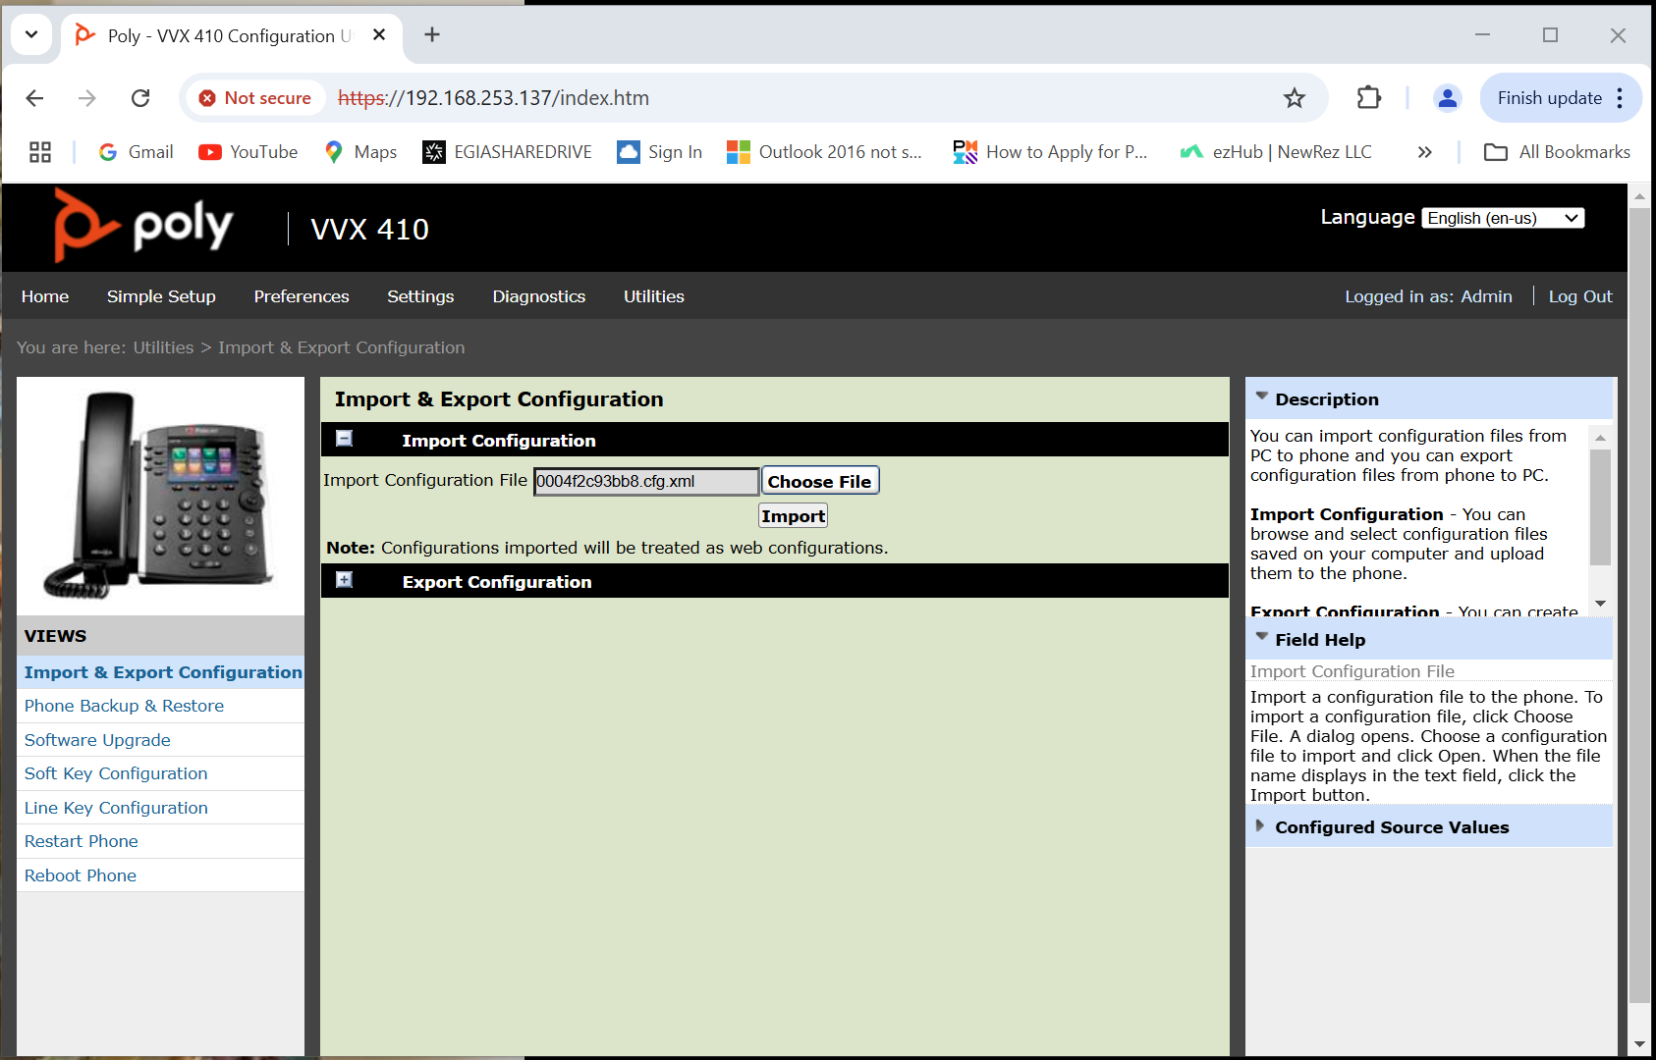
The phone will reboot and then show the new extension and become green.

