Nimble Interplay Process

- Find the Primary Contact, or the person paying for Interplay access, in Nimble. If needed, add their credit card to the account prior to creating the order.
- Create a new order. Choose “Subscription” as the type of order you’d like to start.
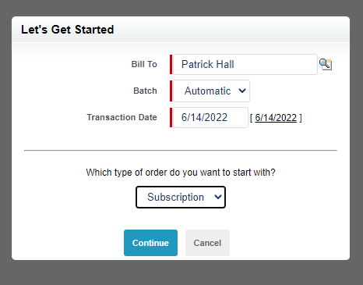
- On the order screen, change the “Customer” to the company name.
- Change the quantity to the amount of users they are purchasing.
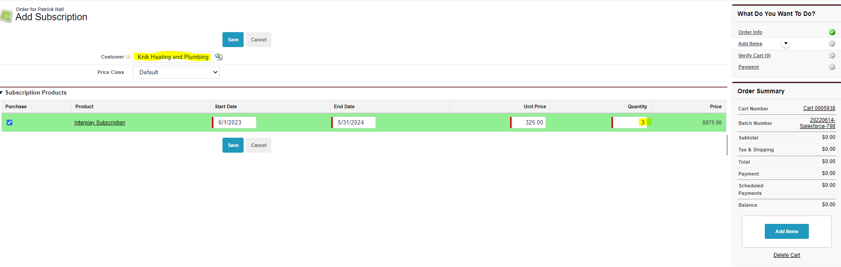
- Click save then Go to Payment. Pay for the order with a credit card. Submit the order. Email the invoice to the member.
- Return to the Company account and select the users that will be given the access. Add the Internal Interplay role and check the box that says Interplay User, click save. Do this for each user.
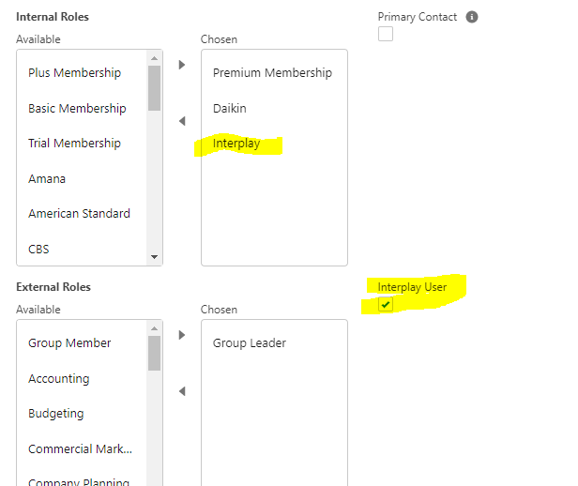

- Email Danny Rentschler, drentschler@egia.org, to notify a new company has purchased Interplay. He will add the training to their Group Reporting. Otherwise, they won’t have the capability to track their team’s Interplay progress.

