Workshop Cancellation & Refund Process in Nimble

- Log into Nimble
- Search primary contact/attendee name
  - Refund can only be made from the person who purchased the workshop
- Go to orders – shows registration with grand total and total payment

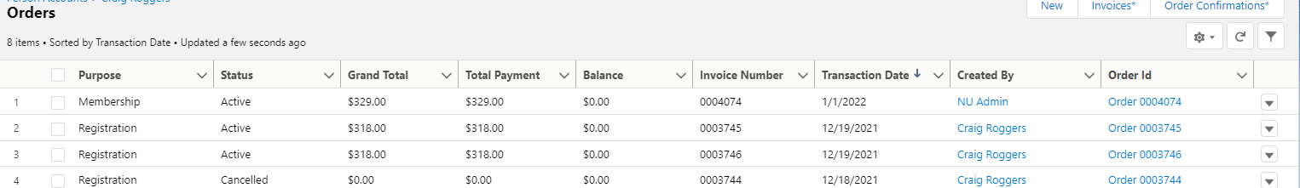

- Find the correct order – to the far right click drop down arrow choose edit
- Let’s get started window – click continue
- Click cancel by the person you are canceling (if multiple people cancel all of them first)
- It will prompt without fees or with fees (always choose without fees)
- In the Order Summary on the right there will be a negative balance if fees were paid for the workshop
- Click on payment in upper right
- Click Refund in the middle of the screen
- Select refund option (choose credit card – it was show the detail of what was charged to the card)
- Enter note – example workshop canceled, illness, etc
- Click Save
- Box refreshes
- Submit order

