EGIA Number | (866) 367-3442
Member Services | (866) 502-2021
Events Phone | (888) 213-9320
Contractor Services (Optimus) | (833) OPT1MUS | (833) 678-1687
Joelle | 916-256-4267
Stephanie Spray | 916-265-0817
Stephanie Spray | 317-431-7380
Katrina | 916-993-5239
Katrina | 415-645-3346
Robin | 916-582-3639
Robin | 916-480-7356
Stephanie Angeles | 916-265-0322
Stephanie Angeles | 916-480-7313 | leads straight to voicemail with my name on it, I am not sure if this voicemail is different than my primary number. I do not use this #
Justin | 702-575-4430
Merced Mobile | 702-575-3006

Dictionary to be updated next week for all EGIA employees.
Topics for Discussion:
- Member Services incoming calls appear as SPAM on the caller I.D.
Trouble Shooting: I called myself through Nice In Contact, Joelle also called me through Nice in Contact, our MS numbers appeared, no name, SPAM did not appear either. This could depend on the carrier
Solution:
- Account Managers appear as different names when incoming calls appear. Example: Joelle appears as Martin on the caller I.D.
Trouble shooting, I had Joelle call my cell phone, her number appeared, no name showed. She appears as Martin for some incoming calls, could it be a carrier thing?
Solution:
- Voicemail Mail Hold Times:
  - When in after work call:
    - Member services: voicemail offered after 2:26minutes
    - Events: voicemail offered after 2:26minutes
    - Account manager: voicemail offered after 2:26minutes
  - When logged out of phones:
    - Member services:
    - Events:
      - Gives you an option to enter an extension, 1 to enter extension, 2 to be transferred to someone. Voicemail answers within 18 seconds
    - Account manager: voicemail is offered after 10 seconds
  - When on another call:
    - Member services skill: hold for 2:26 minutes then voicemail is offered after
    - Events Skill: hold for 2:26 minutes then voicemail is offered after
    - Account manager individual skill: hold for 2:26 minutes then voicemail is offered after
  - When in a different phone status: Project Work Time
    - After 2:26 minutes: voicemail was offered
- You can press 0 at any time after ….
  - When in “meeting/ training”
    - Katrina - Incoming call to her MS number went sent straight to voicemail within 12 sections- no hold time (she was in meeting status for 10 minutes
    - Robin- Incoming call to her MS number went to hold for 2:26 minutes then a voicemail option was offered
    - Spray: incoming call to her MS number went to hold for 2:26 minutes then a voicemail option was offered (she in meeting status for 5 minutes)
** 0 can be pressed at any time to leave a voicemail – can we have that said in the beginning of the call? It is only said once after holding for 2:26 minutes (if you would like to leave a voicemail press 0 then it goes back to the hold music)
- Decide what intervals you would like the 0 option hold messaging to play.
- Transferring Calls:
  - To Other Departments:
    - Member Services Account manager to Contractor Services department:
      - When someone is available: I called in, transferred myself to Contractor Services, the system was showing one person available, I clicked transferred and waited on the line for someone in optimus to answer, call connected then it went through.
      - Hold times:
        - Incoming Call to Go Green when in after work call or meeting mode: voicemail was offered after 2:26 minutes
      - When does voicemail answer: no one logged in = voicemail answers
  - Cold transfer vs warm transfer
Call = warm transfer – conference
Cold transfer – transfer – cold
Incoming call – transfer – call – call disconnects agent but keeps caller on the line so agent with the skill can answer
Incoming call – transfer – call – conference – connects agent and incoming call to agent with the skill

Story Time:
Stephanie Spray cold transferred a call to “Contractor Services” about 5 minutes before she left me this message. I COLD transferred it “Contractor Services” about 5 minutes before she left me this message. She then transferred it to a specific person in contractor services:
Incoming number: 2527174336 Aug 5, 2024 1:26pm.
Here is what I found:
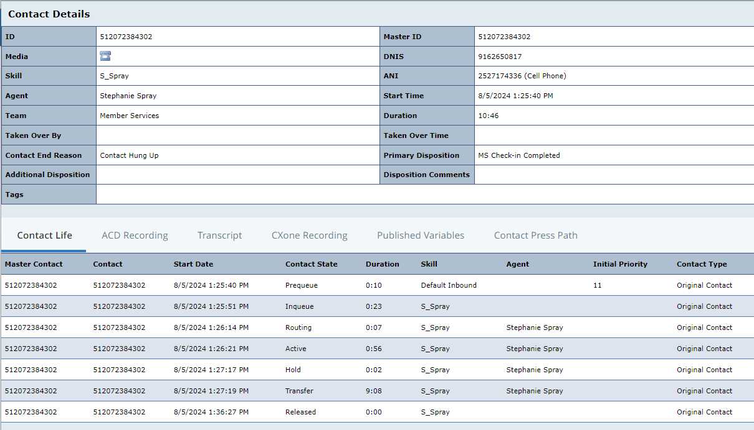
- Stephanie transferred call to Contractor Services
- Contractor Services voicemail was offered after 2 minutes on hold
- After 9minutes the call was transferred to Stephanie Spray’s voicemail

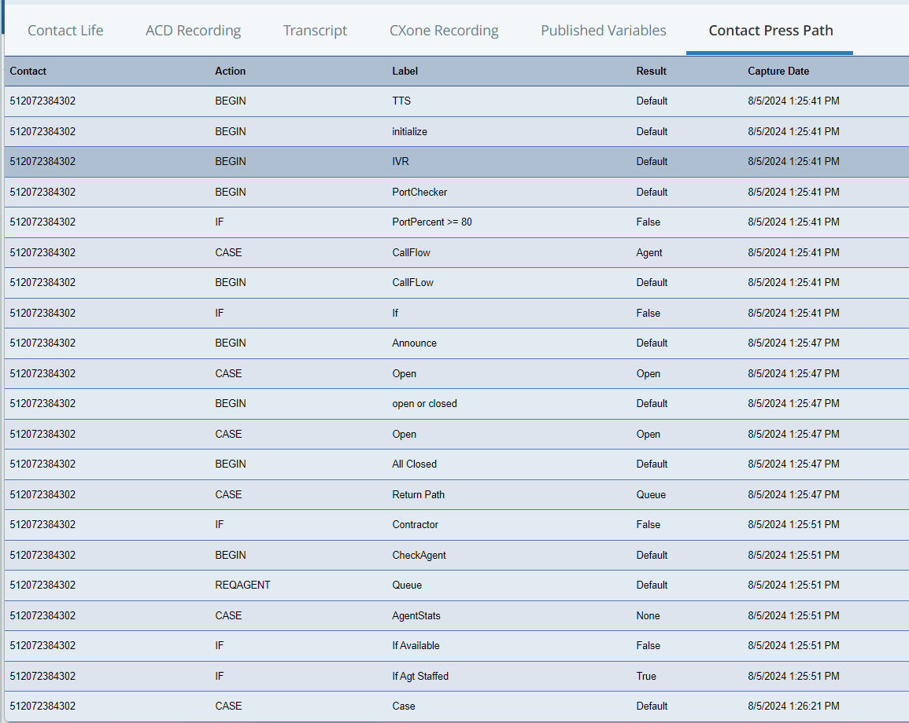

Which number did this member call into that led her to Stephanie Spray?
Why did this call get routed back to Stephanie Spray when agents in Contractor Services were showing available?
Thoughts: member originally called Stephanie Spray’s number , because no one answered in Contractor Services department the call was re routed back to Stephanie Spray because the member originally called her number that is the reason for the voicemail in her inbox.
Do contractor services log into the contractor services nice in contact phone line or do they use their cell phone to take calls?
Will look through the reporting to see what point by points happened to offered agents – if at all.

Why: does Spray show 3 options?
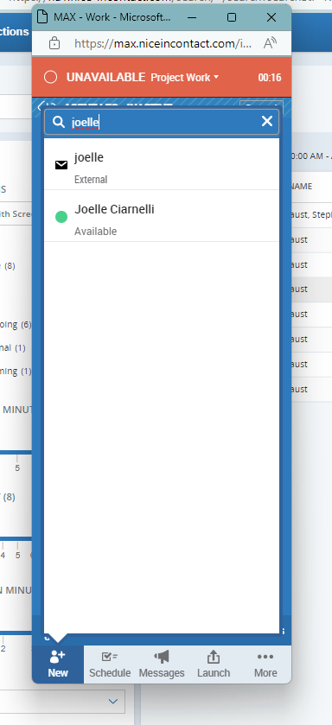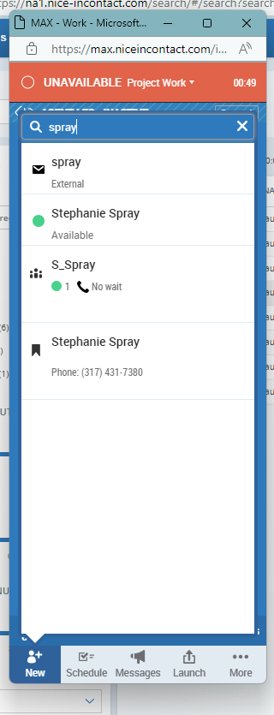

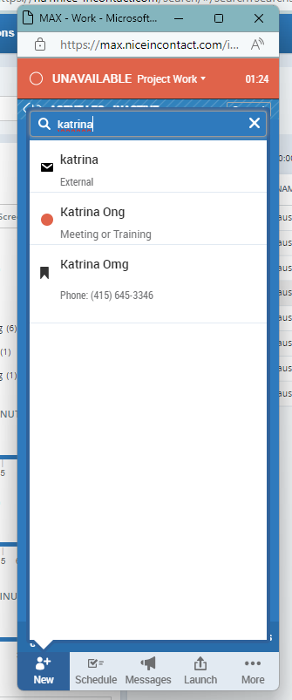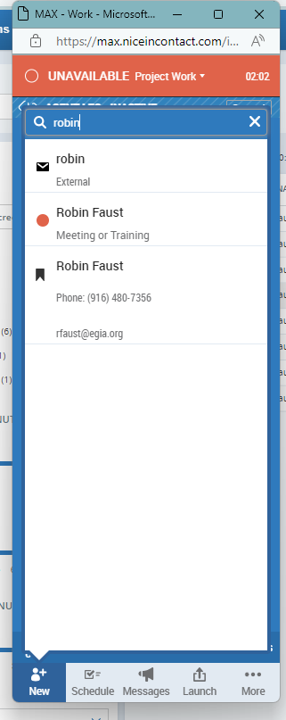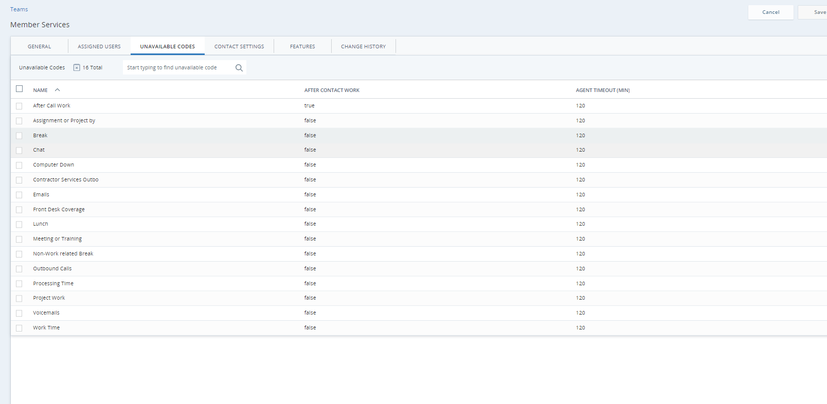

This is how our department is currently set up.

