- CPA will be creating PDF files to translate the email’s into Spanish and Chinese
- CPA will provide EGIA with the PDF next week
  - EGIA needs to host these PDF Files (create the URL & maintain it)
  - EGIA need to place these two links in the emails on the top left in between the Application number line & “We’ve Received Your Sun Storage Rebate reservation Application” Line.
    - Have 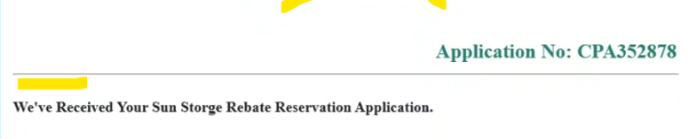
  - Links should look similar to what they have listed on their website.
    - cleanpoweralliance.org
  - 
- Email Template Feedback
  - Wrong Logo
    - Clayton will send us the correct logo
  - Font needs to be updated to match the CPA approved Font
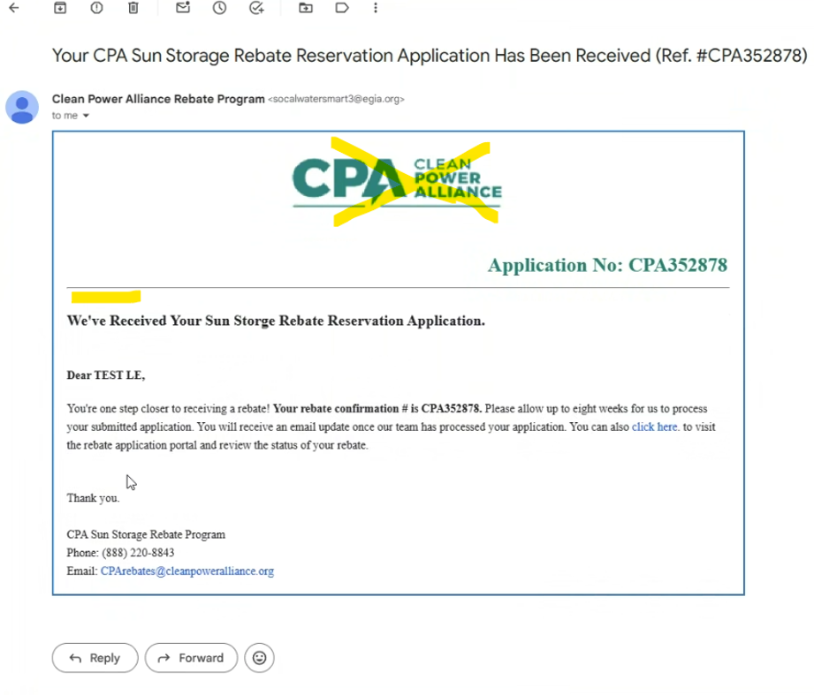
Rebate Calculations:
- Based on Energy Storage Capacity form backend instead of web.
- If a measure has the Energy Storage Capacity blank/empty -> then claim gets flagged for review.
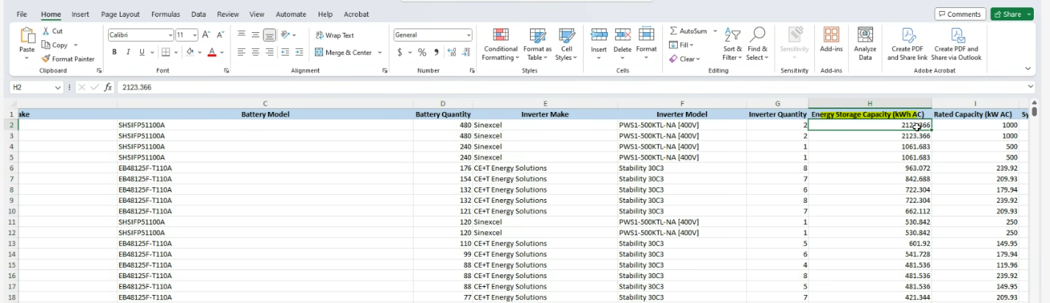
Call Center
- Alex having a meeting with their Call center people next week, detail coming shortly after.
Invoices:
- Moving forward Clayton will upload the invoices on a shared folder with CPA instead of emailing them to secure Customer Account Information.

