Notification Email Notes:
- Received CPA Approved Logo via email & Clayton uploaded to the Jira ticket.
- Font for the notification emails should be: “Nunito Sans (Regular)”
- CPA continues working on the PDF (for translations) that will be hosted by EGIA -> More info on this coming soon.
RPS RFD
- Pending BU Review & Feedback
  - Notification Emails
  - Reject codes
  - RPS
- Once BU reviews if all is well -> then BU will provide CPA with testing credentials for CPA to review.
  - CPA will provide testing feedback
Processing Notes based on Data Verification Excel Sheet
- Line 19: When CPA adds note: “NEM Yet” -> this an internal CPA note & these can continue with the claim process
  - Laurie confirmed she understands and the reason this line is not highlighted green is because she needs more information from CX.
  - Moving forward Laurie will add a note “Request Info” anytime she is waiting on CX information.
- Line 45:
  - Account number: 8003741098: Meing Wu
    - CPA was not able to locate this customer on their DB.
    - BU to double check the correct Account number was entered

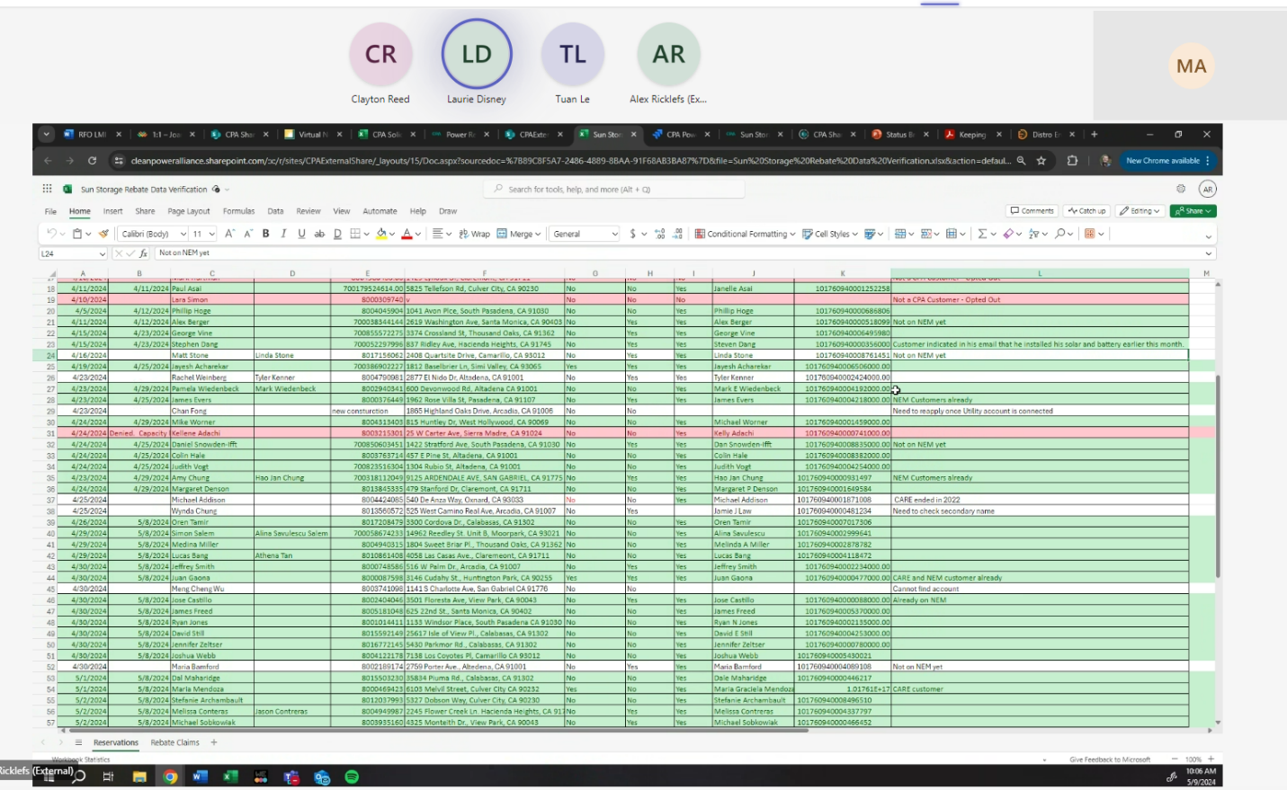

@Clinton CramerNo update on call tree from CPA.

