Hey Maria there’s is located on the 2nd page of PAP, was approved in August.

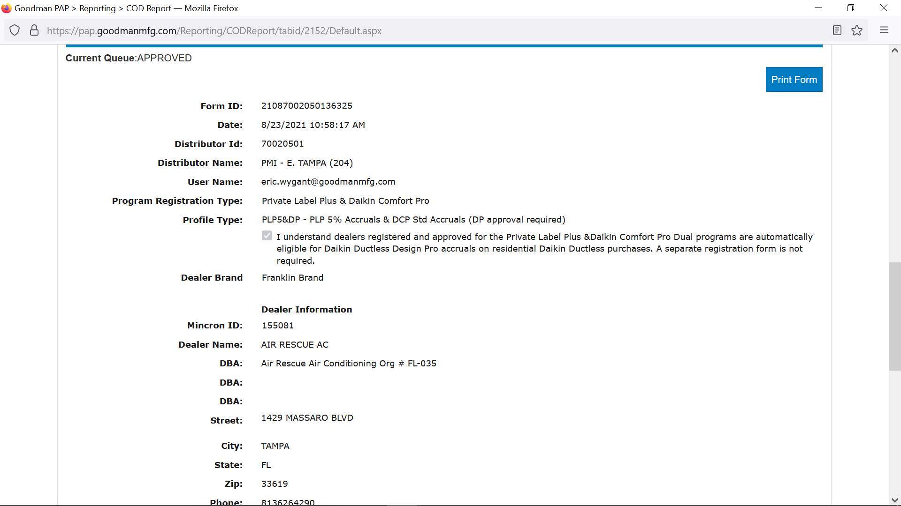

David “Zac” Myers - Territory Sales Manager
C: 813-410-0141

Branch Emails for Ordering
East Tampa - Branch204ETampa@goodmanmfg.com
West Tampa – Branch262NTampa@goodmanmfg.com
Clearwater - Branch252Clearwater@goodmanmfg.com
Port Richey – Branch242PortRichey@goodmanmfg.com
Winter Haven - Branch266WinterHaven@goodmanmfg.com
Sarasota – Branch268Sarasota@goodmanmfg.com

Technical Support – Ryan MacNaughton
Ryan.MacNaughton@daikincomfort.com
(407) 721-9695

Daikin Tech Support (Follow the Prompts)
(855) 324-5461

www.daikinhub.com for eCommerce
Download: “Daikin Tech Hub” App from Google or Apple:
For Specs, Install Literature, Error Codes…etc

From: Maria Alatorre <malatorre@egia.org>
Sent: Monday, November 22, 2021 3:15 PM
To: Myers, David (Zac) <Zac.Myers@daikincomfort.com>
Cc: dhowellarac@gmail.com; Jeremy Chandler <jchandler@egia.org>
Subject: [EXTERNAL] RE: Air Rescue # 155081 - EGIA Daikin Account

Hi Zac,

I only show this dealer as PLP, can you send me the DCP approval?

Thanks,
Maria Alatorre

From: Myers, David (Zac) <Zac.Myers@daikincomfort.com>
Sent: Monday, November 22, 2021 11:52 AM
To: Maria Alatorre <malatorre@egia.org>
Cc: dhowellarac@gmail.com; Jeremy Chandler <jchandler@egia.org>
Subject: Air Rescue # 155081 - EGIA Daikin Account

Maria good afternoon,

Have just signed up Dan Howell with Air Rescue #155081. He’s able to log in but believe the account still needs to be approved on your end. He’s looking to begin entering rebates for FIT systems. Please approve their account #155081? Email used for the account is: dhowellarac@gmail.com

Dan’s phone# (813) 356-8896

David “Zac” Myers - Territory Sales Manager
C: 813-410-0141

Branch Emails for Ordering
East Tampa - Branch204ETampa@goodmanmfg.com
West Tampa – Branch262NTampa@goodmanmfg.com
Clearwater - Branch252Clearwater@goodmanmfg.com
Port Richey – Branch242PortRichey@goodmanmfg.com
Winter Haven - Branch266WinterHaven@goodmanmfg.com
Sarasota – Branch268Sarasota@goodmanmfg.com

Technical Support – Ryan MacNaughton
Ryan.MacNaughton@daikincomfort.com
(407) 721-9695

Daikin Tech Support (Follow the Prompts)
(855) 324-5461

www.daikinhub.com for eCommerce
Download: “Daikin Tech Hub” App from Google or Apple:
For Specs, Install Literature, Error Codes…etc

