Hey guys! Just got a reply on this – yes, Arnold’s AC of South Florida is indeed a brand new DCP. Please grant access. Thanks!

 | Jeremy Chandler  Regional Manager  Cell: 916-759-0515

From: Dealer Rebates
Sent: Wednesday, October 13, 2021 9:01 AM
To: Jeremy Chandler <jchandler@egia.org>
Cc: Maria Alatorre <malatorre@egia.org>
Subject: DCP verification for Arlond's AC /Arnold's Air Conditioning of South Florida Inc

Good morning, Jeremy,
I hope all is well. I am working on getting Arnold's /
Arnold's Air Conditioning of South Florida Inc
(EGIA-74653)
They are PLP under Franklin. They are only interested in Consumer Instant not FBD.
Please let us know if you have any details.
Thanks for your time.
Best,
Erika
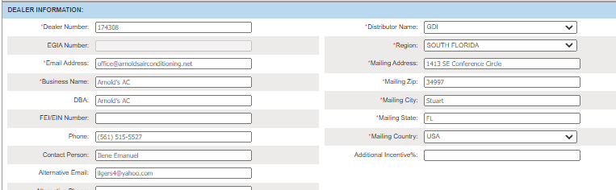
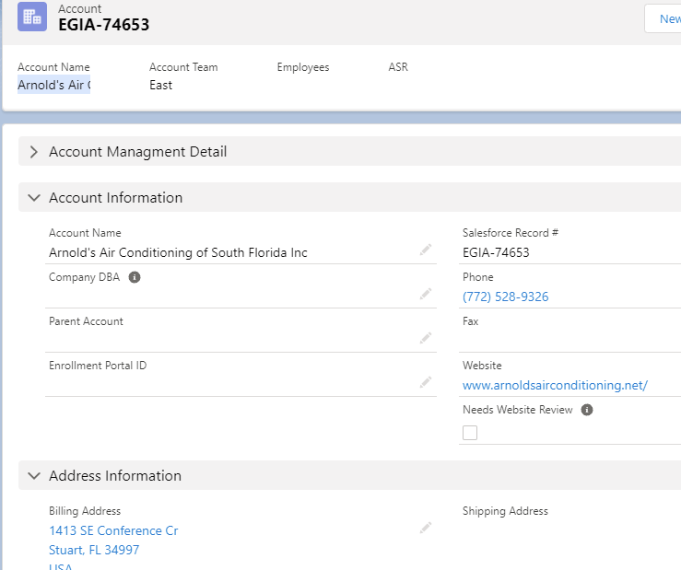

From: Leslie Lewis
Sent: Wednesday, October 13, 2021 8:14 AM
To: Dealer Rebates
Cc: Ilene@arnoldsairconditioning.net
Subject: Please contact Ilene Emanuel 772-247-0337

Hello Dealer Rebates and Ilene,

Dealer Rebates will be happy to call you and assist with your Daikin Fit Claims

Daikin Dealer Also PLP Dealer

Please contact Ilene Emanuel 772-247-0337
Daikin Fit Claims ( not enrolled w/ finance w/ EGIA)
For Fit Daikin claims
Ilene@arnoldsairconditioning.net
772-247-0337

 | Leslie D. Lewis  Account Manager, Contractor Services  888-523-2144

