Hey guys! This is a claim that was literally just submitted so no rush, but when you get to it, please approve claim 744795 at $575 as a one time exception.

The product is a Daikin FIT ($525 rebate to dealer), and Daikin ONE Smart Thermostat ($50 to dealer).

I just spent a looooong time on the phone with her and Daikin… the TSM explained the program wrong. They thought it was a rebate that was mailed to the customer, not the dealer so they put “after mail in rebate” on their invoice (see below). They are sending the customer a check now for $1,150. The Daikin ASM was on the call with me, we have authorization to approve this claim at $575 to the dealer. They should be clear (I hope) moving forward.

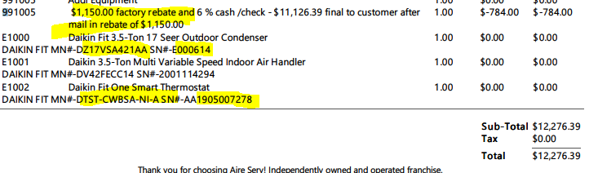

 | Jeremy Chandler  Regional Manager  Cell: 916-759-0515

