From: Molly Luchetti <molly@fithomeservices.com>
Date: Thursday, May 13, 2021 at 6:07 PM
To: Tony Luchetti <tony.luchetti@daikincomfort.com>
Subject: [EXTERNAL] [BULK] Rebate for EGIA - Claim #725868

Hi Tony -

I need your help. Apparently one of my rebates has been denied and I am past the window for receiving funds. I am new at helping my brother-in-law and I didn't realize EGIA needed additional information to complete the rebate process. The EGIA rep said they needed the DV15 stickers to complete the rebate. I have attached a picture of the 4 stickers for the DV15- 2117-AB (Serial Numbers: 20062280, 20062281, 20062284, 20062282).
Hopefully, you can help me get the rebate and I will be more aware next time.

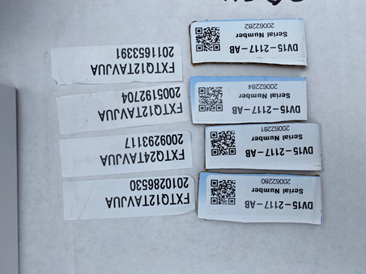
Thank you,

Molly
Fit Home Services

