From: Jeremy Chandler
Sent: Wednesday, August 4, 2021 2:27 PM
To: Dealer Rebates; Maria Alatorre
Cc: Sierra Pryor; Grigg, Jason K.
Subject: FW: [EXTERNAL] FW: IAQ Claims - Thermostat Rebate

EGIA Rebate team, please see below. The claims in the image below from Lakebrink are for the Daikin One Stat ($50 to the dealer). These have been approved by Daikin to pay in full (some if not all will be from the Q2 time period):

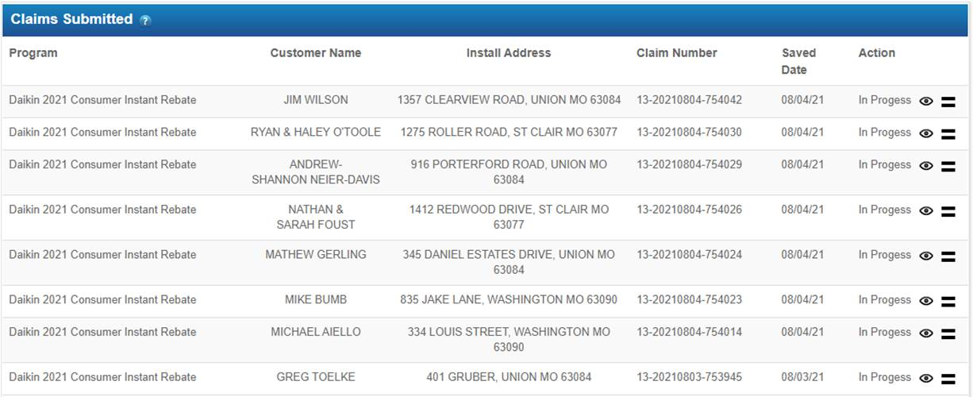

 | Jeremy Chandler  Regional Manager  Cell: 916-759-0515

From: Grigg, Jason K. [mailto:Jason.Grigg@daikincomfort.com]
Sent: Wednesday, August 4, 2021 12:59 PM
To: Sierra Pryor <Sierra.Pryor@tmi-stl.com>
Cc: Jeremy Chandler <jchandler@egia.org>
Subject: RE: [EXTERNAL] FW: IAQ Claims - Thermostat Rebate

Approved. Thanks.

Jason Grigg
Sales Programs Manager
DAIKIN NORTH AMERICA
E: jason.grigg@daikincomfort.com
C: 713-454-3251

From: Sierra Pryor <Sierra.Pryor@tmi-stl.com>
Sent: Wednesday, August 4, 2021 2:55 PM
To: Grigg, Jason K. <Jason.Grigg@daikincomfort.com>
Cc: Jeremy Chandler <jchandler@egia.org>
Subject: [EXTERNAL] FW: IAQ Claims - Thermostat Rebate

Hi Jason,

Below are some more rebate claims for the Daikin One Stat that Lakebrink missed claiming correctly the first time. Our apologies. They have been trained correctly on how to claim moving forward. Their invoices show the $100 offered on the first claim but Donna (new employee) wasn’t adding the Daikin One as a IAQ product with the FIT system. She is aware now and will do it correctly moving forward. We sure appreciate your help with this!

Thank you,

Sierra Pryor
Programs Manager/Marketing Coordinator



Office: 715 Goddard Ave. , Chesterfield MO, 63005
Warehouse: 18065 Chesterfield Airport Rd. , Chesterfield MO, 63005
Follow us: Facebook
Contact us: SERVICE | PARTS | SHIP DATES

Email: sierra.pryor@tmi-stl.com Website: tmi-stl.com
Main: (636) 532-1110 | Direct: 636-778-7587
Mobile: 573-259-0747

From: donna@lakebrinkhvac.com <donna@lakebrinkhvac.com>
Sent: Wednesday, August 4, 2021 10:43 AM
To: Sierra Pryor <Sierra.Pryor@tmi-stl.com>
Cc: kathy@lakebrinkhvac.com
Subject: IAQ Claims - Thermostat Rebate

Hi Sierra,

So below are the IAQ systems that I resubmitted, per our discussion of Lakebrink not knowing the change in filing the claim. Let me know what you find out. Thank you for your help.

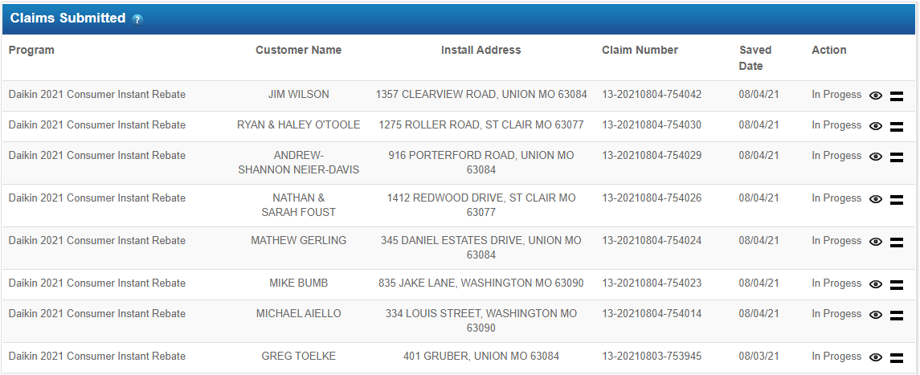

Donna Hopkins, Office Manager
Lakebrink Heating & Air Conditioning
Phone: (636) 583-3365
donna@lakebrinkhvac.com

