EGIA Rebates team, please see attached for several screenshots of rebate claims that were denied. We have an exception from Daikin below to approve these claims. Can you please update to approved in full and reply back once complete.

Jeremy Chandler
Regional Manager
Cell: 916-759-0515

From: Grigg, Jason K. [mailto:Jason.Grigg@daikincomfort.com]
Sent: Monday, June 6, 2022 1:02 PM
To: Schneider, David S. <David.Schneider@daikincomfort.com>; Jeremy Chandler <jchandler@egia.org>
Cc: Trzyna, Mark S. <Mark.Trzyna@daikincomfort.com>
Subject: FW: [EXTERNAL] The Rail (Red Bank) - Rebate's
Importance: High

David…please work with Jeremy Chandler on these.

Jeremy…these are approved to pay in full.

Thanks all.

Jason Grigg
Promotions Manager

M: 713.454.3251 | E: jason.grigg@daikincomfort.com
19001 Kermier Road | Waller, TX, 77484
https://northamerica-daikin.com

From: Schneider, David S. <David.Schneider@daikincomfort.com>
Sent: Friday, June 3, 2022 12:13 PM
To: Grigg, Jason K. <Jason.Grigg@daikincomfort.com>
Subject: FW: [EXTERNAL] The Rail (Red Bank) - Rebate's

Hey bud

I know we have been back and forth on these rebates for a long time now. Please see marks approval below.

Thanks

From: Trzyna, Mark S. <Mark.Trzyna@daikincomfort.com>
Sent: Friday, June 3, 2022 1:06 PM
To: Schneider, David S. <David.Schneider@daikincomfort.com>
Subject: RE: [EXTERNAL] The Rail (Red Bank) - Rebate's

Since we went in with higher margin we are good with the program approval.

From: Schneider, David S. <David.Schneider@daikincomfort.com>
Sent: Friday, June 3, 2022 12:48 PM
To: Trzyna, Mark S. <Mark.Trzyna@daikincomfort.com>
Subject: RE: [EXTERNAL] The Rail (Red Bank) - Rebate's

Call me when you get a chance about this. Thanks

From: Trzyna, Mark S. <Mark.Trzyna@daikincomfort.com>
Sent: Friday, June 3, 2022 10:05 AM
To: Schneider, David S. <David.Schneider@daikincomfort.com>
Subject: RE: [EXTERNAL] The Rail (Red Bank) - Rebate's

This was something that you worked directly with Jason on. Please follow up with him on the exact details and approvals that you have for the project.

From: Schneider, David S. <David.Schneider@daikincomfort.com>
Sent: Friday, June 3, 2022 10:00 AM
To: Trzyna, Mark S. <Mark.Trzyna@daikincomfort.com>
Subject: FW: [EXTERNAL] The Rail (Red Bank) - Rebate's

Hey bud

Did these rebates get back to Jason to approve? Alpine said they haven’t received anything yet.

Thanks
Dave

From: Schneider, David S.
Sent: Monday, March 14, 2022 1:54 PM
To: Trzyna, Mark S. <Mark.Trzyna@daikincomfort.com>
Subject: FW: [EXTERNAL] The Rail (Red Bank) - Rebate's

Mark

Attached are the rebates we need to approve for Alpine

Thanks

Dave

From: Benny Dembinsky <bd@alpineairhvac.com>
Sent: Wednesday, March 2, 2022 9:59 AM
To: Schneider, David S. <David.Schneider@daikincomfort.com>; Frank Cocco <frank@alpineairhvac.com>; Yehuda Ungar <yu@alpineairhvac.com>
Cc: Chaya Klein <cklein@alpineairhvac.com>
Subject: [EXTERNAL] The Rail (Red Bank) - Rebate's

David,

As requested,

Attached are screenshots of all the rebates we filed for The Rail.

Benny Dembinsky - Service Manager
1985 Swarthmore Ave, Unit 6
Lakewood, NJ 08701

PH: 732.800.0180 x202 - Cell: 848.240.7649
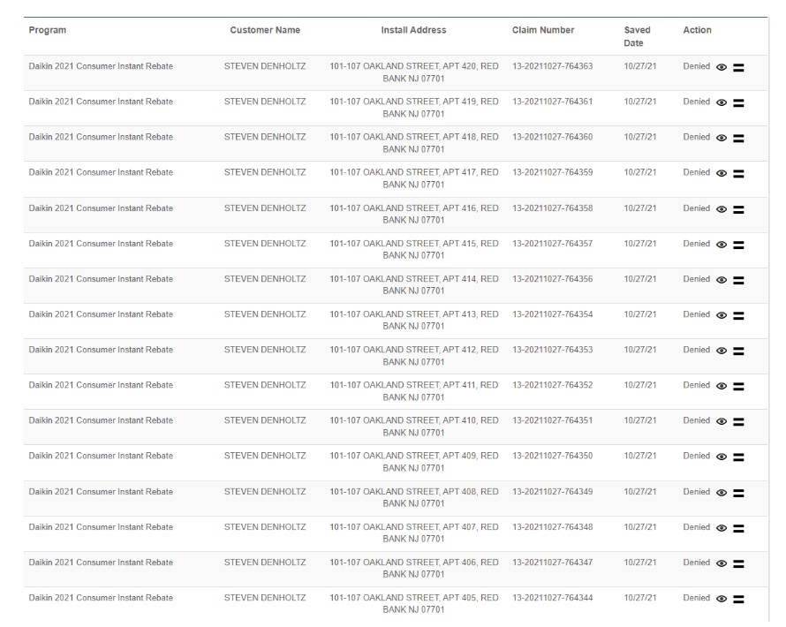
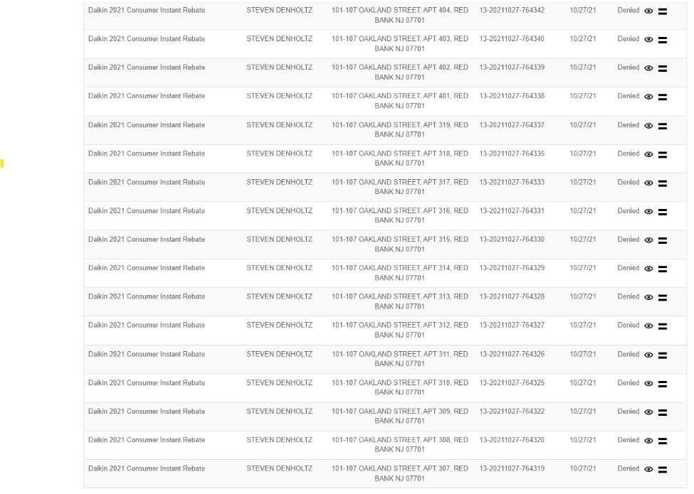

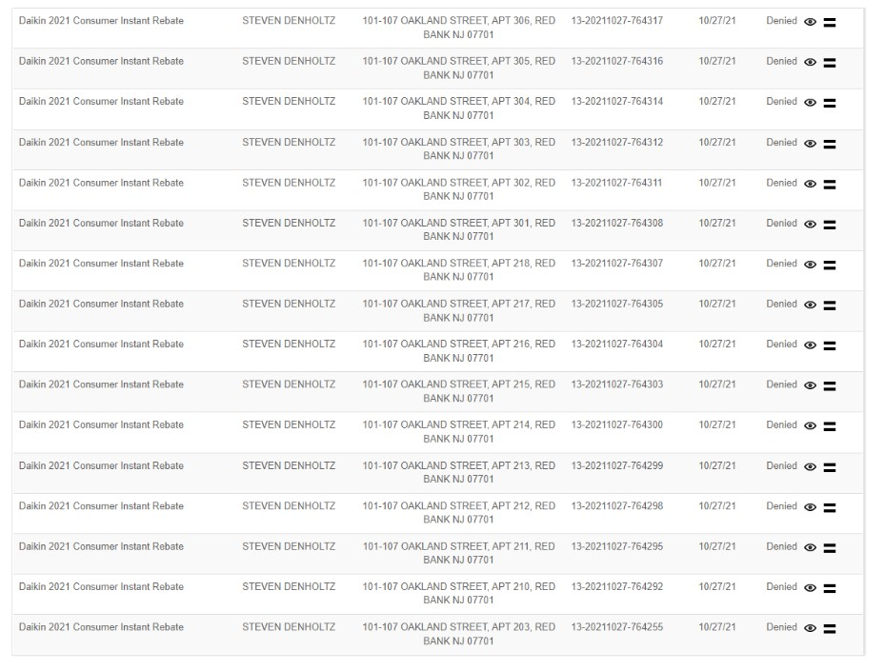

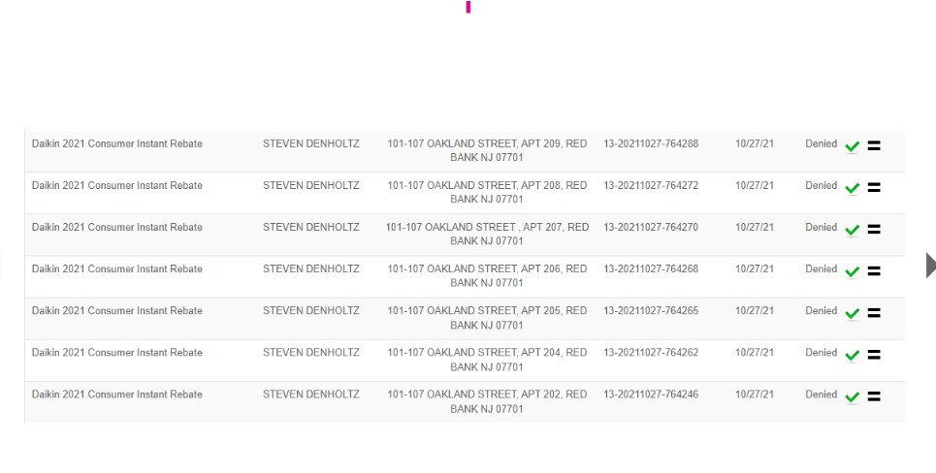

No rush, tomorrow is good

From: Trzyna, Mark S. <Mark.Trzyna@daikincomfort.com>
Sent: Tuesday, February 22, 2022 3:42 PM
To: Schneider, David S. <David.Schneider@daikincomfort.com>
Subject: Re: bid pricing The Rail at Red Bank Station - Alpine Air - COD-PHI

Will do. I’m at a TSM event in Philly. Maybe late or tomorrow if that is ok

Get Outlook for iOS

From: Schneider, David S. <David.Schneider@daikincomfort.com>
Sent: Tuesday, February 22, 2022 3:30:35 PM
To: Trzyna, Mark S. <Mark.Trzyna@daikincomfort.com>
Subject: FW: bid pricing The Rail at Red Bank Station - Alpine Air - COD-PHI

Hey Mark

Call me when you get a chance about this.

From: Schneider, David S.
Sent: Wednesday, January 12, 2022 2:14 PM
To: Grigg, Jason K. <Jason.Grigg@daikincomfort.com>
Subject: FW: bid pricing The Rail at Red Bank Station - Alpine Air - COD-PHI

From: Grigg, Jason K. <Jason.Grigg@daikincomfort.com>
Sent: Thursday, March 25, 2021 1:02 PM
To: Schneider, David S. <David.Schneider@daikincomfort.com>; Trzyna, Mark S. <Mark.Trzyna@daikincomfort.com>
Cc: Clements, John <John.Clements@daikincomfort.com>
Subject: RE: bid pricing The Rail at Red Bank Station - Alpine Air - COD-PHI

Coolio.

Jason Grigg
Sales Programs Manager
DAIKIN NORTH AMERICA
E: jason.grigg@daikincomfort.com
C: 713-454-3251

From: Schneider, David S. <David.Schneider@daikincomfort.com>
Sent: Thursday, March 25, 2021 12:00 PM
To: Grigg, Jason K. <Jason.Grigg@daikincomfort.com>; Trzyna, Mark S. <Mark.Trzyna@daikincomfort.com>
Cc: Clements, John <John.Clements@daikincomfort.com>
Subject: RE: bid pricing The Rail at Red Bank Station - Alpine Air - COD-PHI

Please set up the code They will be purchasing the FITs

Thanks guys

From: Grigg, Jason K. <Jason.Grigg@daikincomfort.com>
Sent: Thursday, March 25, 2021 12:59 PM
To: Trzyna, Mark S. <Mark.Trzyna@daikincomfort.com>
Cc: Clements, John <John.Clements@daikincomfort.com>; Schneider, David S. <David.Schneider@daikincomfort.com>
Subject: RE: bid pricing The Rail at Red Bank Station - Alpine Air - COD-PHI

Should I wait to setup up the pc code contingent if they agree to place the order? Thoughts?

Jason Grigg
Sales Programs Manager
DAIKIN NORTH AMERICA
E: jason.grigg@daikincomfort.com
C: 713-454-3251

From: Trzyna, Mark S. <Mark.Trzyna@daikincomfort.com>
Sent: Thursday, March 25, 2021 11:51 AM
To: Grigg, Jason K. <Jason.Grigg@daikincomfort.com>
Cc: Clements, John <John.Clements@daikincomfort.com>; Schneider, David S. <David.Schneider@daikincomfort.com>
Subject: RE: bid pricing The Rail at Red Bank Station - Alpine Air - COD-PHI

Thanks Jason.

I will work with Dave Schneider to communicate to Alpine. Thanks to the both of you for your help.

From: Grigg, Jason K. <Jason.Grigg@daikincomfort.com>
Sent: Thursday, March 25, 2021 11:50 AM
To: Trzyna, Mark S. <Mark.Trzyna@daikincomfort.com>
Cc: Clements, John <John.Clements@daikincomfort.com>
Subject: FW: bid pricing The Rail at Red Bank Station - Alpine Air - COD-PHI
Importance: High

Hey, Mark. Got the pc code idea for Alpine approved. In summary…

- Setup new pc code for the Free ONE stat for Alpine only (will send pc code # once established)
- ONE stat will be reimbursed at $386 (dealer cost)
- Capping claims at 60 & no instant rebate claims on ONE stat allowed
- Program effective April 1 – Dec 31, 2021 (can report in January 2022)

Please let me know if you have any questions.

Jason Grigg
Sales Programs Manager
DAIKIN NORTH AMERICA
E: jason.grigg@daikincomfort.com
C: 713-454-3251

From: Clements, John <John.Clements@daikincomfort.com>
Sent: Thursday, March 25, 2021 10:19 AM
To: Grigg, Jason K. <Jason.Grigg@daikincomfort.com>
Subject: Re: bid pricing The Rail at Red Bank Station - Alpine Air - COD-PHI

Ok, I approve

John Clements
Director, Strategic Programs
Daikin North America LLC
M: 678.427.1320 | E: john.clements@daikincomfort.com | www.daikincomfort.com

Schedule time with me here: https://calendly.com/john-clements

From: Grigg, Jason K. <Jason.Grigg@daikincomfort.com>
Date: Wednesday, March 24, 2021 at 3:50 PM
To: Clements, John <John.Clements@daikincomfort.com>
Subject: RE: bid pricing The Rail at Red Bank Station - Alpine Air - COD-PHI
After some discussion with Mark, to offer the Free ONE on this proposal, I would suggest setting up a new PC code solely for Alpine where they can get the $386 back on the ONE stat. We would cap it at 60 claims, run through the end of 2021 & not allow them to claim on the $100 ONE stat instant rebate.

Thoughts?

Jason Grigg
Sales Programs Manager
DAIKIN NORTH AMERICA
E: jason.grigg@daikincomfort.com
C: 713-454-3251

From: Clements, John <John.Clements@daikincomfort.com>
Sent: Wednesday, March 24, 2021 1:09 PM
To: Trzyna, Mark S. <Mark.Trzyna@daikincomfort.com>; Grigg, Jason K. <Jason.Grigg@daikincomfort.com>
Subject: Re: bid pricing The Rail at Red Bank Station - Alpine Air - COD-PHI

Ok. I’m ok with the free Daikin ONE for this customer only, since it was available when you started the discussions.

Jason…please let Mark know if he needs to do anything special with PC codes.

John Clements
Director, Strategic Programs
Daikin North America LLC
M: 678.427.1320 | E: john.clements@daikincomfort.com | www.daikincomfort.com

Schedule time with me here: https://calendly.com/john-clements

From: Trzyna, Mark S. <Mark.Trzyna@daikincomfort.com>
Date: Wednesday, March 24, 2021 at 2:00 PM
To: Clements, John <John.Clements@daikincomfort.com>, Grigg, Jason K. <Jason.Grigg@daikincomfort.com>
Subject: RE: bid pricing The Rail at Red Bank Station - Alpine Air - COD-PHI
Nothing has been communicated to them.

I wanted to gain clarity of what we could or couldn’t do first.

From: Clements, John <John.Clements@daikincomfort.com>
Sent: Wednesday, March 24, 2021 1:54 PM
To: Trzyna, Mark S. <Mark.Trzyna@daikincomfort.com>; Grigg, Jason K. <Jason.Grigg@daikincomfort.com>
Subject: Re: bid pricing The Rail at Red Bank Station - Alpine Air - COD-PHI

Looks like you already have the free Daikin ONE in there. Has that been communicated to them?
Sent from my iPhone

On Mar 23, 2021, at 5:26 PM, Trzyna, Mark S. <Mark.Trzyna@daikincomfort.com> wrote:
﻿
This is the 60 system project that is in discussion. The orange section is the one that falls under promotional.

If there is a way to extend and protect the customer on any or all of the programs it may help secure the job FIT.

<image006.png>

From: Schneider, David S. <David.Schneider@daikincomfort.com>
Sent: Tuesday, March 9, 2021 8:54 AM
To: Goldman, Jeff <jeff.goldman@daikincomfort.com>
Cc: Trzyna, Mark S. <Mark.Trzyna@daikincomfort.com>
Subject: RE: bid pricing The Rail at Red Bank Station

Thanks Jeff, I appreciate it.

From: Goldman, Jeff <jeff.goldman@daikincomfort.com>
Sent: Tuesday, March 9, 2021 8:42 AM
To: Schneider, David S. <David.Schneider@daikincomfort.com>
Cc: Trzyna, Mark S. <Mark.Trzyna@daikincomfort.com>
Subject: RE: bid pricing The Rail at Red Bank Station

David
Since little is know about competition and what they are quoting, not sure level of price support needed.

Took 10% off their current pricing. There are some good selling advantages for our FIT such as efficiency, space saving side discharge and extremely quiet. Check with Mark regarding sales programs such as dealer spiff and consumer instant rebate that might be a benefit to selling project Know these exist but not as familiar with rules for participation on project such as this. From my project margin perspective, we can support this

This is contractor’s price for this project, no discount on Daikin One stat.

<image001.png>

Jeff Goldman
Project Desk Manager
Daikin Texas Technology Park
19001 Kermier Road
Waller, TX 77484
713-346-6415

From: Schneider, David S. <David.Schneider@daikincomfort.com>
Sent: Monday, March 8, 2021 2:22 PM
To: Goldman, Jeff <jeff.goldman@daikincomfort.com>
Cc: Trzyna, Mark S. <Mark.Trzyna@daikincomfort.com>
Subject: RE: bid pricing

Jeff

The DCP is Alpine Air Mincron # 195906 Pricing profile MDA07321
They are COD out of the Edison branch 600

Project info:
Name: The Rail at Red Bank Station
Address: 116 Chestnut St. Red Bank NJ

Model number are below with their current DCP pricing

Quantity Model each

28 DZ17VSA241A* $1,913
28 DV24FECB14A* $1,162
15 DZ17VSA301A* $2,093
15 DV36FECC14A* $1,294
15 DZ17VSA361A* $2,276
15 DV36FECC14A* $1,294
2 DZ17VSA481A* $2,698
2 DV48FECD14A* $1,359
58 HKSC10XC 9.6 $82
2 HKSC20DA 19.2 $155
60 Daikin one $386

Thanks

Dave

From: Goldman, Jeff <jeff.goldman@daikincomfort.com>
Sent: Monday, March 8, 2021 2:50 PM
To: Schneider, David S. <David.Schneider@daikincomfort.com>
Cc: Trzyna, Mark S. <Mark.Trzyna@daikincomfort.com>
Subject: RE: bid pricing

David
No one has contacted us for pricing on Mi Place at First Radio

As for second opportunity , information is too vague. What is their current pricing levels and have you quoted them using it ? Is this going through Abco or our COD in Edison? Who is the dealer, what is name of project? What are the model number sand quantity ?

Jeff Goldman
Project Desk Manager
Daikin Texas Technology Park
19001 Kermier Road
Waller, TX 77484
713-346-6415

From: Schneider, David S. <David.Schneider@daikincomfort.com>
Sent: Monday, March 8, 2021 1:34 PM
To: Goldman, Jeff <jeff.goldman@daikincomfort.com>
Cc: Trzyna, Mark S. <Mark.Trzyna@daikincomfort.com>
Subject: bid pricing

Hey Jeff

I have a DCP in NJ who is bidding a project and I was wondering if you already had bid pricing or have seen the Job before?

Job Name – Mi Place at First Radio
Location – Roselle Park NJ

Also the same DCP has another job going that was originally York equipment and he is trying to convert them to FIT. Is there a price point or percentage to work with the items below?

Equipment Needed:
Daikin Fit Air Handlers
Daikin Fit Heat Pumps
Daikin One Controllers
10 KW heat strips

Equipment quantities listed below:

Item | Tons | Qty.
AHU-A / HP-A | 2.0 | 28
AHU-B / HP-B | 2.5 | 15
AHU-C / HP-C | 3.0 | 15
AHU-D / HP-D | 4.0 | 2

Dave Schneider
Territory Sales Manager
Daikin North America LLC
M: 973.945.0077 | E: david.schneider@daikincomfort.com | www.daikincomfort.com

<image002.jpg>
19001 Kermier Road | Waller, TX, 77484
<image003.png>

<image004.png>

<image005.png>

Transmission is intended only for use by the intended recipient and may contain confidential or proprietary information. If the reader of this message is not the intended recipient, you are hereby notified that any dissemination, distribution or copying of this communication is strictly prohibited. If you have received this transmission in error, please immediately reply to the sender that you have received this communication in error and then delete it. Thank you.

<The Rail - Equipment Pricing - RUUD vs DAIKIN.xlsx>

