EGIA Rebate team, please see below list of claims that were denied due to being filed past the deadline. We have an exception from Daikin to go ahead and approve these claims in full, all are Instant rebates, claim numbers in list below. Please approve when you have a chance.

Jeff / Scott, we will get these approved and let you know if any additional info is needed on any of the claims. I am assuming it is just these ones in the screenshot below? If there are others please send, Jason will need to sign off on additional claims if there are any.
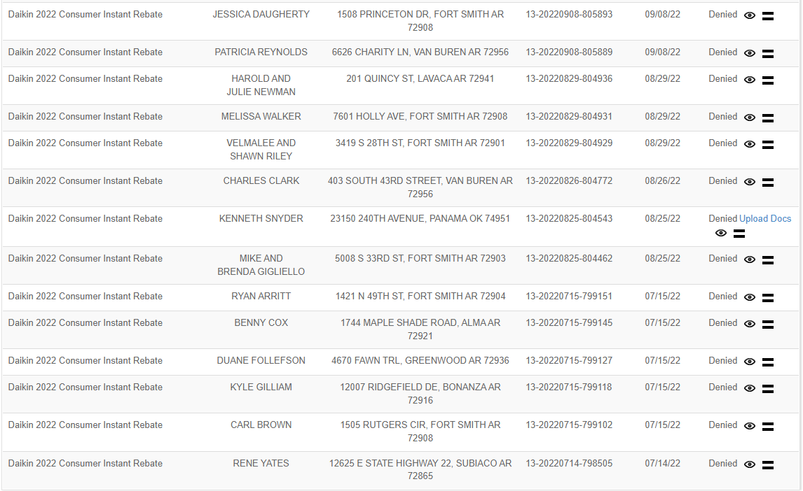

From: Britt, Jeff I. [mailto:Jeff.Britt@daikincomfort.com]
Sent: Thursday, November 17, 2022 9:08 AM
To: Grigg, Jason K. <Jason.Grigg@daikincomfort.com>; Vines, Leonard S. <Scott.Vines@daikincomfort.com>
Cc: Jeremy Chandler <jchandler@egia.org>
Subject: Re: [EXTERNAL] Rebates Denied

Thank you!!

Jeff Britt
Region Manager
Mid-South
M: 407-616-1767 | E: jeff.britt@daikincomfort.com

19001 Kermier Road | Waller, TX, 77484
https://northamerica-daikin.com
#Ignite2022

From: Grigg, Jason K. <Jason.Grigg@daikincomfort.com>
Sent: Thursday, November 17, 2022 11:01:28 AM
To: Vines, Leonard S. <Scott.Vines@daikincomfort.com>
Cc: Britt, Jeff I. <Jeff.Britt@daikincomfort.com>; Jeremy Chandler <jchandler@egia.org>
Subject: RE: [EXTERNAL] Rebates Denied

Any outstanding claims are approved to process.

Scott…please work with Jeremy Chandler on any information his team needs to get this completed.

Thanks all!

Jason Grigg
Promotions Manager
M: 713.454.3251 | E: jason.grigg@daikincomfort.com
  
19001 Kermier Road | Waller, TX, 77484
https://northamerica-daikin.com

From: Vines, Leonard S. <Scott.Vines@daikincomfort.com>
Sent: Tuesday, November 15, 2022 7:01 PM
To: Radabaugh, Rachael N. <Rachael.Radabaugh@daikincomfort.com>; Grigg, Jason K. <Jason.Grigg@daikincomfort.com>; Figura, Jumer J. <Jumer.Figura@daikincomfort.com>; Britt, Jeff I. <Jeff.Britt@daikincomfort.com>; Centeno, Alicia P. <Alicia.Centeno@daikincomfort.com>; Carreiro, Scott D. <Scott.Carreiro@daikincomfort.com>
Cc: Cornillaud, Mike <mike.cornillaud@daikincomfort.com>; Mastrangelo, David <David.Mastrangelo@daikincomfort.com>
Subject: RE: [EXTERNAL] Rebates Denied

Everyone,
Looking at the Companies that are owned by Hometown Services. The account numbers listed are the old account numbers and company names. They were given new account numbers when they changed their names.
They are as follows:

Martin- 106245 now is Airco- Ft Smith- 207004

Pearce- 202383
Jay’s- 100437 these three are now Airco Little Rock – 207003

Chenal- 100551

Air Control- 100029 now is Airco- NWA- 207000

Can this be why they haven’t been getting the rebates?
Thanks
Scott

Scott Vines
TSM Daikin Comfort Technologies
M: [479-461-3236] | E: scott.vines@daikincomfort.com
19001 Kermier Road | Waller, TX, 77484
https://northamerica-daikin.com

From: Radabaugh, Rachael N. <Rachael.Radabaugh@daikincomfort.com>
Sent: Monday, November 14, 2022 1:46 PM
To: Grigg, Jason K. <Jason.Grigg@daikincomfort.com>; Figura, Jumer J. <Jumer.Figura@daikincomfort.com>; Britt, Jeff I. <Jeff.Britt@daikincomfort.com>; Centeno, Alicia P. <Alicia.Centeno@daikincomfort.com>; Carreiro, Scott D. <Scott.Carreiro@daikincomfort.com>
Cc: Vines, Leonard S. <Scott.Vines@daikincomfort.com>; Cornillaud, Mike <mike.cornillaud@daikincomfort.com>; Mastrangelo, David <David.Mastrangelo@daikincomfort.com>
Subject: RE: [EXTERNAL] Rebates Denied

Hi Jason,

Please see attached. There are columns that specify what they should and should not have starting in column O.

Thank You!
Rachael Radabaugh
Key Accounts Analyst
M: (713) 806-5485 | T: (713) 263-5938 | E: Rachael.Radabaugh@daikincomfort.com
19001 Kermier Road | Waller, TX, 77484
https://northamerica-daikin.com


CONFIDENTIALITY NOTE: The information contained in this transmission is intended only for use by the intended recipient and may contain confidential or proprietary information. If the reader of this message is not the intended recipient, you are hereby notified that any dissemination, distribution or copying of this communication is strictly prohibited. If you have received this transmission in error, please immediately reply to the sender that you have received this communication in error and then delete it. Thank you.

From: Grigg, Jason K. <Jason.Grigg@daikincomfort.com>
Sent: Monday, November 14, 2022 9:59 AM
To: Figura, Jumer J. <Jumer.Figura@daikincomfort.com>; Britt, Jeff I. <Jeff.Britt@daikincomfort.com>; Centeno, Alicia P. <Alicia.Centeno@daikincomfort.com>; Carreiro, Scott D. <Scott.Carreiro@daikincomfort.com>
Cc: Vines, Leonard S. <Scott.Vines@daikincomfort.com>; Cornillaud, Mike <mike.cornillaud@daikincomfort.com>; Radabaugh, Rachael N. <Rachael.Radabaugh@daikincomfort.com>; Mastrangelo, David <David.Mastrangelo@daikincomfort.com>
Subject: RE: [EXTERNAL] Rebates Denied
Importance: High

I still haven’t received the list of PE dealers from our call couple of weeks ago.

Jason Grigg
Promotions Manager
M: 713.454.3251 | E: jason.grigg@daikincomfort.com
19001 Kermier Road | Waller, TX, 77484
https://northamerica-daikin.com

From: Figura, Jumer J. <Jumer.Figura@daikincomfort.com>
Sent: Monday, November 14, 2022 8:04 AM
To: Britt, Jeff I. <Jeff.Britt@daikincomfort.com>; Centeno, Alicia P. <Alicia.Centeno@daikincomfort.com>; Carreiro, Scott D. <Scott.Carreiro@daikincomfort.com>
Cc: Vines, Leonard S. <Scott.Vines@daikincomfort.com>; Grigg, Jason K. <Jason.Grigg@daikincomfort.com>
Subject: RE: [EXTERNAL] Rebates Denied

I am going to let Scott speak more about this but in general, if they are a PE member their DCP benefits such as instant rebates and finance buydown is nullified because of the high back end programs they are receiving and pricing. I would hate to do one off stuff such as netting their DCP programs with their back end programs as it will be a mess. Also their corporate folks will need to sign off on it.

Scott, anything to add…
Thanks.

Jumer

From: Britt, Jeff I. <Jeff.Britt@daikincomfort.com>
Sent: Monday, November 14, 2022 7:56 AM
To: Centeno, Alicia P. <Alicia.Centeno@daikincomfort.com>; Carreiro, Scott D. <Scott.Carreiro@daikincomfort.com>
Cc: Vines, Leonard S. <Scott.Vines@daikincomfort.com>; Figura, Jumer J. <Jumer.Figura@daikincomfort.com>; Grigg, Jason K. <Jason.Grigg@daikincomfort.com>
Subject: Re: [EXTERNAL] Rebates Denied

Thanks All for your help, please advise on further information needed from our end.

Jeff Britt
Region Manager
Mid-South
M: 407-616-1767 | E: jeff.britt@daikincomfort.com

19001 Kermier Road | Waller, TX, 77484
https://northamerica-daikin.com
#Ignite2022

From: Centeno, Alicia P. <Alicia.Centeno@daikincomfort.com>
Sent: Monday, November 14, 2022 7:08:25 AM
To: Carreiro, Scott D. <Scott.Carreiro@daikincomfort.com>
Cc: Britt, Jeff I. <Jeff.Britt@daikincomfort.com>; Vines, Leonard S. <Scott.Vines@daikincomfort.com>; Figura, Jumer J. <Jumer.Figura@daikincomfort.com>; Grigg, Jason K. <Jason.Grigg@daikincomfort.com>
Subject: Re: [EXTERNAL] Rebates Denied

Thank you Scott, I appreciate that. I’m also going to include Jason as he manages all promotions and the process.

Kindly, Alicia
Sent from my iPhone

On Nov 13, 2022, at 9:42 PM, Carreiro, Scott D. <Scott.Carreiro@daikincomfort.com> wrote:
﻿ 
Alicia,
Center Oak (Hometown) is eligible for consumer rebates (we pay 50%) or the finance buydown, I looked at their program this evening. Finance is going to need to look into this.

,

 | Fits your comfort. Fits your budget. Fits your space. Fits your life.  Get Fit Every Day. Click here to see the New Daikin Fit System.  Do you know how much energy you can save? Click here to find out!

From: Britt, Jeff I. <Jeff.Britt@daikincomfort.com>
Sent: Sunday, November 13, 2022 1:52 PM
To: Centeno, Alicia P. <Alicia.Centeno@daikincomfort.com>
Cc: Carreiro, Scott D. <Scott.Carreiro@daikincomfort.com>; Vines, Leonard S. <Scott.Vines@daikincomfort.com>
Subject: FW: [EXTERNAL] Rebates Denied

Alicia,

I have this customer, Airco, that is part of the Center Oak Private Investment group and they have had a number of issues when it comes to getting consumer instant rebates paid, as Airco also purchases from the Johnstone’s in Tulsa, OK. This has been an issue and our TSM, Scott Vines, has gathered the consumer rebates in question. A few notes for you on this account, at one point because the Airco corporate team is based out of Tulsa, they were initially working the Johnstone Tulsa group doing various rebate inputting which we found out and had to have them work with our COD teams in Arkansas. This PE was set-up this last March for us and we have struggled the first half of the year trying to get all the details right to be smooth in the processing.
So, the question is there a process to get these consumer rebates paid so we don’t jeopardize future business? I have cc’d Scott, so he is aware of the issues this group has had.
Thanks,
Jeff Britt
Region Manager
Mid-South
M: 407-616-1767 | E: jeff.britt@daikincomfort.com
19001 Kermier Road | Waller, TX, 77484
https://northamerica-daikin.com
#Ignite2022

From: Vines, Leonard S. <Scott.Vines@daikincomfort.com>
Sent: Friday, November 11, 2022 5:46 PM
To: Britt, Jeff I. <Jeff.Britt@daikincomfort.com>
Subject: FW: [EXTERNAL] Rebates Denied

Jeff,
This is a screen shot of the consumer rebates that are being denied due to them being filed past the date allowed.. I’ve sent this to you before and I don’t know if they have gotten an exception. Chase told Buford that they need to get them paid. We are in danger of having the Fit taken off their price book offering.
I’ll reach out to Chase Monday to find out about the warranty rebates he said he isn’t getting. He never called me.
Thanks
Scott

Scott Vines
TSM Daikin Comfort Technologies
M: [479-461-3236] | E: scott.vines@daikincomfort.com
19001 Kermier Road | Waller, TX, 77484
https://northamerica-daikin.com

From: Christina Gregory <cgregory@aircoservice.com>
Sent: Friday, November 11, 2022 1:11 PM
To: Vines, Leonard S. <Scott.Vines@daikincomfort.com>
Subject: [EXTERNAL] Rebates Denied

Scott,

Here is the list of rebates that we discussed:

Please let me know.

Thank you,

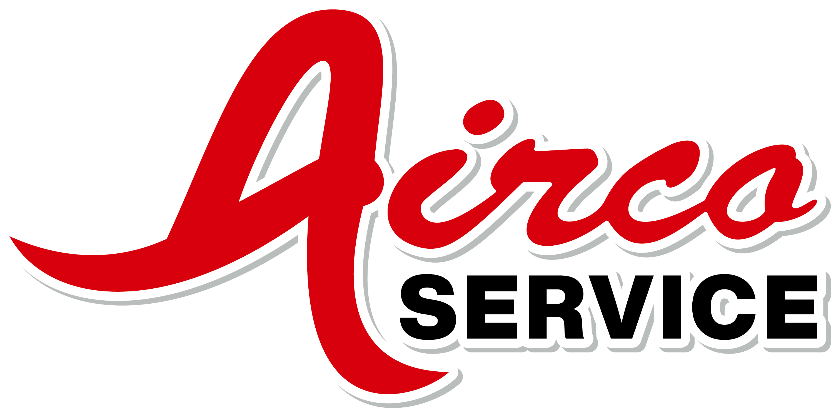
Christina Gregory
Office Manager
512 South Fresno
Fort Smith, AR 72916
PH: 479-785-4444
Cell: 479-629-0831

