 | Jeremy Chandler  Regional Manager  Cell: 916-759-0515

From: Steve Stalvey [mailto:steve.stalvey@jmwoodhvac.com]
Sent: Thursday, January 20, 2022 11:22 AM
To: Grigg, Jason K. <Jason.Grigg@daikincomfort.com>
Cc: Jeremy Chandler <jchandler@egia.org>
Subject: RE: [EXTERNAL] FW: EGIA - Claims Denied

Thank you Jason.


  Steve Stalvey
  Director of Daikin Dealers
  T: 843-662-8781 | M: 843-409-2768
  E: steve.stalvey@jmwoodhvac.com
  1802 Trade St | Florence, SC 29501

From: Grigg, Jason K. <Jason.Grigg@daikincomfort.com>
Sent: Thursday, January 20, 2022 1:51 PM
To: Steve Stalvey <steve.stalvey@jmwoodhvac.com>
Cc: Jeremy Chandler <jchandler@egia.org>
Subject: Re: [EXTERNAL] FW: EGIA - Claims Denied

Sounds good. Approved to pay in full. Please forward this email. I’ve copied Jeremy Chandler, as well. Thanks all.

Get Outlook for iOS

From: Steve Stalvey <steve.stalvey@jmwoodhvac.com>
Sent: Thursday, January 20, 2022 12:45:34 PM
To: Grigg, Jason K. <Jason.Grigg@daikincomfort.com>
Subject: [EXTERNAL] FW: EGIA - Claims Denied

Jason,

My DCP (Coastline Heating & Cooling) reached out to EGIA to find out why these were denied and Sandra told her that they were not filed in time, but that I could approve them. I had never heard this before so I called and Sandra told me that you might give us an exception. This customer has just put an office manager in place and she is learning the programs and trying to clean up their books. If you could give us a one-time exception it would be appreciated.

Thanks!

Steve Stalvey
Director of Daikin Dealers
T: 843-662-8781 | M: 843-409-2768
E: steve.stalvey@jmwoodhvac.com
1802 Trade St | Florence, SC 29501

From: Andrew Veigel <coastlineheatandcooling@gmail.com>
Sent: Thursday, January 20, 2022 12:57 PM
To: Steve Stalvey <steve.stalvey@jmwoodhvac.com>
Subject: EGIA - Claims Denied

Hi Steve, per our conversation, I reached out to the EGIA claims rebate representative and mentioned the Territory Sales Manager, (which is you), can make exceptions to the following claims submitted to EGIA. Most were denied because EGIA received them after the program end date. I've attached their registrations for your reference.
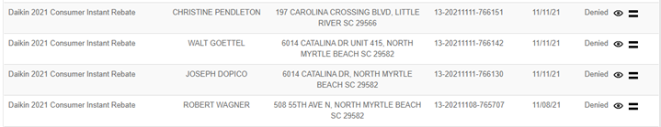

Please let me know if you need any more information.
Thank you,
Linda Keasler
843-399-5555



