Jeremy Chandler






To:​Dealer Rebates​
Cc:​blake harrison <harrisonheatingandcooling@gmail.com>​
Wed 11/15/2023 6:39 PM
EGIA Team, please see below. When you have a chance please deny claims 850720, and 850709. These were resubmitted under the Dealers Choice program. New claim numbers are 882129 and 882130 and have an exception from Daikin to be paid in full under the Dealers Choice program. New Invoice has been uploaded for claim 881212, this should be good to approve now. Please let us know once all are approved.

Jeremy Chandler
EGIA
916-759-0515

From: blake harrison <harrisonheatingandcooling@gmail.com>
Sent: Wednesday, November 15, 2023 4:07 PM
To: Jeremy Chandler <jchandler@egia.org>
Subject: Re: DKNG Claims

Thank you,

881212- copy of company invoice has been added to the claim (install date 10/12/23)

850720- resubmitted under the Dealer’s Choice Program under Donald Leavell with copy of customer invoice (install date 4/19/23)

850709- resubmitted under the Dealer’s Choice Program under Adrian Noriega Aldave with copy of customer invoice (install date 4/25/23)

Hopefully this will suffice. Let me know if there is anything else we can do.

Harrison Heating & Air

On Wed, Nov 15, 2023 at 4:51 PM Jeremy Chandler <jchandler@egia.org> wrote:
Hi Blake,
We can also accept a copy of your Invoice/Contract with the customer as long as it includes: Your company name, customer name and address, date, model & serial numbers, and lists the $1,100 Daikin rebate given to the customer including that deduction off the final price. Both this or the copy of the Daikin Product Registration Certificate are required for approval. Listed in the Terms & Conditions from Daikin below.

The warranty docs that were submitted do not show the customer name or address. Your Invoice/Contract with the customer would work though. Do you have those available?

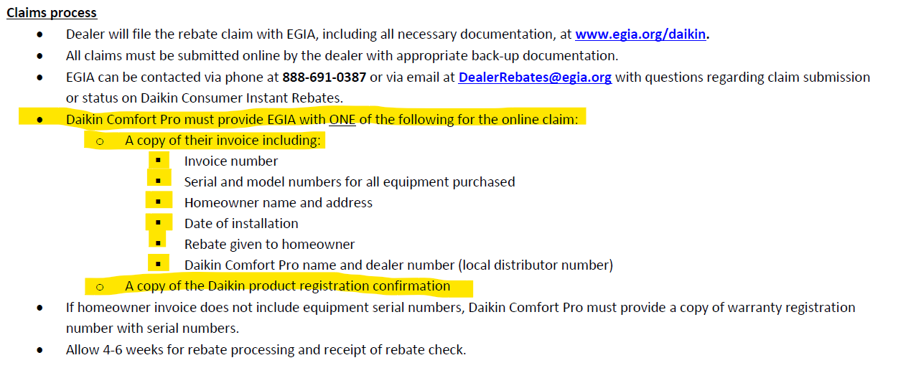

Jeremy Chandler
EGIA
916-759-0515

From: blake harrison <harrisonheatingandcooling@gmail.com>
Sent: Wednesday, November 15, 2023 1:06 PM
To: Jeremy Chandler <jchandler@egia.org>
Subject: DKNG Claims

Good afternoon,

This is Harrison Heating & Air. We recently received an email from Mr. Gregg Hamm telling us what needs to be done in order to get some denied claims approved. He told us the following…

For the claims under “Claims Submitted” here are the statuses. Jason – two claims that were supposed to be entered on Dealers Choice, another denied because it was late, would you be OK with us approving on exception? If so, Gregg, they will need to resubmit under Dealers Choice with the correct Product Registration Certs:

881212 – Claim submitted today, has not been reviewed yet. I took a look and the FIT Model/Serial is not listed on the Product Registration. It is listed on the AEC Invoice, but the customer info is not listed on that document. Can you please upload the Product Registration Cert with the FIT Model/Serial?
851898 – Claim denied per dealer’s request on 6/26. They meant to enter under the Dealers Choice program, which they did, and claim #852143 was approved and paid already.
850720 – Claim denied (on hold) – the Registration Certs uploaded were the Warranty Registration Certs which does not have customer name/address. BUT this was also supposed to be submitted under the Dealers Choice program. Do they want to re-submit and if so, Jason would you be ok with us approving?
850709 – Same as above. Also not entered under Dealers Choice. Do they want to re-submit and if so, Jason would you be ok with us approving?
826216 – Same as above, however this Install date was 9/5/2022 so not Dealers Choice. That said, it was entered late on 1/19/2023 (would be paid at half if they can get us the corrected docs, Jason would you approve paying in full?)
714818 – Claim denied, submitted late. This claim is from 2020. Installed 9/16/2020, last day to submit for full payment was 10/15, and half 10/31.”

For 881212- the customer himself registered the product himself, but I can upload the warranty from the Daikin warranty look-up page on the Daikin website, but it won’t have all the information.

For 850720, 850709, and 826216- can they be reapproved with the provided documents? Or can we provide to you via email customer information?

Thank you for your help,

Harrison Heating & Air

