ReplyReply (R / Ctrl+R) Reply to this message.
Reply allReply all (Shift+R / Ctrl+Shift+R) Reply all to this message.
ForwardForward (Shift+F / Ctrl+Shift+F) Forward this message.
Read / UnreadRead / Unread (Ctrl+Q / Ctrl+U) Mark this message as read or unread.
CategorizeCategorize (C) Categorize this item. Categories applied to a conversation will be applied to all current and future items in the conversation.
Flag / UnflagFlag / Unflag Flag or unflag this message.
Print Print this email.


RE: [EXTERNAL] EGIA rebates
Working on it

MN
Mark Naylor <parts@powellac.com>






To:​Jeremy Chandler;​Dealer Rebates​
Cc:​Carrie Buege​
Wed 12/6/2023 6:37 AM

SKM_36823120608500.pdf
936 KB

See attached invoices for claim numbers 885722 and 863412.

Thank you for all your help Jeremy!

Kaylee Glidden | Data Entry & Permitting
Powell Heating & Air Conditioning, Inc.



2610 Dobbs Rd.
St. Augustine, Fl. 32086
904-794-2665 office

From: Jeremy Chandler [mailto:jchandler@egia.org]
Sent: Tuesday, December 05, 2023 6:33 PM
To: Dealer Rebates; Mark Naylor
Cc: Carrie Buege
Subject: FW: [EXTERNAL] EGIA rebates

EGIA Team, please see below for claim numbers for Daikin One Thermostats. Powell AC has an exception from Daikin for these late claims to be paid in full.

Kaylee, for claim numbers 885722 and 863412 we can also accept a copy of your Invoice / Contract showing the Daikin One Thermostat model number and rebate given to the homeowner. You can upload that to the rebate portal or reply all with those attached if easier.

Jeremy Chandler
EGIA
916-759-0515

From: Mark Naylor <parts@powellac.com>
Sent: Tuesday, December 5, 2023 7:22 AM
To: Jeremy Chandler <jchandler@egia.org>
Subject: RE: [EXTERNAL] EGIA rebates

Here are the claim numbers for the tstats:

824678 – Claim Number: DCP13-20231205-885701 (Install date: 01/09/23) - The furthest I could go back was 04/01/23

849116 – Claim Number: DCP13-20231205-885721 (Install date: 06/13/23)

849321 – Claim Number: DCP13-20231205-885722 (Install date: 06/13/23) – same issue as claim #863412 (tstat not on registration certificate)

850003 – Claim Number: DCP13-20231205-885723 (Install date: 06/16/23)

Thank you,

Kaylee Glidden | Data Entry & Permitting
Powell Heating & Air Conditioning, Inc.

2610 Dobbs Rd.
St. Augustine, Fl. 32086
904-794-2665 office

From: Jeremy Chandler [mailto:jchandler@egia.org]
Sent: Thursday, November 30, 2023 11:40 AM
To: Carrie Buege; Mark Naylor; Dealer Rebates
Cc: 'Casacci, Mark'
Subject: RE: [EXTERNAL] EGIA rebates

Awesome, thanks Carrie!

Kaylee, just need the correct Product Registration Cert for 863412, and need to submit the 5 stat claims and send over the claim numbers and we can approve.

Jeremy Chandler
EGIA
916-759-0515

From: Carrie Buege <cbuege@egia.org>
Sent: Thursday, November 30, 2023 7:10 AM
To: Jeremy Chandler <jchandler@egia.org>; Mark Naylor <parts@powellac.com>; Dealer Rebates <dealerrebates@egia.org>
Cc: 'Casacci, Mark' <Mark.Casacci@daikincomfort.com>
Subject: RE: [EXTERNAL] EGIA rebates

Jeremy,

I have updated the claim to include the indoor unit and have sent it over to accounting for a reissue. Nothing is required by the dealer at this time.

Thank you,

 | Carrie F.Buege  Rebate Processing Supervisor  888-691-0387

From: Jeremy Chandler <jchandler@egia.org>
Sent: Wednesday, November 29, 2023 7:39 PM
To: Mark Naylor <parts@powellac.com>; Dealer Rebates <dealerrebates@egia.org>; Carrie Buege <cbuege@egia.org>
Cc: 'Casacci, Mark' <Mark.Casacci@daikincomfort.com>
Subject: RE: [EXTERNAL] EGIA rebates

Thanks Kaylee! However, for claim 863412 the Warranty Registration Cert provided does not include the homeowners name/address on it. We need a Product Registration Cert with customer name/address and Stat Model. Example attached.

For the 5 thermostat rebates that were approved by Daikin, please enter those as new claims. Select IAQ Products, and enter the Daikin One Stat model. Will need to upload the Product Registration Certs with models and customer info. Please send us the claim numbers once submitted.

EGIA Team, for claim 860148, any thoughts on how the additional dollars can be claimed:
Claim 860148 was already approved and paid as a Daikin Outdoor Only (plus Daikin one stat) claim. The dealer entered the claim as an Outdoor only but did in fact have an Indoor unit installed and meant to submit as a full system rebate.

How would you prefer the dealer enter so we can make them whole? Would it be better to submit as a new claim and then manually adjust the amount to $400 back to the dealer? Or can we add the Indoor model on the current claim and add $400 as a check re-issue?

Jeremy Chandler
EGIA
916-759-0515

From: Mark Naylor <parts@powellac.com>
Sent: Tuesday, November 28, 2023 4:40 AM
To: 'Casacci, Mark' <Mark.Casacci@daikincomfort.com>; Jeremy Chandler <jchandler@egia.org>
Subject: RE: [EXTERNAL] EGIA rebates

Good morning,

863412 – Denied after no response. Claim missing Model Number for the Daikin One Thermostat, it was not included on the Product Registration or Invoice. Can be reviewed if Powell can send us a copy of Product Registration with the Daikin One Thermostat. Rebate would be $625 total if so. See attached document for correction. Thank you!

860148 – Rebate paid at $225. Daikin FIT Outdoor only model submitted on claim, $300 rebate, 50% = $150. Plus Daikin One Thermostat $150, 50% = $75. Total rebate $225. Indoor system was not included on the claim submission so was paid as the FIT Outdoor model only. There is no way I can edit what was already submitted. Should I just re submit everything again?

Thank you,

Kaylee Glidden | Data Entry & Permitting
Powell Heating & Air Conditioning, Inc.

2610 Dobbs Rd.
St. Augustine, Fl. 32086
904-794-2665 office

From: Casacci, Mark [mailto:Mark.Casacci@daikincomfort.com]
Sent: Friday, November 17, 2023 11:21 AM
To: Mark Naylor
Subject: FW: [EXTERNAL] EGIA rebates

Details on each claim below. For a majority of them, they are not adding the Daikin One Thermostat to the claim, so they are not receiving the $75 for the stat. I have included instructions below for how to include the Daikin One Thermostat on the claim, however for Q4 they don’t need to do this since the Free Daikin One is a branch/purchase credit with a PC Code.

For all of the claims that are missing the Daikin One Thermostat, they are all from prior Quarters. Jason, would you be OK approving 5 Daikin One Thermostat claims for Powell as an exception? Mark it was approved…

Mark, please check the notes on the highlighted claims and pass along to Powell for update or possible corrections:

786148 – Rebate paid at $500. FIT Rebate was $1,000 at that time, 50% = $500. Daikin One Thermostat was not entered on the claim submission.
821811 – Approved (today) for $625. Claim was flagged as duplicate address with the claim below. Updated to Approved for the FIT system.
821813 – Paid at $75. Claim was submitted as just the Daikin One Thermostat. Same address/customer as 821811 above.
824678 – Rebate paid at $550. FIT Rebate was $1,100 at the time, 50% = $550. Daikin One Thermostat was not entered on the claim submission.
849116 – Rebate paid at $550. FIT Rebate was $1,100 at the time, 50% = $550. Daikin One Thermostat was not entered on the claim submission.
849321 – Rebate paid at $550. FIT Rebate was $1,100 at the time, 50% = $550. Daikin One Thermostat was not entered on the claim submission.
850003 – Rebate paid at $550. FIT Rebate was $1,100 at the time, 50% = $550. Daikin One Thermostat was not entered on the claim submission.
863412 – Denied after no response. Claim missing Model Number for the Daikin One Thermostat, it was not included on the Product Registration or Invoice. Can be reviewed if Powell can send us a copy of Product Registration with the Daikin One Thermostat. Rebate would be $625 total if so.
860148 – Rebate paid at $225. Daikin FIT Outdoor only model submitted on claim, $300 rebate, 50% = $150. Plus Daikin One Thermostat $150, 50% = $75. Total rebate $225. Indoor system was not included on the claim submission so was paid as the FIT Outdoor model only.

Instructions for future reference if a Daikin One Thermostat Rebate to the homeowner/dealer is brought back:

FIT Entered, now click on Add Products again:
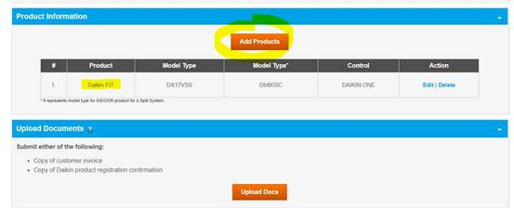

Select IAQ Systems as Product, then Daikin One Stat, enter Model:
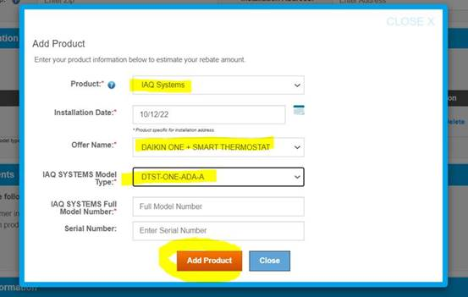

Now we have both the FIT System AND Daikin One Stat on the claim:
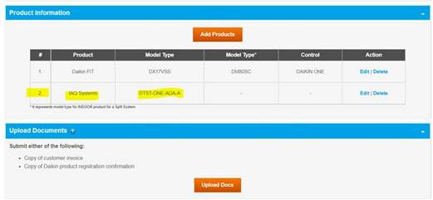

Jeremy Chandler
EGIA
916-759-0515

From: Casacci, Mark <Mark.Casacci@daikincomfort.com>
Sent: Wednesday, November 1, 2023 12:54 PM
To: Grigg, Jason K. <Jason.Grigg@daikincomfort.com>; Jeremy Chandler <jchandler@egia.org>; Carrie Buege <cbuege@egia.org>
Subject: RE: [EXTERNAL] EGIA rebates

Thank you, Jason

From: Grigg, Jason K. <Jason.Grigg@daikincomfort.com>
Sent: Wednesday, November 1, 2023 3:53 PM
To: Jeremy Chandler <jchandler@egia.org>; Carrie Buege <cbuege@egia.org>
Cc: Casacci, Mark <Mark.Casacci@daikincomfort.com>
Subject: FW: [EXTERNAL] EGIA rebates

Pulling in Jeremy and Carrie from EGIA. Thanks.

Jason Grigg
Promotions Manager
M: 713.454.3251 | E: jason.grigg@daikincomfort.com
  
19001 Kermier Road | Waller, TX, 77484
https://northamerica-daikin.com

From: Casacci, Mark <Mark.Casacci@daikincomfort.com>
Sent: Wednesday, November 1, 2023 2:50 PM
To: Grigg, Jason K. <Jason.Grigg@daikincomfort.com>
Subject: FW: [EXTERNAL] EGIA rebates

Jason,
Could you please help me with my customers request or point me in the right direction.
Thank you,
Mark

From: Mark Naylor <parts@powellac.com>
Sent: Wednesday, November 1, 2023 3:23 PM
To: Casacci, Mark <Mark.Casacci@daikincomfort.com>
Subject: [EXTERNAL] EGIA rebates

Hey Mark,

We have tried reaching out to Daikin@egia regarding these rebates. I am now reaching out to you to see if you know of someone who you could reach out to that could help us with this.
Please see attached statement. Some claims are partially paid or not paid at all. If these have been paid in full could they provide the dates and check numbers, and an explanation as to why the full amount was not paid.

Thank you,

Kaylee Glidden | Data Entry & Permitting
Powell Heating & Air Conditioning, Inc.

2610 Dobbs Rd.
St. Augustine, Fl. 32086

