Jeremy Chandler
To:
- jason.grigg@daikincomfort.com;
- Dealer Rebates;
- Carrie Buege
Cc:
- Tompkins, Meredith A. <Meredith.Tompkins@daikincomfort.com>
Wed 8/23/2023 1:29 PM
Awesome thanks! EGIA Rebate team, please approve claims below when you have a chance. The dealer will be submitting more claims shortly, please note that they have an exception to submit with customer name listed as “TJIPOGTOTJG Band”.

14-20230712-856715
14-20230712-856652
18-20230326-851932
18-20230626-851920
14-20230516-843238
14-20220203-775328

Jeremy Chandler
EGIA
916-759-0515

From: Grigg, Jason K. <Jason.Grigg@daikincomfort.com>
Sent: Wednesday, August 23, 2023 1:24 PM
To: Jeremy Chandler <jchandler@egia.org>; Tompkins, Meredith A. <Meredith.Tompkins@daikincomfort.com>
Cc: Dealer Rebates <dealerrebates@egia.org>; Carrie Buege <cbuege@egia.org>
Subject: RE: [EXTERNAL] FW: Denied Rebate Claims

Approved. Thanks.

Jason Grigg
Promotions Manager
M: 713.454.3251 | E: jason.grigg@daikincomfort.com
  
19001 Kermier Road | Waller, TX, 77484
https://northamerica-daikin.com

From: Jeremy Chandler <jchandler@egia.org>
Sent: Wednesday, August 23, 2023 2:11 PM
To: Grigg, Jason K. <Jason.Grigg@daikincomfort.com>; Tompkins, Meredith A. <Meredith.Tompkins@daikincomfort.com>
Cc: Dealer Rebates <dealerrebates@egia.org>; Carrie Buege <cbuege@egia.org>
Subject: RE: [EXTERNAL] FW: Denied Rebate Claims

Yes, each individual homeowner received the rebate.

Jeremy Chandler
EGIA
916-759-0515

From: Grigg, Jason K. <Jason.Grigg@daikincomfort.com>
Sent: Wednesday, August 23, 2023 11:24 AM
To: Jeremy Chandler <jchandler@egia.org>; Tompkins, Meredith A. <Meredith.Tompkins@daikincomfort.com>
Cc: Dealer Rebates <dealerrebates@egia.org>; Carrie Buege <cbuege@egia.org>
Subject: RE: [EXTERNAL] FW: Denied Rebate Claims

Was the rebate offered on each?

Jason Grigg
Promotions Manager
M: 713.454.3251 | E: jason.grigg@daikincomfort.com
19001 Kermier Road | Waller, TX, 77484
https://northamerica-daikin.com

From: Jeremy Chandler <jchandler@egia.org>
Sent: Wednesday, August 23, 2023 1:20 PM
To: Grigg, Jason K. <Jason.Grigg@daikincomfort.com>; Tompkins, Meredith A. <Meredith.Tompkins@daikincomfort.com>
Cc: Dealer Rebates <dealerrebates@egia.org>; Carrie Buege <cbuege@egia.org>
Subject: [EXTERNAL] FW: Denied Rebate Claims

Hey there! Please see below. Bob’s Heating & Cooling in Moncton NB submitted six claims that were installed on an Indigenous Reserve and product was registered with customer name “TJIPOGTOTJG Band”. They were installed at individual homeowners homes but not registered as such.

Would you be willing to grant an exception for these? The dealer has more to claim as well but wanted to get the OK first before submitting. Here’s a screenshot of what is on the Registration Certificate:

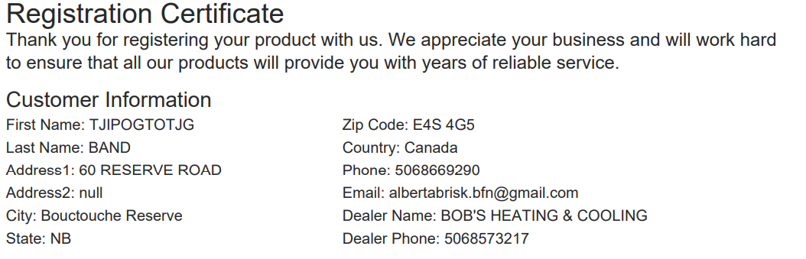

Jeremy Chandler
EGIA
916-759-0515

From: Beth Munro <bmunro@emcoltd.com>
Sent: Wednesday, August 23, 2023 10:46 AM
To: Jeremy Chandler <jchandler@egia.org>
Subject: RE: Denied Rebate Claims

Hi Jeremy, checking in with you on this. Thanks so much,

Beth

From: Beth Munro
Sent: August 14, 2023 11:33 AM
To: Jeremy Chandler <jchandler@egia.org>
Subject: Denied Rebate Claims

Hi Jeremy,

Hope you had a relaxing weekend! I wanted to ask if you could take a look at the claim numbers below. These are installs at individual homes, however they are on a local Indigenous Reserve, and therefore the homes are legally owned by the Band. They definitely would not be considered commercial properties. This dealer has more claims to submit but we wanted to get your approval first before moving forward. Also, just wanted to mention that an email was not generated alerting the dealer of a claim denial, they just logged on and noticed. Can we get notifications turned on for future instances like this?

Thank you for your help!!!

14-20230712-856715
14-20230712-856652
18-20230326-851932
18-20230626-851920
14-20230516-843238
14-20220203-775328

Beth Munro  Regional Programs Manager  Atlantic Canada | 
Counter: 902.468.9911 (call or text)  Cell: 902.818.6685  Email: bmunro@emcoltd.com  https://youtu.be/VxxYqE4Gil8 | EMCO HVAC-133  42 Borden Avenue  Dartmouth, NS B3B 1C8

