TERNAL] Approval Request Equipment Rebates
Working on it



You replied on Tue 12/12/2023 11:18 AM
You replied on Tue 12/12/2023 11:18 AM
JC
Jeremy Chandler






To:​Dealer Rebates;​Carrie Buege​
Cc:​Jason K. Grigg <Jason.Grigg@daikincomfort.com>;​+1 other​
Tue 12/12/2023 10:52 AM
EGIA Team, please see below. Please approve all claims listed with this exception. Please confirm once approved.

Jeremy Chandler
Regional Manager, EGIA
916-759-0515

Please excuse typos, sent from a mobile device
Begin forwarded message:
From: "Grigg, Jason K." <Jason.Grigg@daikincomfort.com>
Date: December 12, 2023 at 7:46:57 AM PST
To: Beth Munro <bmunro@emcoltd.com>, Jeremy Chandler <jchandler@egia.org>
Subject: RE: [EXTERNAL] Approval Request Equipment Rebates
﻿
Approved to pay all in full. Thanks all.

Jason Grigg
Promotions Manager
M: 713.454.3251 | E: jason.grigg@daikincomfort.com
  
19001 Kermier Road | Waller, TX, 77484
https://northamerica-daikin.com

From: Beth Munro <bmunro@emcoltd.com>
Sent: Tuesday, December 12, 2023 9:31 AM
To: Grigg, Jason K. <Jason.Grigg@daikincomfort.com>; Jeremy Chandler <jchandler@egia.org>
Subject: [EXTERNAL] Approval Request Equipment Rebates

Hi Jeremy and Jason, can I please ask for a special exception on these claims? This first address is a group home for adults with intellectual disabilities where they live together, and learn life and work skills. They are setting up an additional building for high functioning adults to live somewhat independently while still on the property.

The second set of claims are for residential properties, but they are billed through the Clean Foundation, which is a non-profit org that helps low income homeowners retrofit their homes with green upgrades.
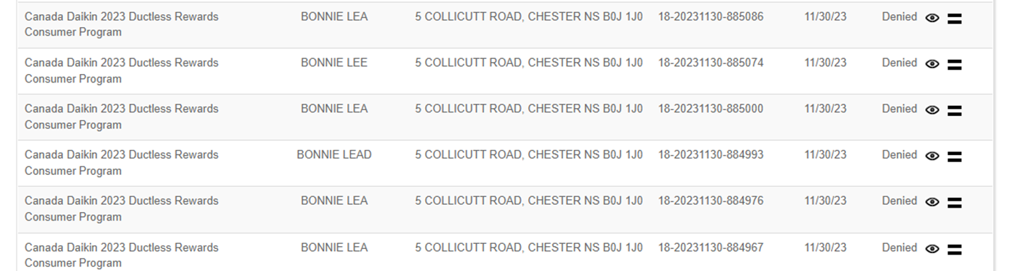

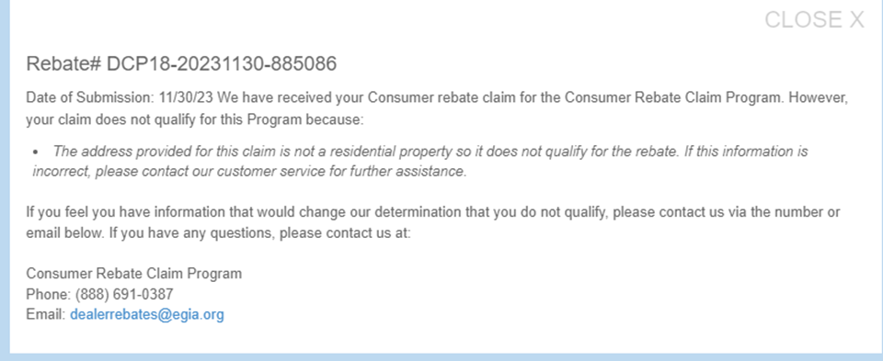

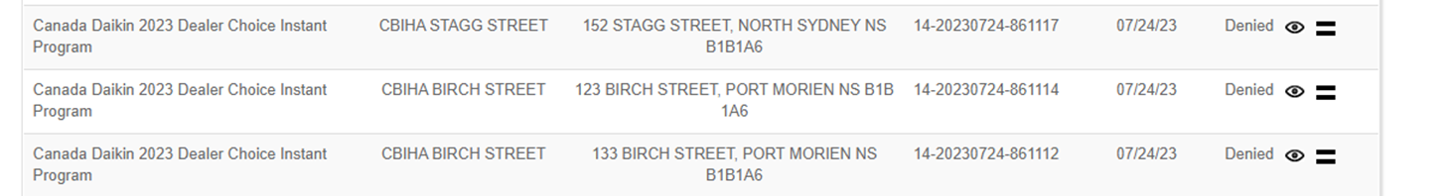

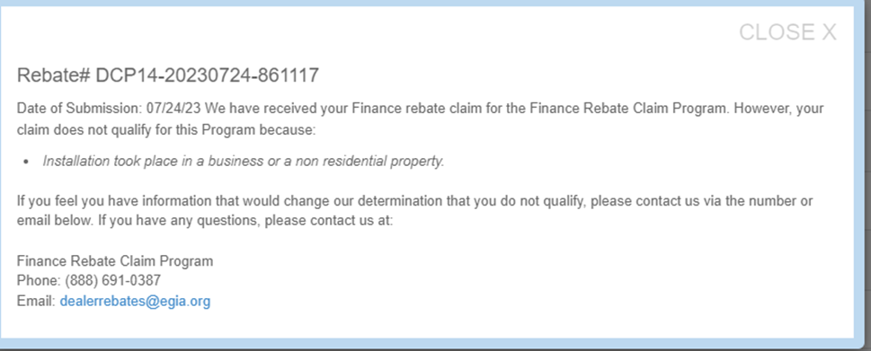

Beth Munro  Regional Programs Manager  Atlantic Canada | 
Counter: 902.468.9911 (call or text)  Cell: 902.818.6685  Email: bmunro@emcoltd.com  https://youtu.be/VxxYqE4Gil8 | EMCO HVAC-133  42 Borden Avenue  Dartmouth, NS B3B 1C8

