Jeremy Chandler

Reply
Reply all
Forward


To:​Dennis Lewis <DennisL@johnstonecg.com>;​Dealer Rebates​
Cc:​Dottavio, Kyle <Kyle.Dottavio@daikincomfort.com>;​Grigg, Jason <Jason.Grigg@daikincomfort.com>;​Brianna Lyle​
Fri 6/28/2024 4:03 PM
Hey Dennis, please have the dealer send the claim numbers over for each claim and we will approve with this exception. Note, the dealer can easily pull the claim numbers by logging in, clicking on “Reports”, then select Daikin 2024 Consumer Instant Rebate under “Program”, then click “Download Detail”. This will pull up an Excel file they can copy/paste the rebate numbers into an email. Please be sure to include dealerrebates@egia.org when they send them over. Image below of Reports screen:

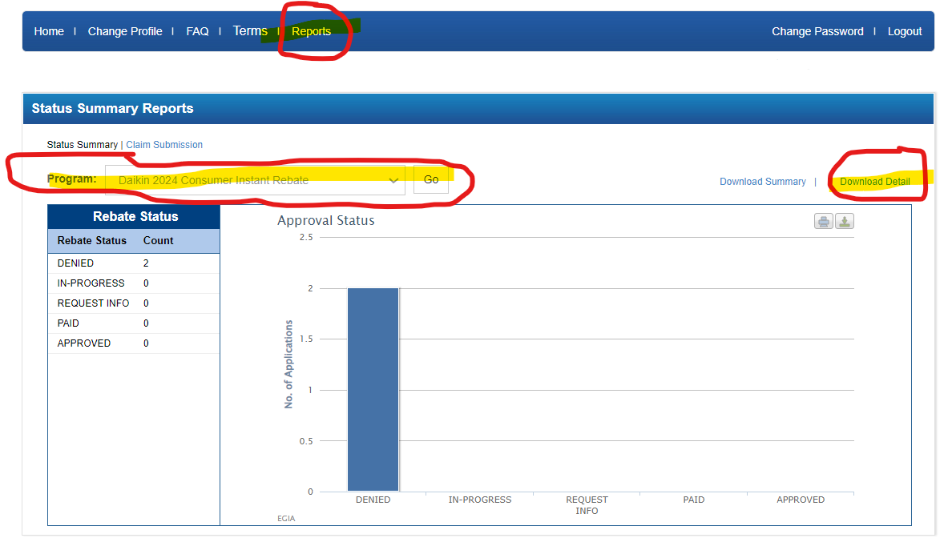

Jeremy Chandler
EGIA
916-759-0515

From: Dennis Lewis <DennisL@johnstonecg.com>
Sent: Friday, June 28, 2024 1:45 PM
To: Grigg, Jason <Jason.Grigg@daikincomfort.com>
Cc: Jeremy Chandler <jchandler@egia.org>; Dottavio, Kyle <Kyle.Dottavio@daikincomfort.com>
Subject: RE: [EXTERNAL] FW: EGIA REBATE ISSUES

Jason thank you very much.

Jeremy is there anything I need to do on my end?

Dennis Lewis
Product Manager
Cell: 515-422-8567
Office: 402-339-2342

Johnstone Supply – Cafferty Group
NE: Omaha - Lincoln - Kearney
IA: Des Moines - Davenport – Ames-Waterloo - Cedar Rapids
KS: Topeka
CO: Grand Junction - Durango
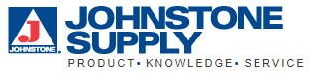

From: Grigg, Jason <Jason.Grigg@daikincomfort.com>
Sent: Friday, June 28, 2024 3:32 PM
To: Dennis Lewis <DennisL@johnstonecg.com>
Cc: Jeremy Chandler <jchandler@egia.org>; Dottavio, Kyle <Kyle.Dottavio@daikincomfort.com>
Subject: RE: [EXTERNAL] FW: EGIA REBATE ISSUES

CAUTION: This email originated outside of the organization. Do not click links or open attachments unless you are expecting this email and know the contents are safe.

I’ll approve as a one time exception. Thanks all.

Jason Grigg
Promotions Manager
Marketing – Customer Experience – Promotions
M: 713.454.3251 | E: jason.grigg@daikincomfort.com
  
19001 Kermier Road | Waller, TX, 77484
https://northamerica-daikin.com

From: Dennis Lewis <DennisL@johnstonecg.com>
Sent: Friday, June 28, 2024 3:25 PM
To: Grigg, Jason <Jason.Grigg@daikincomfort.com>
Cc: Jeremy Chandler <jchandler@egia.org>; Dottavio, Kyle <Kyle.Dottavio@daikincomfort.com>
Subject: [EXTERNAL] FW: EGIA REBATE ISSUES

Jason this is not a normal request this was a job I thought would qualify for the rebate.
Is there anything we can do to get this approved? I know this is a big ask this company is now focusing on Fit as their main focus this is a newer DCP Bek and Call dealer # 19594

Please let me know if you have any questions

Dennis Lewis
Product Manager
Cell: 515-422-8567
Office: 402-339-2342

Johnstone Supply – Cafferty Group
NE: Omaha - Lincoln - Kearney
IA: Des Moines - Davenport – Ames-Waterloo - Cedar Rapids
KS: Topeka
CO: Grand Junction - Durango

From: Adam Bek <bekandcall.llc@gmail.com>
Sent: Friday, June 28, 2024 1:15 PM
To: Dennis Lewis <DennisL@johnstonecg.com>
Subject: EGIA REBATE ISSUES

CAUTION: This email originated outside of the organization. Do not click links or open attachments unless you are expecting this email and know the contents are safe.

Here are the Daikin Warranty Registration Certificates for16 systems that EGIA is having issues with allowing the rebate because they don't fall under their guidelines of "owner occupied"

Hopefully this can be easily sorted out.
I did include the rebate in my original bid per your says so, so the client has already seen the discount.
