- Follow the link below.
https://dkng.conservationrebates.com/dealer-portal/
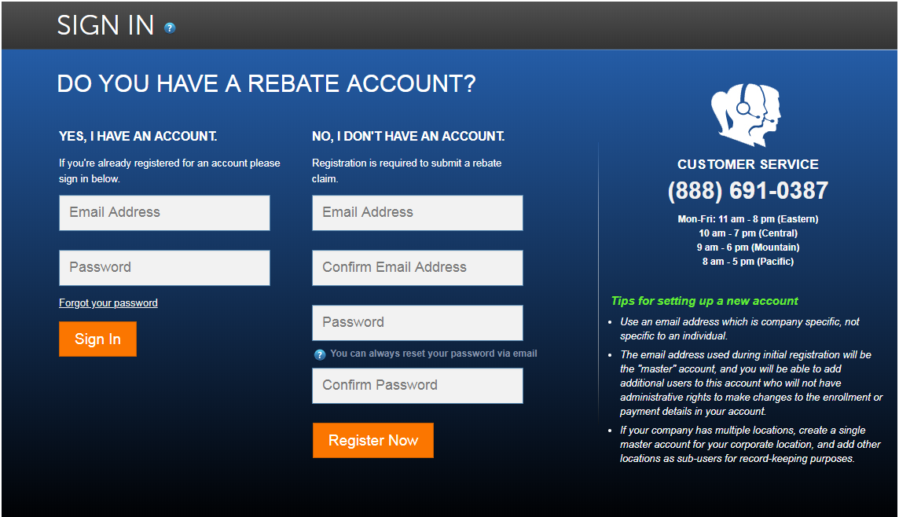
- If you already have an account then you will login by entering your Email and Password on the left hand side and press “Sign In”.
- If you are a new Dealer, then you will create an account on the right hand side under “No, I don’t have an account” Enter an Email Address, Confirm Email Address, enter Password, Confirm Password then press “Register Now”

- User Profile
Once logged in you will be prompted to fill out your “User Profile” all sections highlighted in yellow on the screen shot below need to be filled out.
NOTES:
- “Dealer Number” can be found on an invoice from your distributor under your Customer Number. It should be the exact same number on all invoices from your distributor.
- Once you enter the Business Zip, press “TAB” on the keyboard. This will generate the City and State to Auto Populate, which will also allow you to select the “Program Participation”
- Primary Email should already be entered per it’s the same email you used to create the account. ***If you ever need to add Additional Users you will login to this account***
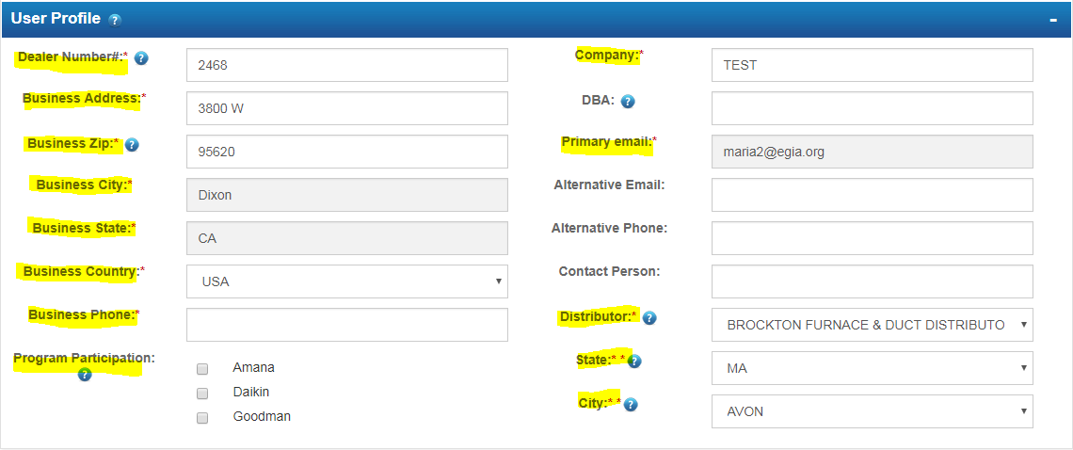
- Program Participation
Select the programs you will be submitting rebates under (Amana, Daikin, Goodman) once selected each will give you a drop down to select the “Rebate Programs” select all that apply.
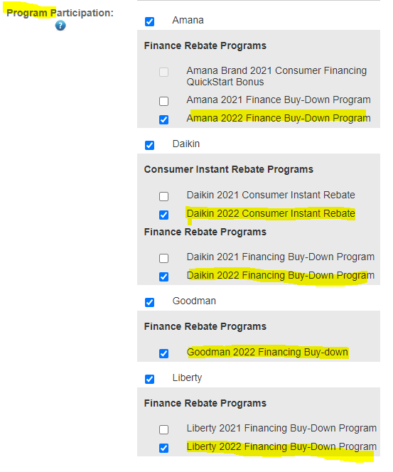

- Additional Users
You may add Additional Users if there will be multiple people submitting rebates. This way each person will have their own login account but all rebates will be tracked under one “Primary Account”
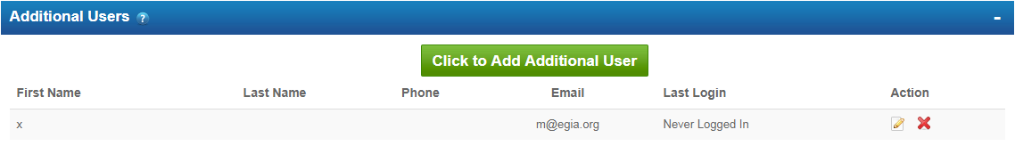
- Press the green button “Click to Add Additional User” a Pop Up window will appear. (screen shot below)
- Fill out all highlighted section shown on the screen shot below.
- Press “Add New”
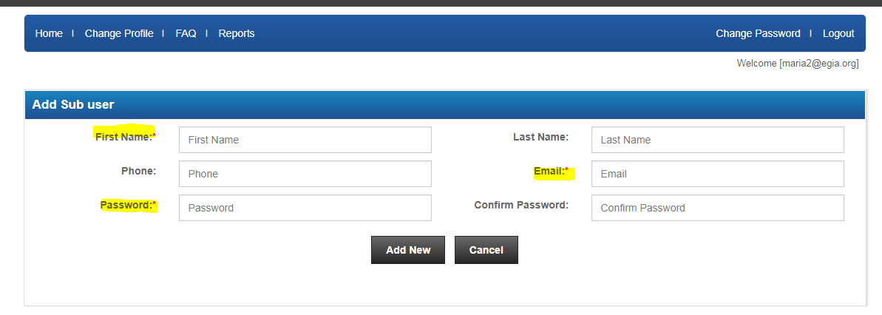
NOTES:
- Only the “Primary Account” Holder will have access to make changes within the “User Profile” Additional User accounts will only have access to enter and manage the rebates.
- The Primary Account holder may Delete Additional Users at any time by pressing the red “X” under Action .
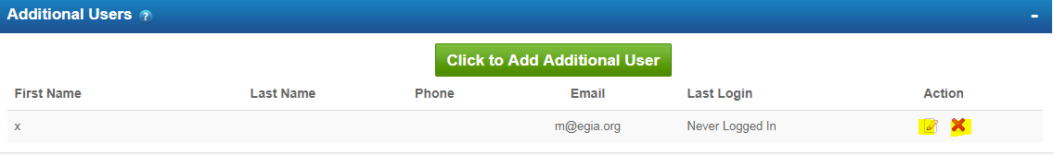

- Rebate Payment Information
Check: you will enter the mailing Address of where you would like the Rebate Checks to be sent.
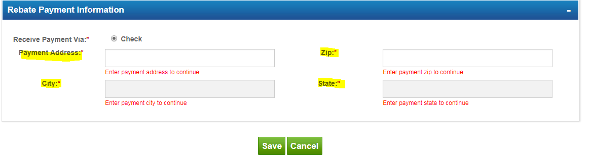
ACH: Enter the Bank account information where you would like the Rebates to be deposited.
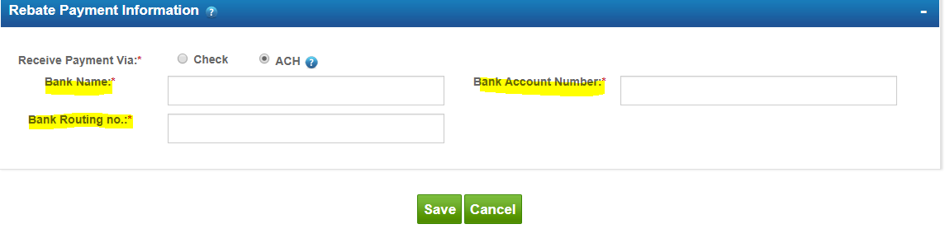
Make sure to press “Save” once all the above has been completely filled out. This will take you back to the home page.
- Rebate Home Page
You can manage your rebate submissions from your Rebate Home Page.
- You can search for rebate claims by entering the last 6 digits of the claim number in the “Search Section” located on the top right corner.
- Any claims listed under the “Claims to be Submitted” section are claims that have been Saved but not submitted. You may continue working on them by pressing the paper and pencil icon. Or you can delete them by pressing the red “X” to the far right under Action.
- “Claim Submitted” Section will include a list of claims that have been submitted and are in queue for review.
- “Claims Completed” will have the list of claims that have been processed and Approved.
- Use the “Pick a Claim and Press the green Button” section to select the rebate program and submit rebate claims.
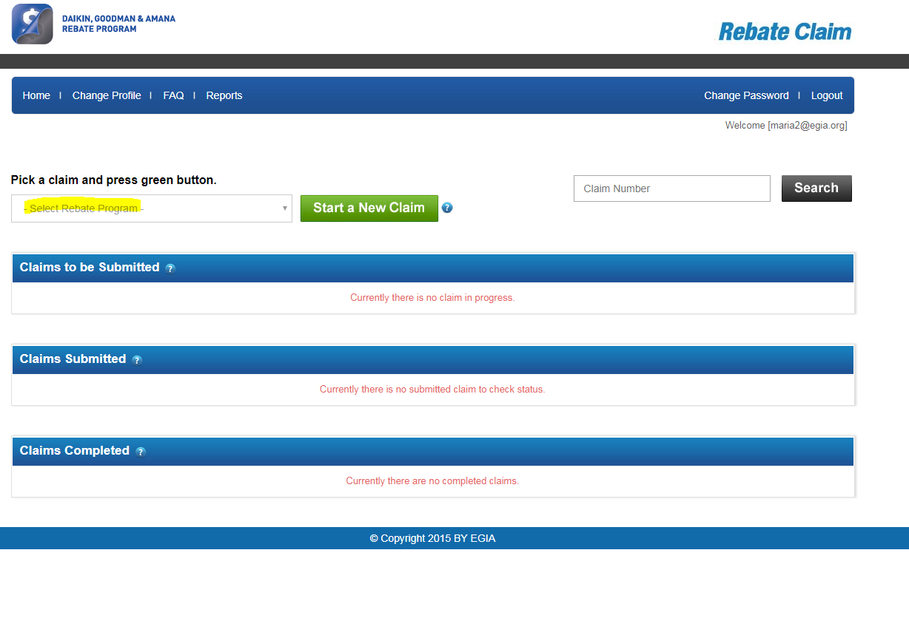
General Notes
- Use Google Chrome as the internet browser.
- It usually takes about 24-48 hours for Approval to submit rebates. If 48 hours pass and you still don’t have an option to submit rebates under the “Pick a Claim Section” give us a call as we might need to do a manual approval.
- You can always go back and edit your profile by selecting “Change Profile” from the Primary Account holder.
- If you ever need to change your Password, press the “Change Password” on the top right corner. Enter the old password and then enter and confirm the new password.
- Forget your password.
  - Select Forgot Password from the from the Rebate Portal login page.
  - Enter your email (the one associated with the account)
  - Press “Submit”
The system will send you an automatic email with a Temporary Password. Make sure to check all inboxes per sometimes auto generated emails go to the junk mail inbox.

