How to submit a Daikin Finance Buy-Down Claim
- Log in to your rebate portal: https://dkng.conservationrebates.com/dealer-portal/
- Select the program you would like to submit for under the Pick a Claim Section.
- Select the Green button: “Start New Claim”
  - 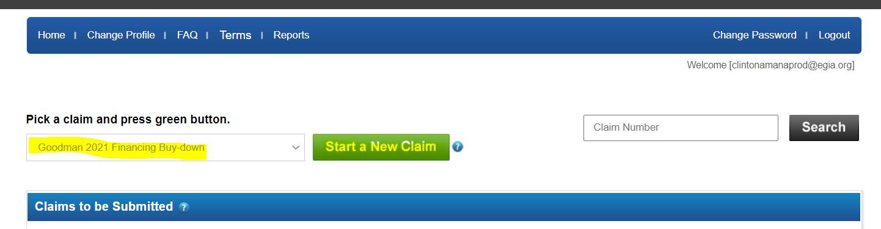
- Complete the installation information:
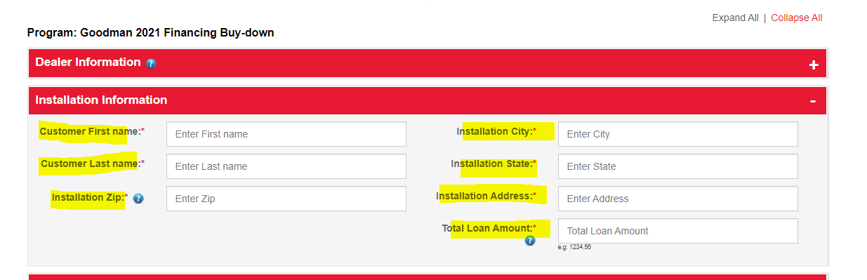
  - Enter:
    - Customer First Name
    - Customer Last name
    - Installation Zip
      - NOTE – once entered select TAB on your Keyboard and the installation City and State should auto populate
    - Installation Address
    - Total Funded loan amount
      - NOTE – no need to enter a dollar sign.
- Enter product information by selecting the orange “Enter Product” button.
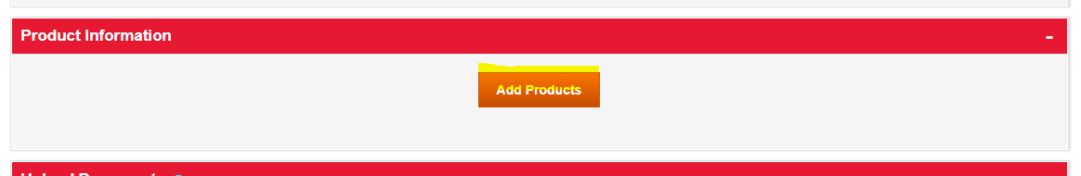
  - This should give you a pop up window, here you will need to select the type of product installed. NOTE – a complete system is not required.
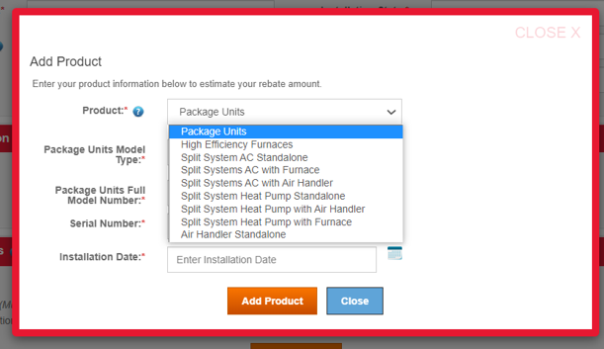
  - Once the product is selected you will need to enter model numbers and serial numbers, and installation date.
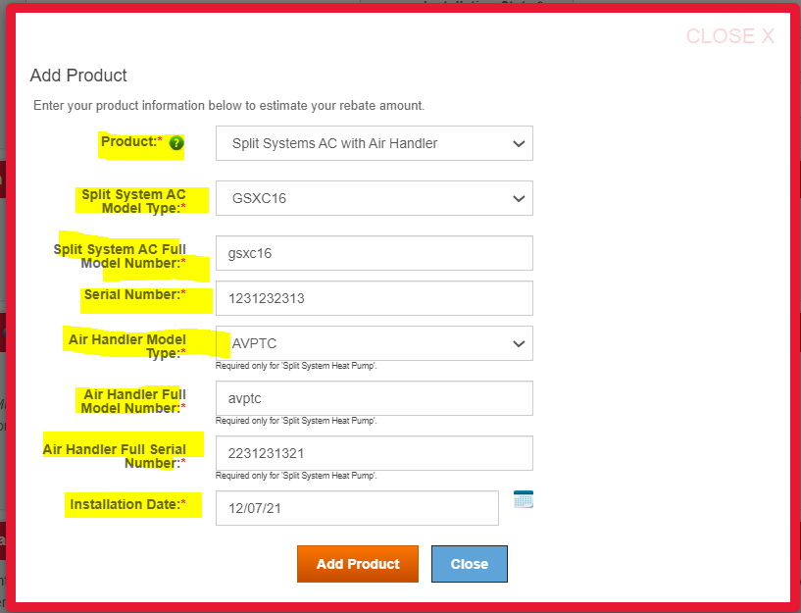
  - Once completed select “Add product”
- You will need to upload two documents.
  - Copy of the Contractor to Customer Invoice
    - Must show:
      - Company Heather
      - Customer First and Last Name
      - Complete Model numbers
      - Complete Serial numbers
      - Total Job cost
      - Date on invoice – which we will take as the installation date.
  - Copy of Funding proof
    - Should come directly from the Leander
    - Must show:
      - Merchant ID number with EGIA
      - Customer information
      - Total Funded Amount
      - Finance Plan number
      - Dealer fees
- Agree to the Certification Statement and Submit the Claim
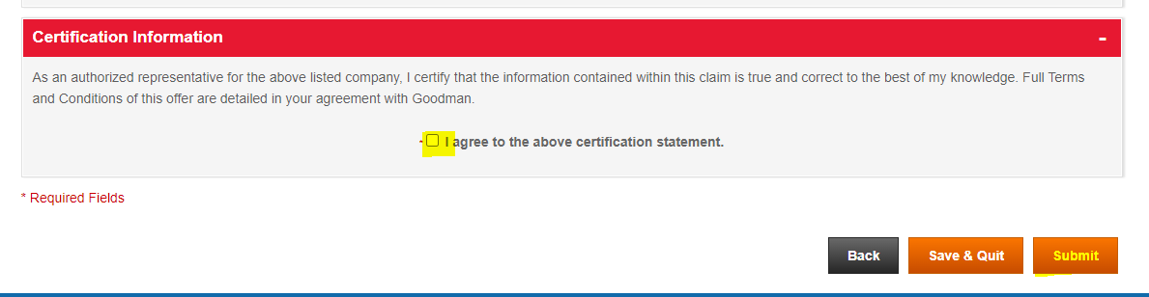
Contact Information
Phone: (888) 691-0387
Email: dealerrebates@egia.org

