Bridgepointe - Discovery Session #3
Talk desk 10 Am 11.15
I has there for half the meeting
Clinton
Tristan
Samantha
Notes
- Nice in contact
  - They are called Front Line
- Monday 9-11 mountain time
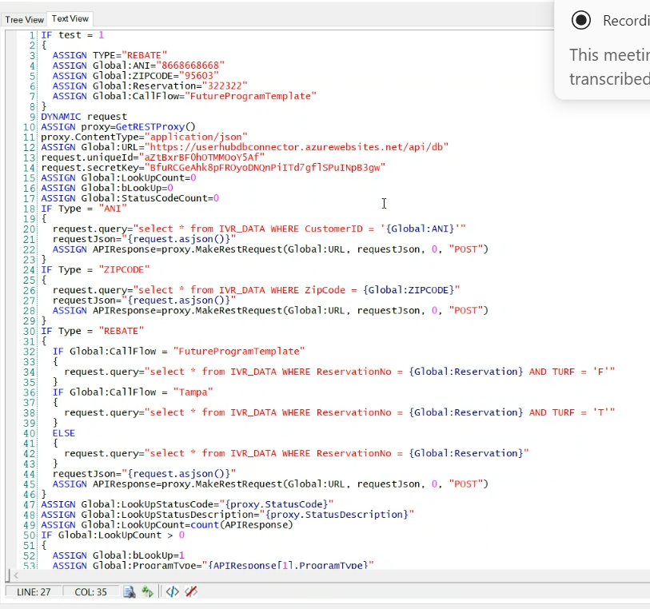

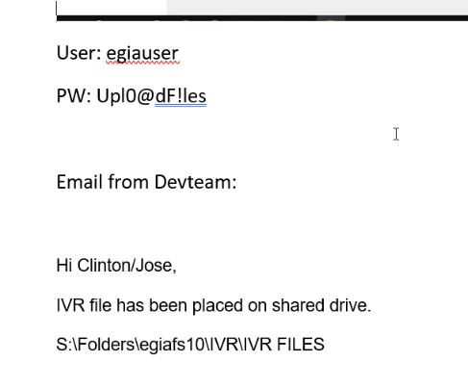
Tristan – needs to connect to our database some how
Is mssing the accecs token URL
Looks like an off server – not sure what is for it but seems like he needs it to tap in

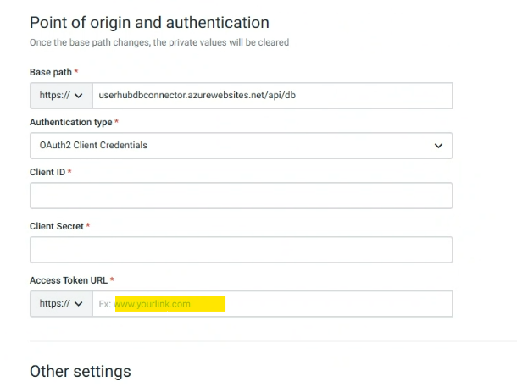

Next meeting Monday at 10AM
Sam to look for the proof of concept
She will add a folder – Pre sales Conversations
Calls and recordings are on the shared folder.

Recap
Went to the API and pull information for the JSON
He wants it to be Oracle – we want it too.
However if he goes on the website route – Does he need a toke.

