10.30.2024 at 2PM
Talk Desk team: Patricio, Waymen & JJ
Presenter: Waymen
- This is what the Agent can see:
  - Single pane of glass (workspace)
    - 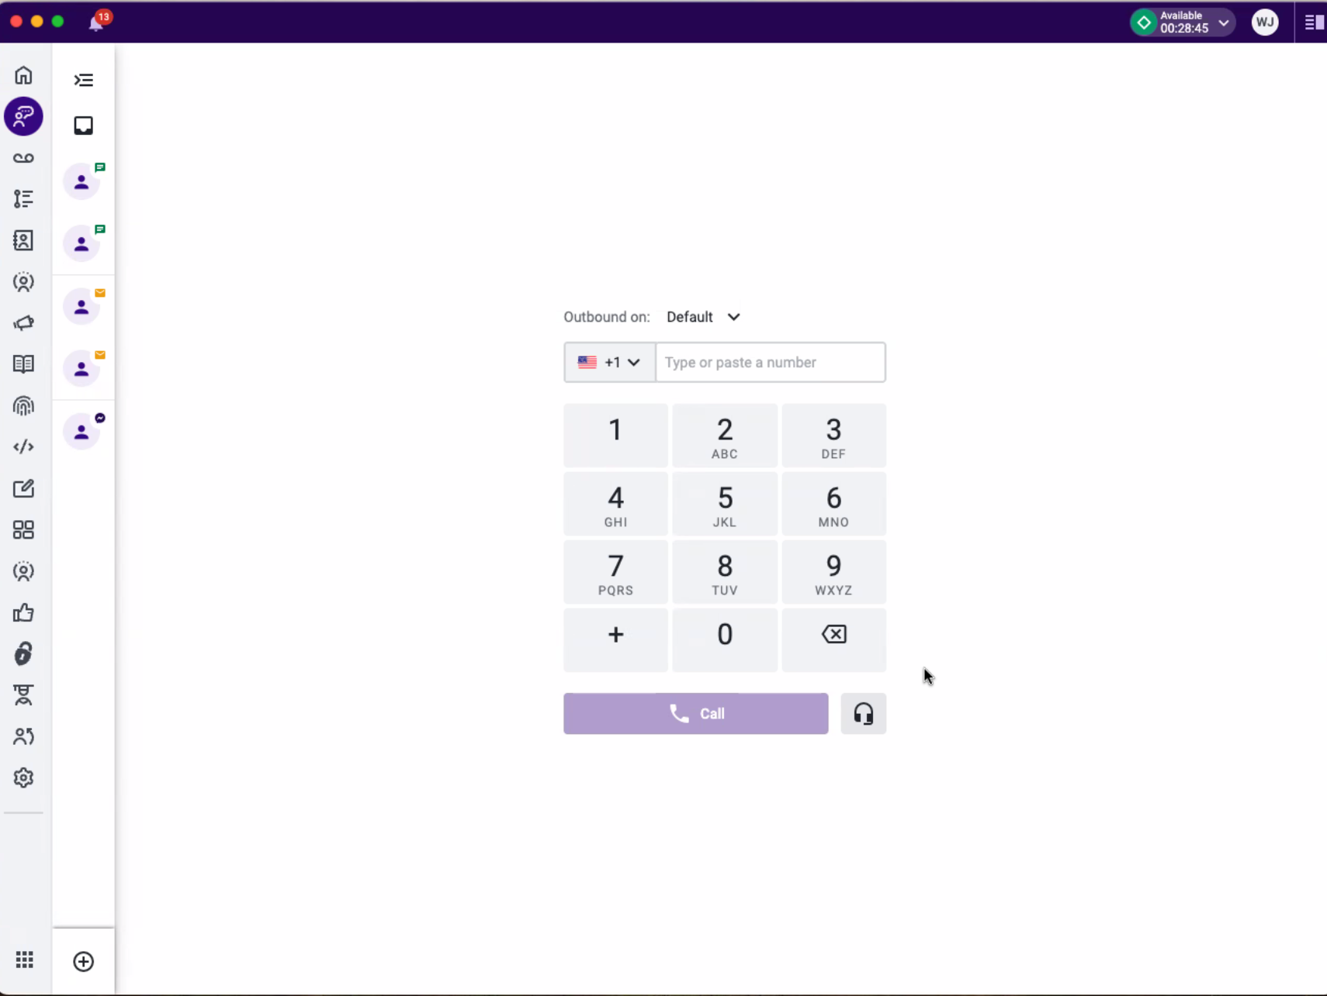
  - Supervisor are able to grant access to the agents to different permissions.
    - Conversations app – to make calls, SMS, Email
      - See assignments
      - Emails,
    - Voicemail
    - Activities
    - Contacts
  - To make a call
    - Call coming in
      - Client contact comes in
        - Data dibs can be added under the context card. Info that can be pulled from the DB to assist the caller.
    - Callback Scheduler
      - To set up a call back to the client within the workspace for a future call back set.
      - At the bottom: are the call controls.

    - 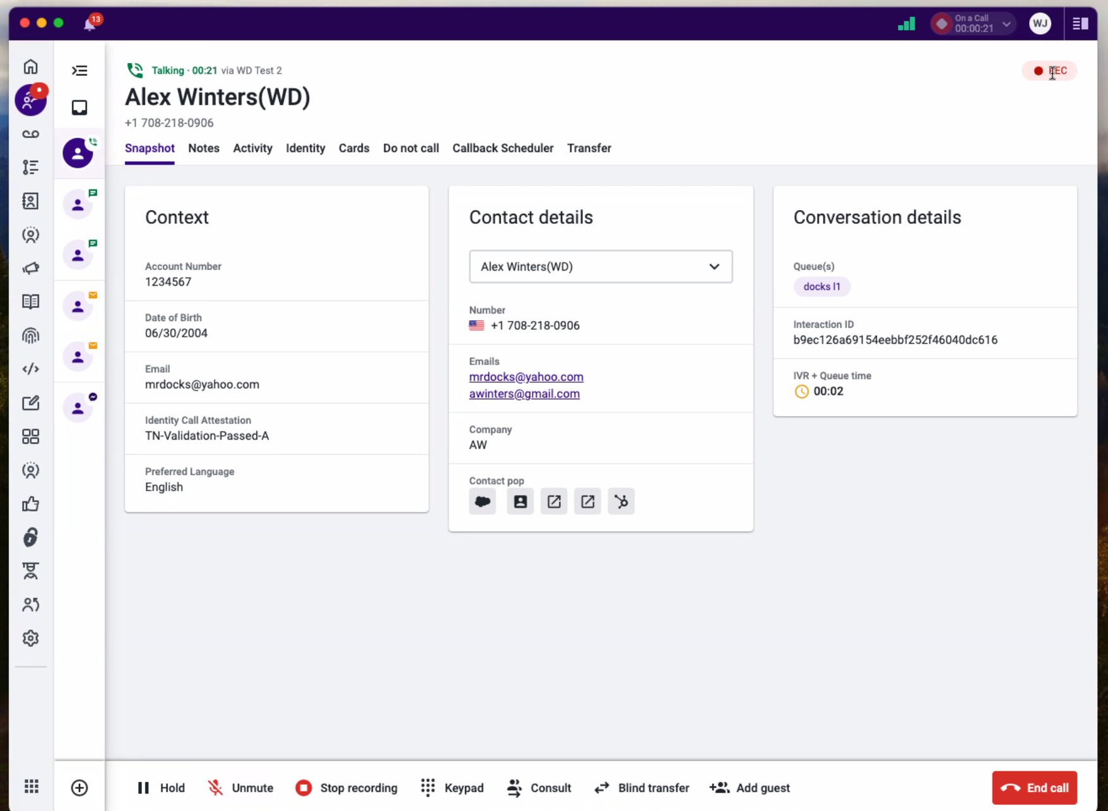

Inbound calls
- Can be integrated to Sales Force
  - Keep track of the interactions on there
  - 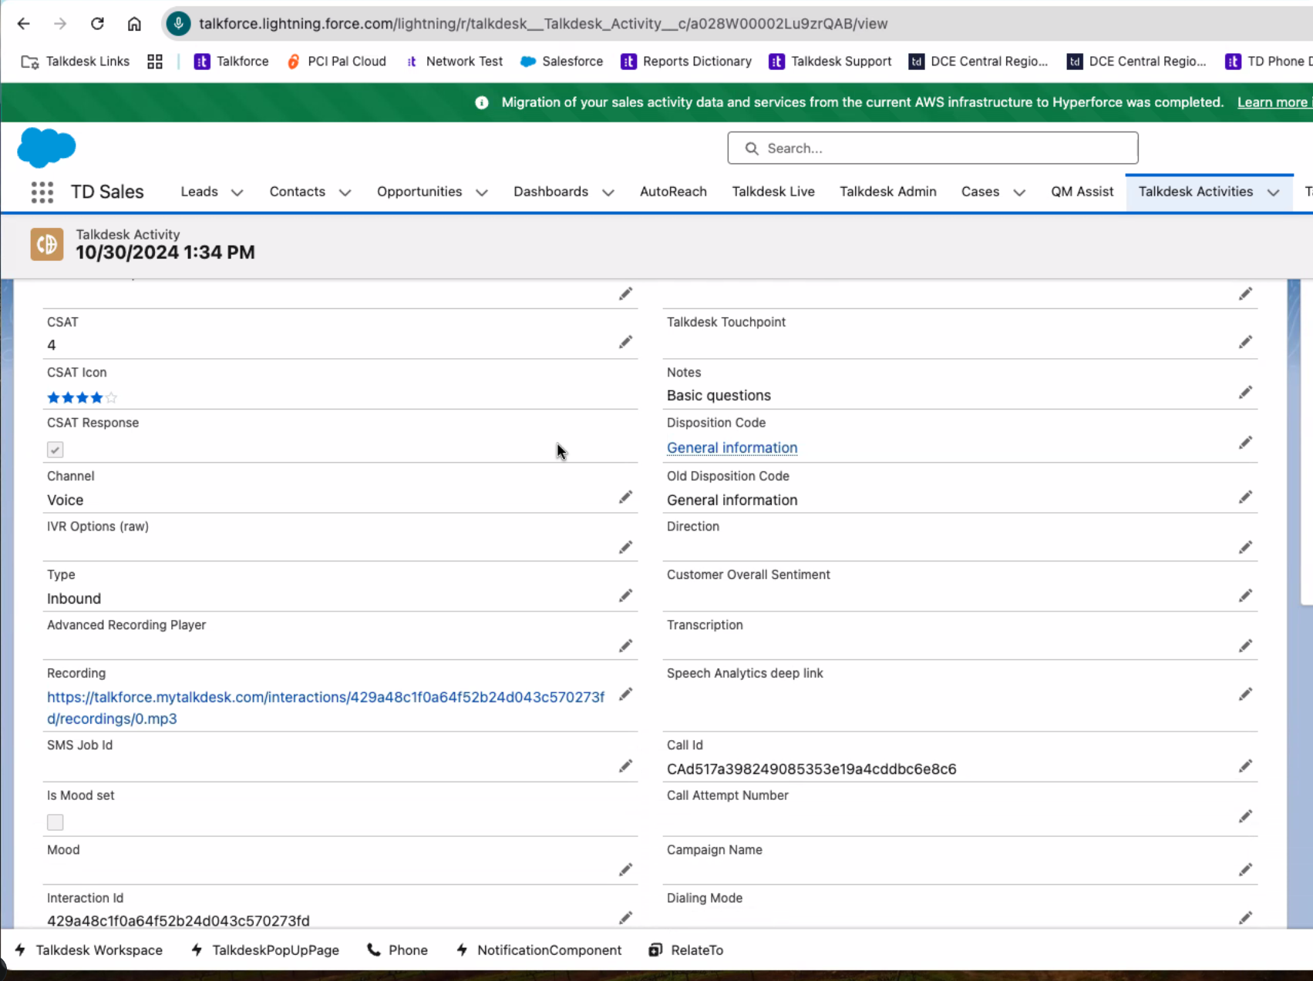
- Outbound calls from SF – yes, we can do that.
- Supervisor Dashboard
- We can set up automatic emails to go out via supervisor
  - Can be arranged differently for each department
- Each dashboard can have up to 16 widgets
  - You can edit the widgets that you have on your page.
    - Remove once they are no longer needed
    - You can set how they look and how to manage those.

- You can listen to call & barge in
- Live agent list and their status.
  - You can change them back to available from the supervisor mode.
- Explore
  - Access to reports & filters
  - You can create your own reports too
    - Out of the box reports – reports they have created
      - Has data dictornary & knowledge – so you know what you are looking at.
    - Set up automatic reporting by setting up a schedule delivery
You cand decide how long you want to keep the recording
Ther is a charge for the screen recording, but the voice recording is free.
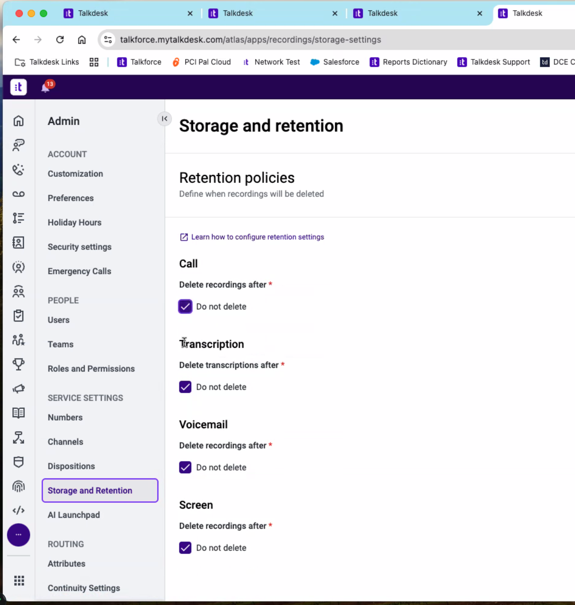
- We can purchase our own s3 bucket and they can place them all on there.
- Roles & Permissions
- Training – can we have
- Multiple users on the same call? Yes
- Talkdesk can have trainings – via academy.
- They will send us the link so that we can start playing with it. There is also a community where you can post questions.
These are interactive trainings with a test for the user to take.

