Bridgepoint – Talk Desk – Discovery call #3
11/18/2024
EGIA team: Clinton, Maria
Bridgepoint Reps: Samantha Sanchez, Tristan Bateman
Items needed prior to next meeting
Next call will be on Friday 11/22: The finalization of the process.
- Main status codes. @Clinton to provide & drop on colab folder.
- On Friday – most of the flow chart will be completed @Tristan to share flow during Friday meeting.
- We should be done with the discovery and planning phase soon.
Continue from last meeting:
- How are the calls supposed to route
- Struggling with the API Call – Tristan got it completed.
- 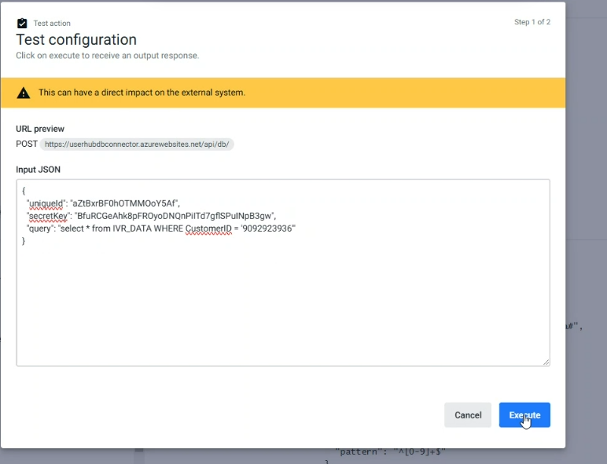

- Tristan is now getting a response from the API.
- 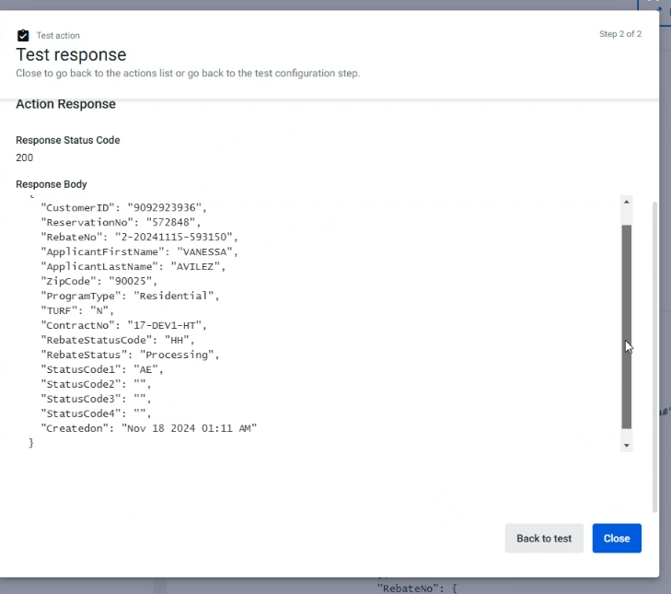
- @Tristan
  - Each one of these are search parameters
    - 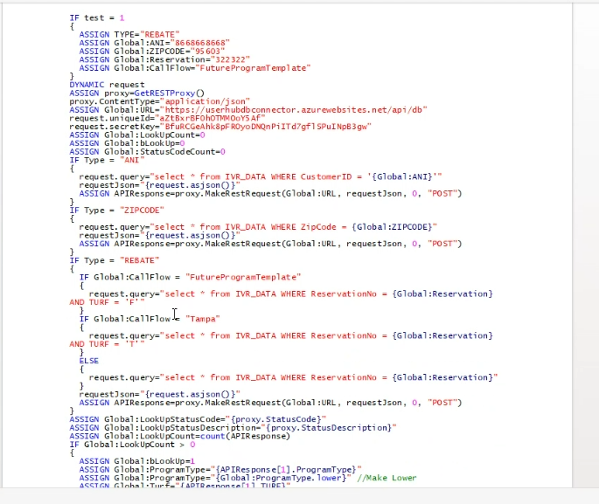
- API Lookup & we are using
  - ANI = Customer phone number.
  - What can I help you with? (Main Menu)
    - FAQ
    - Rebate lookup
      - Verify User by asking for the installation Zip code.
        - If we don’t find the caller via Zip code then it will get routed to the REP.
- Items to think about:
  - How do we determine which REP it goes to
  - What if there are multiple rebates with the same zip code & ANI.
    - System to notify caller, there are multiple rebates for this zip code, & to confirm if they would like to review all or just one.
      - If only one, then caller to provide claim number & System to return the claim status.
      - System to ask if there are any other claims that they would like to review.
    - If caller would like to get the status of all claims found,
      - System to go through all claims one by one providing the status.
        - If caller would like to skip the status of one of the claims and instead move to the next one, then caller to press a digit to skip.
  - Statuses
    - If any of the claims have a status = Denied.
      - Caller will get transferred to a CSR Rep.
    - If Claim status is any other than denied system to provide a status update.
      - Statuses
        - Processing
        - Completed
        - Request info
        - Paid
  - We will do the same with Tampa Bay using the DNIS value.

- General Info
  - Caller will use key touch to navigate the menu for rebate status instead of the Voice Command.
    - The voice command can be used in other places within the call flow.
    - Where is each call supposed to go based on the DNIS Value.

