Bridge Point – Talk Desk Discovery Session#2
11.14.2024 at 10 Am
EGIA Reps: Clinton, Maria
BridgePoint Reps: Samantha Sanchez, Tristan Bateman, Kim Waters
EGIA Tasks to complete prior to next meeting:

Meeting Notes
- Tristan Bateman:
  - PBX Users
    - Are those users who primaries &Talk Desk does not need to build a flow for them.
    - Agents who will most likely not be taking calls.
  - VM
    - Customization of the VM is easy
    - Talk desk users – There is no way to do email notifications instead users will need to listen to VM via phone.
      - @CC: Currently EGIA doesn’t access the VM via phone and we were driven this way by Bridge Point.
  - Phone Users
    - Reps who will be taking inbound calls
    - They have their own number
    - have the below screenshot view:
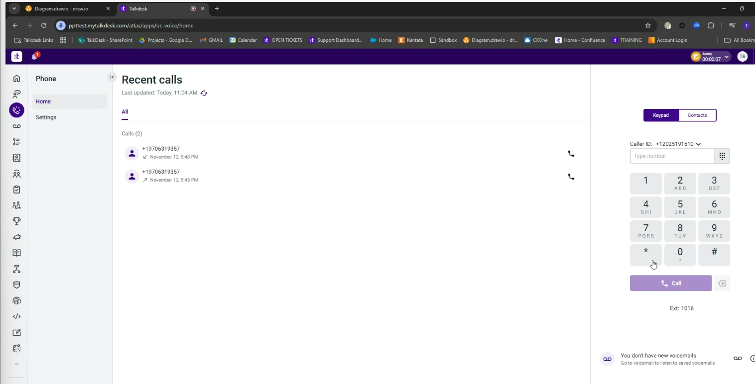

Something to think about
- @CCramer: What if they can login with their cell phone number instead?
  - @Tristan: Possible solution – Talk desk has a role called Office User.
    - Both Roles are similar but the Office user has fewer features.
      - These can access VM via email notifications.
- @Tristan Talk desk current VM functionality:
  - The agent gets an email notification with a link to listen to the VM.
    - They do not attach the actual VM File.
    - To access the VM link, the phone agent must be logged in to Talk Desk.
- Important Details:
  - This might be an additional cost to EGIA.
    - Tristan & Kim to review this info and get back to us.
- EGIA currently has 55 talk desk phone users/licenses.
  - Possible solution for the VM limitation is the Talk Desk Phone APP.
Talk Desk Phone App
Could also be a solution to the remote Agents who don’t have/want the hardware.
  - Polycom Devises on the Desk for some users for accounting & Reps (Laurie’s team) and need option to be on soft phone remotely.
- Email Notifiers
- Emai notification will be coming on the call center site, but not on the talk desk phone.

  - Email VM notification looks like this:
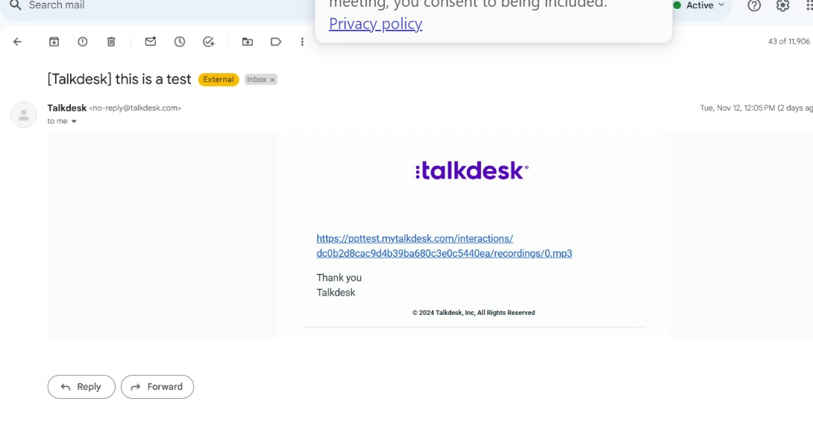
This is how the VM URL looks like, once Phone Agent has logged in to Tak Desk to listen to the VM. 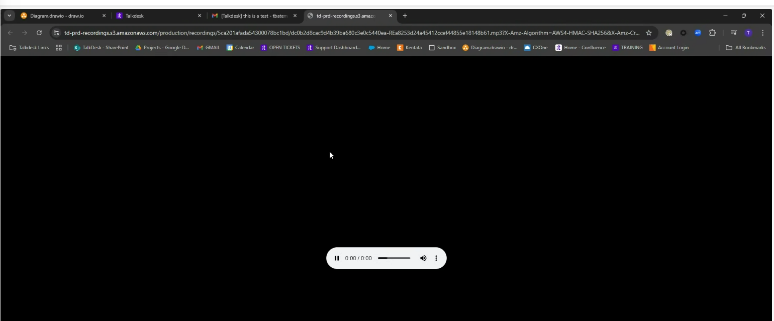

- Next Steps
  - Figure out the least amount of pain and resistance from EGIA Teams.
  - Need a game plan for he field agents -> they can forward the VM to their own phones if worst comes to worst.

- Clinton
  - Verify Tristan & Sam- have access to the shared colab folder.
    - Sam confirmed she has access to the folders
    - Tristan has access to the shared folder.
  - Files under Folder
    - Sam Added files – I need to review
  - Project Management
    - Kick off desk
  - Configuration Folder
    - data collection
    - Poly ComPhoneList
- Sam will continue to add folders & items – EGIA to review prior to next meeting & see if we have questions as we will review on our next discovery meeting.
- Queues
  - List of all the queues we have
  - Column G – which shwos Removal – Don’t need to add it in as those are getting removed

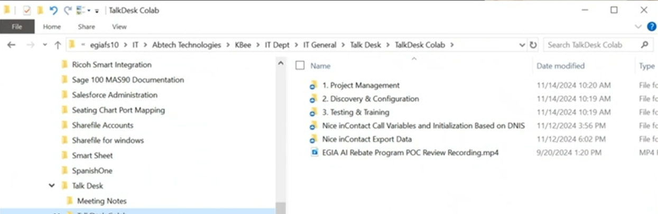 Calls routing to those queues and those agents
- Collections of businesses
  - Example call in to the 800 number -> do you want to talk to x person or x department (call tree)
  - Everything is going DID –
  - What we currently have: Call center -> getting a greeting -> menu choices -> association call queue -> Association for Hours of operation -> association for the Emial of the Program where the VM get sent.
- Color coded the numbers based on the association
  - When routing to the ones in yellow is based on the DNIS
    - They come in the door and -> what is the DNIS & therefore I need to use this number.
    - Each has its own script.
  - Each color its its own call center.
    - Member Services will have a list of tool free numbers/programs
  - All these are Agents
    - Have a direct number to them and also take calls into the queue
    - Yes and no, we have both scenarios, some reps have their own number and others don’t have it.
- Nice in contact Call Variabes & Innitiallization
  - Currently,
    - Assign Variables
      - Time, what music, what are the closed profiles,
    - Tech stuff
    - Reporting Stuff
  - All those buble variables tell the system what to do
  - Are all the queues sharing the same time of day
    - NO – each program/color has their own TOD. Some have two depending on where the REP is located. Each has its own skill.
  - Holidays – everyone has the same TOD
  - English is the default language
    - In some cases we do offer Spanish
  - How does the system determine what skill?
    - The initialization = DNIS program Number /DNIS Agent Number (the color numbers on the excel)
      - Example: Socal Water Smart
        - If I come from one of these number -> emidate assignment = MET _General Skill.
        - Email address -> and sends the VM to the appropriate SKILL
        - How many of these fall into the IVR
          - 2 major situations
            - MET &TBW – gets claim status via IVR
            - The others have a menu for press 1 for x to prevent the robot calls.
            - These will utilize API
          - The others will user just a menu until eventually they land with a REP.
        - Extension dialing = something they can do. But cant do the last name extension.
        - Campaign = Call Campaigns
          - It’s a nice in contact thing, all thse skills belog to Customer service or that Department
        - Call Flow - Where we are determining wat to do with that call.
          - Use this Voice File when holiday
          - Use this other Voice File for This other program ( not people)
        - IF client calls an extension & the Rep does not answer, do we drop them on this Rep VM – Yes

        - -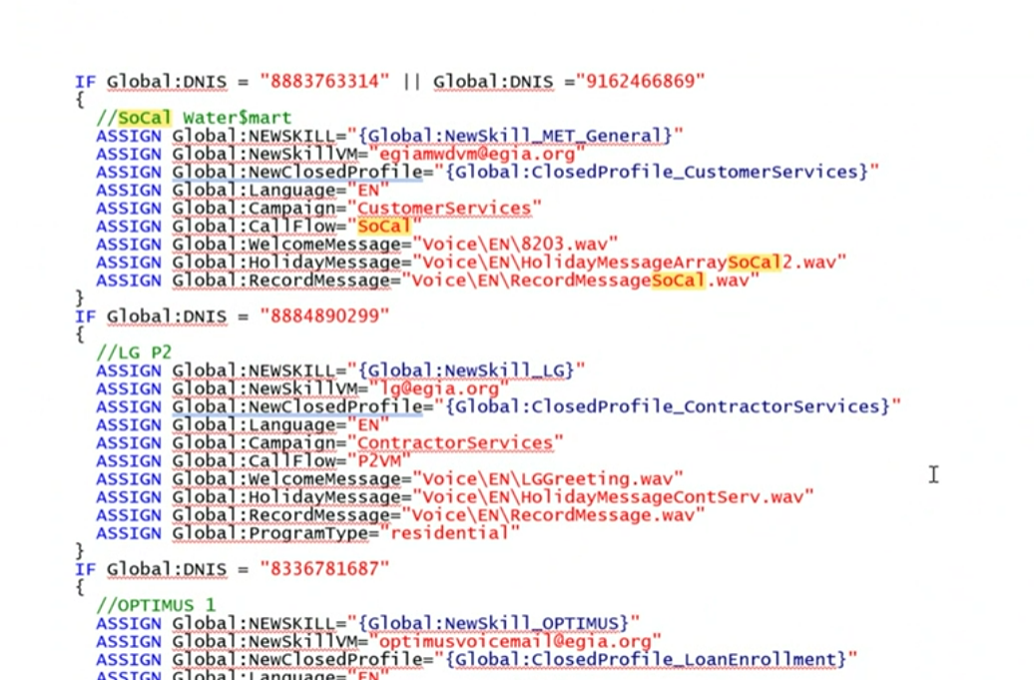
  - 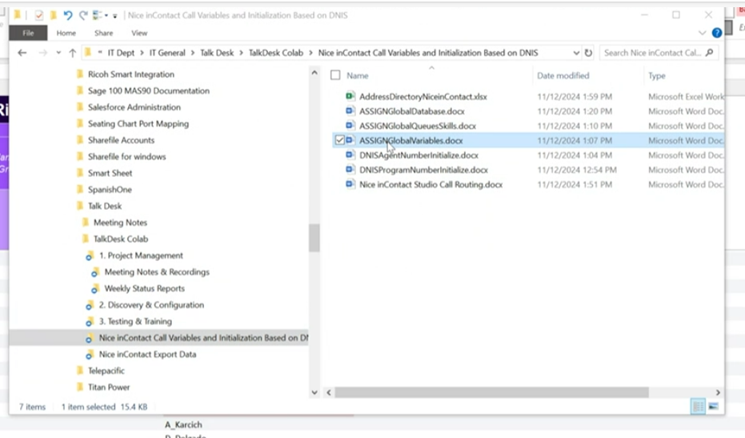
  - 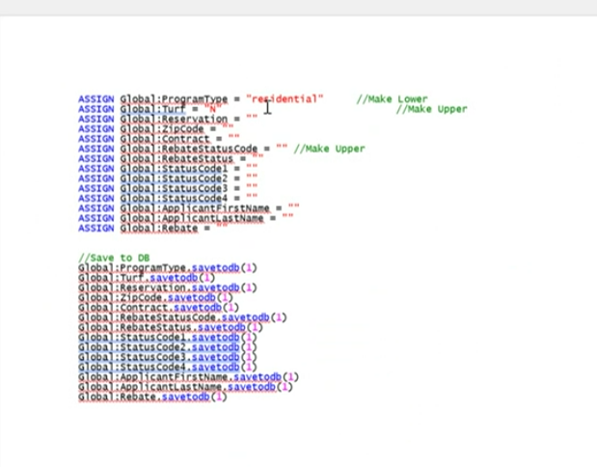
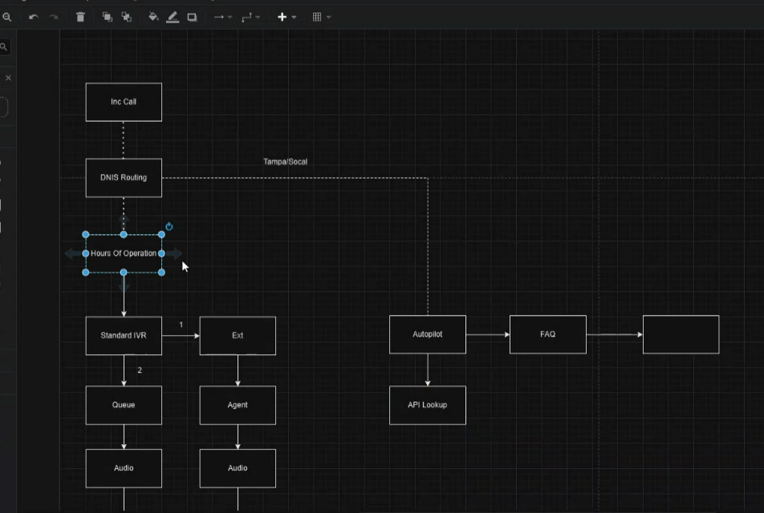
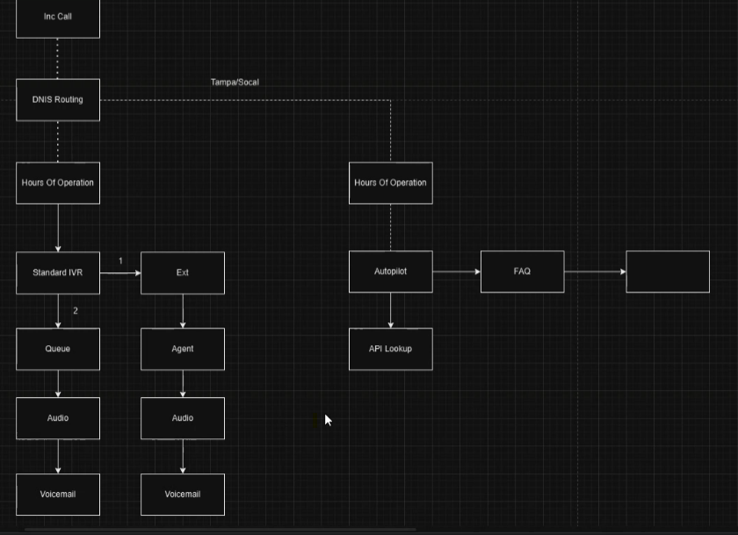

Take a look at the Nice in Contact studio call routing Doc.
Next meeting tomorrow

In coming call
DNIS Routing

11 AM
Clinton, Maria, Eddie
- Jira board Infrastructure IN-
- What does it mean? Circuits -> line of communication to bridge the people.
- Device on one end and Electricity on the other. These need to communicate. Providing information between two system.
- Starting with Circuits Aggregator masergy Implentation. IN-6

Infrastructure we are talking about : Jira Infrastrucre Projects Review talk desk
Column A – Current solution
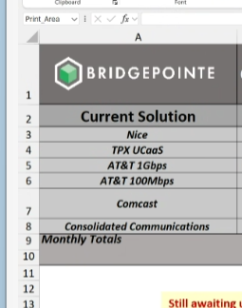
New Solution moving forward.
Messergy & Comcast = Same that deals with Circuit aggregrators which means they are providing connectivity to my customers with multiple circuits, with different companys & backups. They sent a box to monitor & verify all are working. (third party member that administers the flow)
Our vender = Comcast Messergy

Talk Desk & Merssorgy difference = Massory comes first &
Knowbe4 IN-7
Need to do the homework

mig

